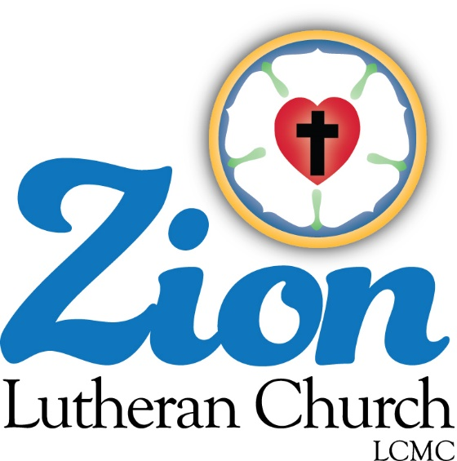

Welcome to ZION Lutheran Church
LCMC ~ Lutheran congregations in mission for Christ
8307 Memorial Hwy. Ottawa Lake, MI 49267 ·
(734) 856-2921
Pastor ∙ Jeffrey Geske
(785) 340-5635
zlcolmpastor@gmail.com
www.zionlutheranottawalakemi.com

Our MISSION
“SHARING THE LOVE OF JESUS”

To Our Guests

We are so glad that you have chosen to join us this morning! We pray that you will be refreshed and renewed as you come into God’s presence. Please take a moment to introduce yourself to the pastor and to those seated around you. Once again, we warmly thank you for worshipping with us this morning!

Those Assisting in Ministry Today
APRIL 5, 2020 ~ PALM SUNDAY
Organist: Joseph extejt Greeters : Ron Clark and All
deacon: Ben Schmidt SCREEN: Nick Baumgartner & Jacob Geske
Altar Guild: Shirley Clark and JoAnn VanSteenkiste
Administrative assistant: Sandy Brady
(419) 410-9380 or skwiles2000@gmail.com

LCMC ~ WHO WE ARE
Free in Christ + Accountable to One Another + Rooted in Scripture and the Lutheran Confessions + Committed to the Great Commission

April 5 – Palm Sunday
Matt. 21:3 – “If anyone says anything to you, you shall say, ‘The Lord needs them,’ and he will send them at once.” Did Jesus really need the donkey? If the man had refused to give the donkey, would the work of salvation have been derailed? Of course not. But what an honor for the man who owned this donkey and foal! Likewise, the Lord needs none of us, but what an honor for God to choose to use our generosity in the work of His Church.

Watch our Service on FACEBOOK LIVE ~
Visit Facebook page ~ ZionLutheran Church Ottawa Lake MI

Go in Peace ~ Sharing the Love of Jesus!

Announcements
IN OUR PRAYERS:
- For our congregation members; that they may be committed to our mission of sharing the love of Jesus.
- Pastor and Jacob Geske
- For LCMC Congregation and Missionaries around the world.
- President Trump, national leaders and our country. Our nation’s military, especially are loved ones:
- For those who are sick, recovering, or in need of God’s grace at this time. We include in our prayers: Pastor Terry and Gail; Loretta and Wes VanDyke; Susan Gaylord; Betty Vesey; Barbara Clark; Arnold Clark, Jesse Harmon; Parker Reau; Sean Ruhl; Linda McGuirre; Julia Matzinger; Sandra Harmon, Linda Geske, John Rittner and Barbara Swope.
Prayer List: Please let us know when we can take the name off of the prayer list. Thank you!.

Our Stewardship ~ Weekly budget needs are $1,698.16: We appreciate any gifts that you can send in through the mail.

This Week at Zion Includes: Today – No Bible Study at 9 am; Worship at 10 a.m. Thursday ~ Maundy Thursday Service at 7:00 p.m. Friday ~ Good Friday Service at 7:00 p.m. Saturday, April 14 ~ Men’s Breakfast at 8:00 a.m. and Contemporary Service at 4:00 p.m. Next Sunday – Easter Sunday ~ No Sunrise at 7:00 a.m. Breakfast at 8:15 Bible Study at 9am and Celebration Worship at 10 a.m.

Zion Lutheran Church Elders
We will have our monthly meeting on April 14th at 7:00 p.m.

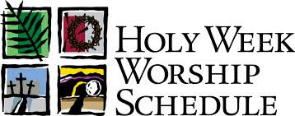

Celebrate the Death and Resurrection of our
Lord and Savior, Jesus Christ!

April 5 – Palm Sunday ~ Celebrating the Triumphant Entry of Jesus into Jerusalem.

April 8 – Maundy Thursday ~ 7:00 p.m. with Communion ~ Celebrating the Institution of the Lord’s Supper and the new command Jesus gave to love one another.

April 9 – Good Friday ~ 7:00 p.m. ~ Remembering the suffering and death of Jesus for our sin and our salvation.

April 12 – Easter Sunday ~ Celebrating the Triumphant Resurrection of Jesus!
No Sunrise Service ~ 7:00 a.m.
Celebration Sunrise Service ~ 10:00 a.m.

