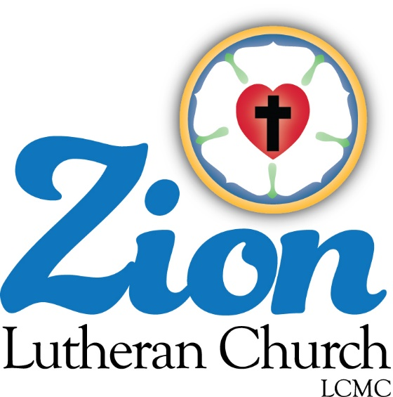

Welcome to ZION Lutheran Church
LCMC ~ Lutheran congregations in mission for Christ
8307 Memorial Hwy. Ottawa Lake, MI 49267 ·
(734) 856-2921
Pastor ∙ Jeffrey Geske
(785) 340-5635
zlcolmpastor@gmail.com
www.zionlutheranottawalakemi.com

Our MISSION
“SHARING THE LOVE OF JESUS”

To Our Guests

We are so glad that you have chosen to join us this morning! We pray that you will be refreshed and renewed as you come into God’s presence. Please take a moment to introduce yourself to the pastor and to those seated around you. Once again, we warmly thank you for worshipping with us this morning!

Those Assisting in Ministry Today
May 10, 2020 ~ fifth Sunday after Easter
Organist: Joseph extejt Greeters : Ron Clark and All
deacon: Ben Schmidt SCREEN: Nick Baumgartner & Jacob Geske
Altar Guild: Shirley Clark and JoAnn VanSteenkiste
Administrative assistant: Sandy Brady
(419) 410-9380 or skwiles2000@gmail.com

LCMC ~ WHO WE ARE
Free in Christ + Accountable to One Another + Rooted in Scripture and the Lutheran Confessions + Committed to the Great Commission

May 10 – Fifth Sunday after Easter (--LCMS website)
1 Peter 2:9 – “But you are a chosen race, a royal priesthood, a holy nation, a people for his own possession, that you may proclaim the excellencies of him who called you out of darkness into his marvelous light.” God has called us to be His own. He has chosen us out of love, out of mercy, out of sheer, divine joy. The Apostle says that God has done this that we may share in His glory and joy, that we may “proclaim the excellencies of Him” who has made us His own. And truly, this is our delight! His joy brings joy in our hearts as well.
Watch our Service on FACEBOOK LIVE ~
Visit Facebook page ~
Zion Lutheran Church Ottawa Lake MI

Go in Peace ~ Sharing the Love of Jesus!

Announcements
IN OUR PRAYERS:
- For our congregation members; that they may be committed to our mission of sharing the love of Jesus.
- Pastor and Jacob Geske
- For LCMC Congregation and Missionaries around the world.
- President Trump, national leaders and our country. Our nation’s military, especially are loved ones:
- For those who are sick, recovering, or in need of God’s grace at this time. We include in our prayers: Pastor Terry and Gail; Loretta and Wes VanDyke; Susan Gaylord; Betty Vesey; Barbara Clark; Arnold Clark, Jesse Harmon; Parker Reau; Sean Ruhl; Linda McGuirre; Julia Matzinger; Sandra Harmon, John Rittner, Sandy Baumgartner, Alan Ahleman, Joann Koester, and Barbara Swope and the family of Linda Geske.
Prayer List: Please let us know when we can take the name off of the prayer list.
Thank you!.

Our Stewardship ~ Weekly budget needs are $1,698.16: We appreciate any gifts that you can send in through the mail.

Thank you so much for the gifts that you have blessed our ministry with through the mail or other means. They are so appreciated!

This Week at Zion Includes: Today – No Bible Study at 9 am; Worship at 10 a.m. Tuesday ~ Food Pantry from 10-12 Next Sunday ~ Drive in Worship at 10 a.m. in the parking lot. We will celebrate the Lord’s Supper. Church Council will meet at 11:00 a.m.

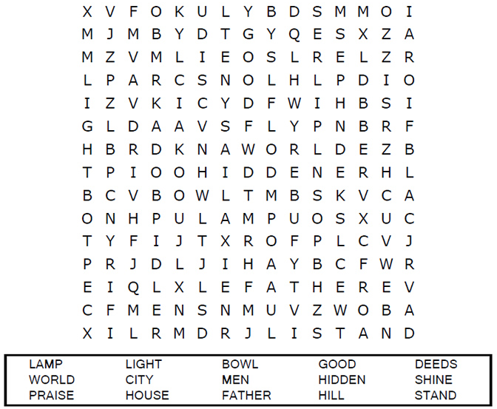
(--sermons4kids.com)
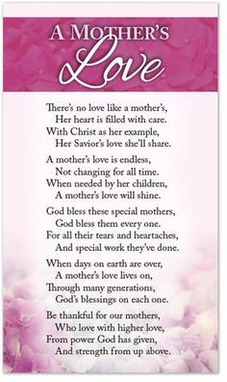

Pastor will be out of town from Sunday afternoon until Friday evening ~ Please keep Pastor and Jacob and their family in your prayers as they travel to Minnesota for the funeral service of Linda Geske who passed away on Tuesday morning May 5.
“Precious in the sight of the Lord
is the death of his faithful servants.” ~ Psalm 116:15

