The Messenger
A newsletter of Zion Lutheran Church ~ Ottawa Lake, MI
July 2020
+ + + + + + + + + +

Join Us for Worship!

Our worship on July 4-5 will be patriotic services with praise to God for the blessings of our country.

Sunday Morning Bible Study
We have begun to watch a video called, “That the World Might Know.” Learn more about this series in the Bible Class section of this newsletter.
Please plan to join us at 9:00 a.m.

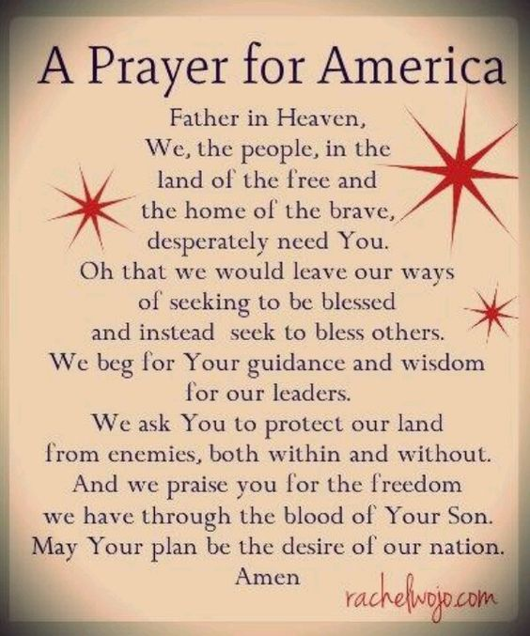
Lutheran Men ~Monthly Breakfast
On July 11, 2020, we will have our Lutheran Men Monthly breakfast. Breakfast will be served at 8:00 a.m. We will have a hot breakfast, devotion, and a Bible study. Please come and feel free to invite a friend or neighbor.

Zion Lutheran Church ~ Congregational Biannual Meeting
Our biannual congregational meeting will be held on July 12 at 11:15 a.m. Please plan to attend!
If you have any questions, please speak to Dwight Gilliland.

Zion Lutheran Elders
We will have our monthly meeting on Thursday July 16, 2020 at 7:00 p.m.

Zion Lutheran Church Council
We will have our monthly Church Council Meeting after church on July 19, 2020.
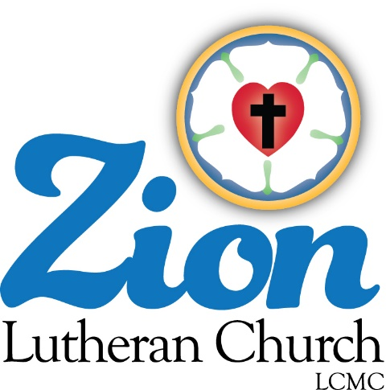
ZION Lutheran Church
LCMC ~ Lutheran congregations in mission for Christ
8307 Memorial Hwy. Ottawa Lake, MI 49267 ·
(734) 856-2921
Pastor ∙ Jeffrey Geske
(785) 340-5635
zlcolmpastor@gmail.com
www.zionlutheranottawalakemi.com

Secretary ~ Sandy brady
(419) 410-9380
skwiles2000@gmail.com
custodian and organist~ Joseph extejt

For Your Information
The following members give of their time to the leadership of this congregation. Please keep them in your prayers. If you have any questions, comments, or offers of help, please contact them.
Chairman: Dwight Gilliland
Secretary: Connie Sieler
Treasurer: Dennis Reitzel
Financial: Ron Clark
Elders: Ron Vincent and Lee Edignton
Deacons: Ben Schmidt
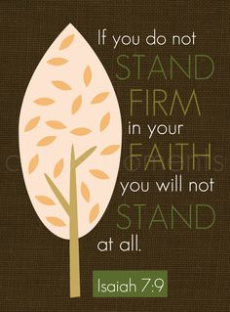
LCMC ~ WHO WE ARE
Free in Christ + Accountable to One Another + Rooted in Scripture and the Lutheran Confessions + Committed to the Great Commission

Prayers Are Important
If you have an occasion to request a prayer, please call the church office. If you would like your request to be on our prayer chain, please call Sandy Brady (419) 410-9380 or Pastor Jeff at the church or on his cell phone (785)340-5635.

Please Inform the Church Office. . .
*when a member of your family is ill or hospitalized or if they are discharged or moved to another facility.
*when your address changes.
*when a new baby arrives.
*when a family member marries or leaves home for college, or military.
*when planning a wedding to be conducted at Zion.
*when a new family moves into your neighborhood.
*when you are planning to be out of town.
*when a brother or sister in Christ needs a visit from Pastor.

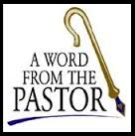
From the desk of Pastor Geske….

Our World Needs Jesus!

As we seek to share the love and forgiveness of Jesus, do we share Jesus with those who may not look like us or act like us? Our world needs Jesus. As the beautiful song says, “Red and yellow, black and white, they are precious in His sight. Jesus loves the little children of the world!” Jesus loves all people and He sends us to help this world know His love and forgiveness.

I came across this prayer that said, “Heavenly Father, Help me remember that the jerk who cut me off in traffic last night is a single mother who worked nine hours that day and was rushing home to cook dinner, help with homework, do the laundry and spend a few precious moments with her children. Bring to my mind often that the pierced, tattooed, disinterested young man who can't make change correctly at McDonalds is a worried 19-year-old college student, balancing his apprehension over final exams with his fear of not getting his student loans for next semester. Remind me, Lord, that the scary looking bum, begging for money in the same spot every day (who really ought to get a job!) is a slave to addictions that I can only imagine in my worst nightmare. Cause me to reflect that the old couple, walking annoyingly slow through the store aisles and blocking our shopping progress are savoring this moment, knowing that, based on the biopsy report she got back last week, this will be the last year that they go shopping together. Heavenly Father, remind me each day that, of all the gifts you give me, the greatest gift is love. It is not enough to share that love with those I hold dear. Open my heart not just to those who are close to me, but to all humanity. Let me be slow in judgment and quick with forgiveness and patience and empathy and love. Amen.”

Can you relate to this prayer? Have you ever had those same thoughts? Sometimes we see people in our community and in our world who maybe are not like us, but our Savior wants us to reach them and teach the unconditional love and forgiveness of our Savior, Jesus Christ. Our world needs Jesus and God is using and blessing us to share Christ to this community and to our world. Yes, we can and we should share Jesus through our words and actions and also through prayer.

Remember those words of Jesus to Zacchaeus, “For the Son of Man came to seek and to save what was lost.” (Luke 19:10 NIV) We witness in thanksgiving to Jesus for what He has done for us and His love for us. May God bless us to witness and to share Jesus with our friends and those we are comfortable with, and also with others!

Yours in Christ,
Pastor Jeffrey Geske

“⁹ But you are a chosen people, a royal priesthood, a holy nation, God’s special possession, that you may declare the praises of him who called you out of darkness into his wonderful light. ¹⁰ Once you were not a people, but now you are the people of God; once you had not received mercy, but now you have received mercy.”
(1 Peter 2:8-9 NIV)

Sunday Morning Bible Class

Please come and join our interesting study of the Word of God!

That The World May Know Series

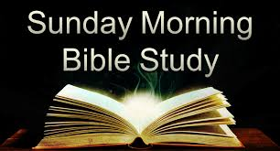
Take your group on a trip to ancient times, places, and customs with trusted Bible scholar Ray Vander Laan as your fun and engaging tour guide. Filmed in Israel, Egypt, Turkey, and Greece, these powerful videos explore what it meant to follow Jesus in the first century—and what it means to follow him today. Each of the 16 volumes provides visually stunning video sessions as well as an easy-to-follow discovery guide that illuminates Jesus’ teachings and helps participants understand the context in which He lived and preached. Join renowned teacher and historian Ray Vander Laan as he guides you through the lands of the Bible. In each lesson, Vander Laan illuminates the historical, geographical, and cultural context of the sacred Scriptures. Filmed on location in the Middle East, the That the World May Know ® film series will transform your understanding of God and challenge you to be a true follower of Jesus.
We are watching the volume called, “In the Dust of the Rabbi.” Here is a little bit about it. “During his ministry in Israel, Jesus called and trained disciples, His ‘talmidim.’ Their job would eventually be to bring His message of redemption to all the nations, Jew and Gentile. What would happen when they began to make disciples of their own and the gospel began to spread to a Greek and Roman world, to cultures completely unfamiliar with the God of the Jews? Follow the rabbi through Israel and Turkey as you explore what it meant to be the message of Jesus to all nations.

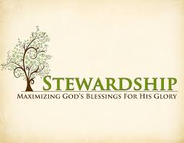
Newsletter Article – July 2020
(--From the LCMS website)

“Good Teacher, what must I do to inherit eternal life?” asked the rich young ruler. Jesus said, “You know the commandments.” And the ruler replied, “All these I have kept from my youth.” And Jesus said to him, “One thing you still lack. Sell all that you have and distribute to the poor, and you will have treasure in heaven; and come, follow me.” (Luke 18:18–22)

As we listen to this, one question is raised in our minds: Is Jesus speaking to us also or only to the rich young ruler? In other words, is Jesus telling us to sell all that we have and give it to the poor? As good Lutherans, we answer: No! But why? Why should we not sell all that we have and distribute it to the poor?

The simplest explanation is this: If we sold everything we have, our wife and our children would be neglected. In other words, to sell everything we have and give it to the poor would ignore, even abandon, those whom God has placed in our care. Our money, everything we have, is not to be used solely for the church. But that doesn’t mean it isn’t to be used for the purpose God intends.

Everyone has three stations in life, three spheres in which we live and are to be of service to our neighbors. These stations are the church, the family, and society. We are members of all three of these by birth.

- We are born into the church by water and the Word of God, and our duties to others in the church arise from either our birth into the church or the birth of others by Baptism into it.
- We are born into a family, and our duties to others stem from either our birth into that family or the birth of others into our family.
- Finally, we are born into society, which is simply a further extension of our birth into our family. The duties we have toward other members of society come from either our birth or the birth of others into the same society.

All that we have and all that we are is to be pressed into service for the church, the family, and society. If we were to sell all we have and give only to one, the other two would be neglected, and our duties toward them would falter.

So consider your life and all that you have in light of these three stations. You pay taxes to support and help those in society. You provide food, clothing, and shelter for the members of your family. You save for college for your children.

But the one station that is usually thought of last is the church. Since the needs of the family and society are more immediate, the church is often given what is left over. This is not how it should be. Rather, we are to give of our first fruits – the best from off the top – even as Abel gave the best of his flock.

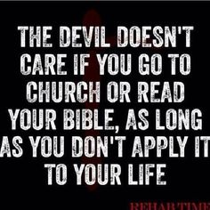
This requires forethought and intent. It means that you sit down and make a plan for what you will give from the beginning. It means sticking to it even when it seems there are other more immediate and pressing things.

This is all the more necessary now as we enter into periods of time while giving is low due to high unemployment or restrictions on meeting in church to give. If we love God, his gifts of forgiveness given through the means of grace we receive at church and only at church, then we will support the church just as we love our country and our family.

For all that we have and all that we are is given to us by our gracious and giving God. He spared no expense for us and our salvation. He gave up His Son into death so that our sins are forgiven, and we will live. What is more, He provides for all that we need for this body and life. And our lives in this world, among these three spheres of the church, the family, and society, are to mirror the generosity of the one who gave us life in all three by birth.

Don’t let the church, your divine family, be ignored or even an afterthought. The church is nurturing you, bringing you up in salvation by Word and Sacrament for eternal life.

WE BELIEVE, TEACH, AND CONFESS
From Luther’s Small Catechism ~ The Sacrament of the Altar
I. The Nature of the Sacrament of the Altar
What is the Sacrament of the Altar?
It is the true body and blood of our Lord Jesus Christ under the bread and wine, instituted by Christ Himself for us Christians to eat and to drink.
Where is this written?
The holy Evangelists Matthew, Mark, Luke, and St. Paul write:
Our Lord Jesus Christ, on the night when He was betrayed, took bread, and when He had given thanks, He broke it and gave it to the disciples and said: “Take, eat; this is My body, which is given for you. This do in remembrance of Me.”
In the same way also He took the cup after supper, and when He had given thanks, He gave it to them, saying, “Drink of it, all of you; this cup is the new testament, in My blood, which is shed for you for the forgiveness of sins. This do, as often as you drink it, in remembrance

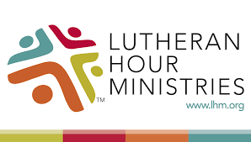
Bringing Christ to the Nations and
the Nations to the Church
"The Lutheran Hour," which began in 1930, is now heard on more than 1,300 radio stations around the world. "The Lutheran Hour," hosted by Dr. Rev. Michael Zeigler, is the world's oldest continually-broadcast Gospel radio program. This weekly half-hour program proclaims the message of Jesus Christ to all people and serves as a bridge, linking them to the Church. Listen to the Lutheran Hour on Sundays at 10:00 a.m. at FM 99.5 KAWZ or AM 1560 WWYC or anytime at www.lhm.org

July 2020

July 5
"Unhelmed"
Speaker: Rev. Dr. Michael Zeigler
Are you living in the reality of life as it is right now, life as it will be, or somewhere in between?
(Matt 6:1-18)
July 12
"Perfection Welcomes Failure"
Speaker: Rev. Dr. Michael Zeigler
God's perfect standards are exceeded only by His perfect patience and forgiveness.
(Matt 6:19-34)
July 19
"TBD"
Speaker: Rev. Dr. Michael Zeigler
(Exodus)
July 26
"TBD"
Speaker: Rev. Dr. Michael Zeigler
Conclude Exodus Series

THRIVENT NEWS . . .
If you would like more information about Thrivent, its products, or its fraternal functions, please contact our area representative Greg Durivage in Maumee, OH at (419)-740-4193.

If you are a Thrivent Member, please consider using a Thrivent Action Team to support our ministry here at Zion..

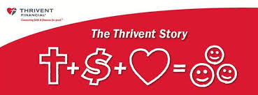
What is a Thrivent Action Team? Thrivent Action Teams make it easy to live generously. Thrivent provides promotional resources and seed money to jump-start your fundraiser, educational event or service project. Your team provides the people power to bring it to life.

Food Bank~
Thank you for your generous help with our Food Bank. If you have any question or would like to help in any way, please contact Rick Keck at (734) 854-4710. The Food Bank serves families and individuals on the second and fourth Tuesday of the month from 10:00 a.m. until noon.

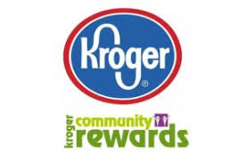
Community Rewards Program
Do you shop at Kroger? If you do, you can sign up for their Community Rewards Program and Kroger will give back to Zion money every quarter. Go on Kroger's website and sign up under Community Rewards. If you need help or don't have an email address, check with Pastor Jeff. (Our code is NC512)
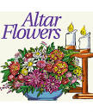
Flowers on the Altar ~ If you would like to place flowers, please sign up in the hallway by the restrooms.

BIRTHDAYS AND ANNIVERSARIES
We would like to wish Happy Birthday and Happy Anniversary to the following individuals who are celebrating this July. If you are not listed or you know someone not listed, please contact Sandy Brady or Pastor Jeff.

1 Roger Smith
6 Sandy Baumgartner
12 Barb Edington
13 Pastor Jeff Geske 50th
15 Dennis Reitzel
15 Charlie Stewart
27 Rick Keck

We wish the following couples a very Happy Anniversary!
26 ~ Wes and Loretta Van Dyke
28 ~ Rick and Karen Keck

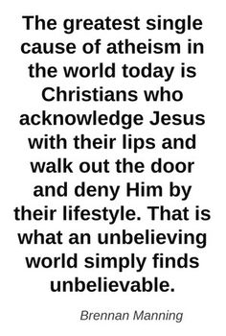
Something to Think About
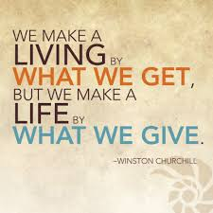
French writer Alexis de Tocqueville, after visiting America in 1831, said, "I sought for the greatness of the United States in her commodious harbors, her ample rivers, her fertile fields, and boundless forests--and it was not there. I sought for it in her rich mines, her vast world commerce, her public school system, and in her institutions of higher learning--and it was not there. I looked for it in her democratic Congress and her matchless Constitution--and it was not there. Not until I went into the churches of America and heard her pulpits flame with righteousness did I understand the secret of her genius and power. America is great because America is good, and if America ever ceases to be good, America will cease to be great!"
(--Alexis de Tocqueville)

