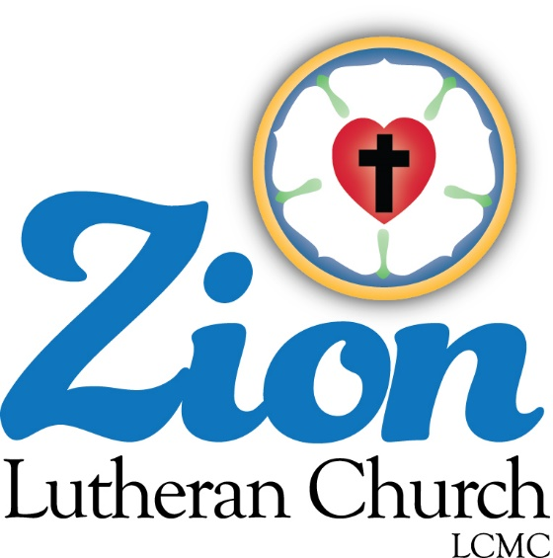

Welcome to ZION Lutheran Church
LCMC ~ Lutheran congregations in mission for Christ
8307 Memorial Hwy. Ottawa Lake, MI 49267 ·
(734) 856-2921
Pastor ∙ Jeffrey Geske
(785) 340-5635
zlcolmpastor@gmail.com
www.zionlutheranottawalakemi.com

Our MISSION
“SHARING THE LOVE OF JESUS”

To Our Guests

We are so glad that you have chosen to join us this morning! We pray that you will be refreshed and renewed as you come into God’s presence. Please take a moment to introduce yourself to the pastor and to those seated around you. Once again, we warmly thank you for worshipping with us this morning!

Those Assisting in Ministry Today
May 31, 2020 ~ The Day of Pentecost
Organist: Joseph extejt Greeters : Ron Clark and All
deacon: Ben Schmidt SCREEN: Nick Baumgartner & Jacob Geske
Altar Guild: Shirley Clark and JoAnn VanSteenkiste
Administrative assistant: Sandy Brady
(419) 410-9380 or skwiles2000@gmail.com

LCMC ~ WHO WE ARE
Free in Christ + Accountable to One Another + Rooted in Scripture and the Lutheran Confessions + Committed to the Great Commission

May 31 – Day of Pentecost (--LCMS website)
Acts 2:1 – “When the day of Pentecost arrived, they were all together in one place.” Pentecost is the Old Testament harvest festival – it happens around the time when the wheat and oats are ready to be brought in. Of course, this was a picture and foreshadowing of the great harvest of humankind that God means to bring in through the preaching of His Word. God gives the seed, and God brings about the harvest. From first to last, in things temporal and things eternal, we stand only by His grace.

Watch our Service on FACEBOOK LIVE ~
Visit Facebook page ~
Zion Lutheran Church Ottawa Lake MI
Services are covered CCLI 1553677
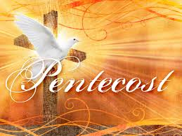
Thoughts on the Readings ~ The Common Thread
Wait for God. Too often, individuals and entire congregations rush ahead of the Spirit. They are determined to do things their way—even if that is the same old way, “the way we’ve always done it in our church.” But God is doing something new, and we may see it, if we wait. Without the outpouring of the Holy Spirit, and his guidance (inspiration), we stumble, at best. Alcoholics Anonymous describes insanity as “doing the same thing over and over again and expecting different results.” We may feel that we must move ahead, but faith (not feelings or emotions) bids us wait on the Lord so that we have renewed strength and godly courage (Isa 40:31, Psa 27:14).

Go in Peace ~ Sharing the Love of Jesus!

Announcements
IN OUR PRAYERS:
- For our congregation members; that they may be committed to our mission of sharing the love of Jesus.
- Pastor and Jacob Geske
- For LCMC Congregation and Missionaries around the world.
- President Trump, national leaders and our country. Our nation’s military, especially are loved ones:
- For those who are sick, recovering, or in need of God’s grace at this time. We include in our prayers: Loretta and Wes VanDyke; Susan Gaylord; Betty Vesey; Barbara Clark; Jesse Harmon; Parker Reau; Sean Ruhl; Linda McGuirre; Julia Matzinger; Sandra Harmon, Alan Ahleman, and Barbara Swope

Prayer List: Please let us know when we can take the name off of the prayer list. Thank you!.

Our Stewardship ~ Weekly budget needs are $1,698.16:

Thank you so much for the gifts that you have blessed our ministry with through the mail or other means.
They are so appreciated!

This Week at Zion Includes: Today – No Bible Study at 9 am; Worship at 10 a.m. Saturday ~ Worship at 4:00 p.m. Next Sunday ~ Bible Study at 9:00 and Worship at 10 a.m. Our Congregational Meeting has been rescheduled for July 12 due to COVID.

NEWSLETTERS ~ Pick up your newsletter today in the fellowship hall.

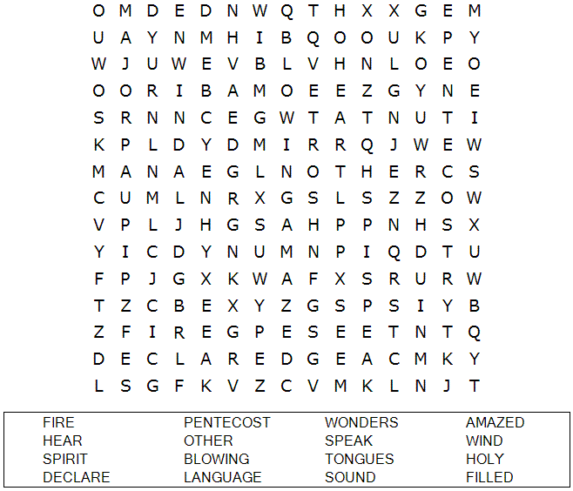
(--sermons4kids.com)

