The Messenger
A newsletter of Zion Lutheran Church ~ Ottawa Lake, MI
August 2020
+ + + + + + + + + +
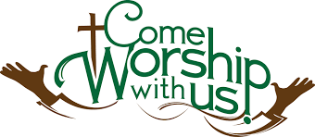

WORSHIP WITH US EACH WEEK!
Join us for worship on Saturday afternoon
at 4:00 p.m. and Sunday morning at 10:00 a.m.

Sunday Morning Bible Study
We have begun to watch a video called, “That the World Might Know.” Learn more about this series in the Bible Class section of this newsletter.
Please plan to join us at 9:00 a.m.

Lutheran Men ~Monthly Breakfast
We will not meet in August ~ Join us again in September

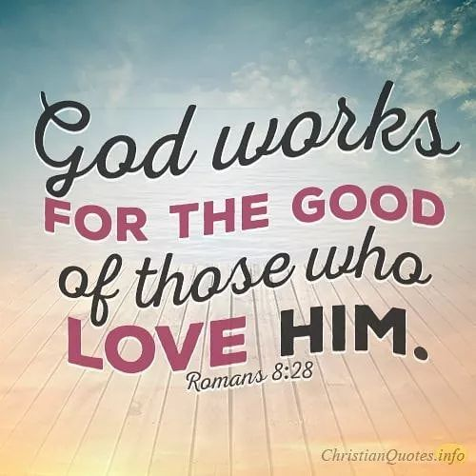

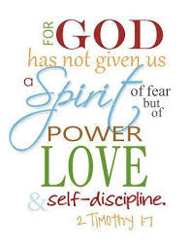

Zion Lutheran Church Elders
We will not meet in August

Zion Lutheran Church Council
We will have our monthly Church Council Meeting after church on August 16, 2020.
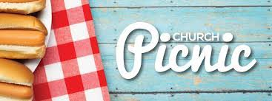

PICNIC AT THE PARSONAGE
Join us for a picnic at the parsonage. We will meet on August 30th at 5:30 p.m. Hamburgers and hotdogs will be provided along with drinks and tableware. Please bring a dish to share.

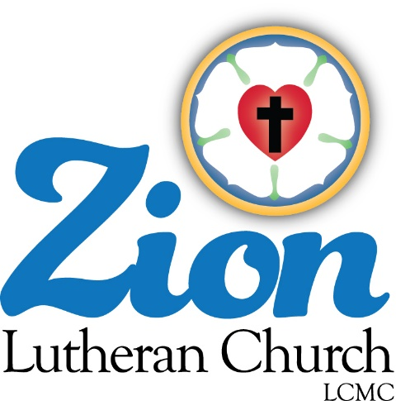
ZION Lutheran Church
LCMC ~ Lutheran congregations in mission for Christ
8307 Memorial Hwy. Ottawa Lake, MI 49267 ·
(734) 856-2921
Pastor ∙ Jeffrey Geske
(785) 340-5635
zlcolmpastor@gmail.com
www.zionlutheranottawalakemi.com

Secretary ~ Sandy brady
(419) 410-9380
skwiles2000@gmail.com
custodian and organist~ Joseph extejt

For Your Information
The following members give of their time to the leadership of this congregation. Please keep them in your prayers. If you have any questions, comments, or offers of help, please contact them.
Chairman: Dwight Gilliland
Secretary: Connie Sieler
Treasurer: Dennis Reitzel
Financial: Ron Clark
Elders: Ron Vincent and Lee Edignton
Deacons: Ben Schmidt
LCMC ~ WHO WE ARE
Free in Christ + Accountable to One Another + Rooted in Scripture and the Lutheran Confessions + Committed to the Great Commission

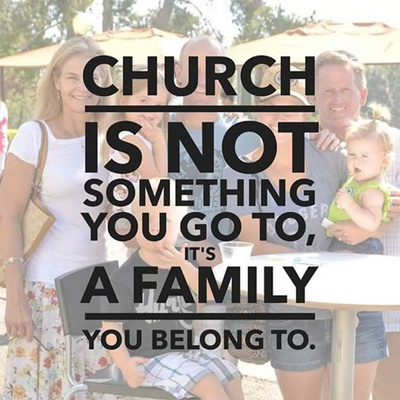
Prayers Are Important
If you have an occasion to request a prayer, please call the church office. If you would like your request to be on our prayer chain, please call Sandy Brady (419) 410-9380 or Pastor Jeff at the church or on his cell phone (785)340-5635.

Please Inform the Church Office. . .
*when a member of your family is ill or hospitalized or if they are discharged or moved to another facility.
*when your address changes.
*when a new baby arrives.
*when a family member marries or leaves home for college, or military.
*when planning a wedding to be conducted at Zion.
*when a new family moves into your neighborhood.
*when you are planning to be out of town.
*when a brother or sister in Christ needs a visit from Pastor.

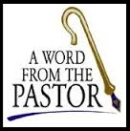
From the desk of Pastor Geske….
(This is an article that I had published in some local newspapers)

Is America Great?
By Pastor Jeff Geske

It was once said, “America is great because America is good.” These words have often been attributed to Alexis de Tocqueville. Where are we today? We have people questioning our history and some seeking to destroy it. As a Christian, I believe and pray that in this time in American history people would turn back to God. We progressed from the Builder Generation that lived through the Great Depression and the World Wars. They held a great respect for God and for America which led to our motto, “In God We Trust,” being placed on our money. This generation was followed by the Boomer generation that seemed to go through a time of questioning anything that was right about God or America from their parents. The Builder generation was also the silent generation in the terms that I do not believe they adequately shared with the next generation why they held the views that they did. They wanted the best for the next generation, and it seems to me, reflecting on history, that we lost some respect and love for God and country. The Boomer generation took their children to church as they were brought as children. Something was lost here. I believe it was the reason why we do what we do. I was raised in a home where we could get up and go to church or get up and get spanked and go to church. The result was that we were going to church. I am a thankful for my mom because she helped us understand the reason that we go. We go to church to be fed and nourished in God’s forgiveness and love. It seems from the Boomer generations to the next generations there has been a steady decline in church attendance and participation.

In the Lutheran Church, we follow the teachings of Martin Luther who lived during the 1400-1500’s. What we share with Luther is who Jesus is and what Jesus has done to give us forgiveness of sin and eternal life to all people. Luther was a sinner saved by Jesus just like we are today. During his time on earth, he saw such ignorance of the Bible as he worshipped in the church of his day. I wonder what he would say of today’s church. I believe there is a need for people to understand what the Bible and the Christian church are all about. Martin Luther wrote a book called, “The Small Catechism.” In this book, he identified six teachings that were central to a Christian understanding of the Bible. These teaching were about what it means when we pray the Lord’s Prayer, and when we confess the Apostles’ Creed identifying the Triune God~Father, Son, and Holy Spirit and Their work in our lives. These teachings also give us understanding of how God is at work and the blessings He is giving through baptism and the Lord’s Supper. These teachings include what it means when we confess our sin and receive God’s forgiveness and how we all have been called to share the Good News of Jesus. The teaching that I would like to focus this article on is how Luther believed that it was necessary that people understand the Ten Commandments and how we are to love God with our heart, soul, and mind and to love our neighbor as ourselves. (Matthew 22:37-39) I believe this is where we as a nation are going astray and ceasing to be good. The Ten Commandments speak of how God wants us to have only one God. He does not want us to misuse His name and He wants us to worship Him faithfully. I have been in ministry over 20 years and it is sad to see the decline of the church as a whole in those years. At one time faithful attendance was practically every Sunday. Today faithful attendance may be once or twice a month. In worship, we go to admit to God our brokenness. We go to hear God’s love and forgiveness spoken to us through the pastor and most importantly through the Word of God being proclaimed. In worship we strive for the acronym ACTS~Adoration, Confession, Thanksgiving, and Supplication. We go to adore God. We go to confess our sin and our faith in Him as Lord and Savior. We go to church to thank and praise God for all His blessings to us. And we go to church to bring to Him our supplications and prayers together as the body of Christ in that place. Many believe that they can worship God anywhere, but do they? Are they honoring God by defying the commandments of God. It is my prayer that somehow, amid this chaos in America where we seem to be ceasing to be good, that we would repent and turn to the Lord. In 2 Chronicles, we read, “⁴ if my people, who are called by my name, will humble themselves and pray and seek my face and turn from their wicked ways, then I will hear from heaven, and I will forgive their sin and will heal their land. “(2 Chronicles 7:14 NIV)

The other commandments speak of how we are to love our neighbor as ourselves. They speak of how we are to honor our father and mother, our elders and all those over us in school, work, and in government. We are called to honor them by respecting and praying for them. In this regard, I again see America ceasing to be great because we have lost respect for people and for those over us and in our government. The commandments go on and speak of how we are not to murder, how we are to honor marriage and family by not committing adultery. Our Heavenly Father knew that it was necessary for both parents to commit to each other to raise their family. In ceasing to be great in America, look what the Great Society has done to the family. The commandments then speak of not stealing. When I teach the faith, I stress in this commandment the saying, “Love people, use things; never love things and use people.” Look at the greed that we see in our world and our lives and our need to turn to God and confess our sin. The next commandment speaks of not giving false witness or testimony against your neighbor. Wow look what our broken world has done with that commandment. Finally, we are called to not covet what is not ours. We are to be thankful for what we have and work for those things that we want.

This summary of the commandments in one word is, “LOVE.” This is how we can LOVE God as we understand Him and how we can LOVE our neighbor as ourselves. The reality that Christians know is that we cannot keep them to earn heaven. We keep the commandments to say, “Thank you” to God for all that He has given to us through His love and forgiveness and the earthly blessings that He has bestowed upon us.

Is America great? I believe that we will not truly be as great as we could be until we again faithfully honor and love God with our lives and our worship and seek to honor and love Him as we love our neighbor as ourselves.

Join in praying for the return of our people to worship God through churches that understand the importance of God’s law and the importance of God’s love and forgiveness as given in the Bible. I pray that you will be like King David when he wrote these words about worship. “I rejoiced with those who said to me, ‘Let us go to the house of the Lord.’” (Psalm 122:1 NIV)

Sunday Morning Bible Class

Please come and join our interesting study of the Word of God!

That The World May Know Series

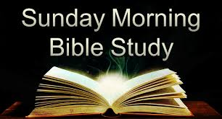
Take your group on a trip to ancient times, places, and customs with trusted Bible scholar Ray Vander Laan as your fun and engaging tour guide. Filmed in Israel, Egypt, Turkey, and Greece, these powerful videos explore what it meant to follow Jesus in the first century—and what it means to follow him today. Each of the 16 volumes provides visually stunning video sessions as well as an easy-to-follow discovery guide that illuminates Jesus’ teachings and helps participants understand the context in which He lived and preached. Join renowned teacher and historian Ray Vander Laan as he guides you through the lands of the Bible. In each lesson, Vander Laan illuminates the historical, geographical, and cultural context of the sacred Scriptures. Filmed on location in the Middle East, the That the World May Know ® film series will transform your understanding of God and challenge you to be a true follower of Jesus.
We began to watch the volume called, “Walk Like Jesus Walked.” Here is a little bit about it. “Becoming a disciple of Jesus demands more than merely a deep commitment to the text and complete devotion to Christian community. The Messiah is king, and believers are called to pick up their crosses in daily pursuit after becoming like Him. Come rediscover the fierce passion of the apostle Paul and our early Christian brothers and sisters as the rabbi leads you through cities such as Aphrodisias, Antioch Pisidia, Lystra, and Cappadocia in ancient Asia Minor.

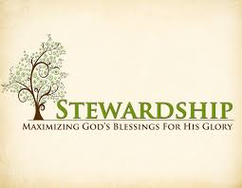
Newsletter Article – August 2020
(--From the LCMS website)

Winston Churchill reportedly said, “we make a living by what we get, but we make a life by what we give.” According to Churchill then, our lives are defined less by what we have gotten and more by what we give away.

Our Lord’s life is defined in this way. He gave completely of Himself for us. He became man for us. He taught the truth of God’s Word. He healed those with many and various diseases. He died the death that we deserve because of sin. He gave of Himself in order to save us from sin, death, and hell. So it is that by giving completely of Himself, He got us for Himself, making us citizens of His eternal kingdom by grace.

As it was for Jesus, so it is also for us. We get more from giving than we do from simply getting. Giving softens our hearts and frees us from the worries of this world and making a living. For when we are singularly focused on making a living, we are singularly focused on what we get.

That mindset begins to bleed into all areas of our lives – our relationships with friends and family, with neighbors and coworkers, and with the Lord. It shifts our focus from asking “How can I be a friend, family member, neighbor, and servant to others?” to “What have they done for me lately?” We become more selfish instead of selfless.

But, when we give, we do not have less, and we do not become less. We have more and become more. Because when we give, we join in the bond of friendship and family, the bond of service to those around us out of love for them. And love is the fulfillment of the Law. It is the nature of God Himself, for God is Love. Thus, we are participating in the divine nature. As Jesus said, “It is more blessed to give than to receive” (Acts 20:35).

WE BELIEVE, TEACH, AND CONFESS
From Luther’s Small Catechism ~ The Sacrament of the Altar

II. The Benefit of the Sacrament of the Altar

What is the benefit of this eating and drinking?
These words, “Given and shed for you for the forgiveness of sins,” show us that in the Sacrament forgiveness of sins, life, and salvation are given us through these words. For where there is forgiveness of sins, there is also life and salvation.

BIRTHDAYS AND ANNIVERSARIES
We would like to wish Happy Birthday and Happy Anniversary to the following individuals who are celebrating this August. If you are not listed or you know someone not listed, please contact Sandy Brady or Pastor Jeff.

3 Gilbert Olrich
5 Ray Schmidt
9 Jacob Geske
15 Wes Van Dyke *100 years old
24 Sheila Vincent
30 Mark Ostrander

Please consider sending Wes Van Dyke a birthday card for his 100th Birthday. His address is 1313 Southwestern Dr. Apt. 11 Tecumseh, MI 49286

We wish the following couples a very Happy Anniversary!
31 Dick and Karen Vollmer

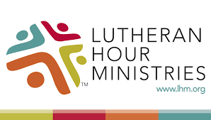
Bringing Christ to the Nations and
the Nations to the Church
"The Lutheran Hour," which began in 1930, is now heard on more than 1,300 radio stations around the world. "The Lutheran Hour," hosted by Dr. Rev. Michael Zeigler, is the world's oldest continually-broadcast Gospel radio program. This weekly half-hour program proclaims the message of Jesus Christ to all people and serves as a bridge, linking them to the Church. Listen to the Lutheran Hour on Sundays at 10:00 a.m. at FM 99.5 KAWZ or AM 1560 WWYC or anytime at www.lhm.org

August 2020

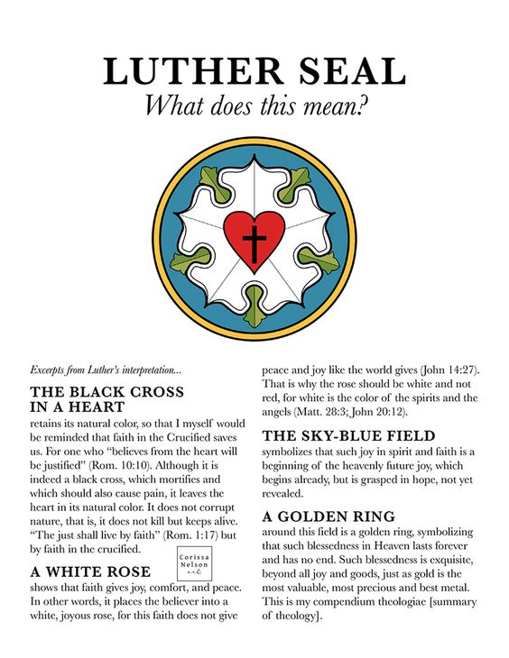
August 2
"Christ's Resurrection Makes Everything New"
Guest Speaker: Dr. Oswald Hoffmann
There is power in doing good works for the sake of others, but that kind of civic righteousness can't compare with the perfect righteousness of God which covers us through faith in Jesus Christ. In a classic radio message, Dr. Oswald Hoffmann shares the power of Christ's resurrection that overcomes death. It's "Archives August".
August 9
"Over The Darkness, God Hovers"
Guest Speaker: Rev. Dr. Dale A. Meyer
A 5-year-old boy once observed, "God has the whole world in His hands-but sometimes He drops it." Hear how Dr. Dale Meyer responded to that young philosopher in a classic message titled "Over the Darkness, God Hovers". It's "Archives August".
August 16
"A Wrong Comparison"
Guest Speaker: Dr. Wallace Schulz
It's "Archives August".
August 23
"Fear And Faith"
Speaker Emeritus of The Lutheran Hour: Rev. Dr. Ken Klausmono
It's "Archives August".
August 30
"It's Not Over 'till Jesus Says It's Over"
Lutheran Hour Speaker: Rev. Dr. Gregory Seltz
It's "Archives August".
THRIVENT NEWS . . .
If you would like more information about Thrivent, its products, or its fraternal functions, please contact our area representative Greg Durivage in Maumee, OH at (419)-740-4193 or Ken Huner at 734-869-2122

If you are a Thrivent Member, please consider using a Thrivent Action Team to support our ministry here at Zion..

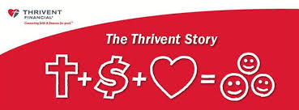
What is a Thrivent Action Team? Thrivent Action Teams make it easy to live generously. Thrivent provides promotional resources and seed money to jump-start your fundraiser, educational event or service project. Your team provides the people power to bring it to life.

Food Bank~
Thank you for your generous help with our Food Bank. If you have any question or would like to help in any way, please contact Rick Keck at (734) 854-4710. The Food Bank serves families and individuals on the second and fourth Tuesday of the month from 10:00 a.m. until noon.

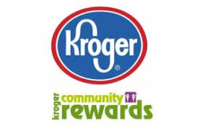
Community Rewards Program
Do you shop at Kroger? If you do, you can sign up for their Community Rewards Program and Kroger will give back to Zion money every quarter. Go on Kroger's website and sign up under Community Rewards. If you need help or don't have an email address, check with Pastor Jeff. (Our code is NC512)
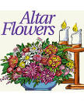
Flowers on the Altar ~ If you would like to place flowers, please sign up in the hallway by the restrooms.

Paschal Candle (PASS-kel) A large candle that has special significance during the Easter Vigil. It is also used at baptisms and funerals. Ordinarily it is located near the baptismal font. During the Fifty Days of Easter (Easter through Pentecost) it is placed near the altar, and at funerals it stands near the casket. Paschal comes from the Greek work for Passover and refers specifically to the celebration of Christ's resurrection.

