The Messenger
A newsletter of Zion Lutheran Church ~ Ottawa Lake, MI
September 2020
+ + + + + + + + + +

WORSHIP WITH US EACH WEEK!
Join us for worship on Saturday afternoon
at 4:00 p.m. and Sunday morning at 10:00 a.m.

Sunday Morning Bible Study
We will begin a new study on September 13.
Please plan to join us at 9:00 a.m.

Lutheran Men ~Monthly Breakfast
On September 12, 2020, we will have our Lutheran Men Monthly breakfast. Breakfast will be served at 8:00 a.m. We will have a hot breakfast, devotion, and a Bible study. Please come and feel free to invite a friend or neighbor. It would be great to see you there!

Zion Lutheran Elders
We will have our monthly meeting after church on September 17, 2020 at 7:00 p.m..

Zion Lutheran Church Council
We will have our monthly Church Council Meeting after church on September 20, 2020.

Zion Church Choir
If you love singing, please join our church choir. They meet after church in the choir room.

Our handbell choir meets on Saturdays at
3:00 p.m. They will begin meeting again on September 12, 2020. They would love to have you join them.

Women of Zion
There will be a meeting on September 28, 2020 at 2 p.m. We will have a meeting and a Bible study. All Women are invited and encouraged to attend

Movie Night
We will have a
Movie Night on September 25, 2020. We will meet at 6:30 for a light supper and then will watch a movie. The movie that we will watch is called, “Courageous.” If you have not seen this movie, it will be one that you don’t want to miss.

Here is a little information about Courageous
Sheriff's deputy Adam Mitchell (Alex Kendrick) endures a terrible personal tragedy that causes him to question what is really important to him. Taking comfort in his religion, Adam vows to become a better parent to his teenage son (Rusty Martin), and convinces his friends on the force to sign a pledge that they will all strive to become better Christians and better parents. Unfortunately, one of the men's moral compass appears to be broken when it comes to earning fast money.

ZION Lutheran Church
LCMC ~ Lutheran congregations in mission for Christ
8307 Memorial Hwy. Ottawa Lake, MI 49267 ·
(734) 856-2921
Pastor ∙ Jeffrey Geske
(785) 340-5635
zlcolmpastor@gmail.com
www.zionlutheranottawalakemi.com

Secretary ~ Sandy brady
(419) 410-9380
skwiles2000@gmail.com
custodian and organist~ Joseph extejt

For Your Information
The following members give of their time to the leadership of this congregation. Please keep them in your prayers. If you have any questions, comments, or offers of help, please contact them.
Chairman: Dwight Gilliland
Secretary: Connie Sieler
Treasurer: Dennis Reitzel
Financial: Ron Clark
Elders: Ron Vincent and Lee Edignton
Deacons: Ben Schmidt
LCMC ~ WHO WE ARE
Free in Christ + Accountable to One Another + Rooted in Scripture and the Lutheran Confessions + Committed to the Great Commission

Prayers Are Important
If you have an occasion to request a prayer, please call the church office. If you would like your request to be on our prayer chain, please call Sandy Brady (419) 410-9380 or Pastor Jeff at the church or on his cell phone (785)340-5635.

Please Inform the Church Office. . .
*when a member of your family is ill or hospitalized or if they are discharged or moved to another facility.
*when your address changes.
*when a new baby arrives.
*when a family member marries or leaves home for college, or military.
*when planning a wedding to be conducted at Zion.
*when a new family moves into your neighborhood.
*when you are planning to be out of town.
*when a brother or sister in Christ needs a visit from Pastor.
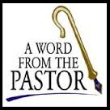
From the desk of Pastor Geske….

Greetings in the name of Christ! Back to school and back to the routines are what many of us our facing as we get into our Fall activities. I often think of this time of the year as that song says, “It’s the most wonderful time of the year!” I am excited to see God’s people of all ages growing in His Word. I would like to encourage you to join in our Bible study on Sunday morning at 9:00 a.m.
I like this article from a church in Ohio, the article was about why Bible study is important. The writer made these four points.
1. Bible study is profitable. It is in our own best interest to study the scriptures. It is good for us spiritually to make an effort to come out to Bible study and to have the opportunity to search the scriptures as often as possible. Paul tells us that the scriptures are profitable (2 Timothy 3:16, 17). Five things are mentioned by Paul in this passage. The scriptures are profitable for (1) doctrine, (2) reproof, (3) correction, (4) instruction in righteousness (5), and to furnish unto all good works. These are not five insignificant things. They are all very important to the welfare of our souls. At any given Bible study, we can profit in one of these areas, and many times more than one. This alone is a good reason to attend Bible study.
2. Bible study causes growth. Every Christian who is concerned about growing will attend Bible study. Sufficient spiritual growth is impossible without a proper diet of God's Word. There are too many Christians who are not as mature as they should be because they do not spend enough time in the Word of God (Hebrews 5:12-14). Do you study the Word of God like you should? Do you take advantage of opportunities to attend services that might enhance your spiritual knowledge? Most people who avoid making a commitment to attend Bible study usually do not study very much outside of Bible class. They become stagnant and grow weak spiritually. Are you allowing that to happen to you? If so, the only person who can do something about it is you. Make a commitment to Christ. Determine to start coming to all Bible classes so that you can grow in the Lord the way you should.
3. Bible study produces faith. It was Paul that told us that faith comes by hearing the “...Shine out among them like beacon lights, holding out to them the Word of Life” (Phil 2:15-16) . . . The Word of God makes a person strong in the faith. This is why the devil wants to keep people away from the Bible. He knows that faith leads to a pleasing relationship with God, and he knows that the Word of God is the source of faith. Don't let the devil beat you. Equip yourself with the Word of God so that you can stand against his assaults. Attend every Bible class and build up your faith.
4. Bible study helps us to distinguish truth from error. We have a responsibility to know truth and fight against error (Ephesians 4:14; 5:11; 1 John 4:1). Those who can't recognize false doctrine for what it is will be led astray and will lose favor with God (2 Timothy 2:15-17). Bible study helps Christians in this area. In many Bible study classes, specific false doctrines are exposed and passages that can help combat the error are revealed. One's ability to rightly handle the Word of truth is thus increased. Doesn't that make coming to Bible study worthwhile?” (Beacon Brother Church of Christ in Akron, OH)

Yes! Worship and Bible study are important and give us opportunities to grow in our relationship with God and with one another. It would be great if we would be a church that is in the Word both in Worship and Bible Study. I believe that the church grows as God’s people are growing and are excited about sharing what God is doing through their church.
May God use us to share the love and forgiveness of Jesus with our communities, our family and friends and may God use us to reach the ends of the earth.

I look forward to seeing you in worship and in Bible class! May God continue to bless us as we serve Him.

In Christ,
Pastor. Jeffrey Geske

Sunday Morning Bible Class
Please come and join our study of the Word of God!

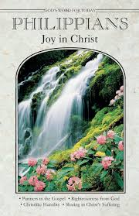
God’s Word of Today ~ Study of Philippians
Each study in the God’s Word for Today series provides an in-depth exploration of a book of the Bible. Each session includes:
- background information on the book of the Bible, its author, audience, occasion, and purpose;
- learning experiences that promote exciting and challenging discussions;
- notes for leaders that answer questions, suggest a learning process, and provide additional information;
- discussion starters that help participants apply God’s Word to their daily lives.
(6 sessions)
In this epistle, Paul characterizes the Christian life in this way: joy no matter what the circumstances; an eagerness to suffer for Christ; humility that follows Christ in putting others first; trust in Christ alone for righteousness.
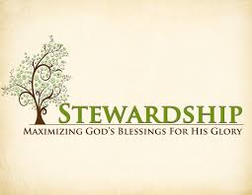
Newsletter Article – September 2020
(--From the LCMS website)

“Whatever your hand finds to do, do it with all your might” (Eccl 9:10).

God bids us to be faithful in the tasks He calls us to do. He calls us to be members of a family (husbands and wives; fathers and mothers; sons and daughters). He calls us to be members of society (those who govern and those who are governed). And He calls us to be members of His family, the Church (those who preach and teach and those who hear and learn). Each of these callings from God places a duty on us.

As members of a family, husbands are given the duty to die for their wives as Christ gave His life for His bride, the Church; while wives are given the duty to respect their husbands and submit themselves to them as the Church does to Christ. Fathers and mothers are to raise their children in the fear and admonition of the Lord, teaching them the Ten Commandments, the Creed, the Lord’s Prayer, and the Scriptures concerning Baptism, Confession, the Office of the Keys, and the Lord’s Supper. Children are to honor their parents throughout their lives, and even when their parents are no longer alive, serving and obeying them, loving and cherishing them, and speaking well of them.

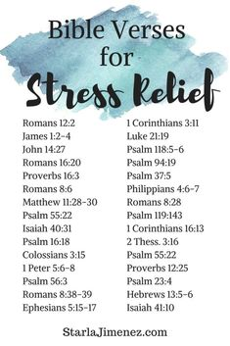
As members of society, God calls those who govern to bear the sword, that is, to punish those who do evil (those who live contrary to God’s will) and to reward those who do good (those whose lives are lived in conformity with God’s will). Those who are governed are to obey their leaders as to the Lord Himself, for their leaders bear the sword of God’s temporal justice for a purpose.

As members of God’s own family, the Church, He calls those who preach and teach to do so in faithfulness to His holy Word. To preach and teach the Law of God to convict the hearts of hearers of their sin and to encourage, admonish, and exhort them to do good works in accordance with God’s will. They are to preach and teach the Gospel, the full forgiveness of their sins accomplished by Christ and received through faith, not by works. They are to administer the means of grace in accordance with the Gospel and the Word of God. They do all this for the young and old alike, for those who are near and far off. Those who hear and learn are to submit themselves to their preachers and teachers. They are support them by their prayers and their gifts.

Each of these callings from God place a duty on us. They make a claim on our presence; on our prayers; and our time, talents, and treasures. So, “Whatever your hand finds to do, do it with all your might” (Eccl 9:10). Pray for your family, your government, and your church. Give of yourself by means of your time, your talents, and your treasures to your family, your government, and your Church. That is what it means to be faithful in the tasks that God has given us. That is what it means to do it with all your might.

WE BELIEVE, TEACH, AND CONFESS
From Luther’s Small Catechism ~ The Sacrament of the Altar
III. The Power of the Sacrament of the Altar
How can bodily eating and drinking do such great things?
Certainly not just eating and drinking do these things, but the words written here: “Given and shed for you for the forgiveness of sins.” These words, along with the bodily eating and drinking, are the main thing in the Sacrament. Whoever believes these words has exactly what they say: “forgiveness of sins.”
BIRTHDAYS AND ANNIVERSARIES
We would like to wish Happy Birthday and Happy Anniversary to the following individuals who are celebrating this August. If you are not listed or you know someone not listed, please contact Sandy Brady or Pastor Jeff.

10 Loretta VanDyke
18 Kay Stewart
19 Shirley Clark
29 Jon Dellabona

We are not aware of anyone celebrating this month.
Please let us know if you should be listed for this month.

Flowers on the Altar ~ If you would like to place flowers, please sign up in the hallway by the restrooms. The cost is $30.00

Food Bank~
Thank you for your generous help with our Food Bank. If you have any question or would like to help in any way, please contact Rick Keck at (734) 854-4710. The Food Bank serves families and individuals on the second and fourth Tuesday of the month from 10:00 a.m. until noon.

Bringing Christ to the Nations and
the Nations to the Church
"The Lutheran Hour," which began in 1930, is now heard on more than 1,300 radio stations around the world. "The Lutheran Hour," hosted by Dr. Rev. Michael Zeigler, is the world's oldest continually-broadcast Gospel radio program. This weekly half-hour program proclaims the message of Jesus Christ to all people and serves as a bridge, linking them to the Church. Listen to the Lutheran Hour on Sundays at 10:00 a.m. at FM 99.5 KAWZ or AM 1560 WWYC or anytime at www.lhm.org

September 2020

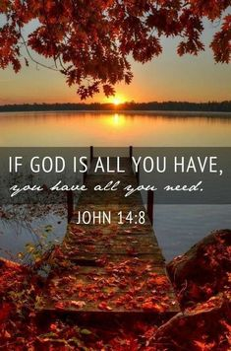
September 6
"Jesus in the House"
Speaker: Rev. Dr. Michael Zeigler
Messy prayers, loud tables, open doors-three signs of a spiritually vibrant household.
(Luke 19:1-10)
September 13
"Fireplace Spirituality"
Speaker: Rev. Dr. Michael Zeigler
Our relationship with God is not something to "set and forget" like a thermostat.
(Acts 2:37-47 )
September 20
"I Stand at the Door"
Speaker: Rev. Dr. Michael Zeigler
New Series "Households of Faith"
(Luke 24:13-35 )
September 27
"Room at the Table"
Guest Speaker: Rev. Dr. Jason Broge
New Series "Households of Faith"
(1 Peter 4)

Divine Service
The name commonly given to the regular weekly service that includes the celebration of the Lord's Supper. Derived from the German Gottesdienst ("God's service"), its meaning is dual in nature. In worship, God serves us with his gifts of forgiveness and life, and we respond in service to him through our sacrifice of thanksgiving and praise.
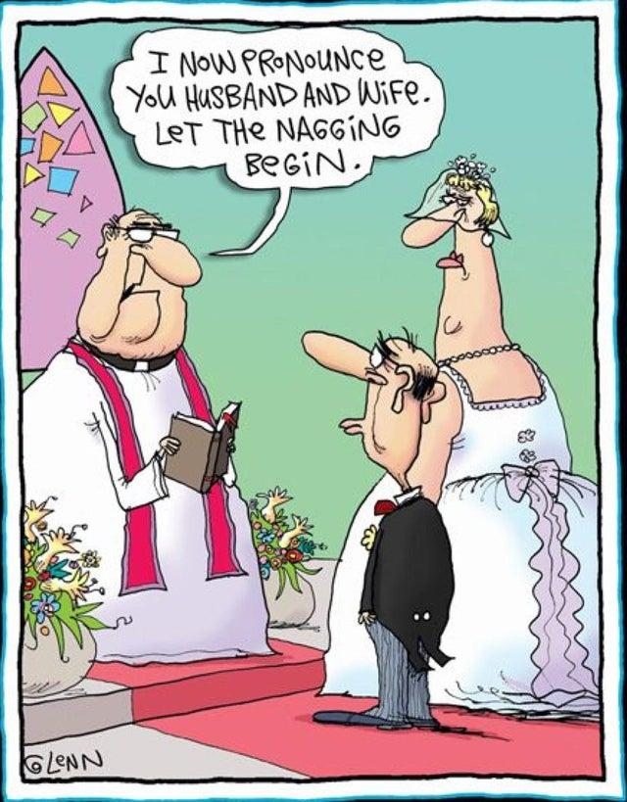
A doctor, a civil engineer, and a computer scientist were arguing about what was the oldest profession in the world. The doctor remarked, 'Well, in the Bible it says that God created Eve from a rib taken from Adam. This clearly required surgery, so I can rightly claim that mine is the oldest profession in the world.'
The civil engineer interrupted and said, 'But even earlier in the book of Genesis, it states that God created the order of the heavens and the earth from out of the chaos. This was the first and certainly the most spectacular application of civil engineering. Therefore, fair doctor, you are wrong; mine is the oldest profession in the world.'
The computer scientist leaned back in his chair, smiled and said confidently, 'Ah, but who do you think created the chaos?'

Community Rewards Program
Do you shop at Kroger? If you do, you can sign up for their Community Rewards Program and Kroger will give back to Zion money every quarter. Go on Kroger's website and sign up under Community Rewards. If you need help or don't have an email address, check with Pastor Jeff. (Our code is NC512)
THRIVENT NEWS . . .
If you would like more information about Thrivent, its products, or its fraternal functions, please contact our area representative Greg Durivage in Maumee, OH at (419)-740-4193 or Ken Huner at 734-869-2122

If you are a Thrivent Member, please consider using a Thrivent Action Team to support our ministry here at Zion..

What is a Thrivent Action Team? Thrivent Action Teams make it easy to live generously. Thrivent provides promotional resources and seed money to jump-start your fundraiser, educational event or service project. Your team provides the people power to bring it to life.

