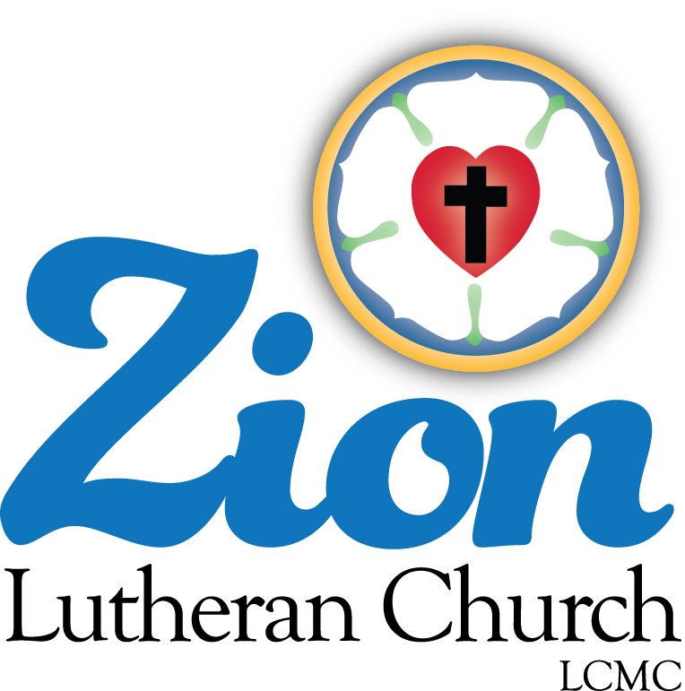

Welcome to ZION Lutheran Church
LCMC ~ Lutheran congregations in mission for Christ
8307 Memorial Hwy. Ottawa Lake, MI 49267 ·
(734) 856-2921
Pastor ∙ Jeffrey Geske
(785) 340-5635
zlcolmpastor@gmail.com
www.zionlutheranottawalakemi.com

Our MISSION
“SHARING THE LOVE OF JESUS”

To Our Guests
We are so glad that you have chosen to join us this morning! We pray that you will be refreshed and renewed as you come into God’s presence. Please take a moment to introduce yourself to the pastor and to those seated around you. Once again, we warmly thank you for worshipping with us this morning!

Those Assisting in Ministry Today
NOVEMBER 1, 2020 ~ ALL SAINTS’ DAY
Organist: Joseph extejt Greeters : Ron Clark and All
deacon: Ben Schmidt SCREEN: Nick Baumgartner & Jacob Geske
Acolyte: Volunteer Reader: Karen Vollmer assistant: Sandy Brady
Altar Guild: Shirley Clark and JoAnn VanSteenkiste
Administrative assistant: Sandy Brady 419- 410-9380 or skwiles2000@gmail.com

LCMC ~ WHO WE ARE
Free in Christ + Accountable to One Another + Rooted in Scripture and the Lutheran Confessions + Committed to the Great Commission

November 1 – All Saints’ Day ~ (--From the LCMS Website)
Matthew 5:7 – “Blessed are the merciful, for they shall receive mercy.” This is one of many Bible passages that remind us that we reap what we sow. Likewise, what God puts into us – His own love, mercy, kindness, and generosity – flows back out of us. It all starts with His self-giving.

ALL SAINTS DAY
November 1, 2020

AS WE GATHER
In the ‘Te Deum,’ one of the great liturgical songs of the Church, we pray that God will help His servants and will “make them to be numbered with (the) saints in glory everlasting.” The Festival of All Saints is an opportunity for God’s people to remember and give thanks for the saints with whom that hope in Christ is to be numbered. The saints are a numberless throng but at the same time are specific individuals. They have completed their earthly journeys, as each of us will be doing, and now they enjoy the eternal rest and reward promised by our Lord. As we hear of them, sing of them, and thank God for them, we are blessed.

RINGING OF THE BELL

WELCOME

OPENING HYMN LSB 677 St. 1-4 “For All the Saints”

INVOCATION
Pastor: In the name of the Father and of the + Son and of the Holy Spirit.
People: Amen.

OPENING SENTENCES Psalm 34:1, 3, 8–9
Pastor: I will bless the Lord at all times; His praise shall continually be in my mouth.
People: Oh, magnify the Lord with me, and let us exalt His name together!
Pastor: Oh, taste and see that the Lord is good! Blessed is the man who takes refuge in Him!
People: Oh, fear the Lord, you His saints, for those who fear Him have no lack!

CONFESSION AND ABSOLUTION
Pastor: Beloved of God, we rejoice to be numbered with the saints. In confidence, let us come before our gracious Lord to confess our sins and to receive His gracious absolution.
People: Almighty God, we are by nature sinful and unclean. We repent of our sins in thought and in word and in deed. In Your mercy, forgive us. Create in us clean hearts, O God, that we may serve You as Your redeemed people now and forever.
Pastor: Because of the sacrifice of His beloved Son for the sins of all people, God has promised His forgiveness. In the stead and by the command of my Lord Jesus Christ I forgive you all your sins in the name of the Father and of the + Son and of the Holy Spirit. May you ever live as the saints that you are in Christ Jesus.
People: Amen.

+ GOD’S WORD FOR US +

HYMN LSB 785 “We Praise You, O God”

SALUTATION
Pastor: The Lord be with you.
People: And also with you.

PRAYER OF THE DAY
Pastor: Almighty and everlasting God, You knit together Your faithful people of all times and places into one holy communion, the mystical body of Your Son, Jesus Christ. Grant us so to follow Your blessed saints in all virtuous and godly living that, together with them, we may come to the unspeakable joys You have prepared for those who love You; through Jesus Christ, our Lord, who lives and reigns with You and the Holy Spirit, one God, now and forever.
People: Amen.

PSALM Psalm 149

EPISTLE 1 John 3:1–3 (We are God’s children now.)

Lector: This is the Word of the Lord.
People: Thanks be to God.

VERSE Hebrews 10:23–25a, 12:1, 2

Pastor: Alleluia. Since we are surrounded by so great a cloud of witnesses, let us look to Jesus, the founder and perfecter of our faith. Alleluia.
People: Let us also lay aside every weight, and sin which clings so closely, and let us run with endurance the race that is set before us. Alleluia.
Pastor: Let us hold fast the confession of our hope without wavering, for He who promised is faithful.
People: And let us consider how to stir up one another to love and good works.
Pastor: Today as we celebrate All Saints, we recall those most special saints who had the blessing of close association with Jesus. We know them as the disciples and as the faithful women who accompanied Jesus in His ministry travels. Each had a distinct personality and special gifts to bring to the group who surrounded our Lord in His time of preaching, teaching, and healing. We thank God for them and their lives of service.

HOLY GOSPEL Matthew 5:1–12
(Jesus speaks the ‘Beatitudes’ on the mountain.)

Pastor: The Holy Gospel according to St. Matthew, the fifth chapter.
People: Glory to You, O Lord.
The Gospel is read
Pastor: This is the Gospel of the Lord.
People: Praise to You, O Christ.

HYMN OF THE DAY LSB 677 St. 5-8 “For All the Saints”

SERMON Blessed by Jesus ~ Matthew 5:1-12

CREED The Third Article
All: I believe in the Holy Spirit, the holy Christian Church, the communion of saints, the forgiveness of sins, the resurrection of the body, and the life everlasting. Amen.
Pastor: What does this mean?
All: I believe that I cannot by my own reason or strength believe in Jesus Christ, my Lord, or come to Him; but the Holy Spirit has called me by the Gospel, enlightened me with His gifts, sanctified and kept me in the true faith. In the same way He calls, gathers, enlightens, and sanctifies the whole Christian Church on earth, and keeps it with Jesus Christ in the one true faith. In this Christian Church He daily and richly forgives all my sins and the sins of all believers. On the Last Day He will raise me and all the dead, and give eternal life to me and all believers in Christ. This is most certainly true.

THE GATHERING OF OUR OFFERING

REMEMBRANCE OF THE SAINTS
Pastor: At this time, now that we have spoken words of faith in the Creed, we remember those from our congregation/our circles of faith and friendship who have been called to the full presence of the Lord in the year span since last All Saints’ Day. We thank God for their earthly lives now concluded and ask that we may follow their examples of faith as we continue our earthly journeys.

[As each name is read, a bell may be tolled as a sign of remembrance and of victory in Christ.]

Bruce Ahleman
Shirley Burns
Nora Cannon
Arnold Clark
Tammy Dreps
Linda Geske
Darrell Gilliland
Dean Jacobs
Terry Jeffries
Mildred Knoblauch
Joni Kuhn
Brad Palmer
Pastor Terry Rebert
Edward Schwake
Sharon Siebert
Delight Sieler
Ross Vincent
Matthew Yates

PRAYER OF THE CHURCH
Pastor: Let us pray for the whole people of God in Christ Jesus and for all people according to their needs. On this day we remember with thanksgiving those who have gone before us with the sign of faith. May their memory be blessed among us, and may we follow our Lord faithfully all our days. Lord, in Your mercy,
People: hear our prayer.
Pastor: Celebrating our lives together as saints, we pray for the fellowship we enjoy as God’s holy people, asking that we may bring the sacrifices of pure hearts and may worship God in His sanctuary with joy. Lord, in Your mercy,
People: hear our prayer.
Pastor: Thankful for the saints among us in these days, we pray for those who serve in leadership positions in our national Synod, our district, and our local congregation, asking that God may bless their work among us as they set examples of devotion and dedication in Jesus’ name. Lord, in Your mercy,
People: hear our prayer.
Pastor: Confident that Your care for the saints knows no limits, Lord, we make our petitions for the sick, the sorrowing, and all who this day are in need of our prayers, [especially . . .]. May their petitions be answered according to Your good and gracious will, and may they be supported by this fellowship of saints. Lord, in Your mercy,
People: hear our prayer.
Pastor: Reflecting on the journey of life we make together as the saints below, we pray for the youngest among us, the infants and children, and also for the most senior of saints, those who have been blessed with extended lives on earth. May we cherish the company of all of God’s people and seek to bring a sense of caring to all those around us with cheerful hearts. Lord, in Your mercy,
People: hear our prayer.
Pastor: With thankfulness for the land in which we live, we ask Your blessing on our nation, its leaders, and all who work for security and a sense of community in our world and in our lives. May we cherish the freedoms we enjoy and do all in our power to maintain the public good and promote peace and harmony. Lord, in Your mercy,
People: hear our prayer.
Pastor: Into Your hands, O Lord, we commend all for whom we pray, trusting in Your mercy through Your Son, Jesus Christ, our Lord.
People: Amen.

LORD’S PRAYER (Matthew 6:9–13)

+GOD’S SACRAMENT FOR US +

WORDS OF OUR LORD Matthew 26:26–28; Mark 14:22–24; Luke 22:19–20; 1 Corinthians 11:23–25

PROCLAMATION OF CHRIST
Pastor: As often as we eat this bread and drink this cup, we proclaim the Lord’s death until He comes. 1 Corinthians 11:26
People: Amen. Come, Lord Jesus. Revelation 22:20

DISTRIBUTION HYMNS
VIDEO “Ancient Words”
LSB 801 “How Great Thou Art”

POST-COMMUNION THANKSGIVING
Pastor: Let us pray,
People: Almighty and ever-living God, we thank You for having fed us with the body and blood of our Savior Jesus Christ, assuring us thereby that we are truly members of His body, the Church. Having been blessed to be at Your Table in the company of the saints, we ask You to help us by Your Holy Spirit that we may continue in this fellowship and do the good works which You desire us to do; through Jesus Christ, Your Son, our Lord, to whom, with you and the same Spirit, be all honor and glory, forever and ever. Amen.

BENEDICTION
Pastor: The Lord bless you and keep you.
The Lord make His face shine on you and be gracious to you.
The Lord look upon you with favor and + give you peace. Numbers 6:24–26
People: Amen.

HYMN LSB 662 “Onward, Christian Soldiers”

Go in Peace ~ Sharing the Love of Jesus! Thanks be to God!

Services covered by CCLI: 1553677

Announcements
IN OUR PRAYERS:
- For our congregation members; that they may be committed to our mission of sharing the love of Jesus.
- Pastor and Jacob Geske
- For LCMC Congregation and Missionaries around the world.
- President Trump, national leaders and our country. Our nation’s military, especially are loved ones:
- For those who are sick, recovering, or in need of God’s grace at this time. We include in our prayers: Loretta and Wes VanDyke; Susan Gaylord; Betty Vesey; Barbara Clark; Parker Reau; Fred VanSteenkiste, Barbara Swope, Dolores Ostrander, and Carol Alexander
Prayer List: Please let us know when we can take the name off of the prayer list. Thank you!.

Our Stewardship ~ Weekly budget needs are $1,698.16: Attendance and Offering given for Sunday and special services were the following: Attendance for last weekend was 36. Offerings totaled $1312.00. Thank you!

his Week at Zion Includes: Today – Bible Study at 9 am; Worship at 10 a.m. Saturday, November 7 ~ Handbell choir at 3:00 p.m. Contemporary Service at 4:00 p.m. Next Sunday – Bible Study at 9 a.m.; Worship at 10 a.m.

Zion Lutheran Church Handbell Choir ~ They practice at 3:00 p.m. on Saturday afternoons. They are preparing to play for the Sunday before Christmas. Please join them!

Zion Lutheran Church Choir ~ They will practice on Sundays at 11:15 a.m. Please join them! For more information, please speak to Joseph Extejt.

Raffle Tickets ~ We are beginning to sell the tickets for the La-Z-Boy raffle for our Christmas Festival and Cookie Walk which will be on December 12.

Mark your Calendars ~ We will have a Thanksgiving Eve Service on Wednesday, November 25th at 7:00 p.m. We will have an In-gathering for our Food Pantry.

Sunday Morning Bible Study ~ We are studying the book of Philippians. A paragraph about this study said, “In this epistle, Paul characterizes the Christian life in this way: joy no matter what the circumstances; an eagerness to suffer for Christ; humility that follows Christ in putting others first; trust in Christ alone for righteousness.”
.

