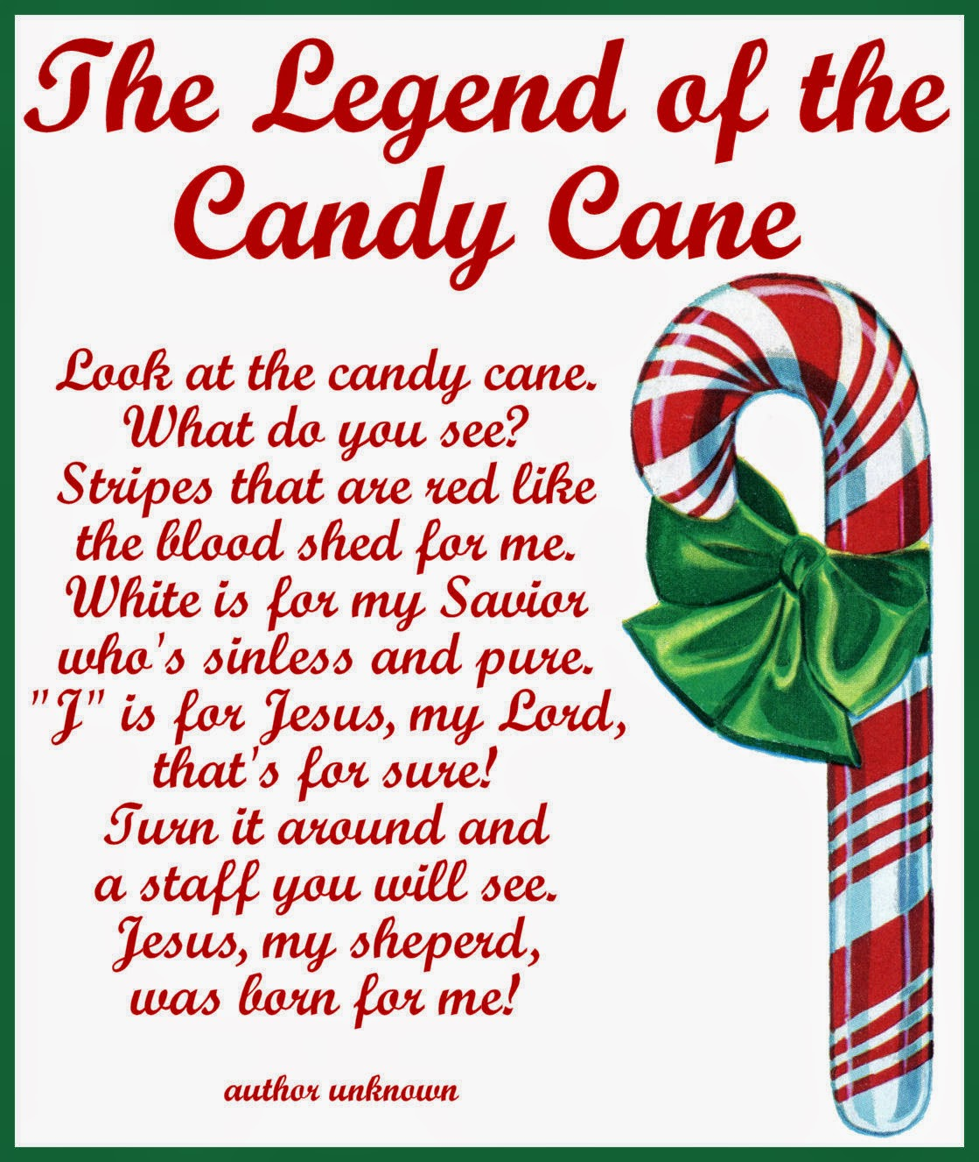

**Zion Lutheran Church**

**8307 Memorial Hwy**

**Ottawa Lake, MI 49267**

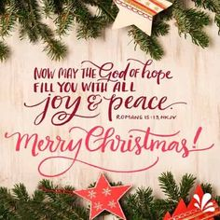 ***Jesus Died for:***