The Messenger
A newsletter of Zion Lutheran Church ~ Ottawa Lake, MI
January 2021
+ + + + + + + + + +
Installation of Officers
On January 3, 2021, we will install our congregational officers during our worship service. We thank those who are willing to serve and those that will be finishing serving for now. ~ Thank You!
Lutheran Men ~Monthly Breakfast
On January 9, 2021, we will have our Lutheran Men’s Monthly breakfast. Breakfast will be served at 8:00 a.m. We will have a hot breakfast, devotion, and a Bible study. Please come and feel free to invite a friend or neighbor. It would be great to see you there!

Zion Lutheran Church Council
We will have our monthly Church Council Meeting after church on January 17, 2021.

Women of Zion
On January 25, 2021, the Women of Zion will have their monthly meeting at 2:00 p.m.

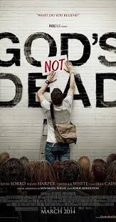
We will begin to have a Movie Night on January 22, 2021. We will meet at 6:30 for a light supper and then will watch a movie. The movie that we will watch is called, “God’s Not Dead,.” If you have not seen this movie, it will be one that you don’t want to miss.

Here is a little information about God’s Not Dead
Written by Cary Solomon and Chuck Konzelman, and based on Rice Broocks' book God's Not Dead: Evidence for God in an Age of Uncertainty, the film follows a Christian college student (Harper) whose faith is challenged by an atheist philosophy professor (Sorbo), who declares God a pre-scientific fiction.
WORSHIP WITH US EACH WEEK!
Join us for worship on Saturday afternoon
at 4:00 p.m. and Sunday morning at 10:00 a.m.
Praying for COVID to END!!
Please kindly wear a mask in the building when you are not at a pew. Thank you! Communion servers will be wearing masks for the protection of all.

Sunday Morning Bible Study
We are studying the book of Philippians.
Please plan to join us at 9:00 a.m.

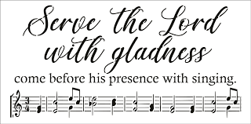
Zion Church Choir
If you love singing, please join our church choir. They meet after church in the choir room. For more information, please speak with Joseph Extejt.

Our handbell choir will take a break and begin practicing again on February 13. They will begin preparing for Easter.
They would love to have you join them.

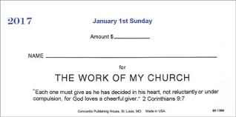
OFFERING ENVELOPES FOR 2021
Offering Envelopes are available for 2021. If you did not receive a box of envelopes for the New Year and want credit for your offerings for tax purposes in 2021, please contact Sandy Brady.

Community Rewards Program
Do you shop at Kroger? If you do, you can sign up for their Community Rewards Program and Kroger will give back to Zion money every quarter. Go on Kroger's website and sign up under Community Rewards. If you need help or do not have an email address, check with Pastor Jeff. (Our code is NC512)

THANK YOU, MEMBERS AND FRIENDS OF ZION
*Thank you to all who decorated the church for Advent and Christmas
*Thank you to those who provided special music for Advent and Christmas.
*Thank you to all of you for attending the celebration of our Lord’s birth and for sharing with everyone that Jesus is the Savior of the world.
*Thank you to everyone for making the celebration of our Lord’s birth so special.

We would like to thank all of you for kindness and love that we received this Christmas. Your love and support are greatly appreciated! May God bless you!
Love in Christ,
Pastor Geske, Sandy Brady, and Joseph Extejt
ZION Lutheran Church
LCMC ~ Lutheran congregations in mission for Christ
8307 Memorial Hwy. Ottawa Lake, MI 49267 ·
(734) 856-2921
Pastor ∙ Jeffrey Geske
(785) 340-5635
zlcolmpastor@gmail.com
www.zionlutheranottawalakemi.com

Secretary ~ Sandy brady
(419) 410-9380
skwiles2000@gmail.com
custodian and organist~ Joseph extejt

For Your Information
The following members give of their time to the leadership of this congregation. Please keep them in your prayers. If you have any questions, comments, or offers of help, please contact them.
Chairman: Ron Vincent
Secretary: Connie Sieler
Treasurer: Dennis Reitzel
Financial: Ron Clark
Elders: Ron Vincent and Lee Edignton
Deacons: Dwight Gilliland
LCMC ~ WHO WE ARE
Free in Christ + Accountable to One Another + Rooted in Scripture and the Lutheran Confessions + Committed to the Great Commission

Prayers Are Important
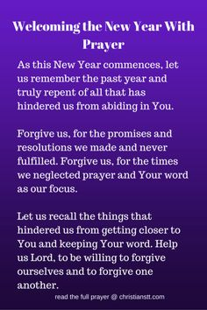
If you have an occasion to request a prayer, please call the church office. If you would like your request to be on our prayer chain, please call Sandy Brady (419) 410-9380 or Pastor Jeff at the church or on his cell phone (785)340-5635.

Please Inform the Church Office. . .
*when a member of your family is ill or hospitalized or if they are discharged or moved to another facility.
*when your address changes.
*when a new baby arrives.
*when a family member marries or leaves home for college, or military.
*when planning a wedding to be conducted at Zion.
*when a new family moves into your neighborhood.
*when you are planning to be out of town.
*when a brother or sister in Christ needs a visit from Pastor.
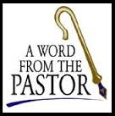
From the desk of Pastor Geske….

Greetings to you in the name of Christ! I wish you a blessed New Year. As you go through this year, I pray that you will be faithful in worship and Bible study. I would also encourage you to be faithful in taking some time each day to be in God’s Word. I love how Scripture talks about Scripture. Think about Psalm 119, where we read, “Your word is a lamp to my feet and a light for my path.” (Psalm 119:105 NIV) The Prophet Isaiah proclaimed, “As the rain and the snow come down from heaven, and do not return to it without watering the earth and making it bud and flourish, so that it yields seed for the sower and bread for the eater, so is my word that goes out from my mouth: It will not return to me empty, but will accomplish what I desire and achieve the purpose for which I sent it.” (Isaiah 55:10-11 NIV)

God wants you to spend time with Him in His Word daily, letting Him encourage you, exhort you, comfort you, and challenge you to keep focused on His love and forgiveness for you in His Son, Jesus Christ. God’s Word tells us the awesome message of what Christ did to give us forgiveness of our sin and eternal life.

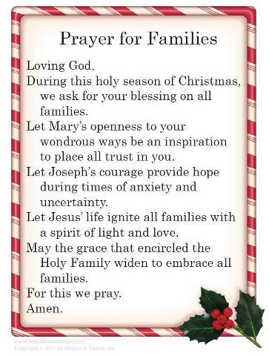
I came across a list of why family devotions are important for families and for individuals. Consider this list:
Twelve convincing reasons for having family devotions:
1. It unifies the family and sweetens home life.
2. It cultivates the Christian graces and relieves tension and misunderstanding that sometimes threaten the fellowship of the home.
3. It aids our boys and girls in learning more about being a Christian and helps them to develop ideals that guide them in vital Christian living.
4. It yields spiritual resources for daily tasks and assists us in cultivating dependence upon God.
5. It strengthens us in the face of adversities and disappointments and enables us to trust Christ implicitly in all of life's circumstances.
6. It makes us conscious during the day of the abiding presence of our Savior and Friend.
7. It bears a Christian witness to the guests in our home.
8. It undergirds the Christian teaching of the Sunday School and the ministry of the church.
9. It affords opportunity for the Christian family to pray for and to sharpen its concern for non-Christian families.
10. It helps us to give a right place to spiritual values and saves us from an undue concern for the temporal things of life.
11. It encourages us to put Christianity into practice in our homes.
12. Its honors God and provides an excellent outlet for the expression of our gratitude for the abundance of daily mercies and blessings which come from Him.

God blesses us through His Word to keep a Christ-centered focus as we go through life. May God richly bless you with His love through His Word. As you are in His Word daily, may you also faithfully seek to worship in this new year. May you be like David when he wrote, “I rejoiced with those who said to me, ‘Let us go to the house of the LORD.’” (Psalm 122:1 NIV)
May God richly bless this new year and may His love encourage you to be in His Word, in worship, and serving in thanksgiving for all His blessings to you!

In Christ,
Pastor Jeffrey Geske

Sunday Morning Bible Class
Please come and join our study of the Word of God!

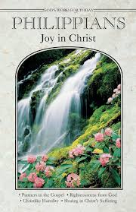
God’s Word of Today ~ Study of Philippians
Each study in the God’s Word for Today series provides an in-depth exploration of a book of the Bible. Each session includes:
- background information on the book of the Bible, its author, audience, occasion, and purpose;
- learning experiences that promote exciting and challenging discussions;
- notes for leaders that answer questions, suggest a learning process, and provide additional information;
- discussion starters that help participants apply God’s Word to their daily lives.
(6 sessions)
In this epistle, Paul characterizes the Christian life in this way: joy no matter what the circumstances; an eagerness to suffer for Christ; humility that follows Christ in putting others first; trust in Christ alone for righteousness.

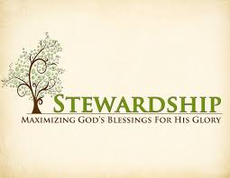
Newsletter Article – January 2021
(--From the LCMS website)

It’s a new year. It’s a time when we take stock of the year past in order to improve the year to come. It’s a time when we sit down to plan and implement what we want to accomplish and even change. Part of that is planning our stewardship for the coming year.

Often, we find this difficult and daunting and even joyless, but it doesn’t have to be. In fact, it is really quite simple and full of joy. So, here are some tips to make that planning less stressful. You begin by answering these three questions:

- Who are you?
- To whom do I give?
- And how much?

So, who are you? The Table of Duties in the Luther’s Small Catechism informs us. Are you a hearer of God’s Word? Are you a citizen of society? Are you a member of a family? Stewardship covers these three estates: church, society, and family. We don’t particularly struggle to give to society or family. Our struggles, our difficulties, and our questions arise in giving to the Church.

So, what is our duty as members of the Church with regard to giving? Again, the Table of Duties, gives us a guide. If you are a hearer – a member of the Church who receives instruction – St. Paul taught: “Let the one who is taught the word share all good things with the one who teaches” (Gal. 6:6). This means the local congregation is primary.

Your pastor is the one called to preach the Gospel to you and administer the Lord’s blessed sacraments to you. Your congregation is the place where those things happen. Thus, when God calls us to give to the Church, He has the local congregation in mind. For “the Lord commanded that those who proclaim the gospel should get their living by the gospel” (1 Cor. 9:14).
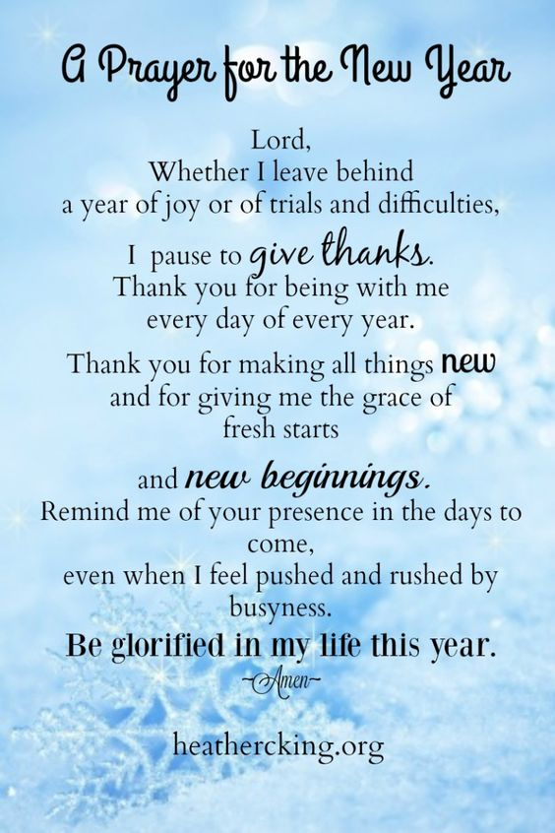
How much do we give to the local congregation? Our only instructions are to give:

- Regularly (1 Cor. 6:1–2);
- Proportionally (1 Cor. 16:1–2; 2 Cor. 8:12);
- Generously (2 Cor. 8:20);
- Of our first fruits (Gen. 4:4; Prov. 3:9; Lev. 27:30); and
- With a spirit of eagerness (2 Cor. 9:2), earnestness (2 Cor. 8:7), cheerfulness (2 Cor. 9:7), and love (2 Cor. 8:23).

In other words, giving to the Church is not to be an afterthought, given after everything else is spent. In this way, it is deliberate. We give regularly – weekly, biweekly, monthly, quarterly, or yearly – keeping in mind our own strengths, weaknesses, and limitations. We set it aside beforehand – before anything else is spent.

From those first fruits, we set aside a proportionate and generous amount. Ten percent was the standard for the Israelites. This was a command for the ancient Israelites. We can give as much as we want, but ask yourself: Do we really want to be less generous than was commanded of the Israelites? Is the job of the New Testament Church bigger or smaller than the job given to Israel?

And how are we to give it? We give it with eagerness and earnestness. We give it cheerfully and with love, not out of compulsion. For through the preaching of the Gospel and the administration of the sacraments, God has made us His children, forgiven us all our sins, given us grace upon grace, promised us life everlasting with Him in His kingdom, and filled us with His own Spirit, the Holy Spirit. This makes giving a joy, as Jesus said, “it is more blessed to give than to receive” (Acts 20:35).

It’s that easy. And it is joyful. For in stewardship, our gracious and giving Lord invites us to take part in the work that He accomplishes here on earth, providing for the ongoing preaching of the Gospel as well as those who are in need. Taking part in that makes all our work holy – work that is done in service to the Lord as priestly members of His kingdom.
WE BELIEVE, TEACH, AND CONFESS

From Luther’s Small Catechism ~ The Lord’s Prayer
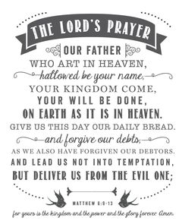
The Second Petition
Thy kingdom come.
Your kingdom come.

What does this mean? The kingdom of God certainly comes by itself without our prayer, but we pray in this petition that it may come to us also.
How does God’s kingdom come? God’s kingdom comes when our heavenly Father gives us His Holy Spirit, so that by His grace we believe His holy Word and lead godly lives here in time and there in eternity.
BIRTHDAYS AND ANNIVERSARIES
We would like to wish Happy Birthday and Happy Anniversary to the following individuals who are celebrating this month. If you are not listed or you know someone not listed, please contact Sandy Brady or Pastor Jeff.

January Birthdays

7 Ron Vincent
14 Judy Nieman
21 John Rittner
28 Dick Vollmer
January Anniversaries
- Charlie and Kay Stewart
21 Jon and Mary Dellabona
28 Melvin and Connie Sieler

Flowers on the Altar ~ If you would like to place flowers, please sign up in the hallway by the restroom. The cost is $30.00 Please consider signing up for the new year.
Thank you to all who purchased Poinsettias for Christmas.
Food Bank~ Thank you for your generous help with our Food Bank. If you have any question or would like to help in any way, please contact Rick Keck at (734) 854-4710. The Food Bank serves families and individuals on the second and fourth Tuesday of the month from 10:00 a.m. until noon.

BI-ANNUAL CONGREGATIONAL MEETING DECEMBER 6, 2020
Meeting was called to order by Dwight Gililand and Pastor Jeff open with a prayer. Motion made by Ron Vincent and 2nd by Ron Clark to dispense with reading of June’s minutes. Mary Jo Gilliland made a motion to accept minutes from June 2020 and 2nd by Sandy Brady . Carried

Pastor Report: See attached and also a calendar of events for year 2021.
Treasurer Report: Ron gave an explanation of the treasurer’s report and open floor to review and discussion. Reports attached. Carried. Connie Sieler and Sandy Brady volunteer to do 2021 Audit. All the lights have been changed over to LED and still waiting for finishing touches on parking lot.
Committee: Women of Zion: Only fund raiser for this year will be the Cookie Walk on December 12th. There won’t be any dinners this year due to Covid 19. Elders: Ron Vincent spoke on our ability to build church membership and still can’t visit shut-ins due to Covid. Food Pantry: See report attached. They will have to work on a new plan for winter months. Lutheran Men: A donation of $100 was given to the Luther Men Club. Trust Fund: PNC money market was cashed and put in general fund to pay for the new lights upgrade. CD for $5999.62 reaches maturity j9-18-23 and Metmora Bank has two CD’s totaling $30,000.00.
Old Business:
New Business: Election of Offices: Ron Vincent for President and Elder, Dwight Gililland for Deacon and Dennis Reitzel for Treasurer. Motion to accept all nominees by Ron Clark and 2nd by Judy Nieman. Carried All were elected per acclamation. Budget for Year 2021 was pasted out and review. Motion made by Ron Vincent and 2nd by Al Alheman to accept 2021 budget. Carried
Sandy Brady made motion to adjourn and 2nd by Carol Alexander. Carried Adjourned at 11:45.
Adjourned with the Lord’s Prayer.
Respectfully submitted
Connie Sieler
Secretary
Bringing Christ to the Nations and
the Nations to the Church
"The Lutheran Hour," which began in 1930, is now heard on more than 1,300 radio stations around the world. "The Lutheran Hour," hosted by Dr. Rev. Michael Zeigler, is the world's oldest continually-broadcast Gospel radio program. This weekly half-hour program proclaims the message of Jesus Christ to all people and serves as a bridge, linking them to the Church. Listen to the Lutheran Hour on Sundays at 10:00 a.m. at AM 1560 WWYC or anytime at www.lhm.org

JANUARY 2021
January 3
"Too Much"
Speaker: Rev. Dr. Michael Zeigler
The Gospel according to St. Mark shows us the Savior Who is always on the move.
(Mark 1:1 - 2:12)

January 10
"The Backstory Behind a Bible 'Contradiction'"
Speaker: Rev. Dr. Michael Zeigler
When you open yourself up to hearing the backstory behind the apparent contradiction, you may encounter what the
Bible is all about.
(Mark 2:13-28)

January 17
"Lost in Wonder, Love, and Praise!"
Guest Speaker: Rev. Dr. Dale A. Meyer
The word of Jesus turns us out from ourselves and our problems to the faith, hope, and love that He brings.
(Mark 3)

January 24
"TBD"
Speaker: Rev. Dr. Michael Zeigler
January 31
"TBD"
Speaker: Rev. Dr. Michael Zeigler

