The Messenger
A newsletter of Zion Lutheran Church ~ Ottawa Lake, MI
February 2021
+ + + + + + + + + +

Lutheran Men ~Monthly Breakfast
On February 13, 2021, we will have our Lutheran Men’s Monthly breakfast. Breakfast will be served at 8:00 a.m. We will have a hot breakfast, devotion, and a Bible study. Please come and feel free to invite a friend or neighbor. It would be great to see you there!

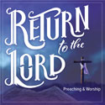
Our Lenten Journey will begin on February 17, 2021
Our Theme: Return to the Lord

“Return to the LORD your God, for He is gracious and merciful, slow to anger, and abounding in steadfast love; and He relents over disaster” (Joel 2:13). God’s invitation and promise finds its fullness in Jesus Christ, who personified and accomplishes all that God declares. Follow different events during the Pasion, specifically focusing on the people that followed Christ, to see how God calls His people to return to Him this Lenten season.
Join us each week as we will discover this theme;
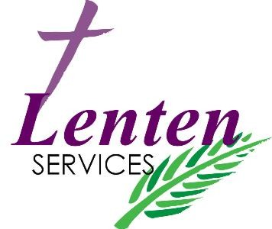
February 17 Ash Wednesday: “A Call to Return”
February 24: “Return to Prayer”
March 3: ” Return from Betrayal”
March 10: “Return from False Witness”
March 17: “Return from Denial”
March 24: “Return from the Kingdom of God”
A free supper will be served at 6:15 before the service each week except Ash Wednesday. ~ Please Join Us in our Lenten Journey!

Zion Lutheran Church Council
We will have our monthly Church Council Meeting after church on February 21, 2021.

Women of Zion
On February 22, 2021, the Women of Zion will have their monthly meeting at 2:00 p.m.

We will begin to have a Movie Night on February 26, 2021. We will meet at 6:30 for a light supper and then will watch a movie. The movie that we will watch is called, “God’s Not Dead 2,.” If you have not seen this movie, it will be one that you don’t want to miss.

Here is a little information about God’s Not Dead 2
High school history teacher Grace Wesley (Melissa Joan Hart) comes under fire for answering a student's (Hayley Orrantia) question about Jesus. When Grace refuses to apologize, the school board votes to suspend her and threatens to revoke her teaching certificate. Forced to stand trial to save her career, Grace hires young lawyer Tom Endler (Jesse Metcalfe) to defend her in court. Endler devises a powerful strategy to show the jury the historical significance of Wesley's classroom discussion.
WORSHIP WITH US EACH WEEK!
Join us for worship on
Sunday morning at 10:00 a.m.

Praying for COVID to END!!
Please kindly wear a mask in the building when you are not at a pew. Thank you! Communion servers will be wearing masks for the protection of all.

Sunday Morning Bible Study
We are studying the book of Philippians.
Please plan to join us at 9:00 a.m.

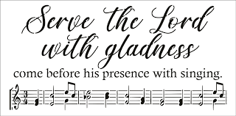
Zion Church Choir
If you love singing, please join our church choir. They meet after church in the choir room. For more information, please speak with Joseph Extejt.

HANDBELL CHOIR ~ We will resume practicing again in April.
We would love to have you join us.

Community Rewards Program
Do you shop at Kroger? If you do, you can sign up for their Community Rewards Program and Kroger will give back to Zion money every quarter. Go on Kroger's website and sign up under Community Rewards. If you need help or do not have an email address, check with Pastor Jeff. (Our code is NC512)
ZION Lutheran Church
LCMC ~ Lutheran congregations in mission for Christ
8307 Memorial Hwy. Ottawa Lake, MI 49267 ·
(734) 856-2921
Pastor ∙ Jeffrey Geske
(785) 340-5635
zlcolmpastor@gmail.com
www.zionlutheranottawalakemi.com

Secretary ~ Sandy brady
(419) 410-9380
skwiles2000@gmail.com
custodian and organist~ Joseph extejt

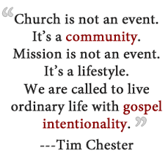
For Your Information
The following members give of their time to the leadership of this congregation. Please keep them in your prayers. If you have any questions, comments, or offers of help, please contact them.
Chairman: Ron Vincent
Secretary: Connie Sieler
Treasurer: Dennis Reitzel
Financial: Ron Clark
Elders: Ron Vincent and Lee Edignton
Deacons: Dwight Gilliland
LCMC ~ WHO WE ARE
Free in Christ + Accountable to One Another + Rooted in Scripture and the Lutheran Confessions + Committed to the Great Commission

Prayers Are Important
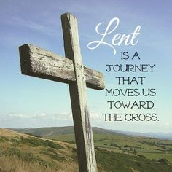
If you have an occasion to request a prayer, please call the church office. If you would like your request to be on our prayer chain, please call Sandy Brady (419) 410-9380 or Pastor Jeff at the church or on his cell phone (785)340-5635.

Please Inform the Church Office. . .
*when a member of your family is ill or hospitalized or if they are discharged or moved to another facility.
*when your address changes.
*when a new baby arrives.
*when a family member marries or leaves home for college, or military.
*when planning a wedding to be conducted at Zion.
*when a new family moves into your neighborhood.
*when you are planning to be out of town.
*when a brother or sister in Christ needs a visit from Pastor.
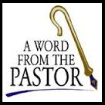
From the desk of Pastor Geske….

How are we doing in Sharing the Love of Jesus

Greetings to you in the name of Christ! Our mission is to be about sharing the love of Jesus. We want people to know the love and forgiveness of Jesus Christ. So how are we doing collectively and individually? How are we intentionally engaging our family, our neighbors and our community with the love and forgiveness of Jesus Christ? In this day and age, there is such a need for the proclamation of Christ. I am reminded of those words of Peter when he wrote, “But in your hearts set apart Christ as Lord. Always be prepared to give an answer to everyone who asks you to give the reason for the hope that you have. But do this with gentleness and respect,” (1 Peter 3:15 NIV)
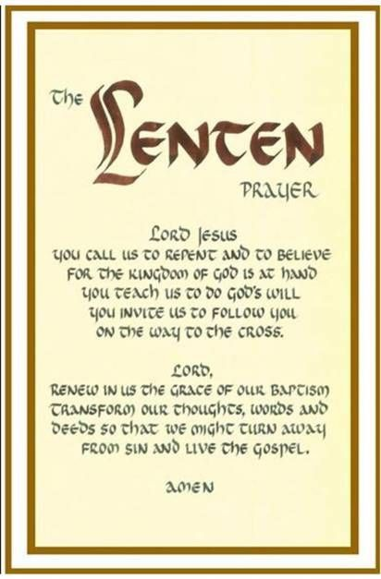
We want our families, our community, and our world to know Jesus as Lord and Savior. We want others to know that we are sinners in our thoughts, words, and deeds. I think about a conversation I had with a brother in Christ. He shared the story of a former pastor he had who was visiting with someone about the importance of church attendance and the person said that he wasn’t going to attend because the church is full of hypocrites. The pastor responded, “That’s where I want them.” The reality is, with sin in our world and its effect on our lives, we fall short. We don’t always do, say, or think what God wants us to, but the message that we focus on when we come together is that with God there is forgiveness and hope. God helps us amend our sinful lives and comforts us with the joy that is ours in Christ. We come together to focus again on these words of promise from the Psalmist, “If you, O LORD, kept a record of sins, O Lord, who could stand? But with you there is forgiveness; therefore you are feared.” (Psalm 130:3-4 NIV)
Yes, with Christ, forgiveness, eternal life, and strength to live each day are given through His Word and the Sacraments. We come to church because God calls us to gather, to grow, and to go. We gather to worship. We grow in His Word. Then we go by His command to reach out with His love. Jesus says, “Go into all the world and preach the good news to all creation.” (Mark 16:15 NIV)
I look forward to seeing each of you gather, grow, and go to share His love. Reflect again on your life. I pray that you understand that God’s desire and will for you is to be in His house about His work and living your life sharing the love of Jesus your Savior. Indeed, I look forward to your faithful participation in God’s house here at Zion. May God bless you as you seek to share the love of Jesus and bring people to know Christ!

In Christ,
Pastor Jeffrey D. Geske
Sunday Morning Bible Class
Please come and join our study of the Word of God!
(Starting in February)
God’s Word of Today ~ Study of Romans
Each study in the God’s Word for Today series provides an in-depth exploration of a book of the Bible. Each session includes:
- background information on the book of the Bible, its author, audience, occasion, and purpose;
- learning experiences that promote exciting and challenging discussions;
- notes for leaders that answer questions, suggest a learning process, and provide additional information;
- discussion starters that help participants apply God’s Word to their daily lives.
(13 sessions)
Romans summarizes well both a quarter century of Paul’s missionary preaching and teaching, and the essential emphases of his evangelical theology.
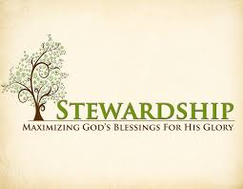
Newsletter Article – February 2021
(--From the LCMS website)

“I am not commanding you, but I want to test the sincerity of your love by comparing it with the earnestness of others. For you know the grace of our Lord Jesus Christ, that though he was rich, yet for your sakes he became poor, so that you through his poverty might become rich" (2 Corinthians 8:8-9).

Without commands or even arm-twisting, St. Paul encourages, even challenges, the Church in Corinth to demonstrate the sincerity of their faith by their generosity in giving. He does this because giving generously is a gift of the Spirit given to us through the Gospel.

St. Paul wrote: “But just as you excel in everything—in faith, in speech, in knowledge, in complete earnestness and in your love for us—see that you also excel in this grace of giving” (2 Corinthians 8:7). In other words, just as we grow in faith and speech and knowledge of eternal things by the Holy Spirit through the Word of God, so also do we grow in giving from the same Spirit through the same Word.

The problem is that the grace of generosity often grows cold in us. It’s not so much that we stop giving, but we don’t put it first. We treat it like all the other bills that must be paid. It becomes a chore, just one more thing to check off a list of things to do. That empties it of its spiritual power and robs us of the joy that Christ and the Scriptures assign to it.

On top of that, since this generosity is linked to faith and knowledge of divine things, a lack of excelling in giving is sure sign that our faith and knowledge of God are under attack as well.

Thus St. Paul points to the foundation of generosity: the generosity of Christ Himself. Even though He was rich, He became poor so that we who are poor might become rich. Thus, the incarnation, suffering, and death of our Lord on the cross is the reason, source, and driving force for our generosity in giving to the church.

And since Christ who was rich became poor so that we might be rich in His grace—of which generous giving is part—so we also who are rich in His grace can excel in pressing His grace into service toward the gracious work of the church.

Pay attention to what you give to the church so that you may excel at it. And if you find that your heart has grown cold or indifferent toward it, immerse yourself in God’s Word. Read it at home. Attend Bible Class. Hear and listen to it preached in the Divine Service. Be reminded of what Christ has done for you in His incarnation, suffering, and death. For this will strengthen your faith and knowledge. And where that excels, so will the grace of giving excel also.

WE BELIEVE, TEACH, AND CONFESS

From Luther’s Small Catechism ~ The Lord’s Prayer
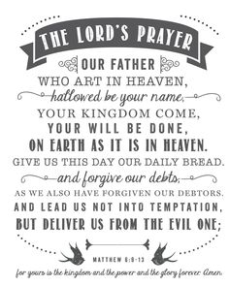
The Third Petition
Thy will be done on earth as it is in heaven.
Your will be done on earth as in heaven.
What does this mean? The good and gracious will of God is done even without our prayer, but we pray in this petition that it may be done among us also.
How is God’s will done?
God’s will is done when He breaks and hinders every evil plan and purpose of the devil, the world, and our sinful nature, which do not want us to hallow God’s name or let His kingdom come; and when He strengthens and keeps us firm in His Word and faith until we die. This is His good and gracious will.

BIRTHDAYS AND ANNIVERSARIES
We would like to wish Happy Birthday and Happy Anniversary to the following individuals who are celebrating this month. If you are not listed or you know someone not listed, please contact Sandy Brady or Pastor Jeff.

February Birthdays

6 Amy Reitzel
14 Russel Bieber
18 Melvin Sieler
20 Brenda Blum
21 Lee Edington
27 JoAnn 3315650-01-7291anSteenkiste

February Anniversaries
We are not aware of any anniversaries this month.

Flowers on the Altar ~ If you would like to place flowers, please sign up in the hallway by the restroom. The cost is $25.00 Please consider signing up for the new year.
Food Bank~ Thank you for your generous help with our Food Bank. If you have any question or would like to help in any way, please contact Rick Keck at (734) 854-4710. The Food Bank serves families and individuals on the second and fourth Tuesday of the month from 10:00 a.m. until noon.
COUNCIL MEETING JANUARY 17, 2021
Member Present: Pastor Jeff, Ron Vincent, Connie Sieler, Lee Edington, Ron Clark and Dennis Reitzel. Absent: Dwight Gilliland
Meeting was called to order by Ron Vincent @11:05 and Pastor Jeff open with a prayer.
Motion made by Ron Clark and 2nd by Lee Edington to dispense with reading of November minutes. Motion made by Lee Edington and 2nd by Dennis Reitzel to accept November minutes.
Pastor Report: Pastor has put together calendar for next year, subject to change. Visiting with shut-ins at home, hospitals and in assisted living and Bible classes. There won’t be Saturday services until first Saturday in March, due to Covid and people going south for winter, attendance is low. Ash Wednesday is February 17th and there will be a service at 7:00 pm, no meal. Please sign up to supply a light meal on February 24th (Pastor will do 24th), March 3rd, 10th Connie will do 10th), 17th, and 24th. Pastor is taking a week vacation in April after Easter Sunday.
President: Discussed ways to get the Youth involved with Zion. Ron has contacted each committee and had a Q & A with each.
Treasurer Report: Zion checking accounts balance with bank at 20/31/2020. A discussion was held on doing a comparison of Budget vs Year to Date Quarterly and this will be posted on bulletin board. Connie Sieler made motion to accept treasurer report and 2nd Dennis Reitzel. Carried.
Elders: Home visits are at a stand still due to Covid.
Old Business: The finishing touches for the ramp will happen in spring and it will be up to code. Media update is still in the works, needs some fine tuning.
New Business: Zion will have a noisy Sunday on February 21st for Lutheran Hour Ministries sponsored by Lutheran Men Group. Al Ahleman has volunteer to do the snow removal for the parking lot. Rick Keck asked if the Food Pantry could be moved to east end of building, council okayed. All maintenance has been done on furnace and broiler by Thompson Htg. & Plbg. The furnace needs a new firewall and Ron is getting quotes for this.
Connie made motion to adjourn and 2nd by Dennis. Carried Adjourned at 12:00 with the Lord’s Prayer.
Respectfully submitted
Connie Sieler
Secretary

Bringing Christ to the Nations and the Nations to the Church

"The Lutheran Hour," which began in 1930, is now heard on more than 1,300 radio stations around the world. "The Lutheran Hour," hosted by Dr. Rev. Michael Zeigler, is the world's oldest continually-broadcast Gospel radio program. This weekly half-hour program proclaims the message of Jesus Christ to all people and serves as a bridge, linking them to the Church. Listen to the Lutheran Hour on Sundays at 10:00 a.m. at AM 1560 WWYC or anytime at www.lhm.org

FEBRUARY 2021
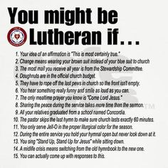
February 7
"Stories Around the Table"
Speaker: Rev. Dr. Michael Zeigler
Dr. Michael Zeigler shares a story about people who had more in common than they thought.
(Mark 6-8)

February 14
"Shines and Saves"
Guest Speaker: Rev. Cody Cooper
Jesus surpasses all expectations as we see Him revealed on the Mount of Transfiguration.
(Mark 9:2-13)

February 21
"Do You See Anything?"
Speaker: Rev. Dr. Michael Zeigler
(Mark)

February 28
"TBD"
Speaker: Rev. Dr. Michael Zeigler
(Mark)

