The Messenger
A newsletter of Zion Lutheran Church ~ Ottawa Lake, MI
March 2021
+ + + + + + + + + +

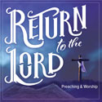
Our Lenten Journey Continues
Our Theme: Return to the Lord

“Return to the LORD your God, for He is gracious and merciful, slow to anger, and abounding in steadfast love; and He relents over disaster” (Joel 2:13). God’s invitation and promise finds its fullness in Jesus Christ, who personified and accomplishes all that God declares. Follow different events during the Pasion, specifically focusing on the people that followed Christ, to see how God calls His people to return to Him this Lenten season.
Join us each week as we will discover this theme;
March 3: ” Return from Betrayal”
March 10: “Return from False Witness”
March 17: “Return from Denial”
March 24: “Return from the Kingdom of God”
A free supper will be served at 6:15 before the service each week.
Please Join Us in our Lenten Journey!

Lutheran Men ~Monthly Breakfast
On March 13, 2021, we will have our Lutheran Men’s Monthly breakfast. Breakfast will be served at 8:00 a.m. We will have a hot breakfast, devotion, and a Bible study. Please come and feel free to invite a friend or neighbor. It would be great to see you there!
Zion Lutheran Church Council
We will have our monthly Church Council Meeting after church on March 21, 2021.

Women of Zion
Women of Zion will have their next monthly meeting on April 26th at 2:00 p.m.

Join Us for Movie Night ~ We will have our next movie night on March 26, 2021. We will meet at 6:30 for a light supper and then will watch a movie. The movie that we will watch is called, “God’s Not Dead ~ A Light in the Darkness,.” If you have not seen this movie, it will be one that you don’t want to miss.
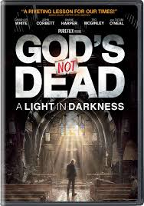
Here is a little information about
God’s Not Dead ~ A Light in the Darkness
The Rev. Dave Hill faces an unexpected setback when his beloved church burns down -- prompting the officials at the adjoining university to try and kick his congregation off campus. Battle lines are quickly drawn between the church and the community as the reverend now finds himself at odds with his longtime friend -- the president of the school. Facing a legal battle, Hill soon seeks help from his estranged brother -- a big-city lawyer and atheist -- in a fight to help rebuild the church.

WORSHIP WITH US EACH WEEK!
Join us for worship on
Sunday morning at 10:00 a.m.

Praying for COVID to END!!
Please kindly wear a mask in the building when you are not at a pew. Thank you! Communion servers will be wearing masks for the protection of all.

Sunday Morning Bible Study
We are studying the book of Romans.
Please plan to join us at 9:00 a.m.

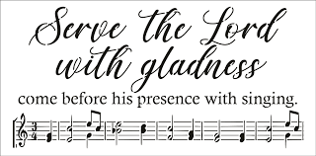
Zion Church Choir
If you love singing, please join our church choir. They meet after church in the choir room. For more information, please speak with Joseph Extejt.

HANDBELL CHOIR ~ We will resume practicing again in April.
We would love to have you join us.

Community Rewards Program
Do you shop at Kroger? If you do, you can sign up for their Community Rewards Program and Kroger will give back to Zion money every quarter. Go on Kroger's website and sign up under Community Rewards. If you need help or do not have an email address, check with Pastor Jeff. (Our code is NC512)
Steps for Linking your Kroger card to help our ministry ~
1, Sign into your account at www.kroger.com or create an account.
2. Click on the NAME.
3. Scroll down to MY ACCOUNT and Click on it,
4. Scroll down to COMMUNITY REWARDS. Click on COMMUNITY REWARDS.
5. Enter Zion Lutheran Church Ottawa Lake MI (NC512)
ZION Lutheran Church
LCMC ~ Lutheran congregations in mission for Christ
8307 Memorial Hwy. Ottawa Lake, MI 49267 ·
(734) 856-2921
Pastor ∙ Jeffrey Geske
(785) 340-5635
zlcolmpastor@gmail.com
www.zionlutheranottawalakemi.com

Secretary ~ Sandy brady
(419) 410-9380
skwiles2000@gmail.com
custodian and organist~ Joseph extejt
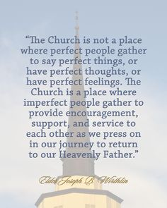
For Your Information
The following members give of their time to the leadership of this congregation. Please keep them in your prayers. If you have any questions, comments, or offers of help, please contact them.
Chairman: Ron Vincent
Secretary: Connie Sieler
Treasurer: Dennis Reitzel
Financial: Ron Clark
Elders: Ron Vincent and Lee Edignton
Deacons: Dwight Gilliland
LCMC ~ WHO WE ARE
Free in Christ + Accountable to One Another + Rooted in Scripture and the Lutheran Confessions + Committed to the Great Commission

Prayers Are Important
If you have an occasion to request a prayer, please call the church office. If you would like your request to be on our prayer chain, please call Sandy Brady (419) 410-9380 or Pastor Jeff at the church or on his cell phone (785)340-5635.
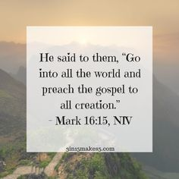
Please Inform the Church Office. . .
*when a member of your family is ill or hospitalized or if they are discharged or moved to another facility.
*when your address changes.
*when a new baby arrives.
*when a family member marries or leaves home for college, or military.
*when planning a wedding to be conducted at Zion.
*when a new family moves into your neighborhood.
*when you are planning to be out of town.
*when a brother or sister in Christ needs a visit from Pastor.

Your Help is Appreciated! ~ Please use you offering envelops either the ones issued or the tan envelope in the pew. Please write your name on it. It is a great help to our recording secretary.
Thank you!
From the desk of Pastor Geske….

How are we doing in Sharing the Love of Jesus
Part 2

Greetings to you in the name of Christ! Our mission is to be about sharing the love of Jesus. As we seek to know Jesus, we also seek to make Him known to our world. Evangelism is certainly the work of the pastor, but it is also the work and mission of every member. We are to live and share the Savior, Jesus Christ. As your pastor, I look forward to receiving those names of friends and neighbors with whom you have shared the Savior’s message. I am a resource to help you share the message of your Savior, but all of us are called to share, witness, and tell others how our congregation is seeking to share Jesus as our Lord and Savior. It is the responsibility of all of us. Just think about how more people would come to know Jesus and how our church would have more people if more of us intentionally shared the Savior’s message and intentionally invited people to join us in worship here at Zion.

I have heard it said about church that they are not evangelizing their community. Ask yourself this question: “What am I doing to help share the message and ministry of Zion Lutheran Church?” If you want to see our church grow, I encourage you to take this question seriously. Evangelism is not simply the pastor’s responsibility. I am called to encourage and equip. In my life, I too, seek those opportunities to share our Savior and the ministry of our church. I too, seek those opportunities to invite people. And if all of us did that, what an amazing difference we would see! I thank God for the new people that have joined or started to attend regularly with us in the past months. Many of those people simply came to our congregation because they had a Lutheran background or because they were seeking a different congregation as a result of challenges facing their congregations and other doctrinal issues.

We have a great and exciting task ahead of us. I am excited about what God is going to be doing in our ministry. I look forward to what God might have ahead of us as we continue to worship and proclaim a Christ alone message of salvation. As we think about what is ahead for our congregation, two Bible verses that I great to reflect upon and pray are the following: “Christ’s love compels us, because we are convinced that one died for all, and therefore all died. And He died for all, that those who live should no longer live for themselves but for Him who died for them and was raised again.” (2 Corinthians 5:14-15 NIV)

May God bless you and excite you to be intentional in prayer and in sharing your faith as you seek to share the love of Jesus and bring people to know Christ as their Lord and Savior!

In Christ,
Pastor Jeffrey D. Geske

Sunday Morning Bible Class
Please come and join our study of the Word of God!

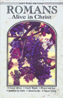
God’s Word of Today ~ Study of Romans
Each study in the God’s Word for Today series provides an in-depth exploration of a book of the Bible. Each session includes:
- background information on the book of the Bible, its author, audience, occasion, and purpose;
- learning experiences that promote exciting and challenging discussions;
- notes for leaders that answer questions, suggest a learning process, and provide additional information;
- discussion starters that help participants apply God’s Word to their daily lives.
(13 sessions)
Romans summarizes well both a quarter century of Paul’s missionary preaching and teaching, and the essential emphases of his evangelical theology.
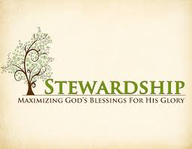
Newsletter Article – March 2021
(--From the LCMS website)

Hudson Taylor, a Nineteenth Century British missionary to China, is reported to have said, “God’s work, done in God’s way, will not lack God’s supply.” To know God’s way, we need to know His Holy Word. Or to say it another way: you need to know your Bible.

St. Paul, before he spends two chapters on giving, wrote that every thought is to be taken captive to the obedience of Christ (2 Cor 10:5). Doctrine matters. And doctrine matters because the Scriptures matter. And the Scriptures matter because this is where we learn the teaching of Christ. Our thoughts must be brought into line with the teaching of Scripture so that our work is what God wants done and so that we do this work in His way.

A good tree bears good fruit. A bad tree bears bad fruit. We have been made good trees in holy baptism. We are fertilized and pruned for bearing good fruit by constantly hearing God’s Word preached and taught in sermon and Bible Class and in receiving the life-giving, faith-sustaining food of the Lord’s Supper. Remember your doctrine, hold on to the Lord’s teaching, and your thoughts will be taken captive to the obedience of Christ.

Bringing every thought captive to the obedience of Christ is recognizing that God does provide. The Lord’s Prayer teaches us to pray for daily bread. Praying this day in and day out reminds us that the Lord is the giver of our daily bread, and that we are to gives thanks for His daily provision of it. God is rarely early and never late in His work, as Abraham learned on the mount of the Lord it will be provided. The Lord’s generosity forms our generosity in return.

Thus, we set aside for the work of God a generous, first-fruits, proportion of the daily bread that God has given to us. This act of trust in the Lord’s provision is the working out of our faith in Him. When budgetary discussions pop up our natural reaction is to point fingers. But remember your doctrine, and what your mother taught about pointing fingers. Our first natural reaction is not always right. In fact, when our thoughts are brought into captivity of Christ, our first reaction should be repentance. It should raise questions in our own lives. As good trees in Christ who are to bear good fruit, we should ask whether our thoughts have been taken captive by obedience to Christ. Have we given generously? Have we given our first-fruits? You know. And God knows. “For the eyes of the Lord run to and fro throughout the whole earth, to show Himself strong on behalf of those whose heart is loyal to Him” (2 Chron 16:9).

God will provide. He always has and He always will. He gives His meat in due season. He has not left you as orphans but has grafted you into His own family. You belong to Him. Remember this, letting this thought dwell in you richly. And you will then be rich toward others.

WE BELIEVE, TEACH, AND CONFESS

From Luther’s Small Catechism ~ The Lord’s Prayer
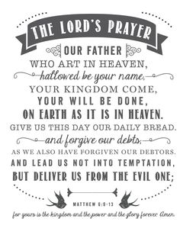
The Fourth Petition
Give us this day our daily bread.
Give us today our daily bread
What does this mean? God certainly gives daily bread to everyone without our prayers, even to all evil people, but we pray in this petition that God would lead us to realize this and to receive our daily bread with thanksgiving.
What is meant by daily bread? Daily bread includes everything that has to do with the support and needs of the body, such as food, drink, clothing, shoes, house, home, land, animals, money, goods, a devout husband or wife, devout children, devout workers, devout and faithful rulers, good government, good weather, peace, health, self-control, good reputation, good friends, faithful neighbors, and the like.
Thrivent Choice Dollars ~ If you have not directed your Thrivent Choice Dollars for 2020. Please contact your Thrivent Rep or call 1-800-847-4836 and direct them before March 31. Please consider giving them to support our ministry here at Zion. Thank you!
BIRTHDAYS AND ANNIVERSARIES
We would like to wish Happy Birthday and Happy Anniversary to the following individuals who are celebrating this month. If you are not listed or you know someone not listed, please contact Sandy Brady or Pastor Jeff.

March Birthdays

14 Bill Brady
16 Larry Blum
23 Karen Vollmer
25 Jim Desko

March Anniversaries
8 Rory and Cheri Hand
16 Russell and Sheri Bieber

Flowers on the Altar ~ If you would like to place flowers, please sign up in the hallway by the restroom. The cost is $25.00 Please consider signing up for sometime this year.
There are currently no flowers for Lent.
Food Bank~ Thank you for your generous help with our Food Bank. If you have any question or would like to help in any way, please contact Rick Keck at (734) 854-4710. The Food Bank serves families and individuals on the second and fourth Tuesday of the month from 10:00 a.m. until noon.
COUNCIL MEETING FEBRUARY 21, 2021

Member Present: Pastor Jeff, Ron Vincent, Connie Sieler, Lee Edington, Ron Clark, Dwight Gilliland and Dennis Reitzel.
Meeting was called to order by Ron Vincent @11:15 and Pastor Jeff open with a prayer.
Motion made by Lee and 2nd by Dennis to dispense with reading of January minutes. Carried
Motion made by Ron Clark and 2nd by Lee to accept January minutes. Carried
Pastor Report: Pastor gave an update on Lent services and studies. Newsletter items are due on 23rd. Bible study is starting a new topic. Pastor can’t wait until he can visit nursing homes etc.
President: Snow removal was done by Alan and Pastor, great job.
Treasurer: Ron gave up date on all accounts and items were discussed. Motion made by Lee and 2nd by Dwight to approve report. Carried
Elder: Lee reported that the men’s breakfast was well attended and they had great bible study.
Deacon: Dwight asked if there was anything that needed to be done in church and at this time repairs are up to date.
Trust Fund: Connie reported that another stock is finally being traded in and Zion should receive a check in about ten days.
Old Business: Ron Clark has Zion on Thompson’s schedule for installation of new furnances.
New Business: It would be helpful if you use a blank envelope for your donation and be sure your name is legible and the amount and envelope number (if you know it) is on the envelope. Pastor and Ron are working on getting the video system up and working. Ron Clark is going to bring in his IT person and see if he’ll check it out. Pastor asked council if we could get Tru-green to spray yard in front of church for dandelions and weeds. Dwight Gilliland is getting quotes. Connie suggested putting how to apply to Krogers for reward for Zion in newsletter so family and friends can sign up.
Connie made a motion to adjourn 2nd by Ron Clark at 12:00. Carried
Closed with Lord’s Prayer

Respectfully submitted
Connie Sieler
Secretary

Bringing Christ to the Nations and the Nations to the Church
"The Lutheran Hour," which began in 1930, is now heard on more than 1,300 radio stations around the world. "The Lutheran Hour," hosted by Dr. Rev. Michael Zeigler, is the world's oldest continually-broadcast Gospel radio program. This weekly half-hour program proclaims the message of Jesus Christ to all people and serves as a bridge, linking them to the Church. Listen to the Lutheran Hour on Sundays at 10:00 a.m. at AM 1560 WWYC or anytime at www.lhm.org

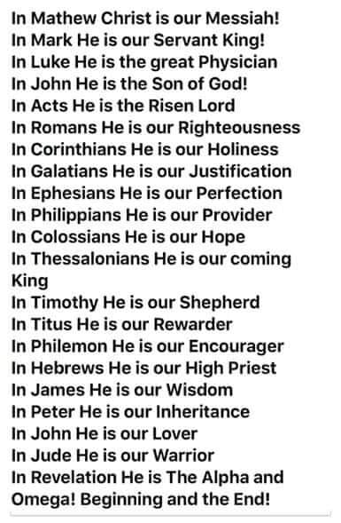
March 2021
March 7
"A Place to Belong"
Speaker: Rev. Dr. Michael Zeigler
(Mark 11: 1-26)
March 14
"All Bets Are Off"
Speaker: Rev. Dr. Michael Zeigler
(Mark 12: 13-34)
March 21
"TBD"
Speaker: Rev. Dr. Michael Zeigler
(Mark)
March 28
"TBD"
Speaker: Rev. Dr. Michael Zeigler
(Mark)

