The Messenger
A newsletter of Zion Lutheran Church ~ Ottawa Lake, MI
June 2021
+ + + + + + + + + +
Happy Father’s Day
To all of our
Fathers and Grandfathers!

Lutheran Men ~Monthly Breakfast
On June 12, 2021, we will have our Lutheran Men’s Monthly breakfast. Breakfast will be served at 8:00 a.m. We will have a hot breakfast, devotion, and a Bible study. Please come and feel free to invite a friend or neighbor.

Zion Lutheran Church
Congregational Meeting
We will have our monthly Church Council Meeting after church on June 13, 2021
at 11:15 a.m.

Congratulations to all area Graduates ~
May God bless your new adventures.
WORSHIP WITH US EACH WEEK!
Join us for worship on Saturday at 4:00 p.m. and
Sunday morning at 10:00 a.m.

Praying for COVID to END!!
Please kindly wear a mask in the building when you are not at a pew. Thank you! Communion servers will be wearing masks for the protection of all.

Sunday Morning Bible Study
We are studying the book of Romans.
Please plan to join us at 9:00 a.m.

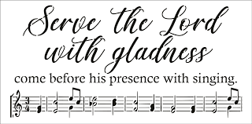
Zion Church Choir
They will resume meeting in September. For more information, please speak with Joseph Extejt.
HANDBELL CHOIR ~ Come! Join us! Come ring in our bell choir! We will rehearse through the first three Saturdays of June and will play during worship on Father’s Day, June 20.
Hope to see you. The more the merrier!

Community Rewards Program
Do you shop at Kroger? If you do, you can sign up for their Community Rewards Program and Kroger will give back to Zion money every quarter. Go on Kroger's website and sign up under Community Rewards. If you need help or do not have an email address, check with Pastor Jeff. (Our code is NC512)

Steps for Linking your Kroger card to help our ministry ~
1. Sign into your account at www.kroger.com or create an account.
2. Click on the NAME.
3. Scroll down to MY ACCOUNT and Click on it,
4. Scroll down to COMMUNITY REWARDS. Click on COMMUNITY REWARDS.
5. Enter Zion Lutheran Church Ottawa Lake MI (NC512)

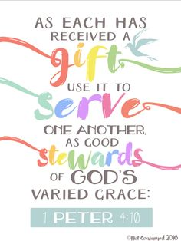
Food Bank~ Thank you for your generous help with our Food Bank. If you have any questions or would like to help in any way, please contact Rick Keck at (734) 854-4710. The Food Bank serves families and individuals on the second and fourth Tuesday of the month from 10:00 a.m. until noon.

ZION Lutheran Church
LCMC ~ Lutheran congregations in mission for Christ
8307 Memorial Hwy. Ottawa Lake, MI 49267 ·
(734) 856-2921
Pastor ∙ Jeffrey Geske
(785) 340-5635
zlcolmpastor@gmail.com
www.zionlutheranottawalakemi.com

Secretary ~ Sandy brady
(419) 410-9380
skwiles2000@gmail.com
custodian and organist~ Joseph extejt

For Your Information
The following members give of their time to the leadership of this congregation. Please keep them in your prayers. If you have any questions, comments, or offers of help, please contact them.
Chairman: Ron Vincent
Secretary: Connie Sieler
Treasurer: Dennis Reitzel
Financial: Ron Clark
Recording Secretary: Sheila Vincent
Elders: Lee Edington
Deacons: Dwight Gilliland

Committees:
Trust Fund: Connie Sieler, Alan Ahleman, Delores Ostrander, Sandy Brady, and Gilbert Olrich

LCMC ~ WHO WE ARE
Free in Christ + Accountable to One Another + Rooted in Scripture and the Lutheran Confessions + Committed to the Great Commission

Prayers Are Important
If you have an occasion to request a prayer, please call the church office. If you would like your request to be on our prayer chain, please call Sandy Brady (419) 410-9380 or Pastor Jeff at the church or on his cell phone (785)340-5635.

Please Inform the Church Office. . .
*when a member of your family is ill or hospitalized or if they are discharged or moved to another facility.
*when your address changes.
*when a new baby arrives.
*when a family member marries or leaves home for college, or military.
*when planning a wedding to be conducted at Zion.
*when a new family moves into your neighborhood.
*when you are planning to be out of town.
*when a brother or sister in Christ needs a visit from Pastor.

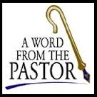
From the desk of Pastor Geske….

We Are All In This Together
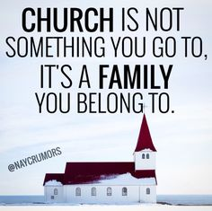
We are all in this together! I like the saying that says, “Church is not something that you go to, it’s a family you belong to.” (--Unknown) We are a family and more importantly, we are God’s family to love and encourage one another and to reach out to our communities through our individual lives to share the hope, forgiveness, and salvation that we have in Jesus Christ alone.
Indeed, we are all in this together, we called by God to support and encourage one another. St. Paul wrote, “¹¹ Therefore encourage one another and build each other up, just as in fact you are doing.” (1 Thessalonians 5:11) We support each other through our worship, our prayers, and in ways that we can hold each other and encourage them in their relationship with Jesus Christ.
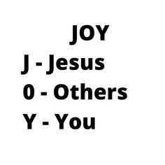
Our work of ministry continues and we need each other to continue to the ministry before us. This obituary made me stop and think about our church. It said, “Our church was saddened to learn this week of the death of one of our most valued members, Someone Else. Someone's passing creates a vacancy that will be difficult to fill. Someone Else has been with us for many years and for every one of those years, Someone Else did far more than a normal person's share of the work. Whenever there was a job to do, a class to teach, or a meeting to attend, one name was on everyone's list, ‘Let Someone Else do it.’ Whenever leadership was mentioned, this wonderful person was looked to for inspiration as well as results; ‘Someone Else can work with that group.’ It was common knowledge that Someone Else was among the most liberal givers in our church. Whenever there was a financial need, everyone just assumed Someone Else would make up the difference. Someone Else was a wonderful person; sometimes appearing superhuman. Were the truth known, everybody expected too much of Someone Else. Now Someone Else is gone! We wonder what we are going to do. Someone Else left a wonderful example to follow, but who is going to follow it? Who is going to do the things Someone Else did? When you are asked to help this year, remember -- we can't depend on Someone Else anymore.” (--Unknown)
We are all in this together, the work of the ministry continues. God uses us through the gifts that He has given us to bring His JOY ~ Jesus, Others, Yourself. May God bless us to be there for one another and to support one another, we the goal of encouraging us to reach out and invite others to join our family and by the Spirit’s work, God’s family. May God bless our service to His glory and may He extend His kingdom through us!

Yours in Christ,
Pastor Jeffrey Geske

“I rejoiced with those who said to me,
‘Let us go to the house of the Lord.’” (Psalm 122:1 NIV)

Sunday Morning Bible Class
Please come and join our study of the Word of God!

That The World May Know Series

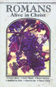
Take your group on a trip to ancient times, places, and customs with trusted Bible scholar Ray Vander Laan as your fun and engaging tour guide. Filmed in Israel, Egypt, Turkey, and Greece, these powerful videos explore what it meant to follow Jesus in the first century—and what it means to follow him today. Each of the 16 volumes provides visually stunning video sessions as well as an easy-to-follow discovery guide that illuminates Jesus’ teachings and helps participants understand the context in which He lived and preached. Join renowned teacher and historian Ray Vander Laan as he guides you through the lands of the Bible. In each lesson, Vander Laan illuminates the historical, geographical, and cultural context of the sacred Scriptures. Filmed on location in the Middle East, the That the World May Know ® film series will transform your understanding of God and challenge you to be a true follower of Jesus.
God’s Word of Today ~ Study of Romans
Our Study of Romans will resume in September.
Pastor would love to offer some adult instruction classes to individuals that may not be confirmed and are now in high school or older. He would love to have this class with anyone that would be interested. The class lasts for four sessions and is done on an individual basis. Classes can be held at the church, the parsonage, or your home. If you know of any one like a child or grandchild that this could be a blessing for them, please let us set something up with them. If you would love to go through this class for a refresher, please let him know what might work well for you and your schedule.
What is a Thrivent Action Team? Thrivent Action Teams make it easy to live generously. Thrivent provides promotional resources and seed money to jump-start your fundraiser, educational event or service project. Your team provides the people power to bring it to life.

THRIVENT NEWS . . .
If you would like more information about Thrivent, its products, or its fraternal functions, please contact our area representative Greg Durivage in Maumee, OH at (419)-740-4193.

Newsletter Article – June 2021
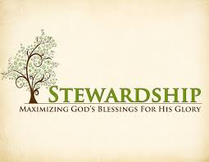
(--From the LCMS website)

“There are three conversions necessary to every man: the head, the heart, and the purse.” Attributed to Luther, though yet to be located in his vast writings, this statement echoes what Jesus taught about hearts and treasures. He said, “For where your treasure is, there will your heart be also.” (Matthew 6:21; Luke 12:34)

But which conversion comes first? I submit that the order is this: first the head, then the purse, then the heart. Let’s explore this topic.

Our Lord Jesus Christ dwelt among us to save us. He took on our flesh, fulfilled the demands of the law in our place, became sin for us, and suffered torture and death on our behalf. He did this in order that we would be free from sin, death, and hell. He gives us what He accomplished through Baptism, Absolution, and the Lord’s Supper. And so, He doesn’t just do it for us but gives it to us. He makes what He did ours by making us His. Thus, we are called by His name: Christians. We have a new life in Him.

Through the preaching of Law and Gospel, God grants us repentance, a changing of our minds. It is a conversion of the mind. We are called to turn away from our sins and turn toward Him for forgiveness, life, and salvation. For when God calls us away from something, He is, at the same time, calling us to something.

And thus, He calls us to a new life, with new deeds. This is the conversion of the purse. Jesus said that “it is easier for a camel to enter through the eye of a needle than for a rich person to enter the kingdom of God.” (Matthew 19:24) “For where your treasure is, there will your heart be also.” Notice that our hearts follow our treasures, not the other way around. As Christians, God calls us to invest our treasures in His Kingdom to ensure that the gospel is preached and the sacraments are administered. He calls us to share all good things with the one who teaches us the doctrines of Christ. He calls us to be generous in giving to the church, for it is more blessed to give than to receive.

So where is your treasure? If it is not invested in the kingdom of God, then the only response is repentance – a conversion of the heart – and to begin doing just that. And as our Lord promised, where your treasure is there your heart will be also.

This is not to say that you earn your way into heaven. It is simply to say that as Christians, those who have been made to be temples of the Holy Spirit, who have been given a new life in Christ, who are dead to sin and now alive in Him, we are actually to live – think (conversion of the mind), do (conversion of the purse), and be (conversion of the heart) – a new life in Him. And when you fail, know that God in Christ loves and forgives you and still calls you away from that and to Himself.
WE BELIEVE, TEACH, AND CONFESS

From Luther’s Small Catechism ~ The Lord’s Prayer
The Seventh Petition
But deliver us from evil.
What does this mean? We pray in this petition, in summary, that our Father in heaven would rescue us from every evil of body and soul, possessions and reputation, and finally, when our last hour comes, give us a blessed end, and graciously take us from this valley of sorrow to Himself in heaven.

Bringing Christ to the Nations and the Nations to the Church
"The Lutheran Hour," which began in 1930, is now heard on more than 1,300 radio stations around the world. "The Lutheran Hour," hosted by Dr. Rev. Michael Zeigler, is the world's oldest continually-broadcast Gospel radio program. This weekly half-hour program proclaims the message of Jesus Christ to all people and serves as a bridge, linking them to the Church. Listen to the Lutheran Hour on Sundays at 10:00 a.m. or at AM 1560 WWYC or anytime at www.lhm.org

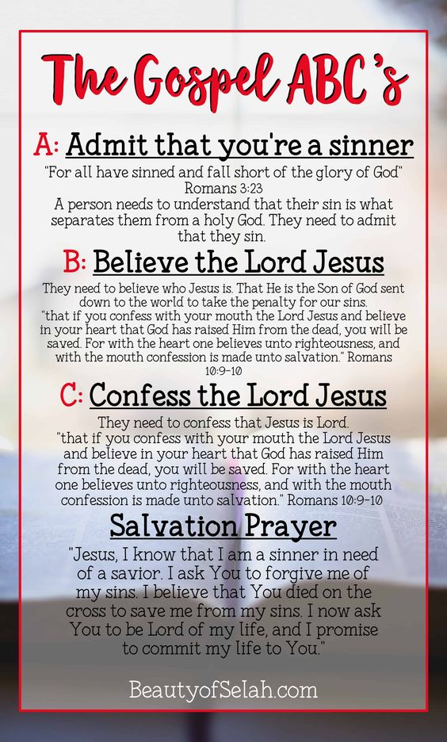
June 2021
June 6
"Out of the Depths"
Guest Speaker: Rev. Dr. Jason Broge
When our words fail us, we find God's word of promise in the words of Psalm 130.
(Psalm 130)
June 13
"Cleary Christian: Good"
Speaker: Rev. Dr. Michael Zeigler
Ephesians Series
June 20
"Cleary Christian: Spiritual"
Speaker: Rev. Dr. Michael Zeigler
(Genesis 1:31)
June 27
"TBD"
Speaker: Rev. Dr. Michael Zeigler
Ephesians Series

BIRTHDAYS AND ANNIVERSARIES
We would like to wish Happy Birthday and Happy Anniversary to the following individuals who are celebrating this month. If you are not listed or you know someone not listed, please contact Sandy Brady or Pastor Jeff.
June Birthdays
Flowers on the Altar ~ If you would like to place flowers, please sign up in the hallway by the restroom.
The cost is $25.00
Please consider signing up for some time this year.

13 Dwight Gilliland
16 Connie Sieler
17 Eric Baumgartner
25 David Vaughan

We wish the following couples a very Happy Anniversary!
10 ~ Ben and Alex Schmidt
19 ~ Ron and Sheila Vincent
25 ~ Brian and Jean Gilliland
Church Council Meeting Minutes~ May 16, 2021

Member Present: Pastor Jeff, Ron Vincent, Connie Sieler, Sheila Vincent, Ron Clark, Dwight Gilliland and Dennis Reitzel and Lee Edington

Meeting was called to order by Ron Vincent @11:15. Pastor Jeff opened with a prayer.

Motion by Dwight to dispense with reading of April’s minutes, 2Nd by Ron C. Carried
Motion to accept April minutes made by Ron C. 2nd by Lee. Motion Carried

Pastor: Worship is increasing, visiting shut-ins and will have a video bible study for summer months.
Pastor will be gone the last week of June. Ron, Dwight and Lee will do the June 27th service.

President: Ron thanked Ron Clark for clearing up the IRS business that was going on for years. Zion is good and doesn’t owe anything to IRS. June 13th will be the Congregation, immediately after services. There will not be any council meetings for the months of June, July and August.

Treasurer: Dennis gave an update on finances and presented a statement from bank and a worksheet for the month of April. Motion made by Connie and 2nd by Sheila to accept treasurer report. Carried

Financial/Building: Ron reported that all bills are paid up to date. The chair lift connector needs to be replaced. Ron will check to see if warranty covers this. Lee made a motion and 2nd by Dennis to get chair repair for up to $500 if warranty doesn’t cover expenses.

Trust Committee: All stocks have been sold and monies are invested in CD’s.

Old Business: Ramp is on hold until lumber prices are lower. Ron C. is having his IT person check out our Facebook live system. Ron C is getting quotes on replacing garage doors and screen door.

Ron C. made a motion to adjourn 2nd by Dwight Gilliland at 11:55. Carried
Closed with Lord’s Prayer
Connie Sieler
Secretary The Church Council will not have a regular meeting for June, July, and August.

