The Messenger
A newsletter of Zion Lutheran Church ~ Ottawa Lake, MI
July 2021
+ + + + + + + + + +
Join Us for Worship!

Our worship on July 3-4 will be patriotic services with praise to God for the blessings of our country.

Sunday Morning Bible Study
We have begun to watch a video called, “That the World Might Know.” Learn more about this series in the Bible Class section of this newsletter.
Please plan to join us at 9:00 a.m.

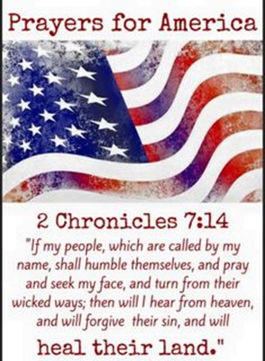
Lutheran Men ~Monthly Breakfast
On July 10, 2021, we will have our Lutheran Men Monthly breakfast. Breakfast will be served at 8:00 a.m. We will have a hot breakfast, devotion, and a Bible study. Please come and feel free to invite a friend or neighbor.

Guest Preacher ~ Rev. George Mornhinweg
On July 11, 2021 Pastor George Mornhinweg will be our guest preacher. He was the pastor here at Zion about 20 years ago. Come and join us in welcoming him and BettyJo for a visit.

Noisy Kettle Sunday ~ Gideon’s International
On July 25, we will have a door offering for the ministry of the Gideon’s as they seek to share the word of God to the ends of the earth.

Church Picnic ~ Mark Your Calendar
Church Picnic will be on August 1 from 4:00-6:00. Roger and Toni Smith have invited us to come to their home for the church picnic.

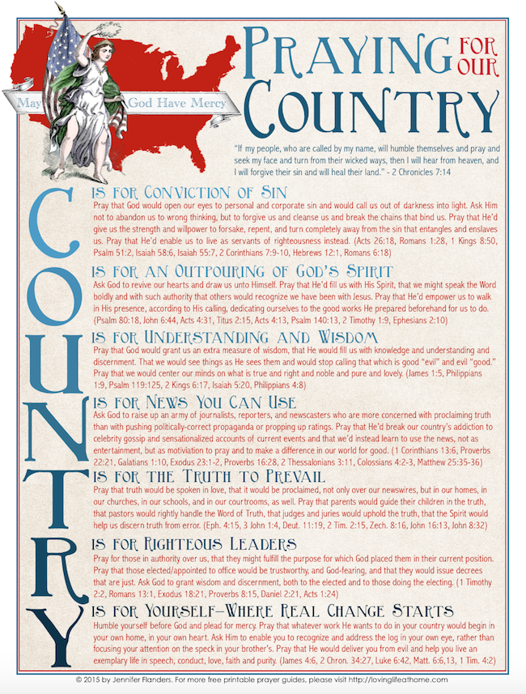

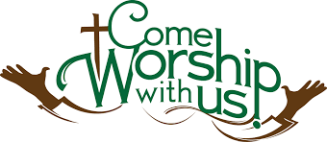
WORSHIP WITH US EACH WEEK!
Join us for worship on Saturday at 4:00 p.m. and
Sunday morning at 10:00 a.m.

Sunday Morning Bible Study
We are studying the book of Romans.
Please plan to join us at 9:00 a.m.

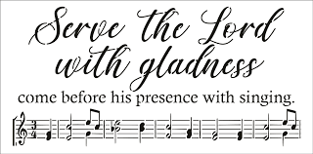
Zion Church Choir
They will resume meeting in September. For more information, please speak with Joseph Extejt.
HANDBELL CHOIR ~ Come join us in the fall. We are taking a break for the summer. We will resume in September. For more information, please speak to Karen Vollmer.

Community Rewards Program
Do you shop at Kroger? If you do, you can sign up for their Community Rewards Program and Kroger will give back to Zion money every quarter. Go on Kroger's website and sign up under Community Rewards. If you need help or do not have an email address, check with Pastor Jeff. (Our code is NC512)
Steps for Linking your Kroger card to help our ministry ~
1. Sign into your account at www.kroger.com or create an account.
2. Click on the NAME.
3. Scroll down to MY ACCOUNT and Click on it,
4. Scroll down to COMMUNITY REWARDS. Click on COMMUNITY REWARDS.
5. Enter Zion Lutheran Church Ottawa Lake MI (NC512)

Food Bank~ Thank you for your generous help with our Food Bank. If you have any questions or would like to help in any way, please contact Rick Keck at (734) 854-4710. The Food Bank serves families and individuals on the second and fourth Tuesday of the month from 10:00 a.m. until noon.

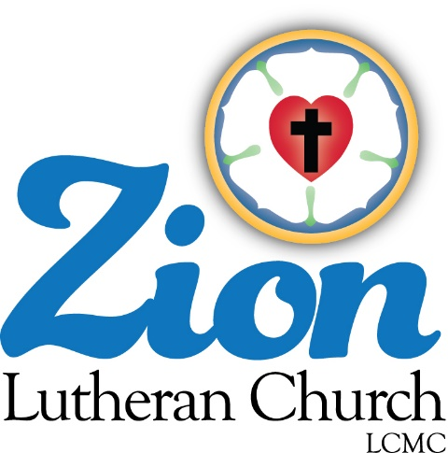
ZION Lutheran Church
LCMC ~ Lutheran congregations in mission for Christ
8307 Memorial Hwy. Ottawa Lake, MI 49267 ·
(734) 856-2921
Pastor ∙ Jeffrey Geske
(785) 340-5635
zlcolmpastor@gmail.com
www.zionlutheranottawalakemi.com

Secretary ~ Sandy brady
(419) 410-9380
skwiles2000@gmail.com
custodian and organist~ Joseph extejt

For Your Information
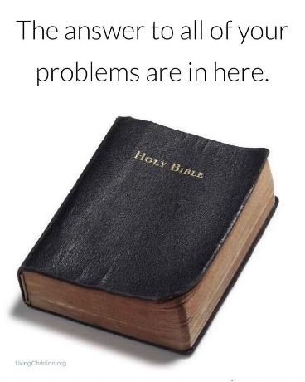
The following members give of their time to the leadership of this congregation. Please keep them in your prayers. If you have any questions, comments, or offers of help, please contact them.
Chairman: Ron Vincent
Secretary: Connie Sieler
Treasurer: Dennis Reitzel
Financial: Ron Clark
Recording Secretary: Sheila Vincent
Elders: Lee Edington
Deacons: Dwight Gilliland

Committees:
Trust Fund: Connie Sieler, Alan Ahleman, Delores Ostrander, Sandy Brady, and Gilbert Olrich

LCMC ~ WHO WE ARE
Free in Christ + Accountable to One Another + Rooted in Scripture and the Lutheran Confessions + Committed to the Great Commission

Prayers Are Important
If you have an occasion to request a prayer, please call the church office. If you would like your request to be on our prayer chain, please call Sandy Brady (419) 410-9380 or Pastor Jeff at the church or on his cell phone (785)340-5635.

Please Inform the Church Office. . .
*when a member of your family is ill or hospitalized or if they are discharged or moved to another facility.
*when your address changes.
*when a new baby arrives.
*when a family member marries or leaves home for college, or military.
*when planning a wedding to be conducted at Zion.
*when a new family moves into your neighborhood.
*when you are planning to be out of town.
*when a brother or sister in Christ needs a visit from Pastor.

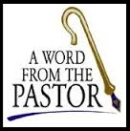
From the desk of Pastor Geske….

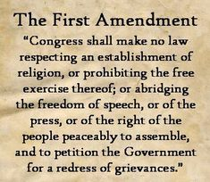
Greetings in the name of Christ! During the month of July, we celebrate the gift that God has given to us through our nation. The United States of America is truly a blessed nation and we are called to be blessing to the world. Among the blessings of this land is the right that we have to worship. About the First Amendment to the US Constitution, Iread, “The First Amendment (1791) prohibits Congress from obstructing the exercise of certain individual freedoms: freedom of religion, freedom of speech, freedom of the press, freedom of assembly, and right to petition. Its Free Exercise Clause guarantees a person's right to hold whatever religious beliefs he or she wants, and to freely exercise that belief, and its Establishment Clause prevents the federal government from creating an official national church or favoring one set of religious beliefs over another. The amendment guarantees an individual's right to express and to be exposed to a wide range of opinions and views. It was intended to ensure a free exchange of ideas even if the ideas are unpopular. . .”,(--Wikipedia)
With this Amendment, we see all kinds of faith, religious views, and some that are hostile to the Christ alone message of salvation. In Acts, we read, “Salvation is found in no one else, for there is no other name under heaven given to mankind by which we must be saved.” (Acts 4:12 NIV) Therefore as God’s people, we need to understand and be able to communicate and share what we hold to be true about our Savior and His work of redemption. We confess our faith to be reminded and encouraged about what we believe, teach, and confess. In a document that summarizes the Lutheran understanding of several teachings. The first article of this document states,
Of the Holy Scriptures
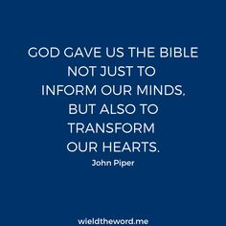
1. We teach that the Holy Scriptures differ from all other books in the world in that they are the Word of God. They are the Word of God because the holy men of God who wrote the Scriptures wrote only that which the Holy Ghost communicated to them by inspiration, 2 Tim. 3:16; 2 Pet. 1:21. We teach also that the verbal inspiration of the Scriptures is not a so-called "theological deduction," but that it is taught by direct statements of the Scriptures, 2 Tim. 3:16, John 10:35, Rom. 3:2; 1 Cor. 2:13. Since the Holy Scriptures are the Word of God, it goes without saying that they contain no errors or contradictions, but that they are in all their parts and words the infallible truth, also in those parts which treat of historical, geographical, and other secular matters, John 10:35.
2. We furthermore teach regarding the Holy Scriptures that they are given by God to the Christian Church for the foundation of faith, Eph. 2:20. Hence the Holy Scriptures are the sole source from which all doctrines proclaimed in the Christian Church must be taken and therefore, too, the sole rule and norm by which all teachers and doctrines must be examined and judged. -- With the Confessions of our Church we teach also that the "rule of faith" (analogia fidei) according to which the Holy Scriptures are to be understood are the clear passages of the Scriptures themselves which set forth the individual doctrines. (Apology. Triglot, p. 441, Paragraph 60; Mueller, p. 684). The rule of faith is not the man-made so-called "totality of Scripture" ("Ganzes der Schrift").
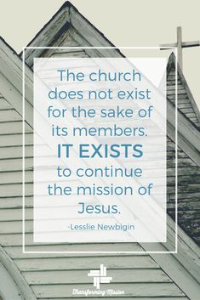
3. We reject the doctrine which under the name of science has gained wide popularity in the Church of our day that Holy Scripture is not in all its parts the Word of God, but in part the Word of God and in part the word of man and hence does, or at least, might contain error. We reject this erroneous doctrine as horrible and blasphemous, since it flatly contradicts Christ and His holy apostles, set up men as judges over the Word of God, and thus overthrows the foundation of the Christian Church and its faith. (--Brief Summary Article 1)

We firmly hold to God’s Word as we carry the mission of God’s church. We work and walk together so that our corner of God’s kingdom, might know and understand the truth of God’s Word and all that He has done through His death and resurrection to give us forgiveness of our sin and the certainty of eternal life. Our community and our world need the witness of God’s church in this land to tell them everything we have is a gift from God and He did not simply create us for this earth, but for an eternal life with Him in Heaven. All of us and those around us can get caught up in the troubles of this world and forget about our God who graciously takes care of us. We need a time and a place to worship and praise God with brothers and sisters in Christ. Daily we are called to be in prayer and His Word and to honor Him by worshipping Him and remembering the Sabbath Day as a thank you for what Christ has done for us.

As you enjoy your summer, make worship a priority. Rejoice in the opportunities to grow in God’s Word and to be strengthen as you continue your Christ centered journey to your home in Heaven. God’s blessings to you!

In Christ,
Pastor Jeff Geske

Sunday Morning Bible Class
Please come and join our study of the Word of God!
That The World May Know Series
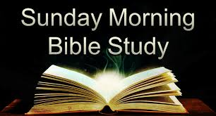
Take your group on a trip to ancient times, places, and customs with trusted Bible scholar Ray Vander Laan as your fun and engaging tour guide. Filmed in Israel, Egypt, Turkey, and Greece, these powerful videos explore what it meant to follow Jesus in the first century—and what it means to follow Him today. Each of the 16 volumes provides visually stunning video sessions as well as an easy-to-follow discovery guide that illuminates Jesus’ teachings and helps participants understand the context in which He lived and preached. Join renowned teacher and historian Ray Vander Laan as he guides you through the lands of the Bible. In each lesson, Vander Laan illuminates the historical, geographical, and cultural context of the sacred Scriptures. Filmed on location in the Middle East, the That the World May Know ® film series will transform your understanding of God and challenge you to be a true follower of Jesus.

God’s Word of Today ~ Study of Romans
Our Study of Romans will resume in September.
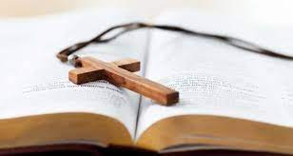
Mark Your Calendars for August 21, 2021 for a 1 day Adult Instruction Class
Pastor Jeff will hold a one day Adult Instruction Class to help people know what the Christians faith with a Lutheran understanding is all about. If you would like to participate or help in any way, please speak to him. The class will go from 9:30 a.m. - 2:00 p.m. A lunch will be served. We will review the six chief teachings of the Lutheran church. Please encourage your family, friends, and neighbors to participate in this informative class. This would be great for those not yet confirmed and are in high school or beyond.
Pastor Jeff also teaches this class on a one-on-one basis. Classes can be held at the church, the parsonage, or your home. If you know of any one like a child or grandchild that this could be a blessing for them, please let us set something up with them. If you would love to go through this class for a refresher, please let him know what might work well for you and your schedule.
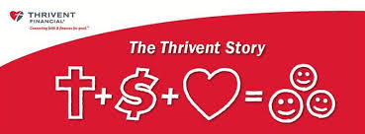
What is a Thrivent Action Team? Thrivent Action Teams make it easy to live generously. Thrivent provides promotional resources and seed money to jump-start your fundraiser, educational event or service project. Your team provides the people power to bring it to life.

THRIVENT NEWS . . .
If you would like more information about Thrivent, its products, or its fraternal functions, please contact our area representative Greg Durivage in Maumee, OH at (419)-740-4193.

Newsletter Article – July 2021
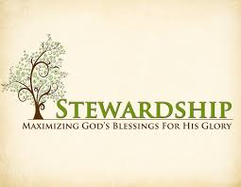
(--From the LCMS website)

“For freedom Christ has set us free; stand firm therefore, and do not submit again to a yoke of slavery” (Galatians 5:1).

We celebrate this month because of the freedoms and liberties our country has afforded us. We are right to do this. We should be thankful for these liberties – the freedom to gather together to worship and to live out what believe in our daily lives.

But freedom and liberty in our age have devolved. It has become a freedom from duty instead of a freedom for it. Indeed, freedom and liberty in our age has turned into licentiousness – a license to do what we want, when we want. This license is a submission again to a yoke of slavery. For freedom as license to do what we desire when we desire it means we are slaves to our desires and slaves to our passions.

Christ died to set us free from our desires. In Holy Baptism, our Old Adam is drowned and put to death along with all sin and evil desires so that a new man may arise and live before God in righteousness and purity. In Christ, we are a new creation. We are set free from the passions of the flesh so that we are free to do our duty and bear fruits of the Spirit.
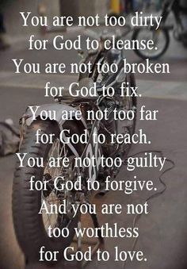
Our duty is what God calls us to do as members of a family, society, and the Church. God calls us to believe in His Word and gladly hear and learn it. He calls us to pray for all people. He calls us to live in faith toward Him and in fervent love for our neighbor. He calls us to put the gifts He gives to us in His service. God calls parents provide for their children and raise them in the fear and admonition of the Lord.

And God calls children to honor their parents and provide and care for them when they are no longer able to do so themselves. God calls the government to punish those who do evil and to reward those who do good. He calls citizens to pay their taxes and honor the governing officials as God’s servants. He calls pastors to preach and teach the Gospel, repentance for the forgiveness of sins. And He calls hearers to support those who teach them with every good thing.

Christ died to set us free from the works of our selfish flesh, giving us the freedom and liberty to do our duty. Stand firm, then, and do not submit again to a yoke of slavery.

WE BELIEVE, TEACH, AND CONFESS

From Luther’s Small Catechism ~ The Lord’s Prayer
The Conclusion
For the kingdom, the power, and the glory are Yours now and forever. Amen.
What does this mean? This means that I should be certain that these petitions are pleasing to our Father in heaven, and are heard by Him; for He Himself has commanded us to pray in this way and has promised to hear us. Amen, amen, which means “yes, yes, it shall be so.”

Bringing Christ to the Nations and the Nations to the Church
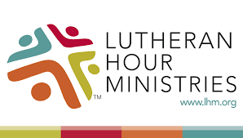
"The Lutheran Hour," which began in 1930, is now heard on more than 1,300 radio stations around the world. "The Lutheran Hour," hosted by Dr. Rev. Michael Zeigler, is the world's oldest continually-broadcast Gospel radio program. This weekly half-hour program proclaims the message of Jesus Christ to all people and serves as a bridge, linking them to the Church. Listen to the Lutheran Hour on Sundays at 10:00 a.m. or at AM 1560 WWYC or anytime at www.lhm.org

July 2021
July 4
"Clearly Christian: Scientific"
Speaker: Rev. Dr. Michael Zeigler
Christians are not against science. They just don't expect science to answer questions beyond its reach.
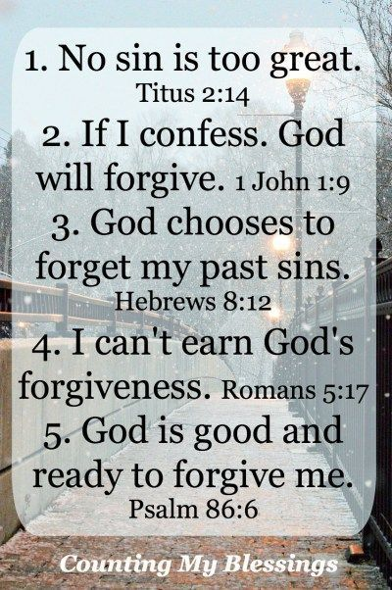
July 11
"Inheritance as Intended"
Speaker: Rev. Dr. Michael Zeigler
An inheritance that's more than places, property, and possessions—the inheritance God intended for His people.
(Ephesians 1)
July 18
"The Problem and Promise of Deathbed Conversion"
Speaker: Rev. Dr. Michael Zeigler
Is a last-minute conversion cause for joy or an insult to lifelong believers? Dr. Michael Zeigler explores both the problem and the promise of deathbed conversions.
(Ephesians 2)
July 25
"The Peace Child"
Speaker: Rev. Dr. Michael Zeigler
(Ephesians 3)
BIRTHDAYS AND ANNIVERSARIES
We would like to wish Happy Birthday and Happy Anniversary to the following individuals who are celebrating this month. If you are not listed or you know someone not listed, please contact Sandy Brady or Pastor Jeff.
July Birthdays
Flowers on the Altar ~ If you would like to place flowers, please sign up in the hallway by the restroom.
The cost is $25.00
Please consider signing up for some time this year.

1 Roger Smith
6 Sandy Baumgartner
8 Ben Schmidt
12 Barb Edington
13 Pastor Jeff Geske
15 Dennis Reitzel
15 Charlie Stewart
27 Mary Jo Price
27 Rick Keck

We wish the following couples a very Happy Anniversary!
28 ~ Rick and Karen Keck

CONGREGATIONAL MEETING JUNE 13, 2021
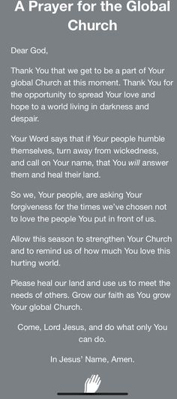
Minutes
Meeting was called to order by Ron Vincent and Pastor Jeff open with a prayer.
Motion made by Sandy Brady and 2nd by Lee Edington to dispensed with reading of December’s minutes. Carried Motion made by John Ritter and 2nd by Mary Jo Gilliland to accept December’s minutes. Carried.
Pastor gave a handout of his activities for the past six months and future agenda for the rest of the year. Pastor also gave an update of the Cash flow and Budget for the last six months. Reports attached
President Ron Vincent gave an over all view of Zion including their finances. He was very proud of Zion coming through the Covid crisis and new features of Facebook to provide services to home bounds and guests.
Treasurer Dennis Reitzel gave the treasurer report with an update of expenses and income compared to budget. As of 6/13/2021, Zion is ($2,981.90) in a credit balance. Motion made by Shirly Clark and 2nd by Sandy Brady to accept the Treasurer report. Carried Reports attached.
Ron Clark reported on projects (Building) that have been completed: two new furnaces installed, new refrigerator, ramp, lighting and many more small items. (Finance Secretary) Reported that all bills are paid and up to date.
Secretary Connie Sieler reported that if Covid restrictions and lifted there is hope to have a Zion dinner in October.
The Trust Fund Committee have finally turn in and received payment for all the stocks that was donated to Zion in the 90’s.
Women of Zion gave a report on donations made through year: Heifer Inc, Mom’s House, Lutheran Home of Williston and Operation Smile.
Rick Keck provided a report on Food Pantry, attached.
Old Business: Ramp on hold till lumber prices fall.
New Business: Roger Smith address the congregation on his arrival to Zion and the progress Pastor Terry and Pastor Jeff have done as part-time pastors. Roger said he believe it would be to Zion advantage to promote Pastor Jeff to full-time pastor and see what can be accomplished (providing funds are available). He asked that council consider this option.
Motion made by Connie Sieler to adjourn and 2nd by Ron Clark. Carried Adjourned at 11:55.
Adjourned with Lord’s Prayer
Respectfully Submitted
Connie Sieler
Sescretary

