The Messenger
A newsletter of Zion Lutheran Church ~ Ottawa Lake, MI
August 2021
+ + + + + + + + + +
Church Picnic ~ Please plan to join in the fun at our church picnic on August 1, 2021 at the home of Roger and Toni Smith. Their address is 12312 S. County Line, Ottawa Lake. (South of Sterns and County Line) The picnic will be from 4-6 p.m. and we will eat about 5:00 p.m.

Sunday Morning Bible Study
We have begun to watch a video called, “That the World Might Know.” Learn more about this series in the Bible Class section of this newsletter.
Please plan to join us at 9:00 a.m.

Lutheran Men ~Monthly Breakfast
On August 14, 2021, we will have our Lutheran Men Monthly breakfast. Breakfast will be served at 8:00 a.m. We will have a hot breakfast, devotion, and a Bible study. Please come and feel free to invite a friend or neighbor.

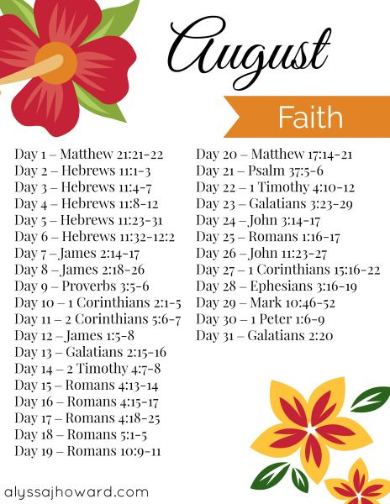
Mark Your Calendars for August 21, 2021 for a 1 day Adult Instruction Class
Pastor Jeff will hold a one day Adult Instruction Class to help people know what the Christian faith with a Lutheran understanding is all about. If you would like to participate or help in any way, please speak to him. The class will go from 9:30 a.m. - 2:00 p.m. A lunch will be served. We will review the six chief teachings of the Lutheran church. Please encourage your family, friends, and neighbors to participate in this informative class. This would be great for those not yet confirmed and are in high school or beyond.
WORSHIP WITH US EACH WEEK!
Join us for worship on Saturday at 4:00 p.m. and
Sunday morning at 10:00 a.m.

Sunday Morning Bible Study
Please plan to join us at 9:00 a.m.

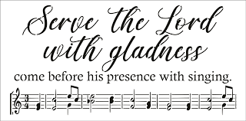
Zion Church Choir
They will resume meeting in September. For more information, please speak with Joseph Extejt.

HANDBELL CHOIR ~ Come join us in the fall. We are taking a break for the summer. We will resume in September. For more information, please speak to Karen Vollmer.

Community Rewards Program
Do you shop at Kroger? If you do, you can sign up for their Community Rewards Program and Kroger will give back to Zion money every quarter. Go on Kroger's website and sign up under Community Rewards. If you need help or do not have an email address, check with Pastor Jeff. (Our code is NC512)
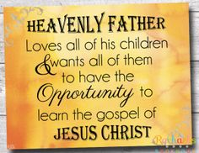
Steps for Linking your Kroger card to help our ministry ~
1. Sign into your account at www.kroger.com or create an account.
2. Click on the NAME.
3. Scroll down to MY ACCOUNT and Click on it,
4. Scroll down to COMMUNITY REWARDS. Click on COMMUNITY REWARDS.
5. Enter Zion Lutheran Church Ottawa Lake MI (NC512)
Food Bank~ Thank you for your generous help with our Food Bank. If you have any questions or would like to help in any way, please contact Rick Keck at (734) 854-4710. The Food Bank serves families and individuals on the second and fourth Tuesday of the month from 10:00 a.m. until noon.

To Join our Text alerts visit:
Text the message @jgesk to the number 81010. If you’re having trouble with 81010, try texting @jgesk to (517) 682-0429.
This is a free service ~ You are only charged if your cellphone charges per text
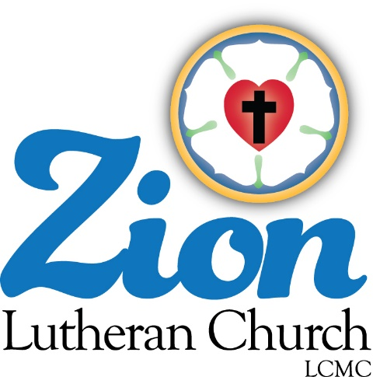
ZION Lutheran Church
LCMC ~ Lutheran congregations in mission for Christ
8307 Memorial Hwy. Ottawa Lake, MI 49267 ·
(734) 856-2921
Pastor ∙ Jeffrey Geske
(785) 340-5635
zlcolmpastor@gmail.com
www.zionlutheranottawalakemi.com

Secretary ~ Sandy brady
(419) 410-9380
skwiles2000@gmail.com
custodian and organist~ Joseph extejt

For Your Information
The following members give of their time to the leadership of this congregation. Please keep them in your prayers. If you have any questions, comments, or offers of help, please contact them.
Chairman: Ron Vincent
Secretary: Connie Sieler
Treasurer: Dennis Reitzel
Financial: Ron Clark
Recording Secretary: Sheila Vincent
Elders: Lee Edington
Deacons: Dwight Gilliland

Committees:
Trust Fund: Connie Sieler, Alan Ahleman, Delores Ostrander, Sandy Brady, and Gilbert Olrich

LCMC ~ WHO WE ARE
Free in Christ + Accountable to One Another + Rooted in Scripture and the Lutheran Confessions + Committed to the Great Commission

Prayers Are Important
If you have an occasion to request a prayer, please call the church office. If you would like your request to be on our prayer chain, please call Sandy Brady (419) 410-9380 or Pastor Jeff at the church or on his cell phone (785)340-5635.

Please Inform the Church Office. . .
*when a member of your family is ill or hospitalized or if they are discharged or moved to another facility.
*when your address changes.
*when a new baby arrives.
*when a family member marries or leaves home for college, or military.
*when planning a wedding to be conducted at Zion.
*when a new family moves into your neighborhood.
*when you are planning to be out of town.
*when a brother or sister in Christ needs a visit from Pastor.
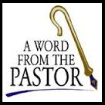
From the desk of Pastor Geske….

Greetings in the name of Christ! Our mission is to know Jesus and make Him known. We do this as we share the love of Jesus through our work together as the body of Christ at Zion and through our individual lives as we encourage others. We love for others to know Jesus as their Savior. Our responsibility as a Christian is to tell the world who Jesus is and what He has done to give us God’s love and forgiveness. We keep before us that great Gospel in a nutshell that we read in John 3:16. There Jesus said, “For God so loved the world that he gave his one and only Son, that whoever believes in him shall not perish but have eternal life.” (John 3:16) So, we want to tell people of Jesus and pray that the Holy Spirit would work in their hearts and lives the gift of faith so that they too trust Jesus as their Lord and Savior.
Last month, I shared some paragraphs from a resource from another Lutheran denomination that speaks of the key summaries of what Lutheran should believe. The document was written in the 1930’s but speaks so faithfully of what we continue to believe. This month, I would like to share the paragraph about faith in Christ. The document said, “9. Since God has reconciled the whole world unto Himself through the vicarious life and death of His Son and has commanded that the reconciliation effected by Christ be proclaimed to men in the Gospel, to the end that they may believe it, 2 Cor. 5:18, 19; Rom. 1:5, therefore faith in Christ is the only way for men to obtain personal reconciliation with God, that is, forgiveness of sins, as both the Old and the New Testament Scriptures testify, Acts 10:43; John 3:16-18, 36. By this faith in Christ, through which men obtain the forgiveness of sins, is not meant any human effort to fulfill the Law of God after the example of Christ, but faith in the Gospel, that is, in the forgiveness of sins, or justification, which was fully earned for us by Christ and is offered by the Gospel. This faith justifies, not inasmuch as it is a work of man, but inasmuch as it lays hold of the grace offered, the forgiveness of sins, Rom. 4:16.” (--Brief Summary)

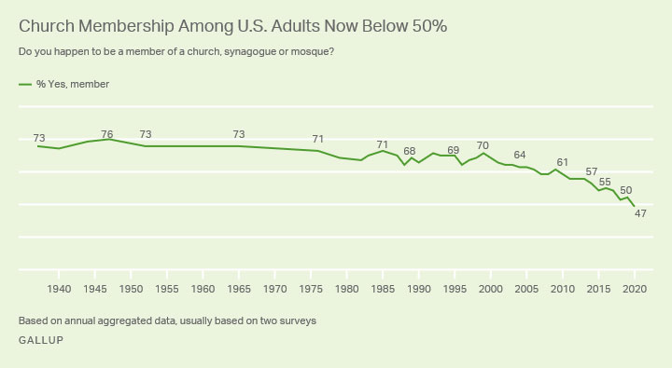
It is God’s desire for all to be saved as St. Paul wrote, “³ This is good, and pleases God our Saviour, ⁴ who wants all people to be saved and to come to a knowledge of the truth.” 1 Timothy 2:3-4) Yes, it is God’s desire for all to be saved and He uses us to reach out to our world to invite people to a relationship with Jesus. Our work continues, yet the devil, the world and our own sinful nature want us to believe that there is no hurry or believe that everyone already has a church home. A statistic that I read recently said that only 45% of Americans claim to have a church home. The need is great to invite and encourage those around us. Yes, we can have a faith life outside of a church setting, but God has given us the church so that He can nurture us in His Word, to grow closer to Him and to brothers and sisters in Christ. He then sends us to call, invite, and encourage people to have a relationship with Him and with His church, the body of Christ.

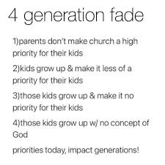
I recently came across this picture of four generation fade. It so speaks to our world today. It said, “1. Parents don’t make church a high priority for their kids. 2. Kids grow up and make it less a priority for their kids. 3. Those kids grow up and make it not priority for their kids. 4. Those kids grow up with no concept of God.” Then it said, “Priorities today, impact generations!”

Where are we today? Where are you? Where is your family? God is calling us to have those serious conversations about faith and a relationship with our God. God is calling us to seek to have those conversations with those around us and our world. The devil would like nothing more than for our kids to have no concept of God. Remember God desires all to be saved and to come to the knowledge of the truth. Today He is using each of us to call to this generation to grow in a relationship with Him through His church feeding and nurturing so that generations of people to come will know the Good News of Jesus and continue to have a relationship with God.

May God bless us as we seek to share His love to our world beginning right where He has placed us!

In Christ,
Pastor Jeff Geske

Sunday Morning Bible Class
Please come and join our study of the Word of God!
That The World May Know Series
Take your group on a trip to ancient times, places, and customs with trusted Bible scholar Ray Vander Laan as your fun and engaging tour guide. Filmed in Israel, Egypt, Turkey, and Greece, these powerful videos explore what it meant to follow Jesus in the first century—and what it means to follow Him today. Each of the 16 volumes provides visually stunning video sessions as well as an easy-to-follow discovery guide that illuminates Jesus’ teachings and helps participants understand the context in which He lived and preached. Join renowned teacher and historian Ray Vander Laan as he guides you through the lands of the Bible. In each lesson, Vander Laan illuminates the historical, geographical, and cultural context of the sacred Scriptures. Filmed on location in the Middle East, the That the World May Know ® film series will transform your understanding of God and challenge you to be a true follower of Jesus.
God’s Word of Today ~ Study of Romans
Our Study of Romans will resume in September.
Adult Instruction Class
Pastor Jeff teaches this class on a one-on-one basis. Classes can be held at the church, the parsonage, or your home. If you know of any one like a child or grandchild that this could be a blessing for them, please let us set something up with them. If you would love to go through this class for a refresher, please let him know what might work well for you and your schedule.
What is a Thrivent Action Team? Thrivent Action Teams make it easy to live generously. Thrivent provides promotional resources and seed money to jump-start your fundraiser, educational event or service project. Your team provides the people power to bring it to life.

THRIVENT NEWS . . .
If you would like more information about Thrivent, its products, or its fraternal functions, please contact our area representative Greg Durivage in Maumee, OH at (419)-740-4193.

Newsletter Article – August 2021
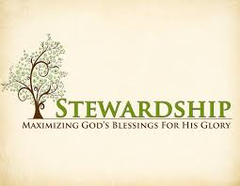
(--From the LCMS website)

When it comes to stewardship, a favorite Bible verse is the account of the widow’s mite (Luke 21:1–4). It’s a moving account. Our Lord praises the seemingly small gift of two copper coins given by a poor widow above the abundance of gifts given by the rich, saying, “Truly, I tell you, this poor widow has put in more than all of them” (Luke 21:3). And that is usually where we stop. But the text goes on. “For they all contributed out of their abundance, but she, out of her poverty, put in all she had to live on” (Luke 21:4).

“She … put in all she had to live on.” She gave everything. She held nothing back. She trusted that the Lord who made her and all creatures; who gave her everything she had; who redeemed her from her own sin, from death, and the power of the devil; who called her by the gospel and enlightened her with His gifts of Word and Sacrament; would continue to do this. He would provide her with all that she needed for this body and life because that is the character of the God she had.
But this is not why we give small gifts. Her gift, though it appeared small, was actually large. When we are tempted to give small gifts, it is precisely because we want them to be small! We don’t trust the Lord to provide for us. We give small gifts because we lack faith in the One who created us, redeemed us, sanctifies and keeps us in the one true faith. We give small gifts because we doubt that God will really give us what we need and desire. We give small gifts because we are not content with what God has already given.

We are not slaves, children of the slave woman, under the Old Covenant (Galatians 4). We are adopted sons of the free woman. And since we are sons, we are also heirs. And heirs receive the inheritance. For everything is already ours in Christ. And thus, moved by the willing spirit of adoption, we do the will of God in financial matters far beyond all that done by those under the Old Covenant who were forced by legal demands.
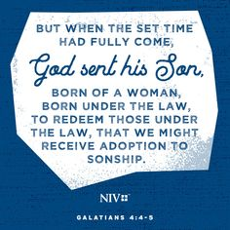
So, what have you decided to give? How do I decide what to give? Let the Scriptures be your guide.

We are to give proportionally to what we have received from God’s giving to us (Luke 12:48; 1 Corinthians 16:1–2, 2 Corinthians 8:12). But you have not been set free to give nothing. See that you excel in the grace of giving (2 Corinthians 8:7)!

We are not free to live selfishly outside the Gospel, without regard for God who gives us all good gifts, without generosity for our neighbor who needs us and our gifts, without supporting the community of faith in which we live, without care for our spiritual fathers and those who teach and help raise our children in the faith, and without resources for the poor and needy.

In short, we are not free to live unto ourselves, hoarding what God has given us only for us. For love is the fulfillment of the law (Romans 13:10). And the sum of the law is this: Love God and love your neighbor (Matthew 22:34–40). We love because He first loved us. We give because He has given to us.

Luther once said, “Possessions belong in your hands, not in your heart” (LW 14:240). There is a reason your 10 fingers spread apart. With your hands you catch God’s gifts for what you need and let the rest fall through your fingers to your neighbors – your family, your friends, your community, your church.

WE BELIEVE, TEACH, AND CONFESS

From Luther’s Small Catechism ~
1. What is Christianity?
Christianity is the life and salvation God has given in and through Jesus Christ.
1 John 14:6 I am the way and the truth and the life. No one comes to the Father except through Me.
2 John 17:3 This is eternal life: that they may know You, the only true God, and Jesus Christ, whom You have sent.
3 Acts 4:12 Salvation is found in no one else, for there is no other name under heaven given to men by which we must be saved.
4 Acts 11:26 The disciples were called Christians first at Antioch.
5 1 John 5:11–12 God has given us eternal life, and this life is in His Son. He who has the Son has life; he who does not have the Son of God does not have life.
Note: Christianity was at first called “the Way” (Acts 9:2; 24:14, 22).

BIRTHDAYS AND ANNIVERSARIES
We would like to wish Happy Birthday and Happy Anniversary to the following individuals who are celebrating this month. If you are not listed or you know someone not listed, please contact Sandy Brady or Pastor Jeff.
Flowers on the Altar ~ If you would like to place flowers, please sign up in the hallway by the restroom.
The cost is $25.00
Please consider signing up for some time this year.

August Birthdays

3 Gilbert Olrich
5 Ray Schmidt
9 Jacob Geske
22 Jim Taylor
24 Sheila Vincent
30 Mark Ostrander
30 Alex Schmidt
31 MaryJo Gilliland
We wish the following couples a very Happy Anniversary!
31 ~ Dick and Karen Vollmer
Bringing Christ to the Nations and the Nations to the Church
"The Lutheran Hour," which began in 1930, is now heard on more than 1,300 radio stations around the world. "The Lutheran Hour," hosted by Dr. Rev. Michael Zeigler, is the world's oldest continually-broadcast Gospel radio program. This weekly half-hour program proclaims the message of Jesus Christ to all people and serves as a bridge, linking them to the Church. Listen to the Lutheran Hour on Sundays at 10:00 a.m. or at AM 1560 WWYC or anytime at www.lhm.org

August 2021

August 1
"Blowing in the Wind"
Speaker Emeritus of The Lutheran Hour: Rev. Dr. Ken Klaus
"Archives August" begins with a classic message from Pastor Ken Klaus in which he contrasts popularly-held urban legends with the unchanging truth of God's Word.
(Ephesians 4:14-16)
August 8
"Seeing The Savior Sore"
Guest Speaker: Rev. Dr. Dale A. Meyer
"Archives August". Jesus got upset when religious people got in the way of those He wanted to reach.
(Ephesians 4:26)
August 15
"A Sunny Place for Shady People"
Guest Speaker: Dr. Oswald Hoffmann
"Archives August". The life of a notorious saint shows how the grace of God makes the Church a sunny place for shady people. (Ephesians 5:8)
August 22
"TBD"
Guest Speaker: Rev. Dr. Dale A. Meyer
"Archives August" (Ephesians 5)
August 29
"Use What You've Been Given"
Lutheran Hour Speaker: Rev. Dr. Gregory Seltz
"Archives August"
(Ephesians 6:10-17)

