The Messenger
A newsletter of Zion Lutheran Church ~ Ottawa Lake, MI
October 2021
+ + + + + + + + + +
Join Us for our German Dinner
Join us for dinner on October 9 from 4-7 pm. Please plan to attend. If you can help in anyway, please sign up in the Fellowship Hall or contact Connie Sieler. We are looking forward to a fun evening with entertainment being provided.

Special Congregational Meeting
On October 17, we will have a special congregational meeting for the purpose of approving a new hymnal for our congregation’s worship. Please note the section regarding this meeting in this newsletter.

New Member Reception
We would like to have a new member reception on October 17. If you have been attending Zion and would like to become a member, please speak with Pastor Jeff so that you may be included in this reception during our worship service.

Lutheran Men ~Monthly Breakfast
On October 9, 2021, we will have our Lutheran Men Monthly breakfast. Breakfast will be served at 8:00 a.m. We will have a hot breakfast, devotion, and a Bible study. Please come and feel free to invite a friend or neighbor.

Zion Lutheran Church Council
We will have our monthly Church Council Meeting after church on October 24, 2021.

Women of Zion
There will be a meeting on October 25, 2021 at 2 p.m. We will have a meeting and a Bible study on the book of Revelations. All Women are invited and encouraged to attend.

Movie Night
We will have a Movie Night on October 22, 2021. We will meet at 6:30 for a light supper and then will watch a movie. The movie that we will watch is called, “War Room.” If you have not seen this movie, it will be one that you don’t want to miss.

Here is a little information about WAR ROOM:
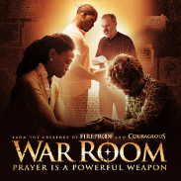
Filled with heart, humor, and wit, WAR ROOM follows Tony and Elizabeth Jordan, a couple who seemingly have it all-great jobs, a beautiful daughter, their dream home. But appearances can be deceiving. In reality, their marriage has become a war zone and their daughter is collateral damage. With guidance from Miss Clara, an older, wiser woman, Elizabeth discovers she can start fighting for her family instead of against them. As the power of prayer and Elizabeth's newly energized faith transform her life, will Tony join the fight and become the man he knows he needs to be? Together, their real enemy doesn't have a prayer. —AFFIRM/Provident
WORSHIP WITH US EACH WEEK!
Join us for worship on Saturday at 4:00 p.m. and
Sunday morning at 10:00 a.m.

Sunday Morning Bible Study
Please plan to join us at 9:00 a.m.

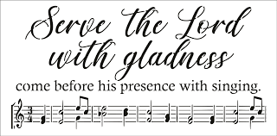
Zion Church Choir
Zion's choir is led by Joseph Extegt. All are welcome to join in. Practice is usually held after Sunday worship service. They practice after church in the choir room in the basement. For more information, please speak with Joseph Extejt.

HANDBELL CHOIR ~ It is time to make a joyful noise to the Lord. Come join the bell choir. They practice on Saturdays at 3:00 P.M. for 45 minutes. Don’t know how? Happy to teach you. Come join the fun! Let’s make music together!
For more information, please speak to Karen Vollmer.

Community Rewards Program
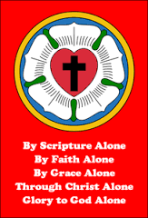
Do you shop at Kroger? If you do, you can sign up for their Community Rewards Program and Kroger will give back to Zion money every quarter. Go on Kroger's website and sign up under Community Rewards. If you need help or do not have an email address, check with Pastor Jeff. (Our code is NC512)

Steps for Linking your Kroger card to help our ministry ~
1. Sign into your account at www.kroger.com or create an account.
2. Click on the NAME.
3. Scroll down to MY ACCOUNT and Click on it,
4. Scroll down to COMMUNITY REWARDS. Click on COMMUNITY REWARDS.
5. Enter Zion Lutheran Church Ottawa Lake MI (NC512)
Food Bank~ Thank you for your generous help with our Food Bank. If you have any questions or would like to help in any way, please contact Rick Keck at (734) 854-4710. The Food Bank serves families and individuals on the second and fourth Tuesday of the month from 10:00 a.m. until noon.

To Join our Text alerts visit: Text the message @jgesk to the number 81010. If you’re having trouble with 81010, try texting @jgesk to (517) 682-0429. This is a free service ~ You are only charged if your cellphone charges per text

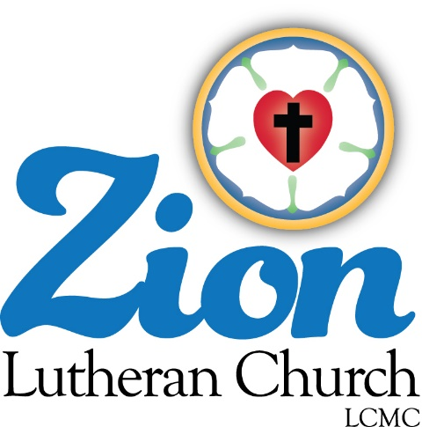
ZION Lutheran Church
LCMC ~ Lutheran congregations in mission for Christ
8307 Memorial Hwy. Ottawa Lake, MI 49267 ·
(734) 856-2921
Pastor ∙ Jeffrey Geske
(785) 340-5635
zlcolmpastor@gmail.com
www.zionlutheranottawalakemi.com

Secretary ~ Sandy brady
(419) 410-9380
skwiles2000@gmail.com
custodian and organist~ Joseph extejt

For Your Information
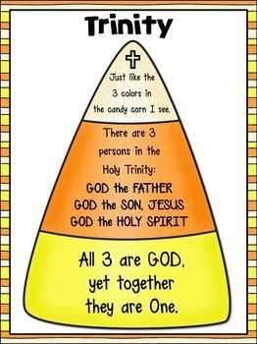
The following members give of their time to the leadership of this congregation. Please keep them in your prayers. If you have any questions, comments, or offers of help, please contact them.
Chairman: Ron Vincent
Secretary: Connie Sieler
Treasurer: Dennis Reitzel
Financial: Ron Clark
Recording Secretary: Sheila Vincent
Elders: Lee Edington
Deacons: Dwight Gilliland

Committees:
Trust Fund: Connie Sieler, Alan Ahleman, Delores Ostrander, Sandy Brady, and Gilbert Olrich

LCMC ~ WHO WE ARE
Free in Christ + Accountable to One Another + Rooted in Scripture and the Lutheran Confessions + Committed to the Great Commission

Prayers Are Important
If you have an occasion to request a prayer, please call the church office. If you would like your request to be on our prayer chain, please call Sandy Brady (419) 410-9380 or Pastor Jeff at the church or on his cell phone (785)340-5635.

Please Inform the Church Office. . .
*when a member of your family is ill or hospitalized or if they are discharged or moved to another facility.
*when your address changes.
*when a new baby arrives.
*when a family member marries or leaves home for college, or military.
*when planning a wedding to be conducted at Zion.
*when a new family moves into your neighborhood.
*when you are planning to be out of town.
*when a brother or sister in Christ needs a visit from Pastor.
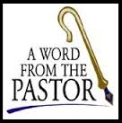
From the desk of Pastor Geske….

Justified by Faith ~ Not by Good Works

Martin Luther struggled in the faith as he saw so many abuses of the church and so much emphasis placed on works. He believed that for his faith it was Jesus plus works or so many other things that the church of his day placed upon the believers. He struggled and was tormented by his own failures and how he felt he was not good enough. He was encouraged to read the book of Romans. There he found what a loving and forgiving God we have and he found these words of St. Paul that said, “²⁸ For we maintain that a person is justified by faith apart from the works of the law.” (Romans 3:28 NIV)
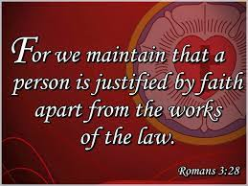
I like this note about this verse that said, “Why does God save us by faith alone? (1) Faith eliminates the pride of human effort, because faith is not a deed that we do. (2) Faith exalts what God has done, not what we do. (3) Faith admits that we can’t keep the law or measure up to God’s standards—we need help. (4) Faith is based on our relationship with God, not our performance for God.” (--Life Application Notes on Romans 3:28) Our faith is in what God has done for us. Luther went so far as saying in this verse that we justified by faith ALONE. Only by faith and not by works.

As we celebrate this month of October, we celebrate the Reformation. We recall when Martin Luther posted the 95 Thesis on Facebook and Instagram. . . oops, I mean the church door as it was the way to communicate important news and events. He wanted the church of his day to discuss the errors and abuses that he saw. We know the result as it led to the protestant reformation.

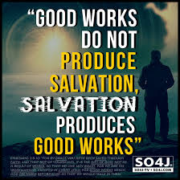
In the first statement of what Luther and other fellow theologians wrote. They had this to say in Article VI: Of New Obedience. They wrote, “1] Also they teach that this faith is bound to bring forth good fruits, and that it is necessary to do good works commanded by God, because of God's will, but that we should not rely on those works to merit justification 2] before God. For remission of sins and justification is apprehended by faith, as also the voice of Christ attests: When ye shall have done all these things, say: We are unprofitable servants. Luke 17:10. The same is also taught by 3] the Fathers. For Ambrose says: It is ordained of God that he who believes in Christ is saved, freely receiving remission of sins, without works, by faith alone.” (--Augsburg Confession, Article VI)

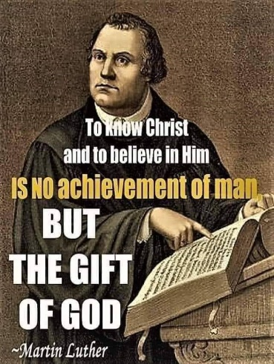
In support of this article, Lutherans in the 1900’s had this to say about Good Works. They wrote, “Of Good Works ~ 20. Before God only those works are good which are done for the glory of God and the good of man, according to the rule of divine Law. Such works, however, no man performs unless he first believes that God has forgiven him his sins and has given him eternal life by grace, for Christ's sake, without any works of his own, John 15:4, 5. We reject as a great folly the assertion, frequently made in our day, that works must be placed in the forefront, and ‘faith in dogmas’ -- meaning the Gospel of Christ crucified for the sins of the world -- must be regulated to the rear. Since good works never precede faith, but are always and in every instance the result of faith in the Gospel, it is evident that the only means by which we Christians can become rich in good works (and God would have us to be rich in good works, Titus 2:14) is unceasingly to remember the grace of God which we have received in Christ, Rom. 12:1; and 2 Cor. 8:9. Hence we reject as unchristian and foolish any attempt to produce good works by the compulsion of the Law or through carnal motives.” (--Brief Summary)

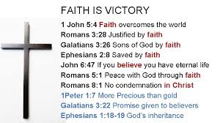
This month, as we celebrate the reformation, we celebrate that we are saved by Grace alone. We celebrate our faith and future in heaven because of Jesus. We celebrate the fact that we can worship and receive again God’s forgiveness and love. We come to worship to confess our sin. We repent. God declares to us again His love and forgiveness. As His people, we serve Him in thanksgiving and thanks-living as we share our faith and live out His love as we serve others by our good works. For Christians, a good work is done to the glory of God in thanksgiving for what God has done for us in Jesus. There are many people that do good works for the good of our communities and world. As Christians, what a joy to do good works to the glory of God and to share His love with us.

May God bless our celebration of the reformation!
In Christ,
Pastor Jeff Geske

Sunday Morning Bible Class
Please come and join our study of the Word of God!
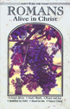
God’s Word of Today ~ Study of Romans
Each study in the God’s Word for Today series provides an in-depth exploration of a book of the Bible. Each session includes:
- background information on the book of the Bible, it’s author, audience, occasion, and purpose;
- learning experiences that promote exciting and challenging discussions;
- notes for leaders that answer questions, suggest a learning process, and provide additional information;
- discussion starters that help participants apply God’s Word to their daily lives. (13 sessions)
Romans summarizes well both a quarter century of Paul’s missionary preaching and teaching, and the essential emphases of his evangelical theology.
A Thank You to our Zion Lutheran Family
Bob and I want to thank all of you for the prayers and concerns while we had Covid. We are still learning the after effects from it. We especially want to thank Pastor Jeff for stepping up and helping bring Bob home from the hospital. We thank Jacob and Pastor for visiting Bob at the hospital through the window and for saying a prayer with Bob. It meant so much for him. For all the wonderful calls that Pastor Jeff has made and to listen during our time of recovery. You are a jewel and our guardian angel in this time. God bless you all! I am so glad to be in Christ care at Zion and our church family. Love, Bob and MaryJo

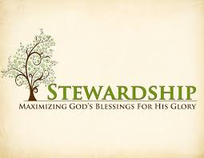
Newsletter Article – October2021
(--From the LCMS website)

Why do we give? Is it simply because God commands us to? Or is there more to it? To be sure, the Word and instruction of God in the Bible says we should give, and this is sufficient to encourage us to give (Luke 6:38; Acts 20:35; 1 Cor. 16:2; 2 Cor. 8:7; Gal. 6:6).

But there’s more to it than just obligation. We’re not just trying to fulfill a work of the law. We are bearing fruits of the Spirit given to us by our Father in heaven through His Son our Lord Jesus Christ. In other words, we’re not just doing what our Father said, we’re also doing what He did.

Children emulate their parents. When they grow up, they often carry many of the same mannerisms and characteristics as their parents. But there is more to it than that. Children copy their parents even on a more mundane level. They watch how their parents cross their legs, how they fold their hands, how they stand and sit and walk, and how they do and say most everything. Then children try to copy it.
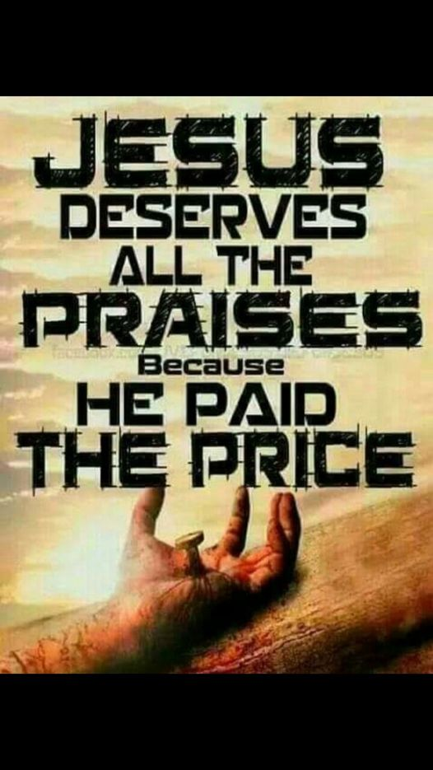
This can be quite humorous when caught in the act. They do this even when parents don’t want them to. Everyone has been in the uncomfortable – and embarrassing situation – where a child does or says something one of their parents have done or said that is less than polite. Sitcoms thrive on these. It only works because of the truth that children emulate their parents, and they do it because they want to be like them.

We are the children of God – by grace through faith. In Holy Baptism, God the Father declares of us what He declared of Jesus at His Baptism in the Jordan, “You are my beloved Son, in whom I am well pleased.” God the Father claims us as His own. He takes away all our sins. In exchange, He gives us His righteousness, His purity, His holiness, and His Spirit – by which we cry out, “Abba, Father.”

We are born again – born from above, born of water and the Spirit – to a new life in Christ as His children. We are sons of God in Christ through Baptism. Since we are sons, we are heirs who share in the glory of the Son of God. The inheritance is ours because of the Father’s grace, mercy, and generosity in sending His Son in time to save us for all eternity.

This is why we give generously of our income to the work of the church. We want to be like our heavenly Father. We want to emulate His generosity by being generous ourselves. We give to the work of the church because we have witnessed the generous giving of our Father in heaven.

More than that, we are recipients of it. It is because we have received our Father’s gifts that we desire to give ourselves. His gifts are not just spiritual. They are temporal and earthly as well. As Luther’s Small Catechism teaches in the Fourth Petition of the Lord’s Prayer:

Give us this day our daily bread.

What does this mean? God certainly gives daily bread to everyone without our prayers, even to all evil people, but we pray in this petition that God would lead us to realize this and to receive our daily bread with thanksgiving.

What is meant by daily bread? Daily bread includes everything that has to do with the support and needs of the body, such as food, drink, clothing, shoes, house, home, land, animals, money, goods, a devout husband or wife, devout children, devout workers, devout and faithful rulers, good government, good weather, peace, health, self-control, good reputation, good friends, faithful neighbors, and the like.

In other words, He gives us everything that we need for the care of both body and soul. His generosity knows no bounds.

Therefore, we sit down at the beginning of the year, the beginning of the month, or the beginning of the week and set aside a generous portion of God’s daily bread for His work in the church. This is not done because He has commanded us so to do but rather because we, as His children by grace, want to emulate His generosity in our own lives. He is our Father; we are His children. And children want to be like their parents.

WE BELIEVE, TEACH, AND CONFESS

From Luther’s Small Catechism ~
2. Where is God’s truth about our Savior Jesus Christ made known?
This truth is made known in the Bible: the Old Testament, which promises the coming Savior, and the New Testament, which tells of the Savior who has come.
6 Heb. 1:1–2 In the past God spoke to our forefathers through the prophets at many times and in various ways, but in these last days He has spoken to us by His Son.
7 Luke 24:27 Beginning with Moses and all the Prophets, He explained to them what was said in all the Scriptures concerning Himself.
8 John 20:31 These are written that you may believe that Jesus is the Christ, the Son of God, and that by believing you may have life in His name.
9 Eph. 2:20 [You are] built on the foundation of the apostles and prophets, with Christ Jesus Himself as the chief cornerstone.
10 1 John 1:1 That which was from the beginning, which we have heard, which we have seen with our eyes, which we have looked at and our hands have touched—this we proclaim concerning the Word of life.
QUESTION: Could you please tell me why a person should join a congregation? Couldn’t they just go to the church, give a little here and there, and do the things a member does without joining? What benefits would I have by joining a church?
ANSWER: Joining a church says to the public you are a Christian and that you are a member of God's own people, who are called "a chosen race, a royal priesthood, a holy nation" (1 Peter 2:9).
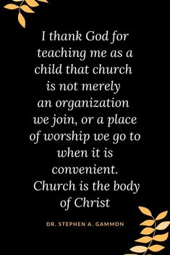
It says you believe and act thus and thus as a witness to the Christian faith and as an example to others. It means you are doing what the very first Christians did in joining to devote themselves to the apostles' teaching and to the fellowship, to the breaking of bread, and to prayer (Acts 2:42).
It means you will be able to receive the encouragement, strength, prayers, Baptism, the Lord's Supper and the application of God's Word from fellow Christians and a pastor, which you may not have the privilege of receiving as a non-member.
It will tell other Christians and the world you have considered it a serious matter to be able to join together with Christians to support the work of the church of calling a pastor, providing instruction in the Christian faith for the youth, adults, the older set, doing evangelism and mission work at home and abroad.
It would not only witness to other people who you are and what you are about, but it would show God what He wants of His groups of His chosen, His own people — that you are not just talking about and maybe doing half-heartedly but are involved whole-heartedly in doing what He expects.
Joining a congregation is a serious declaration you intend — with His help — to participate fully in doing the things of God. In most congregations, only members who have joined receive the Lord's Supper, have the privilege of voting, obtain recognition by the government for tax purposes, and have full use of the church and other amenities.
What would happen to God's church if everyone decided not to join with other Christians to BE His own people? (--lcms.org)
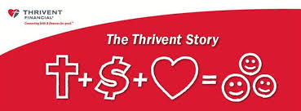
What is a Thrivent Action Team? Thrivent Action Teams make it easy to live generously. Thrivent provides promotional resources and seed money to jump-start your fundraiser, educational event or service project. Your team provides the people power to bring it to life.

THRIVENT NEWS . . .
If you would like more information about Thrivent, its products, or its fraternal functions, please contact our area representative Greg Durivage in Maumee, OH at (419)-740-4193.

BIRTHDAYS AND ANNIVERSARIES
We would like to wish Happy Birthday and Happy Anniversary to the following individuals who are celebrating this month. If you are not listed or you know someone not listed, please contact Sandy Brady or Pastor Jeff.
Flowers on the Altar ~ If you would like to place flowers, please sign up in the hallway by the restroom.
The cost is $25.00
Please consider signing up for some time this year.

October Birthdays

1 ~ Patti Vaughan
2 ~ Ron Clark
3 ~ Gene Weimer
5 ~ Bob Decator
8 ~ Susan Gaylord
16 ~ Karen Schmidt
21 ~ Nick Baumgartner
29 ~ John Castell
30 ~ Sandy Brady
31 ~ Austin Castell
We wish the following couples a very Happy Anniversary!
2 ~ Dwight and MaryJo Gilliland
17~ Ray and Karen Schmidt

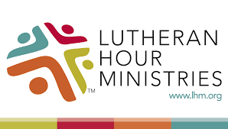
Bringing Christ to the Nations and the Nations to the Church
"The Lutheran Hour," which began in 1930, is now heard on more than 1,300 radio stations around the world. "The Lutheran Hour," hosted by Dr. Rev. Michael Zeigler, is the world's oldest continually-broadcast Gospel radio program. This weekly half-hour program proclaims the message of Jesus Christ to all people and serves as a bridge, linking them to the Church. Listen to the Lutheran Hour on Sundays at 10:00 a.m. or at AM 1560 WWYC or anytime at www.lhm.org
October 2021

October 3
"Approval Cannot Equal Love"
Speaker: Rev. Dr. Michael Zeigler
God places Christians in neighborhoods, among neighbors who don't necessarily share their beliefs. How should they relate? Dr. Michael Zeigler talks about avoiding the pitfalls of isolation and approval.
(1 Corinthians 10:23-11:1)
October 10
"Giving God Our Garbage"
Guest Speaker: Dr. Harold Ristau
Everything belongs to God and there isn't anything anyone could possibly give Him that He doesn't already have. And yet, there is one thing He desires: our garbage—our sins, our shame, our guilt—that He might put it all on Jesus.
(1 Samuel 2:1-10)
October 17
"Dead Man, Walking"
Speaker: Rev. Dr. Michael Zeigler
(1 Samuel 3:18)
October 24
"He will Take It"
Speaker: Rev. Dr. Michael Zeigler
(1 Samuel 15)
October 31
"TBD"
Guest Speaker: Rev. Dr. Dale A. Meyer

COUNCIL MEETING SEPTEMBER 20, 2021
Member Present: Pastor Jeff, Ron Vincent, Connie Sieler, Sheila Vincent, Ron Clark, Dennis Reitzel and Lee Edington. Absent: Dwight Gilliland

Meeting was called to order by Ron Vincent @11:15. Pastor Jeff opened with a prayer.
Motion by Ron C. to dispense with reading of May’s minutes, 2Nd by Lee. Carried
Motion to accept May minutes made by Dennis and 2nd by Ron C. Motion Carried
Pastor: Sunday School has started and Karen Volmer is the teacher. Bible studies is on going. Pastor visited shut-ins and connected with new members.
President: Ron was interested in Pastor either doing a Wednesday night service or put a short sermon and prayers on Facebook each week.
Treasurer: Dennis gave an update on finances and presented a statement from bank and a worksheet for the months of June, July and August . Motion made by Connie and 2nd by Sheila to accept treasurer report. Carried
Financial/Building: Ron reported that all bills are paid up to date. Our finances are stable at this time.
Secretary: Working German Dinner for October 9th.
Old Business: Ramp needs to be sanded and stain before winter. Garage doors and storms doors are done, the parsonage is complete is all repairs. Ron V. is looking into the expense for redoing the parking lot in a couple of years.
New Business: 1. Pastor will be on vacation November 25th thru 29th. Ron, Lee and Dwight will do service in Pastor absent.
2. German Dinner on October 9th
3. Hymnal Proposal: present to congregation for their own purchase and/or do a fund raiser to purchase for the church. Council will call a Special Meeting on October 17th to discuss this with congregation. This will be only item discussed.
4. Budget Preparations: Council will have an extended meeting on October 24th to prepare budget to present to congregation at the December Congregation meeting.
5. Some of the basement windows need to be replaced and all need to be caulked. Ron and Dwight will get quotes on this project.
Connie made a motion to adjourn 2nd by Sheila at 12:25. Carried
Closed with Lord’s Prayer

Special Congregational Meeting to be held.

On October 17th after our worship service, we will have a special Congregational Meeting to discuss the purchase of new hymnals for our congregation’s worship. We ask you to please pray for this meeting and to plan to attend. The Church Council in their September meeting considered a proposal from Pastor Jeff to purchase new hymnals. It was agreed to bring the issue to the congregation for consideration. Pastor Jeff prepared a proposal as to why and how we could purchase the news hymnals even though we have and will continue to use the screen on Sundays.

Here is the proposal for our consideration.
Dear Zion Lutheran Council,

I would like to propose that we move forward with the purchase of new hymnals for the congregation’s worship. I would propose that this purchase would be accomplished through special hymnal donations.

I very much like that our services are projected on the wall. I believe that this enhances our worship and our singing as people are looking up and not down. I like the ability to use different hymns and songs. A draw-back is that there are not hymnals in the pews for people to follow along for the services. There is a rich learning opportunity for people to use a hymnal along with the services to continued to be projected on the wall. Other services that are not on a Sunday morning are a great opportunity to use just the hymnal.

I know that some believe that the Lutheran Book of Worship has been in the church for as long as it has and why not simply continue to use it. It was the put together by various Lutheran denominations and started in the 1960s. It took ten years to produce and was printed in 1978. I believe it greatly lacks in depth of liturgy and other helpful resources that the Lutheran Service Book (LSB) provides. I know we use the same Bible but on occasion people do upgrade Bibles, cars, and other items that we use because of features and other things that make them better or more useful for where we are at now.

The following paragraphs were written by a congregation that was planning to purchase the Lutheran Service Book for their congregation. I find these paragraphs especially helpful.

“Some of you remember a time when youth were given their very own hymnal at the time of their confirmation. This was due to the fact that hymnal is really a prayer book. Using a hymnal on Sunday mornings reminds us that it more than just a book sitting on a pew rack. The hymnal is filled with prayers, psalms, hymns, orders of service for various times of the day, the Small Catechism and more! Aside from the Bible and the Small Catechism, “nothing has done more through all generations to shape the faith of Lutheran Christians than the hymnal.”² Using the hymnal teaches us the value of its devotional use for our everyday lives.”
A Worship Friendly Hymnal
“The beautiful cover art of LSB proclaims the richness God's grace. Aside from its beauty, LSB is a masterfully composed hymnal for use in worship. One of the goals of the LSB committee was to make this hymnal extremely easy to use for both congregants and visitors. Rather than having two sets of page numbers (liturgy pages and hymn numbers) and some numbers at the top and others at the bottom, LSB has one set of numbers that are all at the top of the page. On the back interleaf are printed the Nicene and Apostles' Creeds as well as the Lord's Prayer. If one needs to reference these in worship, they can simply open the back interleaf to find them. Prayers for worship are printed in the front interleaf to aid worship. Unlike TLH or LW, a glossary of terms is provided in front. Various words or phrases such as “Nunc Dimittis,” “Chrism” or “I raise my Ebenezer” are defined throughout the liturgies and hymns (cf. LSB 165, 502, 686). Bible references are also provided throughout. Artwork, prayers and Bible verses are used to fill in blank spaces. Even the type-face was carefully chosen for easy reading.”
A Musically Friendly Hymnal
“Over 100 new and recent Christ-centered and biblically based hymns are included with the 636 hymns in LSB. New and old hymn words and musical settings were carefully examined. On various occasions both were changed or restored to aid easier singing. In some cases keys were adjusted or lowered for the same reason. LSB includes hymns from countries around the world, including Kenya, Tanzania, Argentina and the Caribbean, to name a few. The breadth of the church's song spans from chant in the early centuries of the Christian era, to the chorales of the Lutheran Reformation, to the numerous waves of English hymnody, to American folk hymns, all the way down to contemporary hymns. The church today learns from the church's song both past and present. LSB provides plenty of services and hymns that are familiar, while at the same time providing a wealth of wonderful new materials to enliven our worship for years to come.” (From St. John Lutheran Church Fort Collins, CO.)

Currently we are already using several items of Lutheran Service Book. We use the hymns and some liturgy. To project and use these resources, we also have liturgy and hymns licensing. Joseph currently uses the hymn and liturgy accompaniment books for playing. There is not a liturgy license nor any other available resources for the Lutheran Book of Worship (Green hymnal) It is available for the new Evangelical Lutheran Worship. Since we are LCMC, we do not have a publishing company to produce a hymnal for our association of Lutheran congregations. We simply use what we find is best for our congregations.

Again, I would propose the Council move forward with this purchase and ask the members of the congregation for their support as they could purchase a hymnal(s) in memory of loved one and could also purchase a hymnal for their own personal use.

Some of the cost would include:
Hymnals at $26.99 (We have 21 pews that would fit 4 in each pew) If we buy for each pew that would cost $2,267.16.
Altar Book $75.99 Other resources are available to support the use of the Lutheran Service Book, but are not needed at this time.
Thank you for your prayerful consideration of this request.
In Christ,
Pastor Jeff

