The Messenger
A newsletter of Zion Lutheran Church ~ Ottawa Lake, MI
November 2021
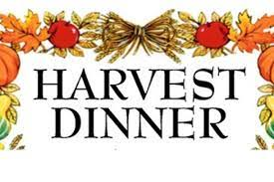
+ + + + + + + + + +
Join Us for our Harvest Dinner
Join us for dinner on November 14 at 11:45 a.m. Please plan to attend. We will have our meal after church with the turkey and the fixings. If you can help in anyway or can plan to attend, please sign up in the Fellowship Hall or contact Connie Sieler.
We are looking forward to a fun time together.
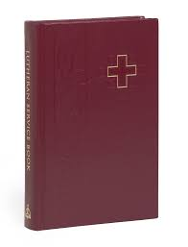
New Hymnals for our worship
The congregation has approved the purchase of new hymnals. We are receiving donations now through November 21. Each hymnal costs $27. Our goal will be about $3200. You can make a donation or give an amount to buy hymnals. You can also purchase a hymnal to have for your personal use. Orders forms are available on the table in the hallway.

New Online Church Directory
We have begun a new family and friends directory for our congregation. Please note the page in this newsletter with all the details. Please have your picture taken at church or send Pastor Jeff a copy of a picture of your family. The church will need your email address so you can view the directory online. We are planning to have printed copies available by November 21. For more information, please speak to Pastor Jeff.

Lutheran Men ~Monthly Breakfast
On November 13, 2021, we will have our Lutheran Men Monthly breakfast. Breakfast will be served at 8:00 a.m. We will have a hot breakfast, devotion, and a Bible study. Please come and feel free to invite a friend or neighbor.
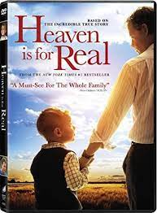
Movie Night
We will have a Movie Night on November 19, 2021. We will meet at 6:30 for a light supper and then will watch a movie. The movie that we will watch is called, “Heaven is for Real.” If you have not seen this movie, it will be one that you don’t want to miss.
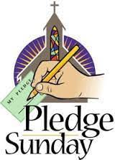
Stewardship Pledge Sunday
We will have Pledge Sunday on Sunday, November 21. The pledge forms will be available on the table. They will be presented on Pledge Sunday. Throughout the year we will pray for those that bring their offerings and tithes to the work of God’s kingdom.

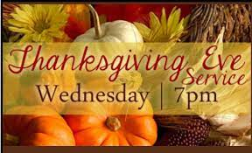
Thanksgiving Eve Service
Join us for worship on Wednesday, November 24, 2021 at 7:00 p.m. This worship service will have celebration of the Lord’s Supper.

Zion Lutheran Church Council
We will have our monthly Church Council Meeting after church on November 21, 2021.

Women of Zion
There will be a meeting on November 22, 2021 at 2 p.m. We will have a meeting and a Bible study on the book of Revelations. All Women are invited and encouraged to attend.

WORSHIP WITH US EACH WEEK!
Join us for worship on Saturday at 4:00 p.m. and
Sunday morning at 10:00 a.m.

Sunday Morning Bible Study
Please plan to join us at 9:00 a.m. Sunday School at 9:15 a.m.
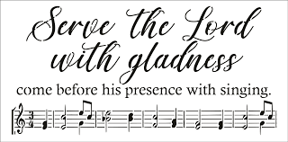
Zion Church Choir
Zion's choir is led by Joseph Extegt. All are welcome to join in. Practice is usually held after Sunday worship service. They practice after church in the choir room in the basement. For more information, please speak with Joseph Extejt.
HANDBELL CHOIR ~ It is time to make a joyful noise to the Lord. Come join the bell choir. They practice on Saturdays at 3:00 P.M. for 45 minutes. Don’t know how? Happy to teach you. Come join the fun! Let’s make music together!
For more information, please speak to Karen Vollmer.
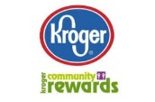
Community Rewards Program
Do you shop at Kroger? If you do, you can sign up for their Community Rewards Program and Kroger will give back to Zion money every quarter. Go on Kroger's website and sign up under Community Rewards. If you need help or do not have an email address, check with Pastor Jeff. (Our code is NC512)

Steps for Linking your Kroger card to help our ministry ~
1. Sign into your account at www.kroger.com or create an account.
2. Click on the NAME.
3. Scroll down to MY ACCOUNT and Click on it,
4. Scroll down to COMMUNITY REWARDS. Click on COMMUNITY REWARDS.
5. Enter Zion Lutheran Church Ottawa Lake MI (NC512)

Food Bank~ Thank you for your generous help with our Food Bank. If you have any questions or would like to help in any way, please contact Rick Keck at (734) 854-4710. The Food Bank serves families and individuals on the second and fourth Tuesday of the month from 10:00 a.m. until noon.
To Join our Text alerts visit: Text the message @jgesk to the number 81010. If you’re having trouble with 81010, try texting @jgesk to (517) 682-0429. This is a free service ~ You are only charged if your cellphone charges per text

ZION Lutheran Church
LCMC ~ Lutheran congregations in mission for Christ
8307 Memorial Hwy. Ottawa Lake, MI 49267 ·
(734) 856-2921
Pastor ∙ Jeffrey Geske
(785) 340-5635
zlcolmpastor@gmail.com
www.zionlutheranottawalakemi.com

Secretary ~ Sandy brady
(419) 410-9380
skwiles2000@gmail.com
custodian and organist~ Joseph extejt

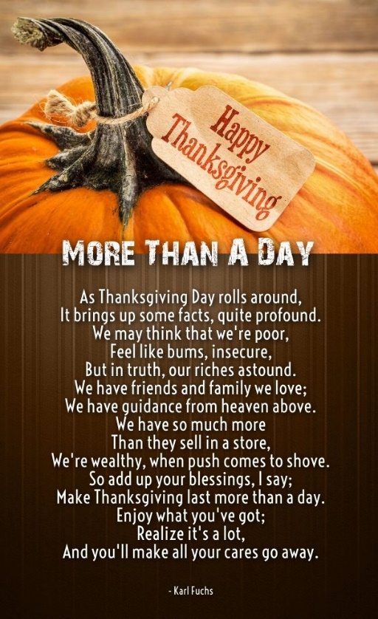
For Your Information
The following members give of their time to the leadership of this congregation. Please keep them in your prayers. If you have any questions, comments, or offers of help, please contact them.
Chairman: Ron Vincent
Secretary: Connie Sieler
Treasurer: Dennis Reitzel
Financial: Ron Clark
Recording Secretary: Sheila Vincent
Elders: Lee Edington
Deacons: Dwight Gilliland

Committees:
Trust Fund: Connie Sieler, Alan Ahleman, Delores Ostrander, Sandy Brady, and Gilbert Olrich

LCMC ~ WHO WE ARE
Free in Christ + Accountable to One Another + Rooted in Scripture and the Lutheran Confessions + Committed to the Great Commission

Prayers Are Important
If you have an occasion to request a prayer, please call the church office. If you would like your request to be on our prayer chain, please call Sandy Brady (419) 410-9380 or Pastor Jeff at the church or on his cell phone (785)340-5635.
Please Inform the Church Office. . .
*when a member of your family is ill or hospitalized or if they are discharged or moved to another facility.
*when your address changes.
*when a new baby arrives.
*when a family member marries or leaves home for college, or military.
*when planning a wedding to be conducted at Zion.
*when a new family moves into your neighborhood.
*when you are planning to be out of town.
*when a brother or sister in Christ needs a visit from Pastor.
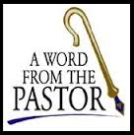
From the desk of Pastor Geske….

The Work of the Church ~ Sharing the Love of Jesus!

Greetings in the name of Christ. For my articles in the newsletter, you will have noticed that I am writing on the articles found in the Augsburg Confession. This Confession was written and presented in 1530 to Emperor of the Roman Empire. I like these words from a website that said, “The Augsburg Confession is comprised twenty-eight articles. Of these articles, twenty-one represent a positive presentation of the Christian faith as taught in the Lutheran Churches while the last seven article cover suggested reforms of certain practices of the medieval Church. Although the ultimate aim of the Augsburg Confession was to summarize the main teachings of the Bible, Melanchthon also wished emphasize the ‘catholic’ (that is, meaning ‘universal,’ not ‘Roman Catholic’) nature of Lutheran teaching. Throughout the confession, Melanchthon quotes or makes reference to the theologians and councils of the ancient Church to demonstrate the Lutheran Church’s continuity with early Christian teaching.” (www.lutheranreformationa.org)
The article that I would like to briefly share is Article VII: Of the Church. The Augsburg Confession states, ‘1] Also they teach that one holy Church is to continue forever. The Church is the congregation of saints, in which the Gospel is rightly taught, and the Sacraments are rightly administered. 2] And to the true unity of the Church it is enough to agree concerning the doctrine of the Gospel and 3] the administration of the Sacraments. Nor is it necessary that human traditions, that is, rites or ceremonies, instituted by men, should be everywhere alike. 4] As Paul says: One faith, one Baptism, one God and Father of all, etc. Eph. 4, 5. 6. ‘ (--Augsburg Confession)
As we gather each time for worship, our focus is on the doctrine of the Gospel. We seek to understand the Gospel in terms of the Law and Gospel. The Law showing us our sin and the Gospel focusing on showing us our Savior. In preaching, teaching, and sharing the Word, it is necessary to understand both Law and Gospel. We preach God’s Word so that God can do His work in the hearts and lives of people. The Prophet Isaiah had this to say about God’s Word,
“As the rain and the snow come down from heaven, and do not return to it without watering the earth and making it bud and flourish, so that it yields seed for the Sower and bread for the eater, so is My word that goes out from My mouth: It will not return to Me empty, but will accomplish what I desire and achieve the purpose for which I sent it.” (Isaiah 55:10-11)
God’s purpose is that all be saved and come to the knowledge of the truth and to know Jesus Christ as Lord and Savior. During this month, we celebrate All Saints Sunday, and we recall those that have gone before us in the faith. We rejoice that those Christians that worshiped and served with us are now safely home in heaven. We rejoice in the fact that as they worshiped, they heard God’s love and God’s forgiveness, that they received through the Word of God and the Sacraments. God so loves each one of us and desires to have a relationship with all people. We get the opportunity to invite people into a relationship with Jesus. God has used our congregation for 160 years to proclaim His Word and to share His Sacraments.
May God bless us and continue to use us to reach our generation and the next generation with the Good News of Jesus. The Words of the Augsburg Confession were true for the 1500’s and true for us today. We pray that our families, our communities, and our world, would join in worshipping and celebrating with us in the blessings of God through His Word and His Sacraments. Yes, God uses us, our lips and our lives to tell about Jesus and to invite people on the journey toward heaven. May God bless the church on earth to continue to faithfully proclaim God’s love, and may all share with us in God’s forgiveness and His love through Jesus as we await His return to take us home.

In Christ,
Pastor Jeff Geske

Sunday Morning Bible Class
Please come and join our study of the Word of God!
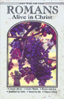
God’s Word of Today ~ Study of Romans
Each study in the God’s Word for Today series provides an in-depth exploration of a book of the Bible. Each session includes:
- background information on the book of the Bible, it’s author, audience, occasion, and purpose;
- learning experiences that promote exciting and challenging discussions;
- notes for leaders that answer questions, suggest a learning process, and provide additional information;
- discussion starters that help participants apply God’s Word to their daily lives. (13 sessions)
Romans summarizes well both a quarter century of Paul’s missionary preaching and teaching, and the essential emphases of his evangelical theology.
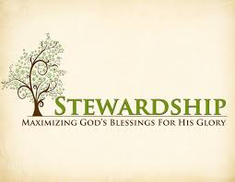
Newsletter Article – November2021
(--From the LCMS website)

Sometimes people don’t like it when pastors talk about stewardship. For some, it hits too close to home. It is easier to talk about bad people in Washington, in history, or wherever than it is to think about what our daily life in Christ is supposed to look like and how we are supposed to love our neighbor.
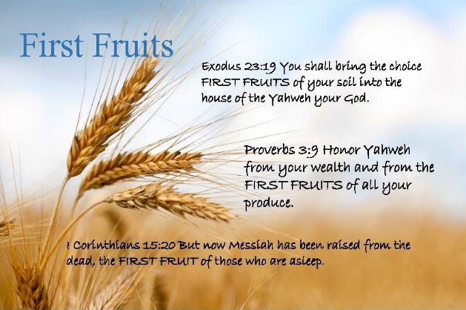
The fact that we don’t like it certainly means we ought to face it. So, here are a few simple and practical realities.
God calls us to first-fruits, sacrificial giving. That means that we should give off the top. We should set a percentage of our income as a deliberate gift for the work of the Church and then give that first. We write the check to the Lord’s work in the Church before we pay the mortgage or pay for our medicine or pay for anything else. We don’t pay for all the stuff we need – and stuff we think we need – and then give from what is left over. That is the first-fruits idea. It is hard because we think we need all sorts of other things first. But that is the point of “sacrificial.” Next, how could the starting point for Christian generosity and sacrifice really be anything less than a tithe – 10%? The ceremonial law of the Old Testament was never arbitrary. In the Old Testament, the Levites received this tithe so that they could be full-time ministers.
Does the New Testament have a ministry that is larger or smaller? It is far larger: “Make disciples of all nations” (Matt. 28:19). And we are still to have a full-time ministry: “The Lord has commanded that those who preach the Gospel should make their living from the Gospel” (1 Cor 9:14). So if 10% is what it took in the Old Testament, and we have a bigger mission need in the New Testament, how can we expect the Lord’s work to be done on less than a tithe?
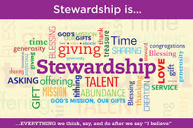
By first-fruits, sacrificial, and generous giving – that’s how. We shouldn’t fool ourselves into thinking that we’ve outgiven God’s goodness or that we’ve given plenty. We might be tempted to think that way, but consider that no one in the Church has given plenty because no one has given all. No one has died for his sins. Only the sinless Son of God did that.
St. Paul brought the Good News of Jesus into the discussion of our giving to support the Lord’s work in the Church when he wrote: “I say this not as a command, but to prove by the earnestness of others that your love also is genuine. For you know the grace of our Lord Jesus Christ, that though he was rich, yet for your sake he became poor, so that you by his poverty might become rich” (2 Cor. 8:8-9).
As you can see, what the Bible commands about our stewardship can sting. It’s Law, and the Law shows our sins. It calls us to repentance. The Law is meant to expose and accuse for the sake of showing us Christ and His fulfillment of the Law. So if first-fruits, sacrificial giving has you squirming, that’s the point.
In Mark’s account of the feeding of the 4,000, Jesus took the disciples’ seven loaves and blessed them. It was nothing among so many, but, of course, it was plenty. Jesus makes something from nothing. Mark doesn’t say that all the disciples gave Jesus all the bread they had. It is quite possible that some of them held something back. But even if they did, that didn’t stop Jesus from blessing them. Jesus makes something out of nothing. He, who fed His people in the desert with Manna every morning, doesn’t need their bread.
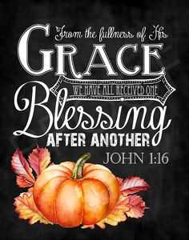
But they need to give it. And what they give – however little it might be and however grudgingly they do so – He blesses. He not only blesses those whom He feeds with it, but He blesses them – the givers. He blesses the givers not just in that they wind up with a basketful for each loaf, but they are blessed by learning to trust and rejoice in Him.
The Lord gives, and the Lord takes away. The Lord gives abundantly, or He asks us to fast. We do not know what will happen. Blessed be the Name of the Lord. He does all things well, and He works all things together for good. The disciples don’t give their bread to Jesus because it is a good investment. They give it because He is good, because they love Him, and because they trust Him. Let us go and do likewise.
WE BELIEVE, TEACH, AND CONFESS

From Luther’s Small Catechism ~
Q. 112. What do we owe our heavenly Father for all His goodness?
It is our duty to
A. “Thank and praise, serve and obey Him”;
374 Ps. 116:12 How can I repay the Lord for all His goodness to me?
375 Ps. 118:1 Give thanks to the Lord, for He is good; His love endures forever.
B. be good stewards of His creation.
376 Gen. 2:15 The Lord God took the man and put him in the Garden of Eden to work it and take care of it.
Note: We are good stewards when we avoid polluting air, land, and water; carefully dispose of waste; use rather than waste natural resources; conserve rather than waste energy; recycle or reuse materials whenever possible; and value and take care of all God’s creation.

What is a Thrivent Action Team? Thrivent Action Teams make it easy to live generously. Thrivent provides promotional resources and seed money to jump-start your fundraiser, educational event or service project. Your team provides the people power to bring it to life.

THRIVENT NEWS . . .
If you would like more information about Thrivent, its products, or its fraternal functions, please contact our area representative Greg Durivage in Maumee, OH at (419)-740-4193.

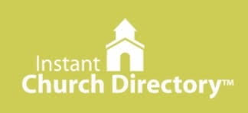
Our Church Directory is Online!
View our church directory online or via the FREE mobile app today.

To view the directory online, go to members.InstantChurchDirectory.com and follow the prompts under “Sign In” to “Create a login now.” Please remember, you must confirm your email address before you can sign in.

There is also a free mobile app available for download at the Apple® App store in iTunes®, Google Play™ store and the Amazon Fire App Store. Simply search for “Instant Church Directory” to get the download.

You will need to use your email address as listed in our directory to create a log-in the first time you use the directory online and via the mobile app.
Need help or have questions? Please contact ___Pastor Jeff____

BIRTHDAYS AND ANNIVERSARIES
We would like to wish Happy Birthday and Happy Anniversary to the following individuals who are celebrating this month. If you are not listed or you know someone not listed, please contact Sandy Brady or Pastor Jeff.
Flowers on the Altar ~ If you would like to place flowers, please sign up in the hallway by the restroom.
The cost is $25.00
Please consider signing up for some time this year.

November Birthdays

1 ~ Carol Decator
3 ~ Sam Schmidt
9 ~ Delores Ostrander
10 ~ Joel Castell
11 ~ Dick Vorbau
12 ~ Carol Alexander
22 ~ Hubert Holtz
29 ~ John Castell
29 ~ Candy Gorr
We wish the following couples a very Happy Anniversary!
11 ~ Lee and Barb Edington
14~ Dennis and Amy Reitzel

Bringing Christ to the Nations and the Nations to the Church
"The Lutheran Hour," which began in 1930, is now heard on more than 1,300 radio stations around the world. "The Lutheran Hour," hosted by Dr. Rev. Michael Zeigler, is the world's oldest continually-broadcast Gospel radio program. This weekly half-hour program proclaims the message of Jesus Christ to all people and serves as a bridge, linking them to the Church. Listen to the Lutheran Hour on Sundays at 10:00 a.m. or at AM 1560 WWYC or anytime at www.lhm.org
November 2021

November 7
"The Father of Solomon, by Uriah's Wife"
Speaker: Rev. Dr. Michael Zeigler
The story of David and Bathsheba is a scandalous tale of adultery, treachery, and murder—but it also shows God's undeserved mercy for David and for us.
(2 Samuel 12:13)
November 14
"Jesus Keeps Filling"
Speaker: Rev. Dr. Michael Zeigler
(2 Samuel 14:14)

November 21
"Between Now and Eternity Thee is Much To Do!"
Guest Speaker: Rev. Hector Hoppe
(Jude 1:20-25)
November 28
"TBD"
Speaker: Rev. Dr. Michael Zeigler

SPECIAL CONGREGATIONAL MEETING MINUTES
OCTOBER 17, 2021
Meeting called to order @11:10 by President Ron Vincent. This meeting was called concerning hymnals for purchasing new hymnals for the church. Twenty-three members were present.
Pastor gave the pro’s of switching to new hymnals. A discussion followed with all questions answered by Ron or Pastor.
A motion was made by Connie Sieler to purchase hymnals as gifts to the church or individually purchased without any cost to the church at the price of approximately $27.00 per hymnal, Mary Jo Gilliland 2nd. Motion carried.
This information will be posted in newsletter and bulletin with a donation sheet and all necessary information to purchase hymnal. All donations etc. will be collected by November 20th and the order will be placed.
Mary Jo Gilliland volunteered to purchase a new Altar Book. Thank you.
Sandy Brady made motion to adjourn and 2nd by Sheila Vincent.
Connie Sieler
COUNCIL MEETING OCTOBER 24, 2021

Member Present: Pastor Jeff, Ron Vincent, Connie Sieler, Sheila Vincent, Ron Clark, Dennis Reitzel, Dwight Gilliland and Lee Edington.
Meeting was called to order by Ron Vincent @11:15. Pastor Jeff opened with a prayer.
Motion by Ron C. to dispense with reading of September minutes, 2Nd by Lee. Carried
Motion to accept September minutes made by Lee and 2nd by Dennis. Motion Carried

Pastor: Visiting shut-ins, handing back tithe pledges on November 21st and can do again for 2022, men’s breakfast is well attended and would like to have a Harvest Dinner in November. Council agreed to dinner and it will be on November 14th and Connie will cook turkeys. Sign up sheets are in fellowship hall, it will be a potluck with turkey and gravy furnished.
Treasurer: Dennis gave an update on finances and presented a statement from bank and a worksheet for the month of June, July and August . Motion made by Connie and 2nd by Sheila to accept treasurer report. Carried
Financial/Building: Ron reported that all bills are paid up to date. Sealing and staining of the ramp is tabled till spring.
Old Business: Pastor will be on vacation November 25h thru 29th. Dwight, Ron and Lee will do the service on the 28th. Orders for the hymnal are due on November 21st. Next council meeting will be November 21st.
New Business: Budget Preparations: Council worked on budget to present to congregation in December. After much discussing, cutting items, adding and trying to prepare for the future Council came up with a budget that represents next year costs. Ron C. made a motion to recommend budget final figures to congregation and 2nd by Sheila. Carried
Congregation meeting will be on December 12th. A nominating committee is needed for December election of officers. Needed: Financial Secretary, Treasurer, Deacon (2) and Elder (2). Please contact Ron Vincent or council member if interested.
Connie made a motion to adjourn 2nd by Sheila at 12:45. Carried
Closed with Lord’s Prayer
Connie Sieler
Secretary
