The Messenger
A newsletter of Zion Lutheran Church ~ Ottawa Lake, MI
January 2022
+ + + + + + + + + +

Lutheran Men ~Monthly Breakfast
On January 8, 2022, we will have our Lutheran Men’s Monthly breakfast. Breakfast will be served at 8:00 a.m. We will have a hot breakfast, devotion, and a Bible study. Please come and feel free to invite a friend or neighbor. It would be great to see you there!

Installation of Officers
On January 9, 2022, we will install our congregational officers during our worship service. We thank those who are willing to serve and those that will be finishing serving for now. ~ Thank You!

Zion Lutheran Church Council
We will have our monthly Church Council Meeting after church on January 16, 2022.

We will begin to have a Movie Night on January 21, 2022. We will meet at 6:30 for a light supper and then will watch a movie. The movie that we will watch is called, “God’s Not Dead ~ We the People.” If you have not seen this movie, it will be one that you don’t want to miss.

Here is a little information about God’s Not Dead
The Rev. Dave Hill defends a group of Christian home-schooling families after they receive an impromptu inspection from a progressive, local government official who doesn't like what she finds. Taken aback by her interference, Dave travels to Washington, D.C., to testify in a landmark congressional hearing that will determine the future of religious freedom in our country for years to come.
WORSHIP WITH US EACH WEEK!
Join us for worship on Sunday morning at 10:00 a.m.
Our Saturday Contemporary Service will resume on March 12, 2022

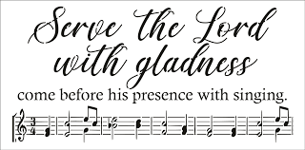
Zion Church Choir
If you love singing, please join our church choir. They meet after church in the choir room. For more information, please speak with Joseph Extejt.

Our handbell choir will take a break and begin practicing again in March. They will begin preparing for Easter.
They would love to have you join them.

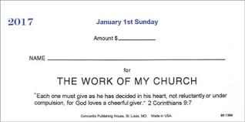
OFFERING ENVELOPES FOR 2022
Offering Envelopes are available for 2022. If you did not receive a box of envelopes for the New Year and want credit for your offerings for tax purposes in 2022, please contact Sandy Brady.

Community Rewards Program
Do you shop at Kroger? If you do, you can sign up for their Community Rewards Program and Kroger will give back to Zion money every quarter. Go on Kroger's website and sign up under Community Rewards. If you need help or do not have an email address, check with Pastor Jeff. (Our code is NC512)
Steps for Linking your Kroger card to help our ministry ~
1. Sign into your account at www.kroger.com or create an account.
2. Click on the NAME.
3. Scroll down to MY ACCOUNT and Click on it,
4. Scroll down to COMMUNITY REWARDS. Click on COMMUNITY REWARDS.
5. Enter Zion Lutheran Church Ottawa Lake MI (NC512)
To Join our Text alerts visit: Text the message @jgesk to the number 81010. If you’re having trouble with 81010, try texting @jgesk to (517) 682-0429. This is a free service ~ You are only charged if your cellphone charges per text

THANK YOU, MEMBERS AND FRIENDS OF ZION
*Thank you to all who decorated the church for Advent and Christmas
*Thank you to those who provided special music for Advent and Christmas.
*Thank you to all of you for attending the celebration of our Lord’s birth and for sharing with everyone that Jesus is the Savior of the world.
*Thank you to everyone for making the celebration of our Lord’s birth so special.

We would like to thank all of you for kindness and love that we received this Christmas. Your love and support are greatly appreciated! May God bless you!
Love in Christ,
Pastor Geske, Sandy Brady, and Joseph Extejt
ZION Lutheran Church
LCMC ~ Lutheran congregations in mission for Christ
8307 Memorial Hwy. Ottawa Lake, MI 49267 ·
(734) 856-2921
Pastor ∙ Jeffrey Geske
(785) 340-5635
zlcolmpastor@gmail.com
www.zionlutheranottawalakemi.com

Secretary ~ Sandy brady
(419) 410-9380
skwiles2000@gmail.com
custodian and organist~ Joseph extejt

For Your Information
The following members give of their time to the leadership of this congregation. Please keep them in your prayers. If you have any questions, comments, or offers of help, please contact them.
Chairman: Ron Vincent
Secretary: Connie Sieler
Treasurer: Brian Gilliland
Financial: Sandy Bondy
Elders: Ron Clark and Lee Edignton
Deacons: Dwight Gilliland and Jim Hredzak
LCMC ~ WHO WE ARE
Free in Christ + Accountable to One Another + Rooted in Scripture and the Lutheran Confessions + Committed to the Great Commission
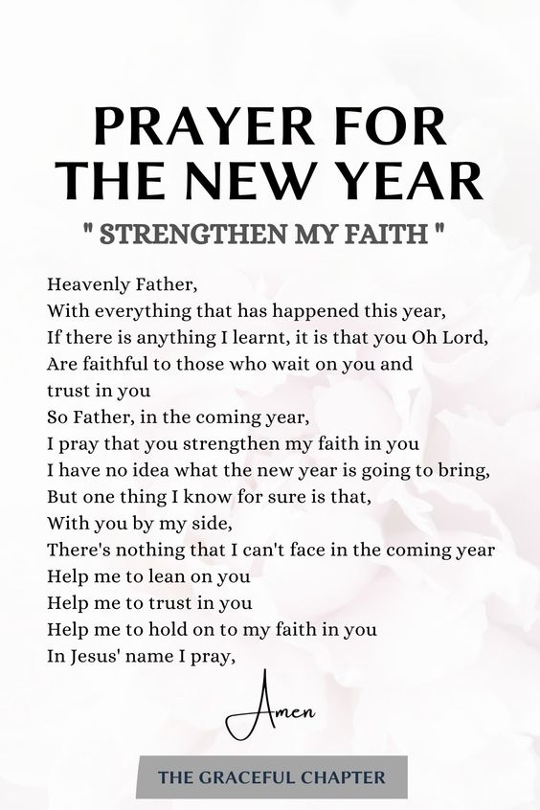
Prayers Are Important
If you have an occasion to request a prayer, please call the church office. If you would like your request to be on our prayer chain, please call Sandy Brady (419) 410-9380 or Pastor Jeff at the church or on his cell phone (785)340-5635.

Please Inform the Church Office. . .
*when a member of your family is ill or hospitalized or if they are discharged or moved to another facility.
*when your address changes.
*when a new baby arrives.
*when a family member marries or leaves home for college, or military.
*when planning a wedding to be conducted at Zion.
*when a new family moves into your neighborhood.
*when you are planning to be out of town.
*when a brother or sister in Christ needs a visit from Pastor.
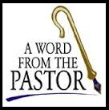
From the desk of Pastor Geske….
Greetings to you in the name of Christ! 2022 will be here soon or may be it is already here as you read this newsletter. 2022 will be another year to experience and to live the grace of our Lord and Savior Jesus Christ. I pray that as we serve our Lord in this new year, we would again commit ourselves to fulfilling the call of Christ and the mission of our church, which is to share the love of Jesus as we know Jesus and seek to make Him known. I ask you to join me in considering new ways that you can be involved at Zion.
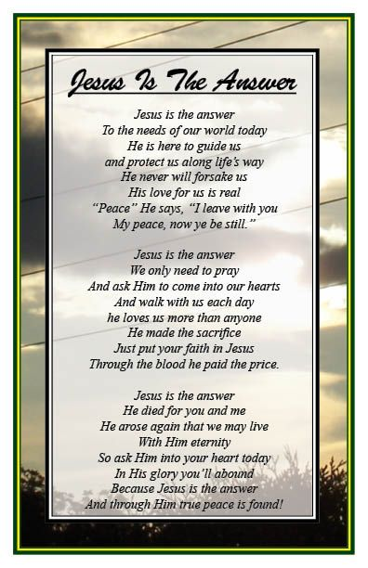
I am thankful to God that He has called me to serve as an under-shepherd of the Good Shepherd in the LCMC and this congregation. I know of churches around the country struggling for a variety of reasons, but I rejoice in the ministry that is happening here and I pray will continue to happen here at Zion. As Christians with a Lutheran understanding of the Gospel, I rejoice in the love and forgiveness that God gives through our worship and life together. We are all broken in our own way. We worship together to come and to be loved and encouraged by God and by one another. I pray that we can be that grace place for all people. I am thankful to be Lutheran and to share the Law and the Gospel of how God speaks to us in our brokenness and comforts us in His love and forgiveness. A Lutheran Church had these words that believe even speak of who we are as Christians with a Lutheran understanding of the Gospel. They said, “Being ‘Lutheran,’ our congregations accept and teach Bible-based teachings of Martin Luther that inspired the reformation of the Christian Church in the 16th century. The teaching of Luther and the reformers can be summarized in three short phrases: Grace alone, Faith alone, Scripture alone. Grace alone: God loves the people of the world, even though they are sinful, rebel against Him and do not deserve His love. He sent Jesus, His Son, to love the unlovable and save the ungodly. Faith alone: By His suffering and death as the substitute for all people of all time, Jesus purchased and won forgiveness and eternal life for them. Those who hear this Good News and believe it, have the eternal life that it offers. God creates faith in Christ and gives people forgiveness through Him. Scripture alone: The Bible is God's inerrant and infallible Word, in which He reveals His Law and His Gospel of salvation in Jesus Christ. It is the sole rule and norm for Christian doctrine.” (--LCMS.org)
As you begin this new year and focus on how you can be involved in our ministry together, I pray that you would live the message of grace alone, faith alone, and Scripture alone in your life as God’s child. What a joy to know as Christians that with Christ there is forgiveness, hope and the certainty of eternal life! That is the message that we seek to bring to all people. I look forward to seeing you faithfully worshipping and growing in God’s House.
In Christ,
Pastor Jeffrey Geske
Sunday Morning Bible Class
Please come and join our study of the Word of God!

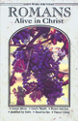
God’s Word for Today ~ Study of Romans
Each study in the God’s Word for Today series provides an in-depth exploration of a book of the Bible. Each session includes:
- background information on the book of the Bible, it’s author, audience, occasion, and purpose;
- learning experiences that promote exciting and challenging discussions;
- notes for leaders that answer questions, suggest a learning process, and provide additional information;
- discussion starters that help participants apply God’s Word to their daily lives. (13 sessions)
Romans summarizes well both a quarter century of Paul’s missionary preaching and teaching, and the essential emphases of his evangelical theology.
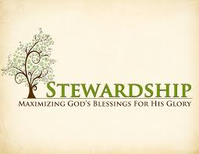
Newsletter Article – January 2022
(--From the LCMS website)

’Tis More Blessed to Give Than to Receive
“In all things I have shown you that by working hard in this way we must help the weak and remember the words of the Lord Jesus, how he himself said, ‘It is more blessed to give than to receive.’ ” (Acts 20:35)

And indeed, it is. Does this not strike a chord that resonates in us all? Which of us can’t recall the look of surprise and thanks for the Christmas gifts that we labored to give to those whom we love? And the joy written on their face when that gift is received with thanksgiving means more than all the gifts we have received. It is more blessed to give than to receive.

Our Lord knew this because He practiced it. He gave of Himself – sparing not even His life in death – in order to give us back to our Father in heaven. He knew that in giving you get more because joy is multiplied in giving. The one who receives and the one who gives both rejoice in what is given and received. And, what is more, the one who receives only wants to give back to the one who has given so generously in thanksgiving.

So it is with our tithes and offerings in church. We want to give because we have received from God all that we are and all that we have. Our giving does not originate in what we must do to earn God’s favor. We have God’s favor because of His gift of His Son, given through Word and Sacrament. Thus, we are made free from the compulsion of giving so that our tithes and offering are freely given in thanksgiving for what God has so generously given to us.

Why then does the church struggle to make budgets? Why does the church always seem stretched so thin when it is the place where God continually gives us His forgiveness of sins? Why does the church struggle when God, out of love for us, generously pours out His grace and mercy?

It is because we are sinners. Our fallen nature makes us selfish and miserly. It leads us to believe that we can have our cake and eat it, too. Because of sin, we want God’s grace and mercy; we want His blessings of body and soul. But we don’t want to share it with those around us. We want to remain comfortable in our own self-contained, neat, and tidy lives – without the headaches of loving those around us by helping them in their time of need.
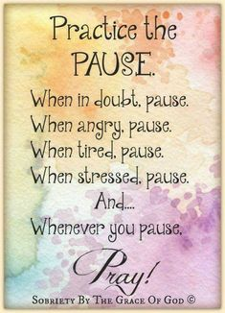
“Remember the words of the Lord Jesus, how he himself said, ‘It is more blessed to give than to receive.’ ” Remember that God has placed you in a church, not only to receive His grace and mercy, but to press His eternal and temporal blessings into service to your neighbor.

Your tithes and offerings ensure that those around you have a pastor to preach the life-saving and life-giving Word of God. They ensure that the lights, heat, and air-conditioning are working. They ensure there is water for Holy Baptism as well as bread and wine for Holy Communion. They even ensure that your pastor has food and clothing and presents for his own family. The gifts of God are immeasurable. They multiply and redound to everyone’s good as the fish and loaves in the feeding of the five thousand.

So, remember the words of the Lord Jesus: “It is more blessed to give than to receive.” And remember the joy that attended the gifts you gave at Christmas. This same joy attends your gifts to the church.

WE BELIEVE, TEACH, AND CONFESS

From Luther’s Small Catechism
117. What does it mean when you confess, “I believe in Jesus Christ”?
It means that I know and trust in Jesus Christ as my only Savior from sin, death, and the devil and believe that He gives me eternal life.
383 John 17:3 This is eternal life: that they may know You, the only true God, and Jesus Christ, whom You have sent.
384 John 3:36 Whoever believes in the Son has eternal life, but whoever rejects the Son will not see life, for God’s wrath remains on him.
385 2 Tim. 1:12 I know whom I have believed, and am convinced that He is able to guard what I have entrusted to Him for that day.
386 Rom. 10:10 It is with your heart that you believe and are justified, and it is with your mouth that you confess and are saved.

BIRTHDAYS AND ANNIVERSARIES
We would like to wish Happy Birthday and Happy Anniversary to the following individuals who are celebrating this month. If you are not listed or you know someone not listed, please contact Sandy Brady or Pastor Jeff.
Flowers on the Altar ~ If you would like to place flowers, please sign up in the hallway by the restroom.
The cost is $25.00
Please consider signing up for some time this coming year.

January Birthdays

5 Rabecca Castell
7 Ron Vincent
14 Dorothy Gaynier
14 Judy Nieman
21 John Rittner
22 Carmen Nesbit
28 Dick Vollmer
January Anniversaries
- Charlie and Kay Stewart
9 John and Rabecca Castell
21 Jon and Mary Dellabona
28 Melvin and Connie Sieler

Food Bank~ Thank you for your generous help with our Food Bank. If you have any question or would like to help in any way, please contact Rick Keck at (734) 854-4710. The Food Bank serves families and individuals on the second and fourth Tuesday of the month from 10:00 a.m. until noon.
What is a Thrivent Action Team? Thrivent Action Teams make it easy to live generously. Thrivent provides promotional resources and seed money to jump-start your fundraiser, educational event or service project. Your team provides the people power to bring it to life.

THRIVENT NEWS . . .
If you would like more information about Thrivent, its products, or its fraternal functions, please contact our area representative Greg Durivage in Maumee, OH at (419)-740-4193.

Our Church Directory is Online!
View our church directory online or via the FREE mobile app today. To view the directory online, go to members.InstantChurchDirectory.com and follow the prompts under “Sign In” to “Create a login now.” Please remember, you must confirm your email address before you can sign in. You will need to use your email address as listed in our directory to create a log-in the first time you use the directory online and via the mobile app.
Need help or have questions? Please contact Pastor Jeff.

Bringing Christ to the Nations and the Nations to the Church
"The Lutheran Hour," which began in 1930, is now heard on more than 1,300 radio stations around the world. "The Lutheran Hour," hosted by Dr. Rev. Michael Zeigler, is the world's oldest continually-broadcast Gospel radio program. This weekly half-hour program proclaims the message of Jesus Christ to all people and serves as a bridge, linking them to the Church. Listen to the Lutheran Hour on Sundays at 10:00 a.m. or at AM 1560 WWYC or anytime at www.lhm.org
JANUARY 2022
January 2
"Gospel Power for Personal Patience"
Lutheran Hour Speaker: Rev. Dr. Gregory Seltz
No one likes to wait! Hear God's promises for impatient people.
(Luke 2:40-52)
January 9
"Facing Rejection"
Speaker: Rev. Dr. Michael Zeigler
How does one deal with rejection? Push through it? Rise above it? Or start over?
(Luke 3:1-22)
January 16
"Hazed and Confused"
Speaker: Rev. Dr. Michael Zeigler
God is against our pride because He wants to give Himself to us.
(Luke 4:1-37)
January 23
"TBD"
Speaker: Rev. Dr. Michael Zeigler
January 30
"TBD"
Speaker: Rev. Dr. Michael Zeigler

January 17
"Lost in Wonder, Love, and Praise!"
Guest Speaker: Rev. Dr. Dale A. Meyer
The word of Jesus turns us out from ourselves and our problems to the faith, hope, and love that He brings.
(Mark 3)

January 24
"TBD"
Speaker: Rev. Dr. Michael Zeigler
January 31
"TBD"
Speaker: Rev. Dr. Michael Zeigler
COUNCIL MEETING DECEMBER 12, 2021

Member Present: Ron Vincent, Connie Sieler, Sheila Vincent, Ron Clark, Dwight Gilliland. Dennis Reitzel and Lee Edington.

Meeting was called to order by Ron Vincent @9:20.

Special Meeting called to discuss members not in church for one year.

Extension time for volunteer services pertaining to membership on Council.
Motion made by Connie to allow members of congregation (less than one year) to be allowed on Council. This isn’t setting a precedent and is temporary for one year only , 2nd by Ron Clark. Discussion held, we have many talented members and need to use their knowledge for the good of the church. Motion Carried.

Connie made a motion to adjourn 2nd by at Dennis @9:40 . Carried

Connie Sieler
Secretary

CONGREGATIONAL MEETING DECEMBER 12, 2021

Meeting was called to order by Ron Vincent @10:50 and Pastor Jeff open with a prayer.

Minutes from June 13th meeting were attached to agenda. Moment to review by congregation and Gilbert Olrich made motion to accept minutes and 2nd by Al Ahleman. Carried

Meeting skipped around the agenda for a special reason.

Treasurer: Dennis gave report on bank balance . Questions and answer period and motion made to accept Dennis report by Connie and 2nd by Al Ahleman. Dennis then presented the budget for 2022. Discussion and questions answered. Motion made by Sheila Vincent and 2nd by Melvin Sieler to approve Budget for 2022. Carried

Financial Secretary: Ron Clark gave a report on improvements to church and bills paid and bank balance.
There a still a few repairs that need to be done but we have the funds to continue improvements. A super thanks to congregation for supporting the church.

President: Ron Vincent gave a review of funds and so many improvements in the church and new members. A special thanks for fixing the leak in the boat!

Pastor: Pastor’s report is attached to Agenda: Pastor pointed out the hi-lites of report.

Deacon: Dwight gave thanks Brian Gilliland and Ron Clark for stepping up when Dwight wasn’t available.

Food Pantry: Rick Keck gave a report on families served this year and the financial balance for the year. His report is also attached to Agenda.

Connie Sieler
Secretary
