The Messenger
A newsletter of Zion Lutheran Church ~ Ottawa Lake, MI
February 2022
+ + + + + + + + + +

Lutheran Men ~Monthly Breakfast
On February 12, 2022, we will have our Lutheran Men’s Monthly breakfast. Breakfast will be served at 8:00 a.m. We will have a hot breakfast, devotion, and a Bible study. Please come and feel free to invite a friend or neighbor. It would be great to see you there!

Zion Lutheran Church Council
We will have our monthly Church Council Meeting after church on February 20, 2022.

We will have a Movie Night on February 25, 2022. We will meet at 6:30 for a light supper and then will watch a movie. The movie that we will watch is called, “Miracles of Heaven.” If you have not seen this movie, it will be one that you don’t want to miss.
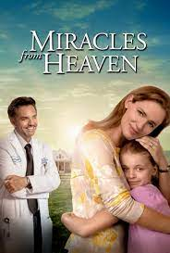
Here is a little information about Miracles of Heaven
Anna Beam (Kylie Rogers) lives with a rare, incurable disorder that leaves her unable to digest food. Despite the dire diagnosis, devoted mom Christy (Jennifer Garner) relentlessly searches for a way to save her beloved daughter. Everything changes in an instant when Anna tells an amazing story of a visit to heaven after surviving a headlong tumble into a tree. Her family and doctors become even more baffled when the young girl begins to show signs of recovering from her fatal condition.

WORSHIP WITH US EACH WEEK!
Join us for worship on Sunday morning at 10:00 a.m.
Our Saturday Contemporary Service will resume on March 12, 2022

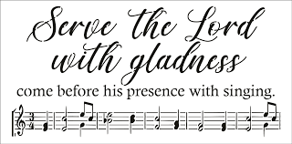
Zion Church Choir
If you love singing, please join our church choir. They meet after church in the choir room. For more information, please speak with Joseph Extejt.

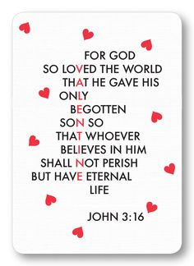
Our handbell choir will take a break and begin practicing again in March. They will begin preparing for Easter.
They would love to have you join them.

Community Rewards Program
Do you shop at Kroger? If you do, you can sign up for their Community Rewards Program and Kroger will give back to Zion money every quarter. Go on Kroger's website and sign up under Community Rewards. If you need help or do not have an email address, check with Pastor Jeff. (Our code is NC512)

Steps for Linking your Kroger card to help our ministry ~
1. Sign into your account at www.kroger.com or create an account.
2. Click on the NAME.
3. Scroll down to MY ACCOUNT and Click on it,
4. Scroll down to COMMUNITY REWARDS. Click on COMMUNITY REWARDS.
5. Enter Zion Lutheran Church Ottawa Lake MI (NC512)
To Join our Text alerts visit: Text the message @jgesk to the number 81010. If you’re having trouble with 81010, try texting @jgesk to (517) 682-0429. This is a free service ~ You are only charged if your cellphone charges per text

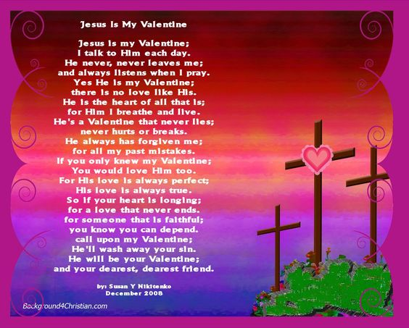
ZION Lutheran Church
LCMC ~ Lutheran congregations in mission for Christ
8307 Memorial Hwy. Ottawa Lake, MI 49267 ·
(734) 856-2921
Pastor ∙ Jeffrey Geske
(785) 340-5635
zlcolmpastor@gmail.com
www.zionlutheranottawalakemi.com

Secretary ~ Sandy brady
(419) 410-9380
skwiles2000@gmail.com
custodian and organist~ Joseph extejt

For Your Information
The following members give of their time to the leadership of this congregation. Please keep them in your prayers. If you have any questions, comments, or offers of help, please contact them.
Chairman: Ron Vincent
Secretary: Connie Sieler
Treasurer: Brian Gilliland
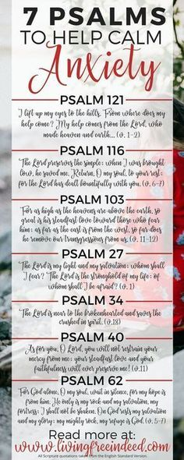
Financial: Sandy Bondy
Elders: Ron Clark and Lee Edignton
Deacons: Dwight Gilliland and Jim Hredzak
LCMC ~ WHO WE ARE
Free in Christ + Accountable to One Another + Rooted in Scripture and the Lutheran Confessions + Committed to the Great Commission

Prayers Are Important
If you have an occasion to request a prayer, please call the church office. If you would like your request to be on our prayer chain, please call Sandy Brady (419) 410-9380 or Pastor Jeff at the church or on his cell phone (785)340-5635.

Please Inform the Church Office. . .
*when a member of your family is ill or hospitalized or if they are discharged or moved to another facility.
*when your address changes.
*when a new baby arrives.
*when a family member marries or leaves home for college, or military.
*when planning a wedding to be conducted at Zion.
*when a new family moves into your neighborhood.
*when you are planning to be out of town.
*when a brother or sister in Christ needs a visit from Pastor.
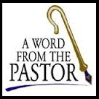
From the desk of Pastor Geske….
THE TWO PERSON CHALLENGE ~ SHARE YOUR FAITH

Greetings to you in the name of Christ! My prayer for each of you is that during this year, you will be intentional in sharing with others the joy of knowing Jesus as your Lord and Savior. I challenge you to daily find two people with whom you can share the hope that you have in Jesus Christ. Remember the words of Peter, “But in your hearts revere Christ as Lord. Always be prepared to give an answer to everyone who asks you to give the reason for the hope that you have.” (1 Peter 3:15 NIV) With all of life’s trials and challenges, it is easy to become focused on the problems of our everyday lives. We need to be reminded that Christ gives us the victory for eternity and that He gives us hope and help for each day. Sharing hope with two people is not a lot, but it is a start. Just think of how you could impact someone’s life with the joy of Jesus!
Christ has given us the command to witness. Jesus said, “Go into all the world and preach the gospel to all creation.” (Mark 16:15 NIV) With His command, He calls us to share His love and invite people to learn and grow in His love and forgiveness. I am reminded of the question in our catechism that asks, “What do the Scriptures teach about our life in the church?” (--LSC. Q. 179) Reflect on these four answers and some of the Bible passages that they quote:
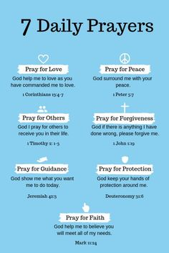
A. we should seek always to be and remain members of the invisible church, Christ’s body, by sincere faith in Christ, our Savior;
“I am the vine; you are the branches. If a man remains in Me and I in him, he will bear much fruit; apart from Me you can do nothing.” (John 15:5 NIV)
B. we should be faithful to that visible church, or denomination, which professes and teaches all of the Bible’s doctrine purely and administers the sacraments according to Christ’s institution;
“If you hold to My teaching, you are really My disciples. Then you will know the truth, and the truth will set you free.” (John 8:31–32 NIV)
“I appeal to you, brothers, in the name of our Lord Jesus Christ, that all of you agree with one another so that there may be no divisions among you and that you may be perfectly united in mind and thought.” (1 Cor. 1:10 NIV)
C. we should avoid false teachers, false churches, and all organizations that promote a religion that is contrary to God’s Word;
“The time will come when men will not put up with sound doctrine. Instead, to suit their own desires, they will gather around them a great number of teachers to say what their itching ears want to hear.” (2 Tim. 4:3 NIV)
D. we should maintain and extend God’s church by telling others about Jesus Christ, by personal service, and by prayer and financial support.
“You are a chosen people, a royal priesthood, a holy nation, a people belonging to God, that you may declare the praises of Him who called you out of darkness into His wonderful light.” (1 Peter 2:9 NIV)

It is our privilege and our opportunity to help those around us know the love and forgiveness of Jesus Christ. We work together to take this great message of the Savior’s story to the ends of the earth. Each day, be intentional about sharing God’s love for you with others. Indeed, I look forward to your faithful participation in God’s house here at Zion. May God bless you as you seek to share the love of Jesus!

In Christ,
Pastor Jeffrey D. Geske

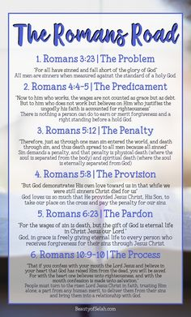
Sunday Morning Bible Class
Please come and join our study of the Word of God!

God’s Word for Today ~ Study of Romans
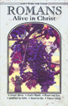
Each study in the God’s Word for Today series provides an in-depth exploration of a book of the Bible.
Each session includes:
- background information on the book of the Bible, it’s author, audience, occasion, and purpose;
- learning experiences that promote exciting and challenging discussions;
- notes for leaders that answer questions, suggest a learning process, and provide additional information;
- discussion starters that help participants apply God’s Word to their daily lives. (13 sessions)
Romans summarizes well both a quarter century of Paul’s missionary preaching and teaching, and the essential emphases of his evangelical theology.
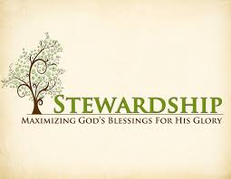
Newsletter Article – February2022
(--From the LCMS website)

God in Man Made Manifest

The season of Epiphany focuses on how God was made manifest in the flesh of Jesus. The church spends time hearing of the miracles, signs, and wonders of Jesus in the world. And this made plain to all that Jesus really is who He said He was. He is the Second Person of the Holy Trinity, the only begotten Son of the Father, in the flesh. For “the Word became flesh and dwelt among us” (John 1:14).

It is revealed for all the world to see that Jesus is God in the flesh. It is made manifest by His words and His work, by what He said and by what He did. And these belong together, for “the Word became flesh and dwelt among us.” Jesus is the Word and will of God in the flesh, that is, He is the walking, talking enactment of God’s Word.

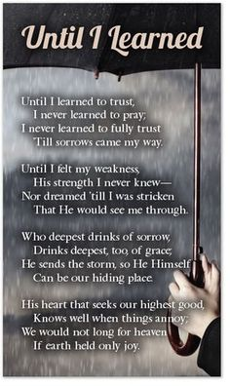
It is no different for us. We are called not just to believe in God in hearts but also to trust in God in word and deed. As James wrote: “But be doers of the word, and not hearers only, deceiving yourselves” (James 1:22), and again, “What good is it, my brothers, if someone says he has faith but does not have works? … So also faith by itself, if it does not have works, is dead. … Show me your faith apart from your works, and I will show you my faith by my works. … For as the body apart from the spirit is dead, so also faith apart from works is dead” (James 2:14, 17–18, 26).

Our faith is lived out in works for our neighbor. Our trust in the Word and will of God is lived out not in word only but also in deed and in truth. In other words, the Epiphany of the Lord creates in us an epiphany of our faith in our works of obedience to God who commanded them. By this, our faith is made manifest to the world. It is, as Luther wrote of faith:

Faith is a divine work in us. It changes us and makes us to be born anew of God (John 1). It kills the old Adam and makes altogether different people, in heart and spirit and mind and powers, and it brings with it the Holy Spirit.

Oh, it is a living, busy, active, mighty thing, this faith. And so it is impossible for it not to do good works incessantly. It does not ask whether there are good works to do, but before the question rises, it has already done them, and is always at the doing of them.

He who does not these works is a faithless man. He gropes and looks about after faith and good works and knows neither what faith is nor what good works are, though he talks and talks, with many words about faith and good works.

Faith is a living, daring confidence in God’s grace, so sure and certain that a man would stake his life on it a thousand times. This confidence in God’s grace and knowledge of it makes men glad and bold and happy in dealing with God and all His creatures. And this is the work of the Holy Spirit in faith. Hence a man is ready and glad, without compulsion, to do good to everyone, to serve everyone, to suffer everything, in love and praise to God, who has shown him this grace.

And thus it is impossible to separate works from faith, quite as impossible as to separate burning and shining from fire. Beware, therefore, of your own false notions and of the idle talkers, who would be wise enough to make decisions about faith and good works, and yet are the greatest fools. (Preface to the Book of Romans)

So, then, let our faith be active by God’s power in the Word through the Holy Spirit. And let then our faith be made manifest to the world by what this faith does: serving our neighbor – in church, in the family, and society – with the works of faith in time, talents, and treasures.

BIRTHDAYS AND ANNIVERSARIES
We would like to wish Happy Birthday and Happy Anniversary to the following individuals who are celebrating this month. If you are not listed or you know someone not listed, please contact Sandy Brady or Pastor Jeff.
Flowers on the Altar ~ If you would like to place flowers, please sign up in the hallway by the restroom.
The cost is $25.00
Please consider signing up for some time this coming year.

February Birthdays

5 Mark Sorenson
6 Amy Reitzel
14 Russel Bieber
18 Melvin Sieler
21 Lee Edington
27 JoAnn VanSteenkiste
28 Brenda Blum
February Anniversaries
We are unaware of any anniversaries for February.

Food Bank~ Thank you for your generous help with our Food Bank. If you have any question or would like to help in any way, please contact Rick Keck at (734) 854-4710. The Food Bank serves families and individuals on the second and fourth Tuesday of the month from 10:00 a.m. until noon.
What is a Thrivent Action Team? Thrivent Action Teams make it easy to live generously. Thrivent provides promotional resources and seed money to jump-start your fundraiser, educational event or service project. Your team provides the people power to bring it to life.

It’ Time!!! Direct Your Choice Dollars!

If you’re a Thrivent Financial member, you may be eligible to participate in Thrivent Choice® and recommend where some of Thrivent Financial’s 2021 charitable outreach funds go. The deadline to direct Choice Dollars® is March 31!

Here’s what to do:
- Call 1-800-THRIVENT or visit the Thrivent Financial website to find out if you have Dollars you are eligible to direct.
- To direct Choice Dollars® to Zion Lutheran Church. you can do so online or over the phone – but you must direct Choice Dollars® by March 31st!

THRIVENT NEWS . . .
If you would like more information about Thrivent, its products, or its fraternal functions, please contact our area representative Greg Durivage in Maumee, OH at (419)-740-4193.

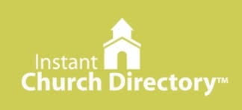
Our Church Directory is Online!
View our church directory online or via the FREE mobile app today. To view the directory online, go to members.InstantChurchDirectory.com and follow the prompts under “Sign In” to “Create a login now.” Please remember, you must confirm your email address before you can sign in. You will need to use your email address as listed in our directory to create a log-in the first time you use the directory online and via the mobile app.
Need help or have questions? Please contact Pastor Jeff.

Bringing Christ to the Nations and the Nations to the Church
"The Lutheran Hour," which began in 1930, is now heard on more than 1,300 radio stations around the world. "The Lutheran Hour," hosted by Dr. Rev. Michael Zeigler, is the world's oldest continually-broadcast Gospel radio program. This weekly half-hour program proclaims the message of Jesus Christ to all people and serves as a bridge, linking them to the Church. Listen to the Lutheran Hour on Sundays at 10:00 a.m. or at AM 1560 WWYC or anytime at www.lhm.org

