The Messenger
A newsletter of Zion Lutheran Church ~ Ottawa Lake, MI
April 2022
+ + + + + + + + + +

Celebrate the Death and Resurrection of our
Lord and Savior, Jesus Christ!

April 10 – Palm Sunday ~ Celebrating the Triumphant Entry of Jesus into Jerusalem.

April 14 – Maundy Thursday ~ 7:00 p.m. with Communion ~ Celebrating the Institution of the Lord’s Supper and the new command Jesus gave to love one another.

April 15 – Good Friday ~ 7:00 p.m. ~ Remembering the suffering and death of Jesus for our sin and our salvation.

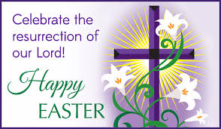
April 17– Easter Sunday ~ Celebrating the Triumphant Resurrection of Jesus!
Sunrise Service ~ 7:00 a.m.
Easter Breakfast ~ 8:15 a.m.
Celebration Sunrise Service
~ 10:00 a.m.
+ + + + + + + + +

Our Lenten Journey Continues

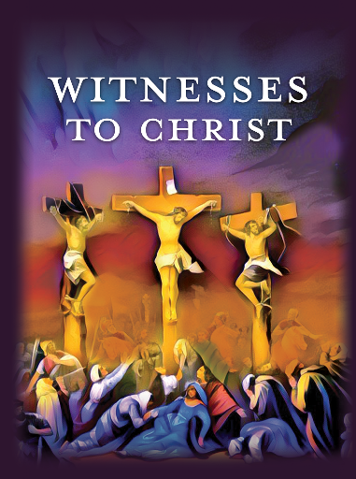
Witnesses to Christ: People from His Passion
John tells us why he wrote his Gospel: “Jesus did many other signs in the presence of the disciples, which are not written in this book; but these are written so that you may believe that Jesus is the Christ, the Son of God, and that by believing you may have life in His name” (John 20:30–31). Life! When we believe that Jesus is the Christ, God gives us life—abundant life, forgiven life, and eternal life.
Historically, the Fourth Gospel is likened to an eagle—an image that suggests John soars to heights of glory and grandeur. That’s because the evangelist paints a stunning portrait of Jesus, who is the bread of life, the resurrection and the life, and the way, the truth, and the life. Life in Jesus. That’s God’s gift to you!
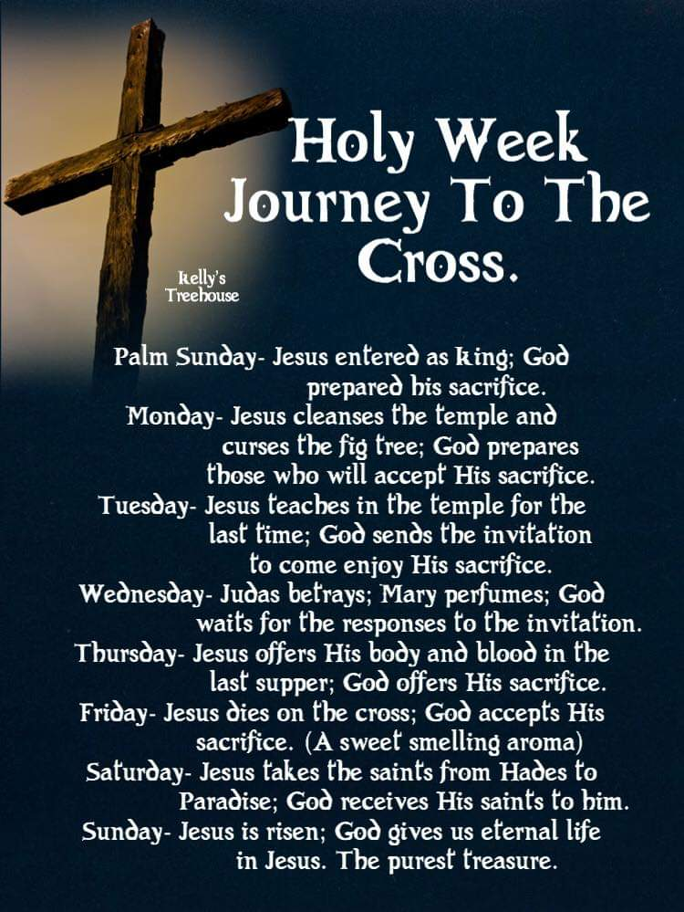
This Lent, our life in Christ will be strengthened as we hear the witness of those in John’s Gospel who journeyed to the cross. Along the way, we’ll meet villains, such as Barabbas and Pontius Pilate, as well as sinners, such as Peter (who denied Jesus three times), Mary Magdalene (who was possessed by seven demons), and Judas Iscariot (who betrayed Jesus for thirty pieces of silver).
Please join us for worship as we hear the witness of these people in John’s Gospel:
April 6 ~ Midweek of Lent 5: Pontius Pilate, John 19:1–16
April 14 ~ Maundy (Holy) Thursday: Judas Iscariot, John 13:21–30
April 15 ~ Good Friday: John, the Gospel Writer, John 19:25–37
April 17 ~ Easter Sunrise Service: Nicodemus, John 19:38–42
The Resurrection of Our Lord: Mary Magdalene, John 20:1–18

Please Join Us on April 6th for our Lenten Journey and join us for our Holy Week services.

Lutheran Men ~Monthly Breakfast
On April 9, 2022, we will have our Lutheran Men’s Monthly breakfast. Breakfast will be served at 8:00 a.m. We will have a hot breakfast, devotion, and a Bible study. Please come and feel free to invite a friend or neighbor. It would be great to see you there!

Zion Lutheran Church Council
We will have our monthly Church Council Meeting after church on April 24, 2022.

Women of Zion
Women of Zion will have their next monthly meeting on April 25th at 2:00 p.m.

Join Us for Movie Night ~ We will have our next movie night on Thursday, April 28, 2021. We will meet at 6:30 for a light supper and then will watch a movie. The movie that we will watch is called, “Risen.” If you have not seen this movie, it will be one that you don’t want to miss.

Here is a little information about “Risen”
"Risen" is the epic Biblical story of the Resurrection, as told through the eyes of a non-believer. Clavius (Joseph Fiennes), a powerful Roman Military Tribune, and his aide Lucius (Tom Felton), are tasked with solving the mystery of what happened to Jesus in the weeks following the crucifixion, in order to disprove the rumors of a risen Messiah and prevent an uprising in Jerusalem.

WORSHIP WITH US EACH WEEK!
Join us for worship on Sunday morning at 10:00 a.m.
Our Contemporary Service is on Saturday at 4:00 p.m.

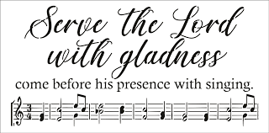
Zion Church Choir
If you love singing, please join our church choir. They meet after church in the choir room. For more information, please speak with Joseph Extejt.

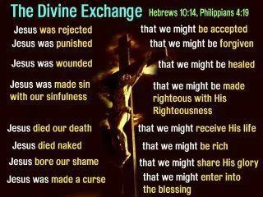
Our handbell choir meets on Saturdays at 3:00 p.m. They are practicing for Lent and Easter and playing in May. They would love to have you join them. For more information, please speak to Karen Vollmer.

ZION Lutheran Church
LCMC ~ Lutheran congregations in mission for Christ
8307 Memorial Hwy. Ottawa Lake, MI 49267 ·
(734) 856-2921
Pastor ∙ Jeffrey Geske
(785) 340-5635
zlcolmpastor@gmail.com
www.zionlutheranottawalakemi.com

Secretary ~ Sandy brady
(419) 410-9380
skwiles2000@gmail.com
custodian and organist~ Joseph extejt

For Your Information
The following members give of their time to the leadership of this congregation. Please keep them in your prayers. If you have any questions, comments, or offers of help, please contact them.
Chairman: Ron Vincent
Secretary: Connie Sieler
Treasurer: Brian Gilliland
Financial: Sandy Bondy
Elders: Ron Clark and Lee Edignton
Deacons: Dwight Gilliland and Jim Hredzak
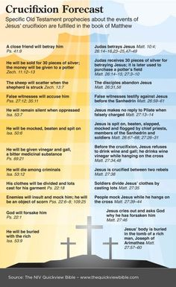
LCMC ~ WHO WE ARE
Free in Christ + Accountable to One Another + Rooted in Scripture and the Lutheran Confessions + Committed to the Great Commission

Prayers Are Important
If you have an occasion to request a prayer, please call the church office. If you would like your request to be on our prayer chain, please call Sandy Brady (419) 410-9380 or Pastor Jeff at the church or on his cell phone (785)340-5635.

Please Inform the Church Office. . .
*when a member of your family is ill or hospitalized or if they are discharged or moved to another facility.
*when your address changes.
*when a new baby arrives.
*when a family member marries or leaves home for college, or military.
*when planning a wedding to be conducted at Zion.
*when a new family moves into your neighborhood.
*when you are planning to be out of town.
*when a brother or sister in Christ needs a visit from Pastor.

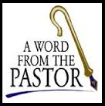
From the desk of Pastor Geske….

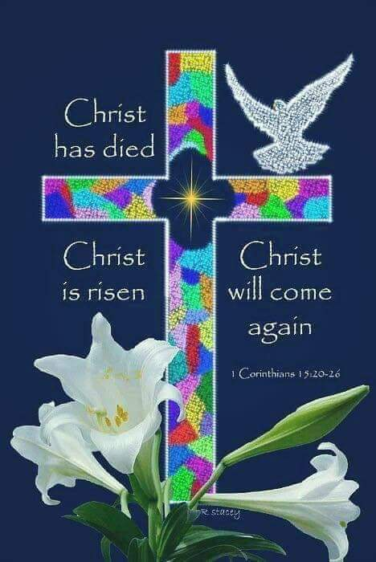
Greetings in the name of Christ! In April we celebrate the resurrection of our Lord on Easter. As we go through this special time in the church year, we renew again what our faith is all about. Our faith is in Jesus Christ who died on the cross to take our sin upon Himself. Through His death and resurrection, we have forgiveness and eternal life. All of these blessing come to us by faith in Jesus as our Lord and our Savior. I love the words of Jesus to Nicodemus when He said, “¹⁶ For God so loved the world that he gave his one and only Son, that whoever believes in him shall not perish but have eternal life. ¹⁷ For God did not send his Son into the world to condemn the world, but to save the world through him.” (John 3:16-17 NIV) During this Lent and Easter time, celebrate all that is yours in Jesus because of His victory on the cross.

As we celebrate this wonderful time, we want to share our faith to others. In this world, it is easy to lose focus on what Easter is truly all about. We believe, we teach, and we confess that Easter is all about Good News that forgiveness of our sins and eternal life are ours in Jesus Christ. How wonderful it is on Easter to shout and proclaim that Christ has risen, He is risen indeed! Alleluia! The second week of April we will be celebrating Holy Week and we will recall all of the events that led up to the first Easter. I love Paul’s words in the fifteenth chapter of First Corinthians where he writes a wonderful message of the resurrection. Just think about these powerful words from this awesome chapter, “For what I received I passed on to you as of first importance: that Christ died for our sins according to the Scriptures, that he was buried, that he was raised on the third day according to the Scriptures, and that he appeared to Peter, and then to the Twelve.” (1 Corinthians 15:3-5 NIV) At the end of the chapter, Paul proclaims, “‘Where, O death, is your victory? Where, O death, is your sting?’ The sting of death is sin, and the power of sin is the law. But thanks be to God! He gives us the victory through our Lord Jesus Christ. Therefore, my dear brothers, stand firm. Let nothing move you. Always give yourselves fully to the work of the Lord, because you know that your labor in the Lord is not in vain.” (1 Corinthians 15:55-58 NIV) Did you catch Paul’s exhortation for you and me? We have this Good News message of forgiveness and eternal life in Christ. We are not to keep it to ourselves, but we are to share it with those we love, our communities and to the very ends of the earth.
I pray that you will make these special worship services an important part of your remembrance and celebration of all that God has done for you to give you His love, forgiveness and eternal life. I would ask you to invite someone or some people to join you in this special time of worship celebrating God’s amazing love.

In Christ,
Rev. Jeffrey Geske
Sunday Morning Bible Class
Please come and join our study of the Word of God!
Each study in the God’s Word for Today series provides an in-depth exploration of a book of the Bible. Each session includes:
- background information on the book of the Bible, its author, audience, occasion, and purpose;
- learning experiences that promote exciting and challenging discussions;
- notes for leaders that answer questions, suggest a learning process, and provide additional information;
- discussion starters that help participants apply God’s Word to their daily lives.
(13 sessions) Paul’s letter to the Ephesians is about the church and about the fellowship of believers who make up the church. It is about us, for by faith we are the church in our time and place. We, by God’s grace, are part of God’s family – a family united in Christ and sustained by the Holy Spirit.
Ephesians
What’s It All About?
Ephesians is one of the four Captivity Letters of the apostle Paul. Along with Philippians,
Colossians, and Philemon, Paul wrote his letter to the Ephesians while he was a prisoner of
Roman authorities.
Church tradition ascribes these letters to Paul's first imprisonment in Rome (A.D. 59-61).
This incarceration in the capital of the Empire followed Paul's final trip to Jerusalem (Acts 21–
23) and his two-year internment in Caesarea (Acts 24:27).
Luke in his Acts of the Apostles tells the moving story of how Paul journeyed to Jerusalem
bearing gifts from the Gentile churches to the church at Jerusalem. He recounts how Paul was
arrested after a riot erupted in the temple courts, how he was sent to Caesarea for his own safety, where he languished in prison for two years at the whim of Felix, and how, finally, he was sent to Rome by Festus to appear before Caesar (Nero), where for another “two whole years Paul stayed there in his own rented house and welcomed all who came to see him” (Acts 28:30).

In spite of the hardship and uncertainty, Paul was not idled by the chains that enshackled
him. Luke tells us this about Paul's stay in Rome: “Boldly and without hindrance he preached the kingdom of God and taught about the Lord Jesus Christ” (Acts 28:31). Paul himself links his letter to the Ephesians to his letters to the Colossians and to Philemon.

Tychicus is the bearer of the letter to the Ephesians (6:21). He is also the bearer of the letter to
the Colossians, and the slave Onesimus is returning to Colossae with him (Col. 4:7–9).
We can infer one of Paul's motives for sending his letter to the Ephesians from a statement
made by Paul near the end of the letter, “Pray also for me” (6:19). Paul's situation provided
another motive. He was “an ambassador in chains” (6:20). Though his chains denied him the joy
of “strengthening the churches” (Acts 15:41) in person, he could encourage and build up the faith of the Ephesians by means of pen and paper. (--God’s Word for Today)

The message of Paul's letter to the Ephesians is an important one. It's all about the church—
and it's all about us. In one sense Paul's letter was a message written to a particular group of
people (the young church at Ephesus in Asia Minor—modern-day Turkey) at a particular time.
In another sense Paul's letter to his Ephesian friends is a message for the whole church of all
time. In that sense it is a message for us. It is God's message for us in the time and place in which we live: “We are God's workmanship, created in Christ Jesus to do good works, which God prepared in advance for us to do” (Ephesians 2:10).

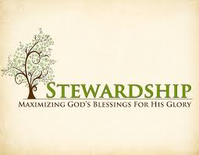
Newsletter Article – April 2022
(--From the LCMS website)

Blessed Shall You Be

“Blessed shall you be in the city, and blessed shall you be in the field. Blessed shall be the fruit of your womb and the fruit of your ground and the fruit of your cattle, the increase of your herds and the young of your flock. Blessed shall be your basket and your kneading bowl. Blessed shall you be when you come in, and blessed shall you be when you go out.” (Deuteronomy 28:3-6)

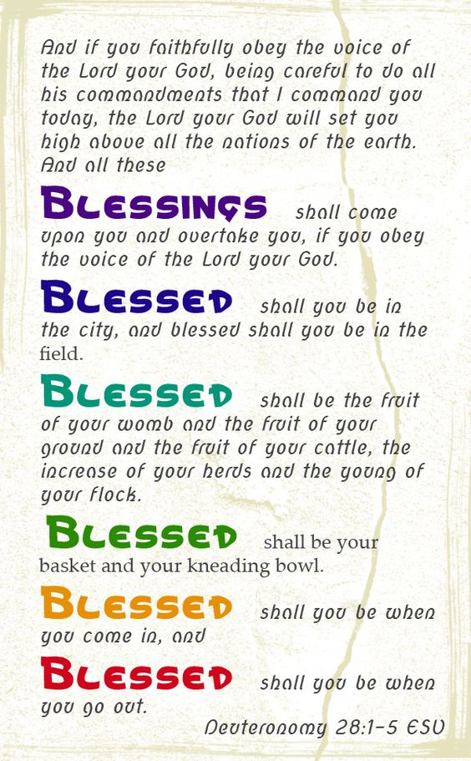
This is God’s promise to the Israelites as they stood beyond the Jordan outside of the Promised Land. He promises blessing to His people. He will make them prosper, whether they are in the city or the field. He will make their fruit of their work to prosper, whether from the ground, their wombs, their flocks, or their herds. He will make them to prosper in all things, whether upon their coming in or their going out.

But there’s a catch. He would do this for Israel only “if you obey the voice of the LORD your God.” (Deut. 28:2b) If they did that, He would cause that “all these blessings shall come upon you and overtake you.” (Deut. 28:2a). If they didn’t obey the voice of the Lord, if they didn’t keep the commandments of the Lord and “walk in His ways” (Deut. 28:9), they would be met with curse and woe. The blessings would be replaced with curses. Everything that the Lord promised to prosper and bless would be cursed and fail.

Thanks be to God that our Lord Jesus Christ has come into our flesh and fulfilled the law for us – in our place and for our benefit. Our Lord Jesus Christ died for us – in our place and for our benefit. Our Lord Jesus Christ is risen from the dead for us – in our place and for our benefit. By this we have justification before God. We are forgiven, clean, holy, and righteous. The blessing of God is promised to us in Christ Jesus. It depends upon His work, not ours.

All this is ours in Holy Baptism. For in Holy Baptism, God claims us as His own, makes us His children, His heirs, and His holy people. And so it is that the work of our hands and its fruit is holy because we are holy in Christ. It is pressed into His service, and it thereby becomes a blessing to us and to our neighbor.

For this great gift, our reception of the blessings of God because of Christ Jesus our Lord, it is our duty to thank and praise, serve, and obey Him. This is not in order to receive the blessings but because, in Christ, we already have. With this in mind, we sit down on the first day of the week and set aside as He has prospered us to give to His church for His work of blessing in our midst (1 Cor. 16:2).

BIRTHDAYS AND ANNIVERSARIES
We would like to wish Happy Birthday and Happy Anniversary to the following individuals who are celebrating this month. If you are not listed or you know someone not listed, please contact Sandy Brady or Pastor Jeff.
Flowers on the Altar ~ If you would like to place flowers, please sign up in the hallway by the restroom.
The cost is $25.00
Please consider signing up for some time this coming year.

April Birthdays

10 Karen Keck
14 Drew Baumgartner
14 Jacob Schmidt
21 Alan Ahleman

27 Sue Beard

April Anniversaries
14 Art and Dorothy Gaynier
20 Roger and Toni Smith
27 Hubert and Barbara Holtz
28 Larry and Brenda Blum

Food Bank~ Thank you for your generous help with our Food Bank. If you have any question or would like to help in any way, please contact Rick Keck at (734) 854-4710. The Food Bank serves families and individuals on the second and fourth Tuesday of the month from 10:00 a.m. until noon.
What is a Thrivent Action Team? Thrivent Action Teams make it easy to live generously. Thrivent provides promotional resources and seed money to jump-start your fundraiser, educational event or service project. Your team provides the people power to bring it to life.

THRIVENT NEWS . . .
If you would like more information about Thrivent, its products, or its fraternal functions, please contact our area representative Greg Durivage in Maumee, OH at (419)-740-4193.

To Join our Text alerts visit: Text the message @jgesk to the number 81010. If you’re having trouble with 81010, try texting @jgesk to (517) 682-0429. This is a free service ~ You are only charged if your cellphone charges per text

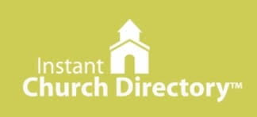
Our Church Directory is Online!
View our church directory online or via the FREE mobile app today. To view the directory online, go to members.InstantChurchDirectory.com and follow the prompts under “Sign In” to “Create a login now.” Please remember, you must confirm your email address before you can sign in. You will need to use your email address as listed in our directory to create a log-in the first time you use the directory online and via the mobile app.
Need help or have questions? Please contact Pastor Jeff.

Community Rewards Program
Do you shop at Kroger? If you do, you can sign up for their Community Rewards Program and Kroger will give back to Zion money every quarter. Go on Kroger's website and sign up under Community Rewards. If you need help or do not have an email address, check with Pastor Jeff. (Our code is NC512)
Steps for Linking your Kroger card to help our ministry ~
1. Sign into your account at www.kroger.com or create an account.
2. Click on the NAME.
3. Scroll down to MY ACCOUNT and Click on it,
4. Scroll down to COMMUNITY REWARDS. Click on COMMUNITY REWARDS.
5. Enter Zion Lutheran Church Ottawa Lake MI (NC512)

Bringing Christ to the Nations and the Nations to the Church
"The Lutheran Hour," which began in 1930, is now heard on more than 1,300 radio stations around the world. "The Lutheran Hour," hosted by Dr. Rev. Michael Zeigler, is the world's oldest continually-broadcast Gospel radio program. This weekly half-hour program proclaims the message of Jesus Christ to all people and serves as a bridge, linking them to the Church. Listen to the Lutheran Hour on Sundays at 10:00 a.m. or at AM 1560 WWYC or anytime at www.lhm.org

Church Council Minutes from March 20, 2022
Member Present: Pastor Jeff, Connie Sieler, Ron Clark, Dwight Gilliland, Sandy Bondy, James Hredzak and Lee Edington. Absent: Ron & Sheila Vincent and Brian Gilliland
Meeting was called to order by Connie Sieler @11:15. Connie requested that Dwight chair the meeting. Pastor Jeff opened with a prayer.
Council approved dispensing with reading of February Minutes.
Motion to accept November minutes made by Ron C. and 2nd by Lee with correction of CD cash in the amount of $14,021.64 instead of $10,000. Motion Carried
Pastor: Thanks to all that have helped with the Lent suppers, services etc. during this Lenten season. Services for Easter Sunday will 7:00 Sunrise and 10:00 regular. There will be a Saturday service at 4:00pm.
Easter breakfast will be provided by Dwight & Mary Jo Gilliland this year and it will be after 7:00 am services until 9:30. All are invited to attend. Pastor has started to work 20 hours at Walmart’s. Also is looking into a trip to Israel for June 2023 for all that would like to take the trip. Pastor is working with a Travel Agent. Pastor will continue to post the newsletter that he receives from LCMC quarterly.
President:
Treasurer/Financial: Sandy reported that all bills are paid up to date.
Elders: Jim offered to fix the downspouts on parsonage and if he can’t Ron Clark will contact an outside vendor to do so.
Building: Ron reported that two lights with sensor were installed, one at glass door and one at the top of the ramp. Ron will have a vendor check on the catch basin to be sure everything is hooked up correctly so there won’t be any problems doing rainy season.
Secretary
New Business: Dwight will work on a new job description for Custodian.
Connie made a motion to adjourn 2nd by Ron at 11:50. Carried
Closed with Lord’s Prayer
Respectfully Submitted
Connie Sieler
Secretary

++++++++++++++++++++++++++++

