The Messenger
A newsletter of Zion Lutheran Church ~ Ottawa Lake, MI
May 2022
+ + + + + + + + + +

Happy Mother’s Day
to all of our
Mothers and Grandmothers!

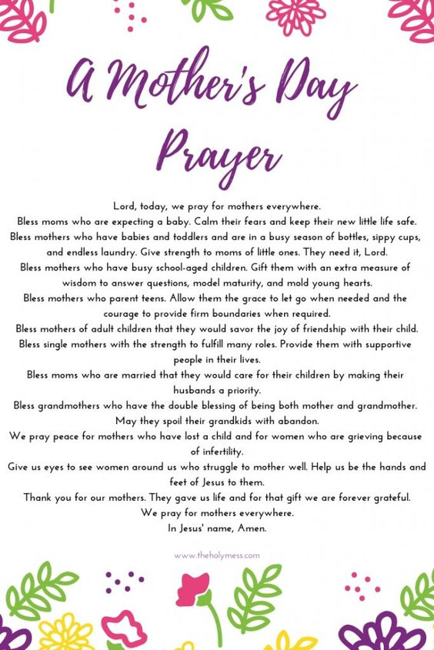
Lutheran Men ~Monthly Breakfast
On May 14, 2022, we will have our Lutheran Men’s Monthly breakfast. Breakfast will be served at 8:00 a.m. We will have a hot breakfast, devotion, and a Bible study. Please come and feel free to invite a friend or neighbor. It would be great to see you there!

Zion Lutheran Church Council
We will have our monthly Church Council Meeting after church on May 15, 2022.

Women of Zion
Women of Zion will have their next monthly meeting on May 23th at 2:00 p.m.

WORSHIP WITH US EACH WEEK!
Join us for worship on Sunday morning at 10:00 a.m.
Our Contemporary Service is on Saturday at 4:00 p.m.

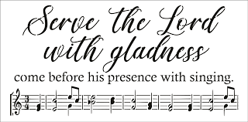
Zion Church Choir
If you love singing, please join our church choir. They meet after church in the choir room. For more information, please speak with Joseph Extejt.

Our handbell choir meets on Saturdays at 3:00 p.m.
They would love to have you join them. For more information, please speak to Karen Vollmer.

ZION Lutheran Church
LCMC ~ Lutheran congregations in mission for Christ
8307 Memorial Hwy. Ottawa Lake, MI 49267 ·
(734) 856-2921
Pastor ∙ Jeffrey Geske
(785) 340-5635
zlcolmpastor@gmail.com
www.zionlutheranottawalakemi.com

Secretary ~ Sandy brady
(419) 410-9380
skwiles2000@gmail.com
custodian and organist~ Joseph extejt

For Your Information
The following members give of their time to the leadership of this congregation. Please keep them in your prayers. If you have any questions, comments, or offers of help, please contact them.
Chairman: Ron Vincent
Secretary: Connie Sieler
Treasurer: Brian Gilliland
Financial: Sandy Bondy
Elders: Ron Clark and Lee Edignton
Deacons: Dwight Gilliland and Jim Hredzak
LCMC ~ WHO WE ARE
Free in Christ + Accountable to One Another + Rooted in Scripture and the Lutheran Confessions + Committed to the Great Commission

Prayers Are Important
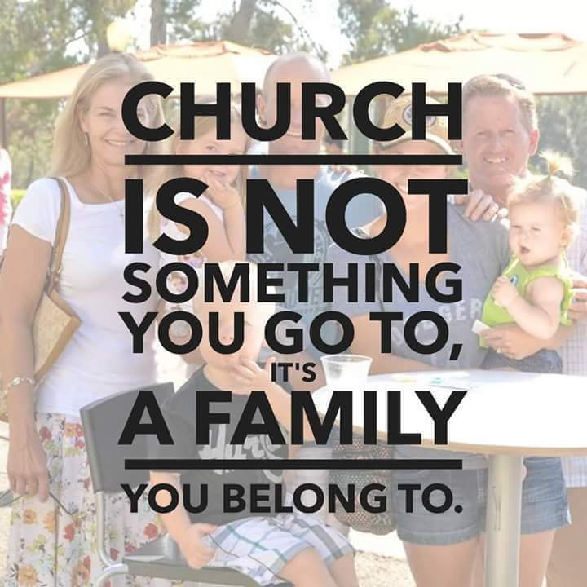
If you have an occasion to request a prayer, please call the church office. If you would like your request to be on our prayer chain, please call Sandy Brady (419) 410-9380 or Pastor Jeff at the church or on his cell phone (785)340-5635.

Please Inform the Church Office. . .
*when a member of your family is ill or hospitalized or if they are discharged or moved to another facility.
*when your address changes.
*when a new baby arrives.
*when a family member marries or leaves home for college, or military.
*when planning a wedding to be conducted at Zion.
*when a new family moves into your neighborhood.
*when you are planning to be out of town.
*when a brother or sister in Christ needs a visit from Pastor.

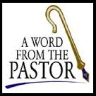
From the desk of Pastor Geske….

As God’s Easter people who are Saved By Grace, we have a bold proclamation to declare to the world that Christ is risen! He is risen indeed! Alleluia. At the heart of our ministry together of sharing the love of Jesus is to bring people to know Christ through our teaching, reaching, and sharing that the message is true that Christ is Risen! Alleluia! One of the most powerful accounts in God’s Word that brings home for us the message of our faith is when Jesus walked on the road to Emmaus with two men. These men discussed all that had happened and they even invited Jesus to eat with them in one of their homes. It was there that He revealed Himself to them. Then Luke wrote, “They got up and returned at once to Jerusalem. There they found the Eleven and those with them, assembled together and saying, ‘It is true! The Lord has risen and has appeared to Simon.’” (Luke 24:33-34 NIV)

This is the message that we have for our world today. Our generation, our world, our friends, our neighbors, and our families need to hear the message that it is true that Jesus Christ rose from the dead to give us the victory over sin, death, and the devil. God uses us to invite those we know and love to share with us in receiving God’s forgiveness and eternal life. We have an exciting opportunity to reach our community and world with the love of Jesus Christ. I love these words that said, “The critical issue is transformational change from country club congregations led by fearful country club managers and an ethos preserving church body into missional congregations with apostolic leadership in walking together as a band of missionaries committed to connect people to Jesus in a spiritually hungry world.”(Unknown)

Our world is filled with spiritually hungry people. God calls us to reach out with His love and bring people to know and believe in Jesus Christ. He blesses us to sow His Word in our lives as we intentionally seek to bring others to know Christ. Consider in the next month who you can share the love of the Savior with and who you can invite to grow with you through the ministry of Zion Lutheran Church. I look forward to seeing you worshipping and growing in God’s house. Indeed, Christ is risen! He is risen indeed! Alleluia!

Yours in Christ,
Pastor Jeffrey Geske
Sunday Morning Bible Class
Please come and join our study of the Word of God!
Each study in the God’s Word for Today series provides an in-depth exploration of a book of the Bible. Each session includes:
- background information on the book of the Bible, its author, audience, occasion, and purpose;
- learning experiences that promote exciting and challenging discussions;
- notes for leaders that answer questions, suggest a learning process, and provide additional information;
- discussion starters that help participants apply God’s Word to their daily lives.
(13 sessions) Paul’s letter to the Ephesians is about the church and about the fellowship of believers who make up the church. It is about us, for by faith we are the church in our time and place. We, by God’s grace, are part of God’s family – a family united in Christ and sustained by the Holy Spirit.
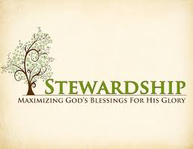
Newsletter Article – May 2022
(--From the LCMS website)

Living Sacrifices

Stewardship is not just about giving money to the church. It includes this, to be sure, but it is not limited to it. Stewardship involves our whole life – everything we have and everything we are.
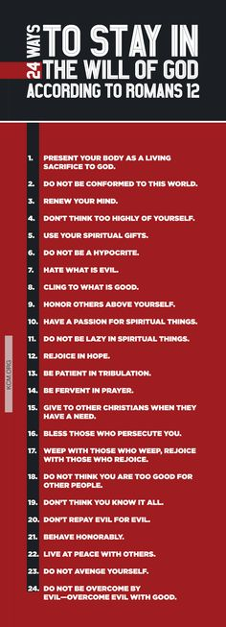
Let us not, though, fall into the trap of thinking that because we give of ourselves in one area then we can neglect giving in another. Stewardship is not stealing from Peter to pay Paul. It is not a game that we play whereby we justify ourselves in not giving a tenth of our income because we have given in some other way.
This is why our Lord warns: “Woe to you, scribes and Pharisees, hypocrites! For you tithe mint and dill and cumin and have neglected the weightier matters of the law: justice and mercy and faithfulness. These you ought to have done, without neglecting the others.” (Matthew 23:23) We are given to do both – tithe of ourselves and what we have.
And so it is that St. Paul makes his appeal to us: “I appeal to you therefore, brothers, by the mercies of God, to present your bodies as a living sacrifice, holy and acceptable to God, which is your spiritual worship. Do not be conformed to this world, but be transformed by the renewal of your mind, that by testing you may discern what is the will of God, what is good and acceptable and perfect.” (Romans 12:1–2)
We are to present our bodies as a living sacrifice to God. We are not to have the mind of the world, where we exchange equal weight of this for an equal weight of that and think that we have done what God has required. Our whole life is given over for service in and for the Church of God. This is to be done in thanksgiving for what God in Christ has accomplished for us. This is our spiritual worship, the reasonable response to what He has done for us. Not one for the other but all in all.
But what does this look like? St. Paul never lays down a general principle without also giving us some practical application of what shape that principle is to take concretely. He gives the general principle that our bodies are to be living sacrifices to God. And, after admonishing those who have been given particular gifts of grace to serve the church, St. Paul then speaks generally of what is expected of all. He says:
“Let love be genuine. Abhor what is evil; hold fast to what is good. Love one another with brotherly affection. Outdo one another in showing honor. Do not be slothful in zeal, be fervent in spirit, serve the Lord. Rejoice in hope, be patient in tribulation, be constant in prayer. Contribute to the needs of the saints and seek to show hospitality.” (Romans 12:9–13)
This is what it looks like to present your bodies as living sacrifices. This is how we live out the grace of God here in time.
Let us then heed the apostle’s teaching. Let us present our bodies – everything that we have and everything that we are – as living sacrifices to God, our reasonable response to what God in Christ Jesus accomplished for us by His death and resurrection. Through this, we have forgiveness of sins, a new life in Christ, and eternal salvation. And through this worship, the grace of God is made manifest in His saints – for the church and the world.
BIRTHDAYS AND ANNIVERSARIES
We would like to wish Happy Birthday and Happy Anniversary to the following individuals who are celebrating this month. If you are not listed or you know someone not listed, please contact Sandy Brady or Pastor Jeff.
Flowers on the Altar ~ If you would like to place flowers, please sign up in the hallway by the restroom.
The cost is $25.00
Please consider signing up for some time this coming year.

May Birthdays

1 Steve Vaughan
8 Olivia Castell
9 Brian Gilliland
14 Joann Koester
16 Fred VanSteenkiste
19 Julie Edington
28 Marilyn Bexten

May Anniversaries
16 ~ Fred and Joann VanSteenkiste
18 ~ Bill and Sandy Brady
18 ~ Ron and Shirley Clark
20 ~ Eric and Sandy Baumgartner
Food Bank~ Thank you for your generous help with our Food Bank. If you have any question or would like to help in any way, please contact Rick Keck at (734) 854-4710. The Food Bank serves families and individuals on the second and fourth Tuesday of the month from 10:00 a.m. until noon.
What is a Thrivent Action Team? Thrivent Action Teams make it easy to live generously. Thrivent provides promotional resources and seed money to jump-start your fundraiser, educational event or service project. Your team provides the people power to bring it to life.

THRIVENT NEWS . . .
If you would like more information about Thrivent, its products, or its fraternal functions, please contact our area representative Greg Durivage in Maumee, OH at (419)-740-4193.

To Join our Text alerts visit: Text the message @jgesk to the number 81010. If you’re having trouble with 81010, try texting @jgesk to (517) 682-0429. This is a free service ~ You are only charged if your cellphone charges per text

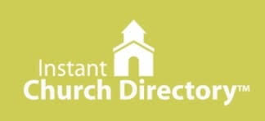
Our Church Directory is Online!
View our church directory online or via the FREE mobile app today. To view the directory online, go to members.InstantChurchDirectory.com and follow the prompts under “Sign In” to “Create a login now.” Please remember, you must confirm your email address before you can sign in. You will need to use your email address as listed in our directory to create a log-in the first time you use the directory online and via the mobile app.
Need help or have questions? Please contact Pastor Jeff.

Community Rewards Program
Do you shop at Kroger? If you do, you can sign up for their Community Rewards Program and Kroger will give back to Zion money every quarter. Go on Kroger's website and sign up under Community Rewards. If you need help or do not have an email address, check with Pastor Jeff. (Our code is NC512)

Steps for Linking your Kroger card to help our ministry ~
1. Sign into your account at www.kroger.com or create an account.
2. Click on the NAME.
3. Scroll down to MY ACCOUNT and Click on it,
4. Scroll down to COMMUNITY REWARDS. Click on COMMUNITY REWARDS.
5. Enter Zion Lutheran Church Ottawa Lake MI (NC512)

Bringing Christ to the Nations and the Nations to the Church
"The Lutheran Hour," which began in 1930, is now heard on more than 1,300 radio stations around the world. "The Lutheran Hour," hosted by Dr. Rev. Michael Zeigler, is the world's oldest continually-broadcast Gospel radio program. This weekly half-hour program proclaims the message of Jesus Christ to all people and serves as a bridge, linking them to the Church. Listen to the Lutheran Hour on Sundays at 10:00 a.m. or at AM 1560 WWYC or anytime at www.lhm.org

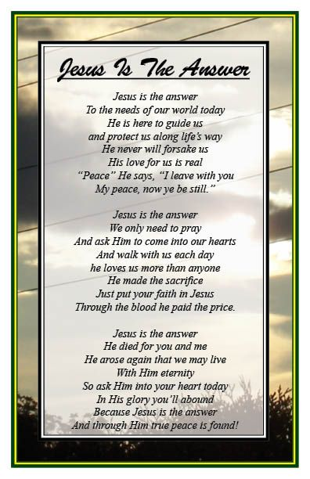
May 2022
May 1
"Three C's of Christian Witness"
Speaker: Rev. Dr. Michael Zeigler
Competence, Conversation, and Caring-the three C's of Christian witness.
(Daniel 3:28)
May 8
"What the Bible Is Like"
Speaker: Rev. Dr. Michael Zeigler
The Bible is like an encyclopedia, a love letter, a self-help book, and a Good News article--but these comparisons all fall short.
(2 Timothy 3:16-17)
May 15
"What the Bible Is About"
Speaker: Rev. Dr. Michael Zeigler
(1 Corinthians 15:3-5)
May 22
"What the Bible Is For"
Speaker: Rev. Dr. Michael Zeigler
(1 Timothy 4:13)
May 29
"Imagine That!"
Guest Speaker: Dr. Dean Nadasdy
(Revelation 22:1-7)

Church Council Minutes ~ There was Council Meeting in April

