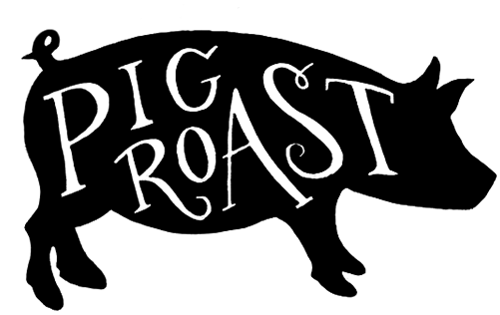

Zion Lutheran Church invites you to join them for their Pig Roast Dinner on
May 21st from 4-7 p.m.
Tickets will be available at the door for a $12 donation. There will also be a 50/50 Raffle during the event.
Zion Lutheran Church is located at 8307 Memorial Hwy. Ottawa Lake, MI 49267

