The Messenger
A newsletter of Zion Lutheran Church ~ Ottawa Lake, MI
June 2022
+ + + + + + + + + +

Happy Father’s Day
to all of our
Fathers and Grandfathers!

Lutheran Men ~Monthly Breakfast
On June 11, 2022, we will have our Lutheran Men’s Monthly breakfast. Breakfast will be served at 8:00 a.m. We will have a hot breakfast, devotion, and a Bible study. Please come and feel free to invite a friend or neighbor. It would be great to see you there!

Zion Lutheran Church Congregational Meeting
We will have our biannual Congregational Meeting on June 12 following our worship service.

WORSHIP WITH US EACH WEEK!
Join us for worship on Sunday morning at 10:00 a.m.
Our Contemporary Service is on Saturday at 4:00 p.m.

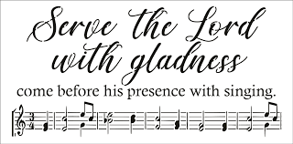
Zion Church Choir
If you love singing, please join our church choir. They meet after church in the choir room. For more information, please speak with Joseph Extejt. Our choir will resume in the Fall.
Zion Handbell Choir
Our handbell choir will resume in the Fall.
They would love to have you join them. For more information, please speak to Karen Vollmer.

ZION Lutheran Church
LCMC ~ Lutheran congregations in mission for Christ
8307 Memorial Hwy. Ottawa Lake, MI 49267 ·
(734) 856-2921
Pastor ∙ Jeffrey Geske
(785) 340-5635
zlcolmpastor@gmail.com
www.zionlutheranottawalakemi.com

Secretary ~ Sandy brady
(419) 410-9380
skwiles2000@gmail.com
custodian and organist~ Joseph extejt

For Your Information
The following members give of their time to the leadership of this congregation. Please keep them in your prayers. If you have any questions, comments, or offers of help, please contact them.
Chairman: Ron Vincent
Secretary: Connie Sieler
Treasurer: Brian Gilliland
Financial: Sandy Bondy
Elders: Ron Clark and Lee Edignton
Deacons: Dwight Gilliland and Jim Hredzak
LCMC ~ WHO WE ARE
Free in Christ + Accountable to One Another + Rooted in Scripture and the Lutheran Confessions + Committed to the Great Commission

Prayers Are Important
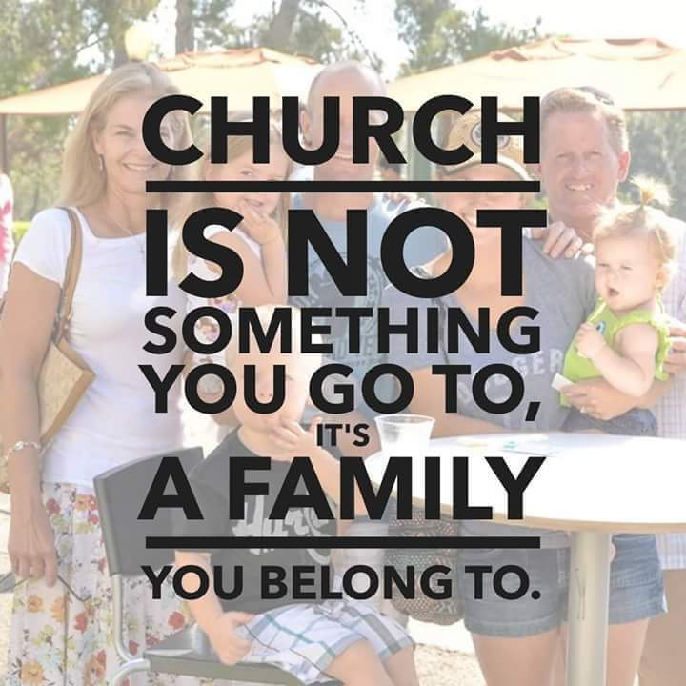
If you have an occasion to request a prayer, please call the church office. If you would like your request to be on our prayer chain, please call Sandy Brady (419) 410-9380 or Pastor Jeff at the church or on his cell phone (785)340-5635.

Please Inform the Church Office. . .
*when a member of your family is ill or hospitalized or if they are discharged or moved to another facility.
*when your address changes.
*when a new baby arrives.
*when a family member marries or leaves home for college, or military.
*when planning a wedding to be conducted at Zion.
*when a new family moves into your neighborhood.
*when you are planning to be out of town.
*when a brother or sister in Christ needs a visit from Pastor.

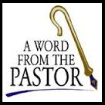
From the desk of Pastor Geske….

Greetings to you in the name of Christ! Summer is upon us and so are all of the joys of summer and all of the activities that pull on our time. I pray that you have an enjoyable and fun summer. As you are enjoying all of the activities and time outdoors, I would like to encourage you to take time to worship our God who is the giver of all things. I love how Martin Luther reminds us in the Meaning of the First Article of the Apostles’ Creed that everything we have and are a gift from our God and so it is our duty to do four things. Do you recall what these are? Martin Luther said, “All this He does only out of fatherly, divine goodness and mercy, without any merit or worthiness in me. For all this it is my duty to thank, praise, serve and obey Him.”

These four things are central to what we do in worship. First and foremost, we gather to hear God’s Word of love and forgiveness for us. We also thank, praise, serve, and obey Him as we worship through our confessions, through our songs, through our offering. Worship is a time to hear and interact in a special way with our Heavenly Father and other brothers and sisters in Christ. This summer, I encourage you not to forget about worship but to be like David when he said, “I rejoiced with those who said to me, ‘Let us go to the house of the LORD.’” (Psalm 122:1 NIV)

It is interesting to think about all that pulls on our time, our talents, and our treasures. One of the churches that I served went through a Strategic Planning process, they developed a list of threats to their ministry and their work together. This list included such things as: community sports programs, no “sacred” church time, other growing churches, competing secular priorities, apathy, laziness, very full schedules, not a churched society anymore, many people who call themselves “Christians” don’t feel a need to affiliate with a church, people’s lack of conviction, a society with no absolutes, media shaping our morality, and a breakdown of family relationships.

These threats are not simply true for that church, but for all churches. I think it is good for families to talk about why they do what they do. Why do we worship and why should we worship every Sunday? The answer is Jesus and all He has done for us! Yes, we are called to remember the Sabbath Day. We are called to hear, learn, and meditate on God’s Word. In our catechism, we are encouraged by a question that asks, “What do the Scriptures teach about our life in the church?” The answer states, “They teach that A. we should seek always to be and remain members of the invisible church, Christ’s body, by sincere faith in Christ, our Savior; B. we should be faithful to that visible church, or denomination, which professes and teaches all of the Bible’s doctrine purely and administers the sacraments according to Christ’s institution; C. we should avoid false teachers, false churches, and all organizations that promote a religion that is contrary to God’s Word; D. we should maintain and extend God’s church by telling others about Jesus Christ, by personal service, and by prayer and financial support.” (--LSC Q. 179) Consider the many Bible passages listed in the answer to this question, like John 15:5; Acts 2:42; John 8:31-32; 2 Timothy 4:3; Acts 1:8; 1 Peter 2:9 and 1 Peter 3:15.

My prayer is that God would so motivate and encourage us to be mightily about His work in this corner of His kingdom. God’s blessings to you as you worship and as you enjoy this summer of fun. I look forward to seeing you in your Father’s house each week!

Yours in Christ,
Pastor Jeffrey Geske
Sunday Morning Bible Class
Please come and join our study of the Word of God!
During the summer, we will be watching videos from this amazing series
That The World May Know Series

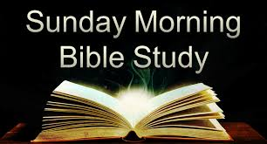
Take your group on a trip to ancient times, places, and customs with trusted Bible scholar Ray Vander Laan as your fun and engaging tour guide. Filmed in Israel, Egypt, Turkey, and Greece, these powerful videos explore what it meant to follow Jesus in the first century—and what it means to follow him today. Each of the 16 volumes provides visually stunning video sessions as well as an easy-to-follow discovery guide that illuminates Jesus’ teachings and helps participants understand the context in which He lived and preached. Join renowned teacher and historian Ray Vander Laan as he guides you through the lands of the Bible. In each lesson, Vander Laan illuminates the historical, geographical, and cultural context of the sacred Scriptures. Filmed on location in the Middle East, the That the World May Know ® film series will transform your understanding of God and challenge you to be a true follower of Jesus.
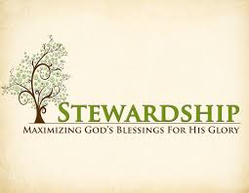
Newsletter Article – June 2022
(--From the LCMS website)

What Do You Have That You Have Not Received?

Some of the disciples of John the Baptist were questioning him about the baptism and preaching of Jesus. John the Baptist replies to their questions in this way: “A person cannot receive even one thing unless it is given him from heaven” (John 3:27).

Now, John the Baptist says this to show that Jesus, His teaching, and His baptism are from heaven. But this statement is true of everything – everything that we have and are in body and soul. In fact, this is what we are taught in the meaning of the Apostles’ Creed in Luther’s Small Catechism.

In the explanation of the Creed’s First Article, we learn that God has made us and everything in the universe. Luther says:

“He has given me my body and soul, eyes, ears, and all my members, my reason and all my senses, and still takes care of them. He also gives me clothing and shoes, food and drink, house and home, wife and children, land, animals, and all I have. He richly and daily provides me with all that I need to support this body and life. He defends me against all danger and guards and protects me from all evil. All this He does only out of fatherly, divine goodness and mercy, without any merit or worthiness in me. For all this it is my duty to thank and praise, serve and obey Him.”

In the Second Article of the Creed, we learn that God sent His Son, Jesus, to humble Himself, taking the form of a servant. Luther writes:

“(Jesus) has redeemed me, a lost and condemned person, purchased and won me from all sins, from death, and from the power of the devil; not with gold or silver, but with His holy, precious blood and with His innocent suffering and death, that I may be His own and live under Him in His kingdom and serve Him in everlasting righteousness, innocence, and blessedness, just as He is risen from the dead, lives and reigns to all eternity.”

In the Third Article of the Creed, we learn that the fruits of what Jesus Christ, the Son of God, are given to us through the work of the Holy Spirit in the Church. Luther explains:

“That I cannot, by my own reason or strength, believe in Jesus Christ, my Lord, or come to Him; but the Holy Spirit has called me by the Gospel, enlightened me with His gifts, sanctified and kept me in the true faith. In the same way He calls, gathers, enlightens, and sanctifies the whole Christian church on earth, and keeps it with Jesus Christ in the one true faith. In this Christian church He daily and richly forgives all my sins and the sins of all believers. On the Last Day He will raise me and all the dead, and give eternal life to me and all believers in Christ.”

Indeed, a person cannot receive even one thing unless it is given him from heaven. But how easy is this for us to forget about this?

How easy is it for us to think that what we have in this life is because we have earned it? How easy is it for us to forget that even all our skills, the abilities of our hands and minds – the very ethic to work diligently and to seek to get better at these skills – is given to us from heaven, just as John the Baptist said? How easy is it for us to forget that it is Christ alone – and the work of the Holy Spirit – that reveals His salvation to us, delivers it to us, and not our doing?

Sure, we have responsibility for coming to church, for delving into God’s Holy Word, and for praying without ceasing. But even these responsibilities are given to us from heaven, not to earn anything but in response to what He has accomplished for us.

A person cannot receive one thing unless it is given to him from heaven. Everything we have, and everything we are – in both body and soul – are gifts from God in heaven. Let us then respond in thanksgiving and give back to Him as He asks us to – with a first-fruits, generous proportion offering of what He has given to us.
Our Church Directory is Online!
View our church directory online or via the FREE mobile app today. To view the directory online, go to members.InstantChurchDirectory.com and follow the prompts under “Sign In” to “Create a login now.” Please remember, you must confirm your email address before you can sign in. You will need to use your email address as listed in our directory to create a log-in the first time you use the directory online and via the mobile app.
Need help or have questions? Please contact Pastor Jeff.
BIRTHDAYS AND ANNIVERSARIES
We would like to wish Happy Birthday and Happy Anniversary to the following individuals who are celebrating this month. If you are not listed or you know someone not listed, please contact Sandy Brady or Pastor Jeff.
Flowers on the Altar ~ If you would like to place flowers, please sign up in the hallway by the restroom.
The cost is $25.00
Please consider signing up for some time this coming year.

June Birthdays

8 Karen Weimer
13 Dwight Gilliland
16 Connie Sieler
17 Eric Baumgartner
25 David Vaughan

June Anniversaries
10 ~ Ben and Alex Schmidt
19 ~ Ron and Sheila Vincent
25 ~ Brian and Jean Gilliland
Food Bank~ Thank you for your generous help with our Food Bank. If you have any question or would like to help in any way, please contact Rick Keck at (734) 854-4710. The Food Bank serves families and individuals on the second and fourth Tuesday of the month from 10:00 a.m. until noon.
What is a Thrivent Action Team? Thrivent Action Teams make it easy to live generously. Thrivent provides promotional resources and seed money to jump-start your fundraiser, educational event or service project. Your team provides the people power to bring it to life.

THRIVENT NEWS . . .
If you would like more information about Thrivent, its products, or its fraternal functions, please contact our area representative Greg Durivage in Maumee, OH at (419)-740-4193.

To Join our Text alerts visit: Text the message @jgesk to the number 81010. If you’re having trouble with 81010, try texting @jgesk to (517) 682-0429. This is a free service ~ You are only charged if your cellphone charges per text

Community Rewards Program
Do you shop at Kroger? If you do, you can sign up for their Community Rewards Program and Kroger will give back to Zion money every quarter. Go on Kroger's website and sign up under Community Rewards. If you need help or do not have an email address, check with Pastor Jeff. (Our code is NC512)
Steps for Linking your Kroger card to help our ministry ~
1. Sign into your account at www.kroger.com or create an account.
2. Click on the NAME.
3. Scroll down to MY ACCOUNT and Click on it,
4. Scroll down to COMMUNITY REWARDS. Click on COMMUNITY REWARDS.
5. Enter Zion Lutheran Church Ottawa Lake MI (NC512)

Bringing Christ to the Nations and the Nations to the Church
"The Lutheran Hour," which began in 1930, is now heard on more than 1,300 radio stations around the world. "The Lutheran Hour," hosted by Dr. Rev. Michael Zeigler, is the world's oldest continually-broadcast Gospel radio program. This weekly half-hour program proclaims the message of Jesus Christ to all people and serves as a bridge, linking them to the Church. Listen to the Lutheran Hour on Sundays at 10:00 a.m. or at AM 1560 WWYC or anytime at www.lhm.org

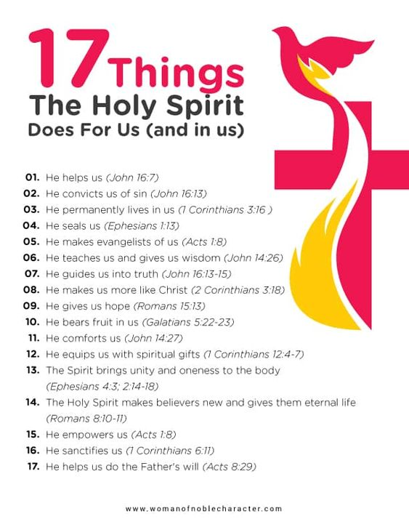
June 2022
June 5
"A Place in the Choir"
Speaker: Rev. Dr. Michael Zeigler
God's world is like a big, beautiful choir in which everyone has a place and a part to sing.
(Colossians 1:15-20)
June 12
"God Comes with a Community"
Speaker: Rev. Dr. Michael Zeigler
(Acts 2:38-39)
June 19
"TBD"
Speaker: Rev. Dr. Michael Zeigler
June 26
"TBD"
Speaker: Rev. Dr. Michael Zeigler

Church Council Minutes ~ May 15, 2022

Member Present: Pastor Jeff, Ron Vincent, Connie Sieler, Ron Clark, Dwight Gilliland, Sandy Bondy, James Hredzak, Sheila Vincent and Lee Edington.
Meeting called to order by Ron Vincent @11:20. Ron opened with a prayer.
Motion made by Dwight and 2nd by Ron C to dispense with reading of minutes. Carried
Motion made by James and 2nd by Ron C to approve March minutes. Carried
Pastor: Visited the sick and shut-ins. Office computer is outdated and would like to purchase a new or used one . Motion made by Connie to allow Pastor to investigate and purchase a computer up to $1000. Motion 2nd by Dwight. Carried Congregational semi-annual meeting will be held June 12, 2022 immediately after services. Pastor will be on vacation from June 28 – July 4 and will be gone for Sunday, July 3rd. Dwight, Lee and Ron will do the services for July 3rd.
President: We need someone to volunteer to do audit for Year 2021. Please contact council member if interested. We used to have books at end of every pew to be used for signing in at services. Different methods are now being used and council decided there isn’t a need to use the blue books any longer.
Treasurer/Financial: Sandy reported that all bills are paid up to date. Treasurer went over income and expenses to previous month. Brian was asked to submit a report of Special Accounts and balances. Motion made by Connie to approve Treasurer’s report, 2nd by Dwight. Carried
Elders: Repairs are up to date, holes filled and grass seed planted. Seeding needs to be redone and Melvin Sieler will provide a bale of straw to cover seeds. Ron V. will take care of planting etc. There is some plaster coming loose in corner of church and needs to be repair. Bob Decator’s son know of someone who does this kind of work and Bob got a bid of $2400 to repair. Bob and Carol offered to pay ½ of bill. Thank you both. Motion made by Ron V. to accept bid and start the repairs, 2nd by Connie. Carried
Building: Ramp is ready for staining. Ron V. volunteer to do and oversee this project.
Secretary: Preparing for Pig Roast and help is needed.
New Business: Dwight will work on a new job description for Custodian. Ron C. made a motion 2nd by Lee to cancel meetings for July & August. Carried The meeting for September will be September 25, 2022 due to absents by some council members. Connie & James will fill in for counting monies after services when either counter is absent.
Recording Secretary turned in her resignation effective June 1st. Sheila will continue to record envelopes and donations until a replacement can be found. Sheila will also train new recording secretary.
Lee made a motion to adjourn 2nd by Dwight at 12:10. Carried
Closed with Lord’s Prayer
Respectfully Submitted
Connie Sieler
Secretary

