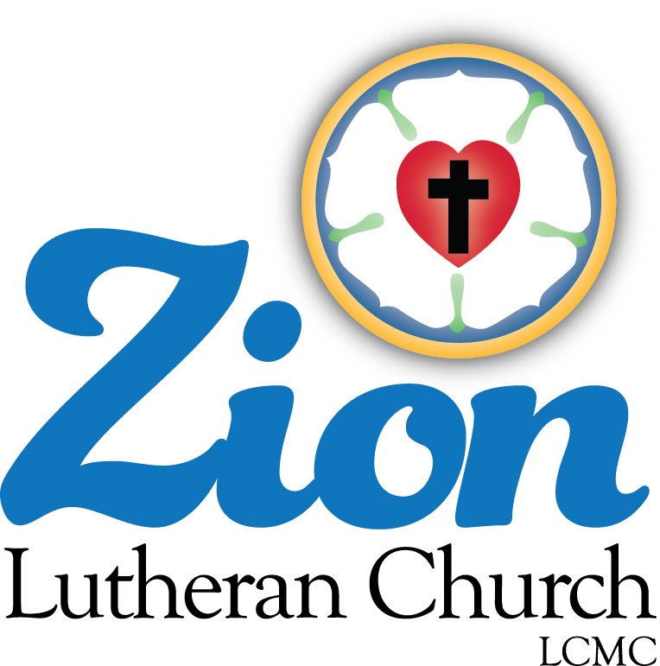

Welcome to ZION Lutheran Church
LCMC ~ Lutheran congregations in mission for Christ
8307 Memorial Hwy. Ottawa Lake, MI 49267 ·
(734) 856-2921
Pastor ∙ Jeffrey Geske
(785) 340-5635
zlcolmpastor@gmail.com
www.zionlutheranottawalakemi.com

Our MISSION:
“SHARING THE LOVE OF JESUS”

To Our Guests
We are so glad that you have chosen to join us this morning! We pray that you will be refreshed and renewed as you come into God’s presence. Please take a moment to introduce yourself to the pastor and to those seated around you. Once again, we warmly thank you for worshipping with us this morning!

Those Assisting in Ministry Today
June 12, 2022 ~ TRINITY SUNDAY
Organist: Joseph extejt Greeters : Ron Clark and All
deacon: Dwight Gilliland and Jim Hredzak
SCREEN: Nick Baumgartner & Jacob Geske
Reader: Dick Vollmer
Altar Guild: Shirley Clark and JoAnn VanSteenkiste
Administrative assistant: Sandy Brady 419- 410-9380 or skwiles2000@gmail.com

LCMC ~ WHO WE ARE
Free in Christ + Accountable to One Another + Rooted in Scripture and the Lutheran Confessions + Committed to the Great Commission

Thoughts on our Readings ~ (-- From the Sola Publishing Website)
The lessons for Trinity Sunday all point to the co-eternal nature of Jesus with the Father and the Holy Spirit. In the New Testament, Jesus is often portrayed as “wisdom,” which connects Jesus, the incarnate Word, to the creation at the beginning of time. It was upsetting to Jesus’ antagonists that he equated himself to God, even going so far as to say that before Abraham was alive, He existed.

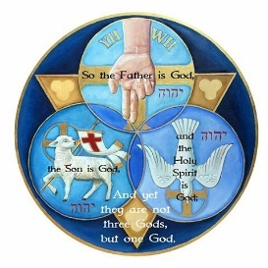
TRINITY SUNDAY
June 12, 2022

RINGING OF THE BELL

WELCOME

HYMN LSB 813 St. 1-3 “Rejoice O Pilgrim Throng”

INVOCATION
Pastor: In the name of the Father and of the Son and of the Holy Spirit.
People: Amen.

CONFESSION AND ABSOLUTION
Pastor: Despite the perfect creation by the Father, Son, and Holy Spirit, we all have fallen into sin and failed to live as holy and perfect creatures. Let us confess our sins to God, our heavenly Father.

People: O Lord, our Lord, how majestic is Your name in all the earth! You have set Your glory above the heavens! Yet we have failed to proclaim Your majestic name in our communities. We have denied Your glory and sought our own glory. We see Your mighty works, wonders, and signs every day, but we often fail to find delight in them. Forgive us for the sake of Jesus. Lead us by Your Spirit.

Pastor: Almighty God in His mercy has given His Son to die for Your sins. Jesus Christ was crucified and killed by the hands of lawless men, but God raised Him up, loosing the chains of death. God has given all authority in heaven and on earth to Jesus, who is both Lord and Christ. He has sent the Holy Spirit, who has called, gathered, and kept you in the one true faith of your Baptism. As a called and ordained servant of Jesus Christ, and by His authority, I forgive you all your sins in the name of the Father and of the Son and of the Holy Spirit.

People: Amen. We are forgiven. The Holy Trinity works together to accomplish our forgiveness and salvation.
GOD’S WORD FOR US

CREED Athanasian Creed, Part 1

Pastor: Whoever desires to be saved must, above all, hold the catholic faith.
People: Whoever does not keep it whole and undefiled will without doubt perish eternally.
Pastor: And the catholic faith is this,
People: that we worship one God in Trinity and Trinity in Unity, neither confusing the persons nor dividing the substance.
Pastor: For the Father is one person, the Son is another, and the Holy Spirit is another.
People: But the Godhead of the Father and of the Son and of the Holy Spirit is one: the glory equal, the majesty coeternal.
Pastor: Such as the Father is, such is the Son, and such is the Holy Spirit:
People: the Father uncreated, the Son uncreated, the Holy Spirit uncreated;
Pastor: the Father infinite, the Son infinite, the Holy Spirit infinite;
People: the Father eternal, the Son eternal, the Holy Spirit eternal.
Pastor: And yet there are not three Eternals, but one Eternal,
People: just as there are not three Uncreated or three Infinites, but one Uncreated and one Infinite.
Pastor: In the same way, the Father is almighty, the Son almighty, the Holy Spirit almighty;
People: and yet there are not three Almighties, but one Almighty.
Pastor: So the Father is God, the Son is God, the Holy Spirit is God;
People: and yet there are not three Gods, but one God.
Pastor: So the Father is Lord, the Son is Lord, the Holy Spirit is Lord;
People: and yet there are not three Lords, but one Lord.
Pastor: Just as we are compelled by the Christian truth to acknowledge each distinct person as God and Lord, so also are we prohibited by the catholic religion to say that there are three Gods or Lords.

HYMN LSB 813 St. 4-5 “Rejoice O Pilgrim Throng”

SALUTATION
Pastor: The Lord be with you.
People: And also with you.

PRAYER OF THE DAY
Pastor: Let us pray.
People: Almighty and everlasting God, you have given us grace to make the confession of a true faith. We acknowledge your glorious eternal Trinity, and we adore the unity of your majestic work. Defend us by this faith from all adversity and opposition to your way; through Jesus Christ, your Son, our Lord, who lives and reigns with you and the Holy Spirit, one God, now and forever. Amen.

OLD TESTAMENT READING Proverbs 8:1-4 (Wisdom Personified)
Lector: This is the Word of the Lord.
People: Thanks be to God.

PSALM Psalm 8 (Humanity is Crowned with Glory and Honor)

THE SECOND READING Acts 2:14a, 22–36 (Peter Explains Who Jesus Was.)

HYMN LSB 813 St. 6-7 “Rejoice O Pilgrim Throng”

CREED Athanasian Creed, Part 2

Pastor: The Father is not made nor created nor begotten by anyone.
People: The Son is neither made nor created, but begotten of the Father alone.
Pastor: The Holy Spirit is of the Father and of the Son, neither made nor created nor begotten, but proceeding.
People: Thus, there is one Father, not three Fathers; one Son, not three Sons; one Holy Spirit, not three Holy Spirits.
Pastor: And in this Trinity none is before or after another; none is greater or less than another;
People: but the whole three persons are coeternal with each other and coequal, so that in all things, as has been stated above, the Trinity in Unity and Unity in Trinity is to be worshiped.
Pastor: Therefore, whoever desires to be saved must think thus about the Trinity.

VERSE
All: Alleluia. Lord, to whom shall we go? You have the words of eternal life. Alleluia, alleluia.

HOLY GOSPEL John 8:48-59 (Before Abraham Was, I Am)

Pastor: The Holy Gospel according to St. John, the eighth chapter.
People: Glory to You, O Lord.
(The Gospel is read.)
Pastor: This is the Gospel of the Lord.
People: Praise to You, O Christ.

HYMN LSB 507 “Holy, Holy, Holy”

SERMON “Our Awesome God” Psalm 8

CREED Athanasian Creed, Part 3
Pastor: But it is also necessary for everlasting salvation that one faithfully believe the incarnation of our Lord Jesus Christ.
People: Therefore, it is the right faith that we believe and confess that our Lord Jesus Christ, the Son of God, is at the same time both God and man.
Pastor: He is God, begotten from the substance of the Father before all ages; and He is man, born from the substance of His mother in this age:
People: perfect God and perfect man, composed of a rational soul and human flesh;
Pastor: equal to the Father with respect to His divinity, less than the Father with respect to His humanity.
People: Although He is God and man, He is not two, but one Christ:
Pastor: one, however, not by the conversion of the divinity into flesh, but by the assumption of the humanity into God;
People: one altogether, not by confusion of substance, but by unity of person.
Pastor: For as the rational soul and flesh is one man, so God and man is one Christ,
People: who suffered for our salvation, descended into hell, rose again the third day from the dead,
Pastor: ascended into heaven, and is seated at the right hand of the Father, God Almighty, from whence He will come to judge the living and the dead.
People: At His coming all people will rise again with their bodies and give an account concerning their own deeds.
Pastor: And those who have done good will enter into eternal life, and those who have done evil into eternal fire.

THE GATHERING OF OUR OFFERING

VIDEO “The New Doxology”

HYMN LSB 802 “Immortal, Invisible, God Only Wise”

PRAYER OF THE CHURCH

LORD’S PRAYER

BENEDICTION
Pastor: The Lord bless you and keep you.
The Lord make His face shine on you and be gracious to you.
The Lord look upon you with favor and give you peace. Numbers 6:24–26
People: Amen.

HYMN LSB 940 “Holy God, We Praise Thy Name”

Go in Peace ~ Sharing the Love of Jesus ~ Thanks be to God”

Announcements

June 12, 2022 ~ Trinity Sunday (--From the LCMS Website)
From the Service of the Sacrament – “Holy, holy, holy Lord, God of Sabaoth adored.” Three times the angels in Isaiah 6 cry out: “Holy, Holy, Holy!” It is an indication of the three-ness in God, Father, Son, and Holy Spirit. This is the Name we are baptized into. We have been made a part of God’s family. And so we are now called to live lives that are in harmony with our new family. We are to be godly and live in God’s image. As God is loving, kind, and generous, so are we called to be.

IN OUR PRAYERS:
- For our congregation members; that they may be committed to our mission of sharing the love of Jesus.
- Pastor and Jacob Geske
- For LCMC Congregation and Missionaries around the world.
- President Biden, national leaders and our country. Our nation’s military, especially our loved ones:
- For those who are sick, recovering, or in need of God’s grace at this time. We include in our prayers: Loretta VanDyke, Susan Gaylord, Betty Vesey, Parker Reau, Marilyn Bexten, Fred and JoAnn VanSteenkiste, Melvin Sieler, Gene Weimer, Jon and Mary Dellabona’s grandchild Madeline and Bill Brady, Ron Vincent and those dealing with Covid.
Prayer List: Please let us know when we can take the name off of the prayer list. Thank you!.

Services covered by CCLI: 1553677 ~ Lutheran Service Book Hymn License # 100014699 ~ Lutheran Service Book Liturgy License. # 000014699

OUR STEWARDSHIP ~ Weekly budget needs are $1,908.12. Attendance last Sunday was 48. Offerings given totaled $2272.57 Thank you for your support of our ministry!

Flowers on the Altar ~ If you would like to place flowers on the altar, please sign up in the hallway. Let pastor or Sandy know if you are celebrating or remembering something special. Flowers this Sunday are given to the glory of God by Bill and Sandy Brady.

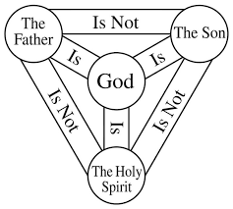
This Week at Zion Includes:
Today – Sunday School/Bible Study; Worship at 10 a.m.
Next Sunday – Bible Study at 9:00 a.m. Worship at 10:00 a.m.

Sunday Morning Bible Study ~Please join us
We are watching video series for our Bible study. The series is called, “That the World Might Know.” We will be watching, “Walking with God in the Desert.” A paragraph about this volume said, “Walking with God in the Desert, by noted teacher and historian, Ray Vander Laan, is volume twelve of the 12-part Faith Lessons series.
Are you going through a difficult period of life? The loss of a loved one? Unemployment? A crisis of faith? During these desert times, it’s easy to think God has disappeared. In Walking with God in the Desert you’ll discover that it’s only when we are totally dependent on him that we find God is closer than ever and can experience his amazing grace and provision.”

Congregational Meeting ~ Today, we will hold our bi-annual congregational meeting. Please plan to attend.

