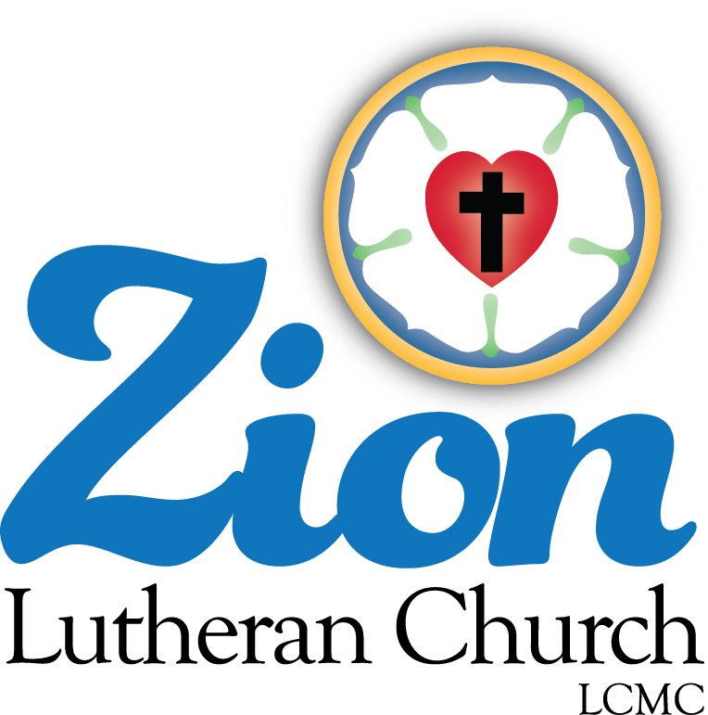

Welcome to ZION Lutheran Church
LCMC ~ Lutheran congregations in mission for Christ
8307 Memorial Hwy. Ottawa Lake, MI 49267 ·
(734) 856-2921
Pastor ∙ Jeffrey Geske
(785) 340-5635
zlcolmpastor@gmail.com
www.zionlutheranottawalakemi.com

Our MISSION:
“SHARING THE LOVE OF JESUS”

To Our Guests
We are so glad that you have chosen to join us this morning! We pray that you will be refreshed and renewed as you come into God’s presence. Please take a moment to introduce yourself to the pastor and to those seated around you. Once again, we warmly thank you for worshipping with us this morning!

Those Assisting in Ministry Today
July 3, 2022 ~ Fourth of July Celebration
Organist: Joseph extejt Greeters : Ron Clark and All
deacon: Dwight Gilliland and Jim Hredzak
SCREEN: Nick Baumgartner & Jacob Geske
Readecr: Karen Vollmer
Altar Guild: Shirley Clark and JoAnn VanSteenkiste
Administrative assistant: Sandy Brady 419- 410-9380 or skwiles2000@gmail.com

LCMC ~ WHO WE ARE
Free in Christ + Accountable to One Another + Rooted in Scripture and the Lutheran Confessions + Committed to the Great Commission

Thoughts on our Readings ~ (-- From the Sola Publishing Website)
The Scriptures for today emphasize the reality of sharing the Good News of Jesus Christ. Either the Gospel and the person who proclaims it are accepted, or the Word and the messenger are rejected. There is no in between. As followers of Christ, we are called to share the message of salvation and offer a sign of peace to every person we come in contact with — but we won’t always receive a blessing in return.
INDEPENDENCE DAY
July 3, 2022

A SERVICE OF PRAYER AND PREACHING

AS WE GATHER
"Independence Day" in the United States of America celebrates the adoption of the Declaration of Independence on July 4, 1776, declaring independence from Great Britain and the "birthday" of the United States as a sovereign nation. Christians live in two kingdoms or realms simultaneously. We are, at once, subjects of an earthly government and, at the same time, members of the heavenly kingdom. Loyalty to both is required (Mark 12:17). It is only when the earthly government requires any denial of the heavenly kingdom (as for instance in the old Soviet Union or under other atheist regimes) that the Christian is constrained "to obey God rather than men" (Acts 5:29). A secular celebration of Independence Day takes great pride in our country in distinction from all other national loyalties. A Christian celebration likewise takes pride in our country all the while mindful of our spiritual family that transcends all national loyalties.

WELCOME

PLEDGE OF ALLEGIANCE TO THE CHRISTIAN FLAG AND THE USA FLAG

HYMN

Star Spangled Banner
Oh, say, can you see, by the dawn's early light,
What so proudly we hail'd at the twilight's last gleaming?
Whose broad stripes and bright stars, thro' the perilous fight,
O'er the ramparts we watch'd, were so gallantly streaming?
And the rockets' red glare, the bombs bursting in air,
Gave proof thro' the night that our flag was still there.
O say, does that star-spangled banner yet wave
O'er the land of the free and the home of the brave?

O, thus be it ever when freemen shall stand,
Between their lov'd homes and the war's desolation;
Blest with vict'ry and peace, may the heav'n-rescued land
Praise the Pow'r that hath made and preserv'd us a nation!
Then conquer we must, when our cause is just,
And this be our motto: "In God is our trust"
And the star-spangled banner in triumph shall wave
O'er the land of the free and the home of the brave!

America the Beautiful

O beautiful for spacious skies,
For amber waves of grain,
For purple mountain majesties
Above the fruited plain!
America! America!
God shed his grace on thee
And crown thy good with brotherhood
From sea to shining sea!
O beautiful for patriot dream
That sees beyond the years
Thine alabaster cities gleam
Undimmed by human tears!
America! America!
God shed his grace on thee
Till nobler men keep once again
Thy whiter jubilee!

OPENING SENTENCES
Pastor: In the name of the Father and of the + Son and of the Holy Spirit.
People: Amen.
Pastor: The earth is the Lord's and the fullness thereof,
People: the world and those who dwell therein.
Pastor: Who shall ascend the hill of the Lord?
People: He who has clean hands and a pure heart. Psalm 24:1, 3a, 4a
Pastor: Better is one day in Your courts than a thousand elsewhere;
People: I would rather be a doorkeeper in the house of my God than dwell in the tents of the wicked. Psalm 84:10
Pastor: Make me to know Your ways, O Lord.
People: Teach me Your paths. Psalm 25: 4
Pastor: Sanctify us in Your truth.
People: Your Word is truth.
Pastor: From the rising of the sun to its setting,
People: the name of the Lord is to be praised. Psalm 113: 3
Glory be to the Father and to the Son and to the Holy Spirit;
as it was in the beginning, is now, and will be forever. Amen.

READINGS FROM HOLY SCRIPTURE

OLD TESTAMENT READING Proverbs 8:1-21 (Wisdom for all who govern justly.)

¹Does not wisdom call?
Does not understanding raise her voice?
²On the heights beside the way,
at the crossroads she takes her stand;
³beside the gates in front of the town,
at the entrance of the portals she cries aloud:
⁴“To you, O men, I call,
and my cry is to the children of man.
⁵O simple ones, learn prudence;
O fools, learn sense.
⁶Hear, for I will speak noble things,
and from my lips will come what is right,
⁷for my mouth will utter truth;
wickedness is an abomination to my lips.
⁸All the words of my mouth are righteous;
there is nothing twisted or crooked in them.
⁹They are all straight to him who understands,
and right to those who find knowledge.
¹⁰Take my instruction instead of silver,
and knowledge rather than choice gold,
¹¹For wisdom is better than jewels,
and all that you may desire cannot compare with her.
¹²“I, wisdom, dwell with prudence,
and I find knowledge and discretion.
¹³The fear of the Lord is hatred of evil.
Pride and arrogance and the way of evil
and perverted speech I hate.
¹⁴I have counsel and sound wisdom;
I have insight; I have strength.
¹⁵By me kings reign,
and rulers decree what is just;
¹⁶by me princes rule,
and nobles, all who govern justly.
¹⁷I love those who love me,
and those who seek me diligently find me.
¹⁸Riches and honor are with me,
enduring wealth and righteousness.
¹⁹My fruit is better than gold, even fine gold,
and my yield than choice silver.
²⁰I walk in the way of righteousness,
in the paths of justice,
²¹granting an inheritance to those who love me,
and filling their treasuries.

Pastor: This is the Word of the Lord.
People: Thanks be to God.

EPISTLE READING Romans 13:1-10 (God's mask of governing authorities.)

¹Let every person be subject to the governing authorities. For there is no authority except from God, and those that exist have been instituted by God. ²Therefore whoever resists the authorities resists what God has appointed, and those who resist will incur judgment. ³For rulers are not a terror to good conduct, but to bad. Would you have no fear of the one who is in authority? Then do what is good, and you will receive his approval, ⁴for he is God’s servant for your good. But if you do wrong, be afraid, for he does not bear the sword in vain. For he is the servant of God, an avenger who carries out God’s wrath on the wrongdoer. ⁵Therefore one must be in subjection, not only to avoid God’s wrath but also for the sake of conscience. ⁶For the same reason you also pay taxes, for the authorities are ministers of God, attending to this very thing. ⁷Pay to all what is owed to them: taxes to whom taxes are owed, revenue to whom revenue is owed, respect to whom respect is owed, honor to whom honor is owed.
⁸Owe no one anything, except to love each other, for the one who loves another has fulfilled the law. ⁹The commandments, “You shall not commit adultery, You shall not murder, You shall not steal, You shall not covet,” and any other commandment, are summed up in this word: “You shall love your neighbor as yourself.” ¹⁰Love does no wrong to a neighbor; therefore love is the fulfilling of the law.

Pastor: This is the Word of the Lord.
People: Thanks be to God.

GOSPEL READING Mark 12:13-17 (Loyalty to church and state)

13 And they sent to him some of the Pharisees and some of the Herodians, to trap him in his talk. 14 And they came and said to him, “Teacher, we know that you are true and do not care about anyone’s opinion. For you are not swayed by appearances, but truly teach the way of God. Is it lawful to pay taxes to Caesar, or not? Should we pay them, or should we not?” 15 But, knowing their hypocrisy, he said to them, “Why put me to the test? Bring me a denarius and let me look at it.” 16 And they brought one. And he said to them, “Whose likeness and inscription is this?” They said to him, “Caesar’s.” 17 Jesus said to them, “Render to Caesar the things that are Caesar’s, and to God the things that are God’s.” And they marveled at him.

Pastor: This is the Word of the Lord.
People: Thanks be to God.

RESPONSORY
Leader: Forever, O Lord, Your Word is firmly set in the heavens.
People: Lord, I love the habitation of Your house and the place where Your glory dwells. Psalm 26: 8

Leader: Blessed are those who hear the Word of God and keep it.
People: Lord, I love the habitation of Your house and the place where Your glory dwells.

Leader: Glory be to the Father and to the Son and to the Holy Spirit.
People: Lord, I love the habitation of Your house and the place where Your glory dwells.

CATECHISM
Pastor: The Ten Commandments.
People: You shall have no other gods.
You shall not misuse the name of the Lord your God.
Remember the Sabbath day by keeping it holy.
Honor your father and your mother.
You shall not murder.
You shall not commit adultery.
You shall not steal.
You shall not give false testimony against your neighbor.
You shall not covet your neighbor's house.
You shall not covet your neighbor's wife, or his manservant or maidservant, his ox or donkey, or anything that belongs to your neighbor.

Pastor: The Apostles' Creed.
People: I believe in God, the Father Almighty,
maker of heaven and earth.

And in Jesus Christ, His only Son, our Lord,
who was conceived by the Holy Spirit,
born of the virgin Mary,
suffered under Pontius Pilate,
was crucified, died and was buried.
He descended into hell.
The third day He rose again from the dead.
He ascended into heaven
and sits at the right hand of God the Father Almighty.
From thence He will come to judge the living and the dead.

I believe in the Holy Spirit,
the holy Christian Church,
the communion of saints,
the forgiveness of sins,
the resurrection of the body,
and the life + everlasting. Amen.

HYMN LSB 966 "Before You, Lord We Bow"

SERMON

THE GATHERING OF OUR OFFERING

HYMN Special Music “My Country Tis of Thee”

My country, 'tis of thee, Sweet land of liberty, Of thee I sing:
Land where my fathers died, Land of the pilgrim's pride,
From ev'ry mountainside Let freedom ring.

My native country, thee, Land of the noble free, Thy name I love;
I love thy rocks and rills, Thy woods and templed hills;
My heart with rapture thrills Like that above.

Let music swell the breeze, And ring from all the trees Sweet freedom's song;
Let mortal tongues awake; Let all that breathe partake;
Let rocks their silence break, The sound prolong.

Our fathers' God, to Thee, Author of liberty, To Thee we sing:
Long may our land be bright With freedom's holy light;
Protect us by Thy might, Great God, our King!

PRAYER OF THE CHURCH
Pastor: Almighty God, all we have and enjoy is a gift from Your gracious hand. We come before You today in heartfelt appreciation for our nation and its people, its just laws and Your gift of liberty. We thank You especially for the freedom to worship You and to serve You without fear.

You have enriched and blessed us with the bounties of farm and factory, the beauty of forest and mountain, and the marvels of medicine and science.

Look with favor upon this nation, this state, and this community. Preserve our cherished liberties. Enable our leaders to govern with wisdom, honesty, courage, and justice. Protect those who serve in the armed forces and those who maintain peace and safety in our communities.

Give us willing hearts to obey our nation's laws and to work for the common good.

Bless our fields that they may produce abundant harvest. Guard us from calamities of nature, terrorism, and warfare, and spare our land from the ravages of disease and epidemic.

Strengthen the homes of our nation. By Your Spirit lead husbands and wives to love each other, parents to nurture their children, young adults to assume responsibility, and children to show respect.

[Special petitions for members of the congregation may be inserted here.]

When times are prosperous let our hearts be thankful; and in troubled times, do not let our trust in You fail. We ask this through Jesus Christ our Lord, who lives and reigns with You and the Holy Spirit, one God, now and forever.
People: Amen.

COLLECT FOR THE WORD
Pastor: Blessed Lord, You have caused all Holy Scriptures to be written for our learning. Grant that we may so hear them, read, mark, learn, and take them to heart that, by the patience and comfort of Your holy Word, we may embrace and ever hold fast the blessed hope of everlasting life; through Jesus Christ, Your Son, our Lord, who lives and reigns with You and the Holy Spirit, one God, now and forever.
People: Amen.

MORNING PRAYER
People: I thank You, my heavenly Father, through Jesus Christ, Your dear Son, that You have kept me this night from all harm and danger; and I pray that You would keep me this day also from sin and every evil, that all my doings and life may please You. For into Your hands I commend myself, my body and soul, and all things. Let Your holy angel be with me, that the evil foe may have no power over me. Amen.

LORD'S PRAYER
All: Our Father who art in heaven, hallowed be thy name, thy kingdom come, thy will be done on earth as it is in heaven. Give us this day our daily bread; and forgive us our trespasses as we forgive those who trespasses against us; and lead us not into temptation, but deliver us from evil. For thine is the kingdom and the power and the glory forever and ever. Amen.

BLESSING
Pastor: Let us bless the Lord.
People: Thanks be to God.

Pastor: The almighty and merciful Lord, the Father, the + Son, and the Holy Spirit, bless and preserve you.
People: Amen.

CLOSING SONGS “God of Our Fathers”

- God of our fathers, whose almighty hand
Leads forth in beauty all the starry band
Of shining worlds in splendor through the skies,
Our grateful songs before Thy throne arise.
- Thy love divine hath led us in the past,
In this free land by Thee our lot is cast;
Be Thou our ruler, guardian, guide and stay,
Thy Word our law, Thy paths our chosen way.
- From war’s alarms, from deadly pestilence,
Be Thy strong arm our ever sure defense;
Thy true religion in our hearts increase,
Thy bounteous goodness nourish us in peace.
- Refresh Thy people on their toilsome way,
Lead us from night to never-ending day;
Fill all our lives with love and grace divine,
And glory, laud, and praise be ever Thine.

“God Bless America”
God Bless America,
Land that I love.
Stand beside her, and guide her
Thru the night with a light from above.
From the mountains, to the prairies,
To the oceans, white with foam
God bless America, My home sweet home.
God bless America, My home sweet home
(2x)

Go in Peace ~ Sharing the Love of Jesus!

Services covered by CCLI: 1553677 ~ Lutheran Service Book Hymn License # 100014699 ~ Lutheran Service Book Liturgy License. # 000014699

IN OUR PRAYERS:
- For our congregation members; that they may be committed to our mission of sharing the love of Jesus.
- Pastor and Jacob Geske
- For LCMC Congregation and Missionaries around the world.
- President Biden, national leaders and our country. Our nation’s military, especially our loved ones:
- For those who are sick, recovering, or in need of God’s grace at this time. We include in our prayers: Loretta VanDyke, Susan Gaylord, Betty Vesey, Parker Reau, Marilyn Bexten, Fred and JoAnn VanSteenkiste, Melvin Sieler, Gene Weimer, Jon and Mary Dellabona’s grandchild Madeline and Bill Brady, Ron Vincent and those dealing with Covid.
Prayer List: Please let us know when we can take the name off of the prayer list. Thank you!.

Announcements

OUR STEWARDSHIP ~ Weekly budget needs are $1,908.12. Attendance last Sunday was 40. Offerings given totaled $1915.00 Thank you for your support of our ministry!

Flowers on the Altar ~ If you would like to place flowers on the altar, please sign up in the hallway. Let pastor or Sandy know if you are celebrating or remembering something special. Flowers this Sunday are given to the glory of God by Ron and Shirley Clark.
This Week at Zion Includes:
Today – Worship at 10 a.m.
Saturday, July 9 ~ Men’s Breakfast at 8:00 a.m. And Contemporary Service at 4:00 p.m.
Next Sunday – Bible Study at 9:00 a.m. Worship at 10:00 a.m.

Zion Lutheran Church Choir ~ They practice after church. They would love to have you join them.

Zion Lutheran Hand bell Choir ~ They will resume practicing in the Fall.

Men’s Breakfast ~ Join us for Men’s Breakfast next Saturday on July 9 at 8:00 a.m. We will have breakfast and a Bible Study.
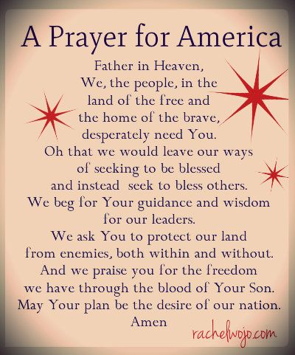
Aaronic Benediction ~ The familiar blessing that begins, "The Lord bless you and keep you." It is given the name "Aaronic" because it is the blessing God commanded Moses to give to his brother Aaron to speak to the people (Num. 6:24—26). (The equation 4 X 6 = 24)

Sunday Morning Bible Study ~Please join us
We are enjoying a video Bible series called, “That the World May Know.” Please join us next Sunday for another interesting video.

