Welcome to ZION Lutheran Church
LCMC ~ Lutheran congregations in mission for Christ
8307 Memorial Hwy. Ottawa Lake, MI 49267 ·
(734) 856-2921
Pastor ∙ Jeffrey Geske
(785) 340-5635
zlcolmpastor@gmail.com
www.zionlutheranottawalakemi.com

Our MISSION:
“SHARING THE LOVE OF JESUS”

To Our Guests
We are so glad that you have chosen to join us this morning! We pray that you will be refreshed and renewed as you come into God’s presence. Please take a moment to introduce yourself to the pastor and to those seated around you. Once again, we warmly thank you for worshipping with us this morning!

Those Assisting in Ministry Today
July 17, 2022 ~ Sixth sunday after Pentecost
Organist: Joseph extejt Greeters : Ron Clark and All
deacon: Dwight Gilliland and Jim Hredzak
SCREEN: Nick Baumgartner & Jacob Geske
Reader and assistant: Jim Hredzak
Altar Guild: Shirley Clark and JoAnn VanSteenkiste
Administrative assistant: Sandy Brady 419- 410-9380 or skwiles2000@gmail.com

LCMC ~ WHO WE ARE
Free in Christ + Accountable to One Another + Rooted in Scripture and the Lutheran Confessions + Committed to the Great Commission

Thoughts on our Readings ~ (-- From the Sola Publishing Website)
Martha is as busy as any person can be, tending to the household chores and working hard to serve Jesus a meal. We don’t know if she enjoys her work, only that she is sorely anxious over it and resentful of her sister’s attention to Jesus. What Martha considers idleness, Jesus renames “the good portion.” Our Lord calls us to seek his face, then sit at his feet, and to be fully present with him as he is fully present.

July 17, 2022 ~ 6th Sunday After Pentecost
(--From the LCMS Website)
Luke 10:40b – “Lord, do you not care that my sister has left me to serve alone?” Martha is doing the right thing but in the wrong order. Her service to the Lord is good, but she has let it get ahead of hearing His Word. Mary has placed the Word first, which is good. Is there any doubt that she will rise once she has heard the Word and get to serving as well? Isn’t that what hearing the Word always leads us to do? We listen, then respond. We believe, and thus we act!

IN OUR PRAYERS:
- For our congregation members; that they may be committed to our mission of sharing the love of Jesus.
- Pastor and Jacob Geske
- For LCMC Congregation and Missionaries around the world.
- President Biden, national leaders and our country. Our nation’s military, especially our loved ones:
- For those who are sick, recovering, or in need of God’s grace at this time. We include in our prayers: Loretta VanDyke, Susan Gaylord, Betty Vesey, Parker Reau, Marilyn Bexten, Joann Koester, Fred and JoAnn VanSteenkiste, Melvin Sieler, Gene Weimer, Joann Koester, Jon and Mary Dellabona’s grandchild Madeline, Ron Vincent and those dealing with Covid.
Prayer List: Please let us know when we can take the name off of the prayer list. Thank you!.

Services covered by CCLI: 1553677 ~ Lutheran Service Book Hymn License # 100014699 ~ Lutheran Service Book Liturgy License. # 000014699

OUR STEWARDSHIP ~ Weekly budget needs are $1,908.12. Attendance last weekend was 41. Offerings given totaled $1964.00 Thank you for your support of our ministry!

Flowers on the Altar ~ If you would like to place flowers on the altar, please sign up in the hallway. Let pastor or Sandy know if you are celebrating or remembering something special. Flowers this Sunday are given to the glory of God by Nancy and Debbie Johnson in memory of Harold Johnson’s 90th birthday.

Worship Service Order
Welcome
Opening Hymn: LBW 390
“I Love to Tell the Story”
Confession and Absolution LSB 151
Kyrie: LSB p. 152
Hymn: LSB p. 155
“This the Feast”

†GOD’S WORD FOR US†
(On Insert)
Collect of the Day
Old Testament Reading:
Genesis 18:1-10a,(10b-14)
Psalm:
Psalm 27”(1-6) 7-14
Epistle Reading
Colossians 1:21-29
Holy Gospel:
Luke 10:38-42
Hymn of the Day:
LSB 575
“My Hope is Built on Nothing Less”

Today’s Message:
“One Thing is Necessary”
Luke 10:38-42

Creed: Nicene Creed
Offering
Hymn: LSB 739
“When Peace Like a River”
Prayers and Lord’s Prayer

The Celebration of the Lord’s Supper
Video: “Who You Say I Am”
Hymn: LSB 529
“What is this Bread”
Benediction ~ Sending
Closing Hymn: LSB 662
“Onward Christian Soldiers”

Announcements

This Week at Zion Includes:
Today – Sunday School/Bible Study; Worship at 10 a.m.
Next Sunday – Bible Study at 9:00 a.m. Worship at 10:00 a.m.
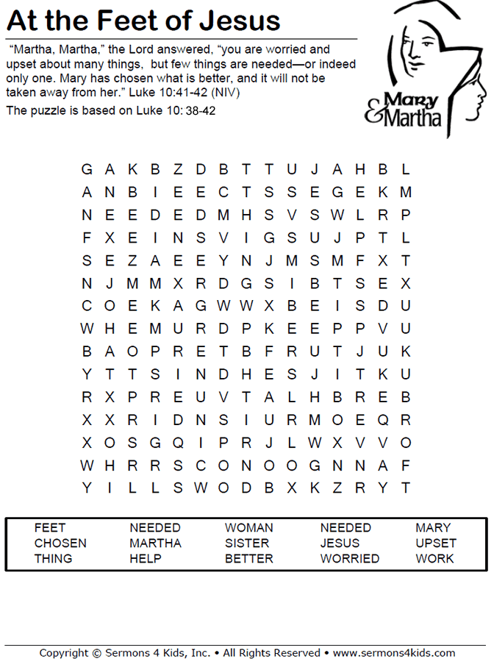
Sunday Morning Bible Study ~Please join us
We are watching video series for our Bible study. The series is called, “That the World Might Know.” We will be watching, “Mission of Jesus.”

Israel Trip Information ~ Pick up a brochure today regarding the trip that Pastor will be hosting in June of 2023. Please pick up additional brochures for family or friends that might be interested in this exciting trip. For more information, please speak to Pastor Jeff.

Church Picnic ~ Mark your calendars for Saturday, August 13 at 5:30 p.m. at Roger and Toni Smith’s home.

Noisy Kettle Sunday ~ On July 24, we will have a Noisy Sunday/Door Offering for the Gideon’s and their ministry of placing God’s Word into the hands and hearts of people.

Did You Know ~ Vestments ~ From the Latin vestimentum, meaning "garment." Vestments are worn by the pastor and other liturgical assistants. Among their many purposes is the fact that they identify the person vested as a servant of the church and cover any individuality of clothing style which may be a distraction in the service of God's Word.

