Welcome to ZION Lutheran Church
LCMC ~ Lutheran congregations in mission for Christ
8307 Memorial Hwy. Ottawa Lake, MI 49267 ·
(734) 856-2921
Pastor ∙ Jeffrey Geske
(785) 340-5635
zlcolmpastor@gmail.com
www.zionlutheranottawalakemi.com

Our MISSION:
“SHARING THE LOVE OF JESUS”

To Our Guests
We are so glad that you have chosen to join us this morning! We pray that you will be refreshed and renewed as you come into God’s presence. Please take a moment to introduce yourself to the pastor and to those seated around you. Once again, we warmly thank you for worshipping with us this morning!

Those Assisting in Ministry Today
July 31, 2022 ~ seventh sunday after Pentecost
Organist: Joseph extejt Greeters : Ron Clark and All
deacon: Dwight Gilliland and Jim Hredzak
SCREEN: Nick Baumgartner & Jacob Geske
Reader: Karen Vollmer
Altar Guild: Shirley Clark and JoAnn VanSteenkiste
Administrative assistant: Sandy Brady 419- 410-9380 or skwiles2000@gmail.com

LCMC ~ WHO WE ARE
Free in Christ + Accountable to One Another + Rooted in Scripture and the Lutheran Confessions + Committed to the Great Commission

Thoughts on our Readings ~ (-- From the Sola Publishing Website)
A life lived without God at the center is an empty life indeed. We may have enough grain to fill multiple barns and silos, but if we are rich in possessions and poor toward God, then all is in vain. The Christian life is characterized by seeking the things of Christ, not the things of this world. Only the things of God offer us new life and life abundant. We are warned to guard against the idolatry of possessions.

July 31, 2022 ~ 8th Sunday After Pentecost
(--From the LCMS Website)
Luke 12:15 – “And he said to them, ‘Take care, and be on your guard against all covetousness, for one’s life does not consist in the abundance of his possessions.’ ” Coveting is the opposite of being content with what God has given us. And the cure for coveting is twofold: thankfulness to God and generosity toward God’s purposes. So be on guard against all covetousness. Acknowledge that your Father has given you all you need, and therefore be free and confident in directing the mammon of this world toward godly purposes.

IN OUR PRAYERS:
- For our congregation members; that they may be committed to our mission of sharing the love of Jesus.
- Pastor and Jacob Geske
- For LCMC Congregation and Missionaries around the world.
- President Biden, national leaders and our country. Our nation’s military, especially our loved ones:
- For those who are sick, recovering, or in need of God’s grace at this time. We include in our prayers: Loretta VanDyke, Susan Gaylord, Betty Vesey, Parker Reau, Marilyn Bexten, Fred and JoAnn VanSteenkiste, Joann Koester, Madeline, Ron Vincent and those dealing with Covid.
Prayer List: Please let us know when we can take the name off of the prayer list. Thank you!.

Services covered by CCLI: 1553677 ~ Lutheran Service Book Hymn License # 100014699 ~ Lutheran Service Book Liturgy License. # 000014699

OUR STEWARDSHIP ~ Weekly budget needs are $1,908.12. Attendance last weekend was 54. Offerings given totaled $2807.57 Thank you for your support of our ministry!

Flowers on the Altar ~ If you would like to place flowers on the altar, please sign up in the hallway. Let pastor or Sandy know if you are celebrating or remembering something special. Flowers this Sunday are given to the glory of God by Bob Hardesty and MaryJo Price in celebration of her 75th birthday.

Worship Service Order
Welcome
Opening Hymn: LSB 704
“Renew Me O Eternal Light”
Confession and Absolution LSB 203
Kyrie: LSB p. 204
Gloria in Excelsis: LSB 204

†GOD’S WORD FOR US†
(On Insert)
Collect of the Day
Old Testament Reading:
Ecclesiastes 1:2, 12-14: 2:18-26
Psalm:
Psalm 100
Epistle Reading:
Colossians 3:1-11
Alleluia and Verse: LSB 205
Holy Gospel:
Luke 12:13-21
Hymn of the Day:
LSB 782 (Tune 803)
“Gracious God, You Send Great Blessings”
Today’s Message:
“Seek the Things that are Above”
Colossians 3:1-11

Creed: Nicene Creed
Offering
Hymn: LSB 789
“Praise and Thanksgiving”
Prayers and Lord’s Prayer
The Celebration of the Lord’s Supper
Video: “You are My All in All”
Hymn: LSB 537
“Beautiful Savior”
Benediction ~ Sending
Closing Hymn: LSB 842
“Son of God, Eternal Savior”

Announcements

This Week at Zion Includes:
Today – Sunday School/Bible Study; Worship at 10 a.m.
Next Sunday – No Bible Study at 9:00 a.m. Worship at 10:00 a.m.

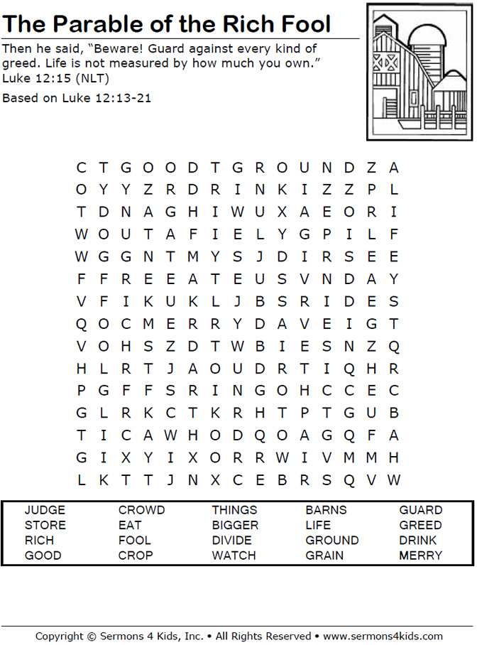
Sunday Morning Bible Study ~Please join us
We are watching video series for our Bible study. The series is called, “That the World Might Know.” We will be watching, “Mission of Jesus.”

Israel Trip Information ~ Pick up a brochure today regarding the trip that Pastor will be hosting in June of 2023. Please pick up additional brochures for family or friends that might be interested in this exciting trip. For more information, please speak to Pastor Jeff.

August Newsletter ~ Please pick up your August newsletter in the Fellowship Hall.

Pastor on Vacation ~ Pastor will be out of town from Friday, August 5 through Sunday, August 7. Please contact Sandy Brady if there are any emergencies.

Men’s Breakfast ~ Mark your calendars for Saturday, August 13 at 8:00 a.m.

Church Picnic ~ Mark your calendars for Saturday, August 13 at 5:30 p.m. at Roger and Toni Smith’s home.

Noisy Kettle Sunday ~ Thank you to everyone for helping us to be a blessing to the ministry of the Gideon’s.



