The Messenger
A newsletter of Zion Lutheran Church ~ Ottawa Lake, MI
August 2022
+ + + + + + + + + +
Church Picnic ~ Please plan to join in the fun at our church picnic on August 13, 2022 at the home of Roger and Toni Smith. Their address is 12312 S. County Line, Ottawa Lake. (South of Sterns and County Line)
The picnic will be from 5:30-8:00 p.m. and we will eat about 6:00 p.m.

Sunday Morning Bible Study
We have begun to watch a video called, “That the World Might Know.” Learn more about this series in the Bible Class section of this newsletter.
There will be no Bible class on August 7.
Please plan to join us at 9:00 a.m. on August 14th.

Lutheran Men ~Monthly Breakfast
On August 13, 2022, we will have our Lutheran Men’s Monthly breakfast. Breakfast will be served at 8:00 a.m. We will have a hot breakfast, devotion, and a Bible study. Please come and feel free to invite a friend or neighbor. It would be great to see you there!

Pastor on Vacation
Pastor will be out of town from Friday, August 5 through Sunday, August 8. For assistance call Sandy Brady.

WORSHIP WITH US EACH WEEK!
Join us for worship on Sunday morning at 10:00 a.m.
Our Contemporary Service is on Saturday at 4:00 p.m.

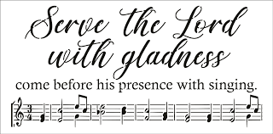
Zion Church Choir
They will resume meeting in September. For more information, please speak with Joseph Extejt.
HANDBELL CHOIR ~ Come join us in the fall. We are taking a break for the summer. We will resume in September. For more information, please speak to Karen Vollmer.
ZION Lutheran Church
LCMC ~ Lutheran congregations in mission for Christ
8307 Memorial Hwy. Ottawa Lake, MI 49267 ·
(734) 856-2921
Pastor ∙ Jeffrey Geske
(785) 340-5635
zlcolmpastor@gmail.com
www.zionlutheranottawalakemi.com

Secretary ~ Sandy brady
(419) 410-9380
skwiles2000@gmail.com
custodian and organist~ Joseph extejt

For Your Information
The following members give of their time to the leadership of this congregation. Please keep them in your prayers. If you have any questions, comments, or offers of help, please contact them.
Chairman: Ron Vincent
Secretary: Connie Sieler
Treasurer: Brian Gilliland
Financial: Sandy Bondy
Recording: MaryJo Price
Elders: Ron Clark and Lee Edignton
Deacons: Dwight Gilliland and Jim Hredzak
LCMC ~ WHO WE ARE
Free in Christ + Accountable to One Another + Rooted in Scripture and the Lutheran Confessions + Committed to the Great Commission

Prayers Are Important
If you have an occasion to request a prayer, please call the church office. If you would like your request to be on our prayer chain, please call Sandy Brady (419) 410-9380 or Pastor Jeff at the church or on his cell phone (785)340-5635.
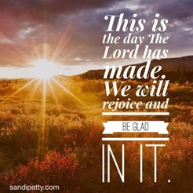

Please Inform the Church Office. . .
*when a member of your family is ill or hospitalized or if they are discharged or moved to another facility.
*when your address changes.
*when a new baby arrives.
*when a family member marries or leaves home for college, or military.
*when planning a wedding to be conducted at Zion.
*when a new family moves into your neighborhood.
*when you are planning to be out of town.
*when a brother or sister in Christ needs a visit from Pastor.

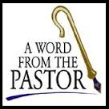
From the desk of Pastor Geske….

Ten Little Christians
Ten little Christians standing in a line,
One disliked the Preacher, then there were nine.
Nine little Christians stayed up very late,
One slept in on Sunday, then there were eight.
Eight little Christians, on their way to Heaven,
One took his own road, then there were seven.
Seven little Christians chirping like some chicks,
One disliked the song leader, then there were six.
Six little Christians seemed very much alive,
One lost his interest, then there were five.
Five little Christians pulling for heaven's shore,
One stopped to rest, then there were only four.
Four little Christians each busy as a bee,
One got his feelings hurt, then there were three.
Three little Christians knew not what to do,
One couldn't forgive another, then there were two.
Two little Christians, our rhyme is nearly done
Quarreled over petty stuff, then there was only one.
One little Christian, can't do much 'tis true;
Brought his friend to Bible Study - then there were two.
Two earnest Christians, each won one more,
That doubled the number, then there were four.
Four sincere Christians worked early and worked late,
Each won another, then there were eight.
Eight splendid Christians, if they doubled as before,
In a few short weeks, we'd have 1,024.
In this little jingle, there is a lesson true:
You either belong to the Building,
Or to the Wrecking Crew.
What a wonderful poem for us to consider as we are about the Lord’s work of sharing the love and forgiveness of Jesus! Anytime you have more than one person involved in an activity, you will have different opinions and ideas. The important thing is for us to seek to work and walk together in ways that bring glory to God and extend His kingdom among us.
I like those words of Luther in our catechism that speak about the petition in the Lord’s Prayer, “Thy Kingdom Come.” We read, “What does this mean? The kingdom of God certainly comes by itself without our prayer, but we pray in this petition that it may come to us also.
How does God’s kingdom come? God’s kingdom comes when our heavenly Father gives us His Holy Spirit, so that by His grace we believe His holy Word and lead godly lives here in time and there in eternity.”
Godly lives here in time and there in eternity. Yes, God wants us to be about living the message of His kingdom as we daily reach out with the love of Jesus. How are we doing with that goal? As I look at our church, I am again so thankful for how God’s people are giving of their time, talents, and treasures to do the Lord’s work and extend His kingdom. Yes, we always can see that there are times that we need to reflect and prayerfully consider our giving to the Lord of all three of T’s. We are not motivated by the Law, but by the Good News that Jesus died and rose for us so that forgiveness and eternal life are ours in Christ.
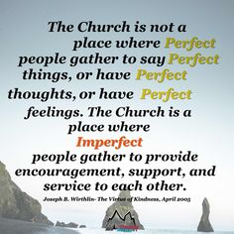
Yes, we are called to be part of building up the kingdom. Peter wrote these words so wonderfully, “But you are a chosen people, a royal priesthood, a holy nation, a people belonging to God, that you may declare the praises of him who called you out of darkness into his wonderful light.” (1 Peter 2:9 NIV) How can you daily reflect and shine the praises of God through your life? I ask you to continue to pray about how you can reflect the love of Christ through our work together as the body of Christ at Immanuel. I pray that God uses our worship and growing together in a way that enhances and excites you to daily witness the love of Jesus Christ through your life. Yes, I will say it again, I look forward to seeing you in God’s house, faithfully worshipping and growing as His child so you will always be part of the building crew.

In Christ,
Pastor Jeffrey D. Geske

Sunday Morning Bible Class
Please come and join our study of the Word of God!
During the summer, we will be watching videos from this amazing series
That The World May Know Series

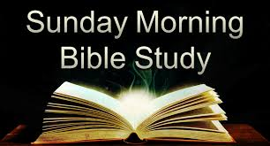
Take your group on a trip to ancient times, places, and customs with trusted Bible scholar Ray Vander Laan as your fun and engaging tour guide. Filmed in Israel, Egypt, Turkey, and Greece, these powerful videos explore what it meant to follow Jesus in the first century—and what it means to follow him today. Each of the 16 volumes provides visually stunning video sessions as well as an easy-to-follow discovery guide that illuminates Jesus’ teachings and helps participants understand the context in which He lived and preached. Join renowned teacher and historian Ray Vander Laan as he guides you through the lands of the Bible. In each lesson, Vander Laan illuminates the historical, geographical, and cultural context of the sacred Scriptures. Filmed on location in the Middle East, the That the World May Know ® film series will transform your understanding of God and challenge you to be a true follower of Jesus.
God’s Word of Today ~ Study of Ephesians
Our Study of Ephesians will resume in September.
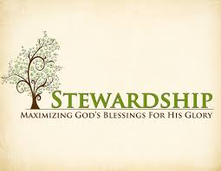
Newsletter Article – August 2022
(--From the LCMS website)

The Ceremony of the Offertory

Have you ever noticed the subtle ceremony involved in receiving the offerings during the Divine Service? After all the offerings have been collected, they are brought forward and given to the pastor or one of his assistants. The pastor then turns toward the altar, and as he slightly bows his head, the collection plates with the offerings in them are raised slightly to the Lord and then placed either on the altar or a table for the offerings. Why do we do have this ceremony? And what does it teach us? For that is what ceremony does; it teaches, as the Augsburg Confession tells us, what we need to know about Christ (AC XXIV, 1–3).

Originally, this ceremony included more than simply bringing forward what was collected in the offering plates. The elements for the Holy Communion—the bread and the wine—were brought forward along with the offering plates. As the offering plates and the elements were lifted toward the Lord, and placed upon the altar, the elements would be put in the center and the altar, now made a table, would be set for the Lord’s Supper.

These gifts brought to the altar came from the sweat of the people’s brow. It is the bread and wine, the fruits of the peoples’ labor in this fallen world. After six days of labor and toil, the people would bring a generous proportion for the Lord’s work. It was set upon the altar and offered to the Lord for Him to take up and press into His service for His gracious work in and among them.

For what they offered to the Lord from the sweat of their brow, the bread of anxious toil, came back to them as the bread of life, the bread come down from heaven that whoever eats this bread and drinks this cup would receive life through the forgiveness of their sins.
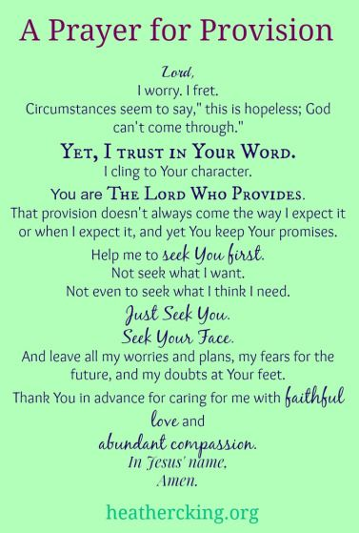
This is not unlike what the Lord did for His people in the Old Testament:

You shall tithe all the yield of your seed that comes from the field year by year. And before the Lord your God, in the place that he will choose, to make his name dwell there, you shall eat the tithe of your grain, of your wine, and of your oil, and the firstborn of your herd and flock, that you may learn to fear the Lord your God always. And if the way is too long for you, so that you are not able to carry the tithe, when the Lord your God blesses you, because the place is too far from you, which the Lord your God chooses, to set his name there, then you shall turn it into money and bind up the money in your hand and go to the place that the Lord your God chooses and spend the money for whatever you desire—oxen or sheep or wine or strong drink, whatever your appetite craves. And you shall eat there before the Lord your God and rejoice, you and your household.

What a blessing! God provides for us in all things. He provides bread from the sweat of our brows, and He receives this from us in the first fruits offerings we give to Him in thanksgiving and praise. He receives and turns it into spiritual bread, heavenly bread, the bread of eternal life and gives it back to us so that we might have joy. So, the next time you are in the Divine Service, watch this ceremony in wonder, that the Lord gives back to us, what we have given to Him so that we may rejoice in the salvation He has won upon the cross and gives to us in His supper.
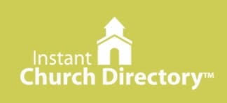
Our Church Directory is Online!
View our church directory online or via the FREE mobile app today. To view the directory online, go to members.InstantChurchDirectory.com and follow the prompts under “Sign In” to “Create a login now.” Please remember, you must confirm your email address before you can sign in. You will need to use your email address as listed in our directory to create a log-in the first time you use the directory online and via the mobile app.
Need help or have questions? Please contact Pastor Jeff.

Food Bank~ Thank you for your generous help with our Food Bank. If you have any question or would like to help in any way, please contact Rick Keck at (734) 854-4710. The Food Bank serves families and individuals on the second and fourth Tuesday of the month from 10:00 a.m. until noon.
What is a Thrivent Action Team? Thrivent Action Teams make it easy to live generously. Thrivent provides promotional resources and seed money to jump-start your fundraiser, educational event or service project. Your team provides the people power to bring it to life.

BIRTHDAYS AND ANNIVERSARIES
We would like to wish Happy Birthday and Happy Anniversary to the following individuals who are celebrating this month. If you are not listed or you know someone not listed, please contact Sandy Brady or Pastor Jeff.
Flowers on the Altar ~ If you would like to place flowers, please sign up in the hallway by the restroom.
The cost is $25.00
Please consider signing up for some time this coming year.

August Birthdays

2 Sandy Bondy
3 Gilbert Olrich
5 Ray Schmidt
9 Jacob Geske
11 Darla Hredzak
22 Jim Taylor
24 Sheila Vincent
30 Mark Ostrander
30 Alex Schmidt
31 MaryJo Gilliland
August Anniversaries

31 Dick and Karen Vollmer

THRIVENT NEWS . . .
If you would like more information about Thrivent, its products, or its fraternal functions, please contact our area representative Greg Durivage in Maumee, OH at (419)-740-4193.

To Join our Text alerts visit: Text the message @jgesk to the number 81010. If you’re having trouble with 81010, try texting @jgesk to (517) 682-0429. This is a free service ~ You are only charged if your cellphone charges per text

Community Rewards Program
Do you shop at Kroger? If you do, you can sign up for their Community Rewards Program and Kroger will give back to Zion money every quarter. Go on Kroger's website and sign up under Community Rewards. If you need help or do not have an email address, check with Pastor Jeff. (Our code is NC512)
Steps for Linking your Kroger card to help our ministry ~
1. Sign into your account at www.kroger.com or create an account.
2. Click on the NAME.
3. Scroll down to MY ACCOUNT and Click on it,
4. Scroll down to COMMUNITY REWARDS. Click on COMMUNITY REWARDS.
5. Enter Zion Lutheran Church Ottawa Lake MI (NC512)

Bringing Christ to the Nations and the Nations to the Church
"The Lutheran Hour," which began in 1930, is now heard on more than 1,300 radio stations around the world. "The Lutheran Hour," hosted by Dr. Rev. Michael Zeigler, is the world's oldest continually-broadcast Gospel radio program. This weekly half-hour program proclaims the message of Jesus Christ to all people and serves as a bridge, linking them to the Church. Listen to the Lutheran Hour on Sundays at 10:00 a.m. or at AM 1560 WWYC or anytime at www.lhm.org

August 2022
August 7
"These Are Not Our Kind of People"
Guest Speaker: Dr. Oswald Hoffmann
Prejudice says, "These are not our kind of people." Charity says, "These are all people for whom Christ died."
(Matthew 5:43-48)
August 14
"Everything Is So Expensive"
Guest Speaker: Dr. Oswald Hoffmann
Everything is so expensive-but do we really

need everything?
(Luke 12:15)
August 21
"Facing the Worst"
Guest Speaker: Dr. Oswald Hoffmann
(John 11:25-26)
August 28
"The Vision We Need"
Guest Speaker: Dr. Oswald Hoffmann
(Romans 8:18-23)

