Welcome to ZION Lutheran Church
LCMC ~ Lutheran congregations in mission for Christ
8307 Memorial Hwy. Ottawa Lake, MI 49267 ·
(734) 856-2921
Pastor ∙ Jeffrey Geske
(785) 340-5635
zlcolmpastor@gmail.com
www.zionlutheranottawalakemi.com

Our MISSION:
“SHARING THE LOVE OF JESUS”

To Our Guests
We are so glad that you have chosen to join us this morning! We pray that you will be refreshed and renewed as you come into God’s presence. Please take a moment to introduce yourself to the pastor and to those seated around you. Once again, we warmly thank you for worshipping with us this morning!

Those Assisting in Ministry Today
August 7, 2022 ~ Ninth sunday after Pentecost
Organist: Joseph extejt Greeters : Ron Clark and All
deacon: Dwight Gilliland and Jim Hredzak
SCREEN: Nick Baumgartner & Jacob Geske
Reader: Lee Edington
Altar Guild: Shirley Clark and JoAnn VanSteenkiste
Administrative assistant: Sandy Brady 419- 410-9380 or skwiles2000@gmail.com

LCMC ~ WHO WE ARE
Free in Christ + Accountable to One Another + Rooted in Scripture and the Lutheran Confessions + Committed to the Great Commission

Thoughts on our Readings ~ (-- From the Sola Publishing Website)
Jesus taught the twelve, “Where your treasure is, there your heart will be also.” God loves his children so deeply that every one of us is a priceless treasure to Him. The psalmist sang of God’s watchful eye and protection. To Abraham, God promised an heir and descendants too numerous to count. God saw the ancestors of the faith through trials and brought them to safety. Our faith rests in Christ alone.

August 7, 2022 ~ 9h Sunday After Pentecost
(--From the LCMS Website)
Luke 12:24 – “Consider the ravens: they neither sow nor reap, they have neither storehouse nor barn, and yet God feeds them.” God feeds the birds of the air – this we know, it’s just that, as one wit put it: God sometimes feeds the birds….to the cats! Yes, crosses and hardships will always come, Christ said that no disciple is above his Master. But through it all, the Lord cares for us and He calls upon us to entrust ourselves to that care. He really is our Father, and He really will guard and keep us through whatever this life has to throw at us. And in the end, we shall receive the gift of eternal life.

IN OUR PRAYERS:
- For our congregation members; that they may be committed to our mission of sharing the love of Jesus.
- Pastor and Jacob Geske
- For LCMC Congregation and Missionaries around the world.
- President Biden, national leaders and our country. Our nation’s military, especially our loved ones:
- For those who are sick, recovering, or in need of God’s grace at this time. We include in our prayers: Loretta VanDyke, Susan Gaylord, Betty Vesey, Parker Reau, Marilyn Bexten, Fred and JoAnn VanSteenkiste, Joann Koester, Madeline, Ron Vincent and those dealing with Covid.
Prayer List: Please let us know when we can take the name off of the prayer list. Thank you!.

Services covered by CCLI: 1553677 ~ Lutheran Service Book Hymn License # 100014699 ~ Lutheran Service Book Liturgy License. # 000014699

OUR STEWARDSHIP ~ Weekly budget needs are $1,908.12. Attendance last weekend was 40. Offerings given totaled $1844.00 Thank you for your support of our ministry!

Flowers on the Altar ~ If you would like to place flowers on the altar, please sign up in the hallway. Let pastor or Sandy know if you are celebrating or remembering something special. Flowers this Sunday are given to the glory of God by Pastor Jeff in honor of Jacob’s 14th birthday this Tuesday.

Worship Service Order
Welcome
Opening Hymn:
LSB 728 St. 1-2,5
“How Firm a Foundation”
Confession and Absolution LSB 151
Kyrie: LSB p. 152
Hymn: LSB 809
“Great is Thy Faithfulness”

†GOD’S WORD FOR US†
(On Insert)
Collect of the Day
Old Testament Reading:
Genesis 15:1-6
Psalm:
Psalm 33:12-22
Second Reading:
Hebrews 11:1-6
Holy Gospel:
Luke 12:22-34 (35-40)
Hymn of the Day:
LSB 735
“Have No Fear Little Flock”
Today’s Message:
“Do Not be Anxious, Seek the Kingdom
Luke 12:22-34
Creed: Apostles’ Creed
Offering
Video: “The Commission”
Hymn: LSB 770
“What a Friend, We have in Jesus”
Prayers and Lord’s Prayer
Benediction ~ Sending
Closing Hymn: LSB 722
“Lord, Take My Hand”

Announcements

This Week at Zion Includes:
Today – No Sunday School/Bible Study; Worship at 10 a.m.
Tuesday ~ Food Pantry 10-12
Saturday ~ Men’s Breakfast at 8:00 a.m., Contemporary Service at 4:00 p.m. and Church Picnic at 5:30 p.m.
Next Sunday – Bible Study at 9:00 a.m. Worship at 10:00 a.m.
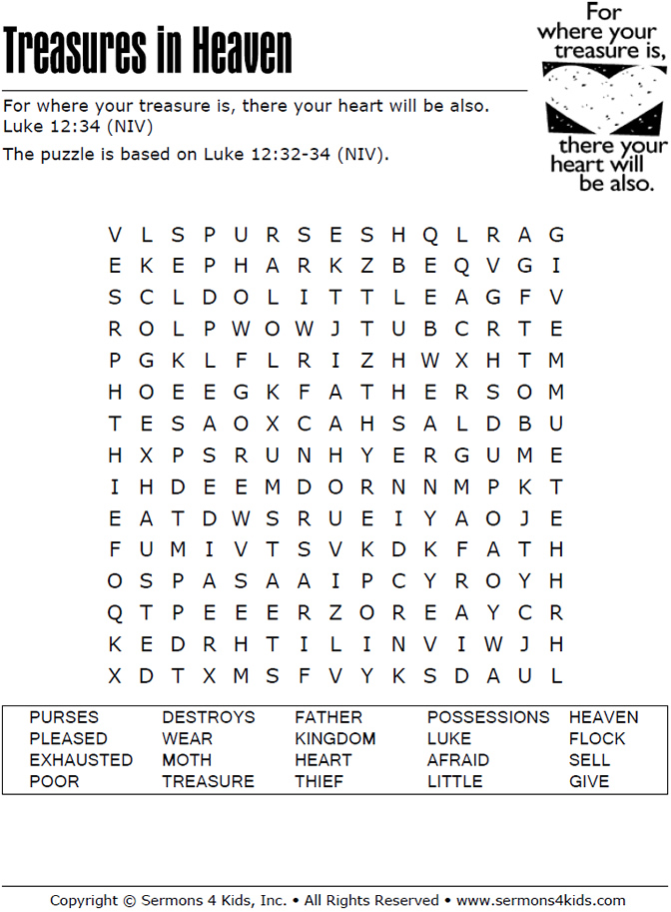
Sunday Morning Bible Study ~ Please join us
We are watching video series for our Bible study. The series is called, “That the World Might Know.” We will be watching, “Mission of Jesus.”

Israel Trip Information ~ Pick up a brochure today regarding the trip that Pastor will be hosting in June of 2023. Please pick up additional brochures for family or friends that might be interested in this exciting trip. For more information, please speak to Pastor Jeff.

Pastor on Vacation ~ Pastor will be out of town from Friday, August 5 through Sunday, August 7. Please contact Sandy Brady if there are any emergencies.

Men’s Breakfast ~ Mark your calendars for next Saturday, August 13 at 8:00 a.m.

Church Picnic ~ Mark your calendars for next Saturday, August 13 at 5:30 p.m. at Roger and Toni Smith’s home.

Thank you! ~ Thank you to all who helped lead the services this weekend.

