Welcome to ZION Lutheran Church
LCMC ~ Lutheran congregations in mission for Christ
8307 Memorial Hwy. Ottawa Lake, MI 49267 ·
(734) 856-2921
Pastor ∙ Jeffrey Geske
(785) 340-5635
zlcolmpastor@gmail.com
www.zionlutheranottawalakemi.com

Our MISSION:
“SHARING THE LOVE OF JESUS”

To Our Guests
We are so glad that you have chosen to join us this morning! We pray that you will be refreshed and renewed as you come into God’s presence. Please take a moment to introduce yourself to the pastor and to those seated around you. Once again, we warmly thank you for worshipping with us this morning!

Those Assisting in Ministry Today
August 21, 2022 ~ eleventh sunday after Pentecost
Organist: Joseph extejt Greeters : Ron Clark and All
deacon: Dwight Gilliland and Jim Hredzak
SCREEN: Nick Baumgartner & Jacob Geske
Reader and assistant: Dwight Gilliland
Altar Guild: Shirley Clark and JoAnn VanSteenkiste
Administrative assistant: Sandy Brady 419- 410-9380 or skwiles2000@gmail.com

LCMC ~ WHO WE ARE
Free in Christ + Accountable to One Another + Rooted in Scripture and the Lutheran Confessions + Committed to the Great Commission

Thoughts on our Readings ~ (-- From the Sola Publishing Website)
The scriptures appointed for today’s worship are ones that are hard to hear. Words about judgment, discipline, and a narrow way can cause us to fear that we aren’t doing enough for the Lord. The Good News for us is what we need to be continually reminded of — we are saved by grace through faith in Jesus Christ our Lord and not by our works. The narrow door is the path of faith and complete trust in Christ.

August 21, 2022 ~ 11th Sunday After Pentecost
(--From the LCMS Website)
Luke 13:26 – “Then you will begin to say, 'We ate and drank in your presence, and you taught in our streets.'” Proximity to Jesus and the things of faith is not faith itself. Many Pharisees heard His Word – but ignored it, refused to believe in it. We want to be not only hearers, but doers of Jesus' Word. We want not just proximity to Jesus, but true communion with Him. We want to hear Him, follow Him, praise Him, and return thanks.

IN OUR PRAYERS:
- For our congregation members; that they may be committed to our mission of sharing the love of Jesus.
- Pastor and Jacob Geske
- For LCMC Congregation and Missionaries around the world.
- President Biden, national leaders and our country. Our nation’s military, especially our loved ones:
- For those who are sick, recovering, or in need of God’s grace at this time. We include in our prayers: Loretta VanDyke, Susan Gaylord, Betty Vesey, Parker Reau, Marilyn Bexten, Fred and JoAnn VanSteenkiste, Joann Koester, Madeline, Ron Vincent, Karen Keck and those dealing with Covid.
Prayer List: Please let us know when we can take the name off of the prayer list. Thank you!.

Services covered by CCLI: 1553677 ~ Lutheran Service Book Hymn License # 100014699 ~ Lutheran Service Book Liturgy License. # 000014699

OUR STEWARDSHIP ~ Weekly budget needs are $1,908.12. Attendance last weekend was 33. Offerings given totaled $2215.00. Thank you for your support of our ministry!

Flowers on the Altar ~ If you would like to place flowers on the altar, please sign up in the hallway. Let pastor or Sandy know if you are celebrating or remembering something special. Flowers this Sunday are given to the glory of God by Sue Beard in memory of her father, Neil Bissonnette, who would have been celebrating his 101st birthday on August 19.

Worship Service Order
Welcome
Opening Hymn: LSB 901
“Open Now Thy Gates of Beauty”
Confession and Absolution LSB 151
Kyrie: LSB p. 152
Hymn: LSB p. 155
“This the Feast”

†GOD’S WORD FOR US†
(On Insert)
Collect of the Day
Old Testament Reading:
Isaiah 66:18-23
Psalm:
Psalm 50:1-15
Second Reading
Hebrews 12:4-24 (25-29)
Holy Gospel:
Luke 13:22-30
Hymn of the Day:
LSB 851
“Lord of Glory”
Today’s Message:
“What are You Striving For?
Luke 13:22-30

Creed: Nicene Creed
Offering
Hymn: LSB 790 St. 1,5
“Praise to the Lord, the Almighty”
Prayers and Lord’s Prayer
The Celebration of the Lord’s Supper
Video: “Living Hope”
Hymn: LSB 563 St. 1-2,6
“Jesus Thy Blood”
Benediction ~ Sending
Closing Hymn: LSB 660
“Stand Up, Stand Up for Jesus”

Announcements

This Week at Zion Includes:
Today – Bible Study; Worship at 10 a.m.
Tuesday ~ Food Pantry 10:00 to Noon
Next Sunday – Bible Study at 9:00 a.m. Worship at 10:00 a.m.

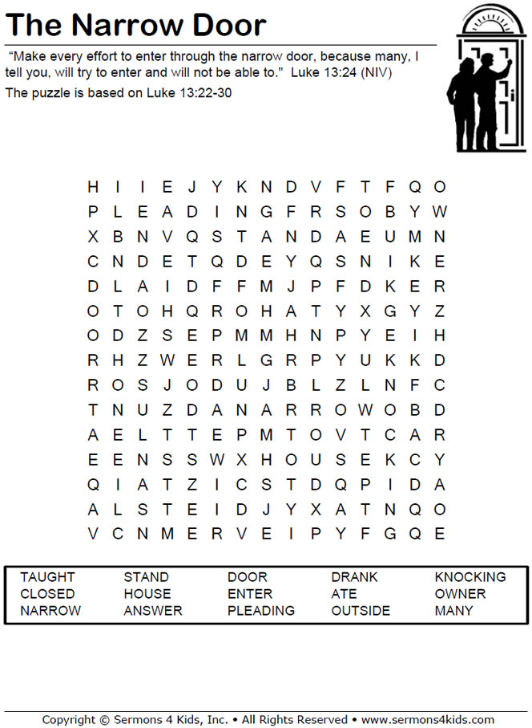
Sunday Morning Bible Study ~Please join us
We are watching video series for our Bible study. The series is called, “That the World Might Know.” We are watching, “Mission of Jesus.”

Israel Trip Information ~ Pick up a brochure today regarding the trip that Pastor will be hosting in June of 2023. Please pick up additional brochures for family or friends that might be interested in this exciting trip. For more information, please speak to Pastor Jeff.

Did You Know ~ Bowing ~ Since early times Christians have bowed as a sign of reverence. Usually a slight inclination of the head or upper body, bowing is often done when approaching the altar and at certain places in the liturgy, like during the voicing of the triune name in the Gloria Patri. As with all customs that are neither commanded nor forbidden, bowing (or not bowing) should not be used as a test of one's piety.

