Welcome to ZION Lutheran Church
LCMC ~ Lutheran congregations in mission for Christ
8307 Memorial Hwy. Ottawa Lake, MI 49267 ·
(734) 856-2921
Pastor ∙ Jeffrey Geske
(785) 340-5635
zlcolmpastor@gmail.com
www.zionlutheranottawalakemi.com

Our MISSION:
“SHARING THE LOVE OF JESUS”

To Our Guests
We are so glad that you have chosen to join us this morning! We pray that you will be refreshed and renewed as you come into God’s presence. Please take a moment to introduce yourself to the pastor and to those seated around you. Once again, we warmly thank you for worshipping with us this morning!

Those Assisting in Ministry Today
August 28, 2022 ~ twelfth sunday after Pentecost
Organist: Joseph extejt Greeters : Ron Clark and All
deacon: Dwight Gilliland and Jim Hredzak
SCREEN: Nick Baumgartner & Jacob Geske
Reader: MaryJo Price
Altar Guild: Shirley Clark and JoAnn VanSteenkiste
Administrative assistant: Sandy Brady 419- 410-9380 or skwiles2000@gmail.com

LCMC ~ WHO WE ARE
Free in Christ + Accountable to One Another + Rooted in Scripture and the Lutheran Confessions + Committed to the Great Commission

Thoughts on our Readings ~ (-- From the Sola Publishing Website)
We don’t say it often in our American culture where class systems are allegedly non-existent, but in previous times it could be heard as a parent instructed a child or a servant to “Know your place.” In the Kingdom of God, the last shall be first and the first shall be last. Humility is the mark of discipleship. Only the humble will be elevated to positions of honor; the faithful are ones who go to the end of the line.

August 28, 2022 ~ 12th Sunday After Pentecost
(--From the LCMS Website)
Luke 14:11 – “For whoever exalts himself will be humbled, and he who humbles himself will be exalted.” The fear of the Lord is the beginning of wisdom: that’s called humility. The Lord is God and we are not. With that in mind, how could we not seek to follow His Word in all aspects of life? He knows what He is talking about and we don’t. If you believe that, then striking out on a path of faithfulness in the realm of stewardship is a lot easier: it just makes sense.

IN OUR PRAYERS:
- For our congregation members; that they may be committed to our mission of sharing the love of Jesus.
- Pastor and Jacob Geske
- For LCMC Congregation and Missionaries around the world.
- President Biden, national leaders and our country. Our nation’s military, especially our loved ones:
- For those who are sick, recovering, or in need of God’s grace at this time. We include in our prayers: Loretta VanDyke, Susan Gaylord, Betty Vesey, Parker Reau, Marilyn Bexten, Fred and JoAnn VanSteenkiste, Joann Koester, Madeline, Ron Vincent, Karen Keck and those dealing with Covid.
Prayer List: Please let us know when we can take the name off of the prayer list. Thank you!.

Services covered by CCLI: 1553677 ~ Lutheran Service Book Hymn License # 100014699 ~ Lutheran Service Book Liturgy License. # 000014699

OUR STEWARDSHIP ~ Weekly budget needs are $1,908.12. Attendance last weekend was 39. Offerings given totaled $1480.00. Thank you for your support of our ministry!

Flowers on the Altar ~ If you would like to place flowers on the altar, please sign up in the hallway. Let pastor or Sandy know if you are celebrating or remembering something special. Flowers this Sunday are given to the glory of God by Dick and Karen Vollmer in celebration of their wedding anniversary.

Worship Service Order
Welcome
Opening Hymn: LSB 915
“Today Your Mercy”
Confession and Absolution LSB 151
Kyrie: LSB p. 152
Hymn: LSB 971
“There is a Redeemer”

†GOD’S WORD FOR US†
(On Insert)
Collect of the Day
Old Testament Reading:
Proverbs 25:2-10
Psalm:
Psalm 131
Second Reading
Hebrews 13:1-17
Holy Gospel:
Luke 14:1-14
Hymn of the Day:
LSB 845 (Tune LSB 528)
“Where Charity and Love Prevail”
Today’s Message:
“Humility”
Luke 14:1-14

Creed: Apostles’ Creed
Offering
Video: “10,000 Reasons”

Hymn: LSB 744
“Amazing Grace”

Prayers and Lord’s Prayer

Benediction ~ Sending
Closing Hymn: LSB 643
“Sent Forth by God’s Blessings”
“Go Now in Peace”

Announcements

This Week at Zion Includes:
Today – Bible Study; Worship at 10 a.m.
Wednesday ~ Confirmation at 5:00 p.m.
Next Sunday – Bible Study at 9:00 a.m. Worship at 10:00 a.m.

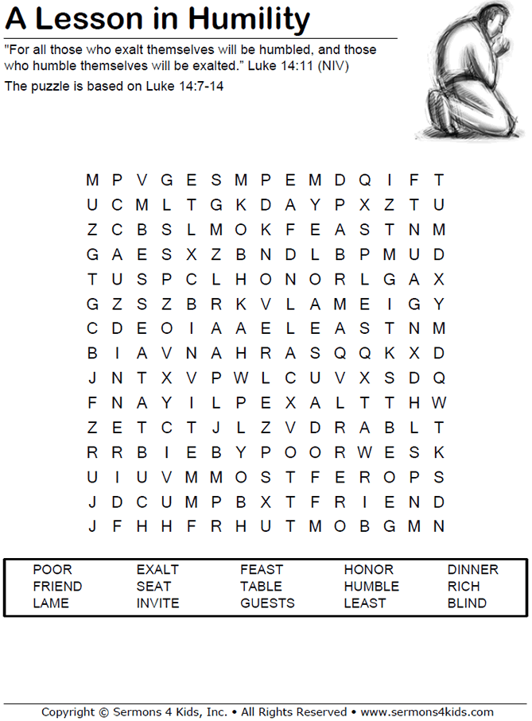
Sunday Morning Bible Study ~Please join us
We are watching video series for our Bible study. The series is called, “That the World Might Know.” We are watching, “Mission of Jesus.” Next Sunday, we will resume our study of Ephesians.

Israel Trip Information ~ Pick up a brochure today regarding the trip that Pastor will be hosting in June of 2023. Please pick up additional brochures for family or friends that might be interested in this exciting trip. For more information, please speak to Pastor Jeff.

September Newsletter ~ Please pick up your September newsletter in the Fellowship Hall.

Confirmation Resumes ~ Our Confirmation class resumes this Wednesday at 5:00 p.m.

Men’s Breakfast ~ Mark your calendars for Saturday, August 13 at 8:00 a.m.

Zion Lutheran Church Choir ~ They will resume practicing on September 18 at 11:15 a.m.

Zion Lutheran Hand bell Choir ~ They will resume practicing on September 17 at 3:00 p.m.



