Welcome to ZION Lutheran Church
LCMC ~ Lutheran congregations in mission for Christ
8307 Memorial Hwy. Ottawa Lake, MI 49267 ·
(734) 856-2921
Pastor ∙ Jeffrey Geske
(785) 340-5635
zlcolmpastor@gmail.com
www.zionlutheranottawalakemi.com

Our MISSION:
“SHARING THE LOVE OF JESUS”

To Our Guests
We are so glad that you have chosen to join us this morning! We pray that you will be refreshed and renewed as you come into God’s presence. Please take a moment to introduce yourself to the pastor and to those seated around you. Once again, we warmly thank you for worshipping with us this morning!

Those Assisting in Ministry Today
september 4, 2022 ~ 13th sunday after Pentecost
Organist: Joseph extejt Greeters : Ron Clark and All
deacon: Dwight Gilliland and Jim Hredzak
SCREEN: Nick Baumgartner & Jacob Geske
Reader and Assistant: Jim Hredzak
Altar Guild: Shirley Clark and JoAnn VanSteenkiste
Administrative assistant: Sandy Brady 419- 410-9380 or skwiles2000@gmail.com

LCMC ~ WHO WE ARE
Free in Christ + Accountable to One Another + Rooted in Scripture and the Lutheran Confessions + Committed to the Great Commission

Thoughts on our Readings ~ (-- From the Sola Publishing Website)
Life lived in the intentional presence of God is one filled with true joy and spiritual abundance. There is a cost, however, to following Jesus. The cost isn’t measured in silver or gold, but in the very giving away of one’s life for the sake of the Gospel. Jesus warned his followers to “count the cost” before they embarked on the journey with him. It sounds daunting, but once you’re on the path it is true freedom.

September 4, 2022 ~ 13th Sunday After Pentecost
(--From the LCMS Website)
Luke 14:33 – “So therefore, any one of you who does not renounce all that he has cannot be my disciple.” None of what we have is ours. It all belongs to God. That is the foundation of Christian stewardship. What we have been given is to be used for God’s purposes according to our callings in home, Church, and society. As we learn to leave generously in these callings, we renounce our ownership of our wealth. It’s not “ours,” it’s His. God owns everything, and we manage for the furtherance of His goals.

IN OUR PRAYERS:
- For our congregation members; that they may be committed to our mission of sharing the love of Jesus.
- Pastor and Jacob Geske
- For LCMC Congregation and Missionaries around the world.
- President Biden, national leaders and our country. Our nation’s military, especially our loved ones:
- For those who are sick, recovering, or in need of God’s grace at this time. We include in our prayers: Loretta VanDyke, Susan Gaylord, Betty Vesey, Parker Reau, Marilyn Bexten, Fred and JoAnn VanSteenkiste, Joann Koester, Madeline, Ron Vincent, Karen Keck and those dealing with Covid.
Prayer List: Please let us know when we can take the name off of the prayer list. Thank you!.

Services covered by CCLI: 1553677 ~ Lutheran Service Book Hymn License # 100014699 ~ Lutheran Service Book Liturgy License. # 000014699

OUR STEWARDSHIP ~ Weekly budget needs are $1,908.12. Attendance last weekend was 39. Offerings given totaled $1636.00. Thank you for your support of our ministry!

Flowers on the Altar ~ If you would like to place flowers on the altar, please sign up in the hallway. Let pastor or Sandy know if you are celebrating or remembering something special. Flowers this Sunday are given to the glory of God by Melvin and Connie Sieler in honor of their family.

Worship Service Order
Welcome
Opening Hymn:
LSB 817 St. 1-2,5-7
“Earth and All Stars”
Confession and Absolution LSB 203
Kyrie: LSB p. 204
Gloria in Excelsis: LSB 204

†GOD’S WORD FOR US†
(On Insert)
Collect of the Day
Old Testament Reading:
Deuteronomy 30:15-20
Psalm:
Psalm 1
Epistle Reading:
Philemon 1-21
Alleluia and Verse: LSB 205
Holy Gospel:
Luke 14:25-35
Hymn of the Day:
LSB 685
“Let us Ever Walk with Jesus”
Today’s Message:
“Walking with Jesus”
Luke 14:25-35

Creed: Nicene Creed
Offering
Hymn: LSB 783
“Take My Life”
Prayers and Lord’s Prayer
The Celebration of the Lord’s Supper
Video: “Remembrance”
Hymn: LSB 629
“What is This Bread”
Benediction ~ Sending
Closing Hymn: LSB 918
“Guide Me, Thou Great Redeemer”

Announcements

This Week at Zion Includes:
Today – Bible Study; Worship at 10 a.m.
Wednesday ~ Confirmation at 5:00 p.m.
Next Sunday – Bible Study at 9:00 a.m. Worship at 10:00 a.m.

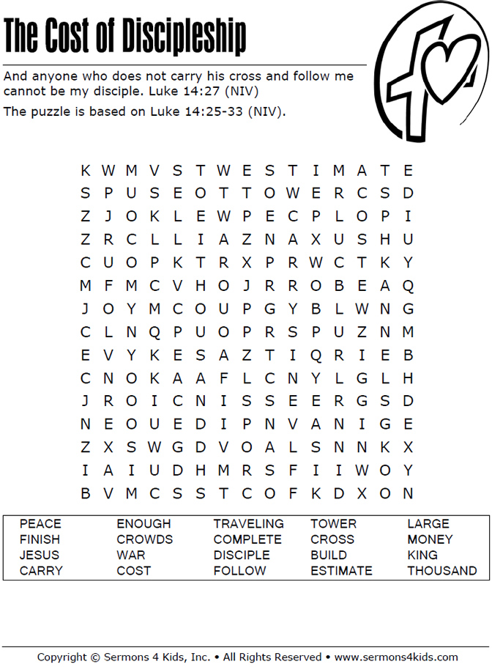
Sunday Morning Bible Study ~
We are resuming our study of the book of Ephesians. Please join us.

Israel Trip Information ~ Pick up a brochure today regarding the trip that Pastor will be hosting in June of 2023. Please pick up additional brochures for family or friends that might be interested in this exciting trip. For more information, please speak to Pastor Jeff.

Elders Meeting ~ The Elders will meet after church next Sunday at 11:15 a.m..

Church Council ~ The Church Council will meet on September 25th instead of September 18th.

Men’s Breakfast ~ Mark your calendars for Saturday, September 10 at 8:00 a.m.

Zion Lutheran Hand bell Choir ~ They will resume practicing on September 17 at 3:00 p.m.

Zion Lutheran Church Choir ~ They will resume practicing on September 18 at 11:15 a.m.

