The Messenger
A newsletter of Zion Lutheran Church ~ Ottawa Lake, MI
September 2022
+ + + + + + + + + +

Our Bible Class Wants You!
We are planning to return to our study of Ephesians on September 4th. Please plan to join in the study of God’s Word.

Lutheran Men ~Monthly Breakfast
On September 10, 2022, we will have our Lutheran Men’s Monthly breakfast. Breakfast will be served at 8:00 a.m. We will have a hot breakfast, devotion, and a Bible study. Please come and feel free to invite a friend or neighbor. It would be great to see you there!

Zion Lutheran Elders
We will have our monthly meeting on September 11, 2022 at 11:15 a.m.

Zion Lutheran Church Council
We will have our monthly Church Council Meeting after church on September 18, 2022.

Women of Zion
There will be a meeting on September 26, 2022 at 2 p.m. We will have a meeting and will continue our Bible study on the book of Revelation.
All Women are invited and encouraged to attend

Movie Night
We will have a Movie Night on Thursday, September 29, 2022. We will meet at 6:30 for a light supper and then will watch a movie. The movie that we will watch is called, “Billy ~ The Early Years” If you have not seen this movie, it will be one that you don’t want to miss.
WORSHIP WITH US EACH WEEK!
Our Contemporary Service is on Saturday at 4:00 p.m.
Join us for worship on Sunday morning at 10:00 a.m.

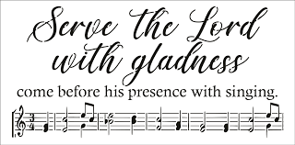
Zion Church Choir
They will resume meeting on September 18th at 11:15 a.m.
For more information, please speak with Joseph Extejt.
HANDBELL CHOIR ~ Come join us in the fall. We will resume practice on September 17th at 3:00 p.m.
For more information, please speak to Karen Vollmer.
ZION Lutheran Church
LCMC ~ Lutheran congregations in mission for Christ
8307 Memorial Hwy. Ottawa Lake, MI 49267 ·
(734) 856-2921
Pastor ∙ Jeffrey Geske
(785) 340-5635
zlcolmpastor@gmail.com
www.zionlutheranottawalakemi.com

Secretary ~ Sandy brady
(419) 410-9380
skwiles2000@gmail.com
custodian and organist~ Joseph extejt

For Your Information
The following members give of their time to the leadership of this congregation. Please keep them in your prayers. If you have any questions, comments, or offers of help, please contact them.
Chairman: Ron Vincent
Secretary: Connie Sieler
Treasurer: Brian Gilliland
Financial: Sandy Bondy
Recording: MaryJo Price
Elders: Ron Clark and Lee Edignton
Deacons: Dwight Gilliland and Jim Hredzak
LCMC ~ WHO WE ARE
Free in Christ + Accountable to One Another + Rooted in Scripture and the Lutheran Confessions + Committed to the Great Commission

Prayers Are Important
If you have an occasion to request a prayer, please call the church office. If you would like your request to be on our prayer chain, please call Sandy Brady (419) 410-9380 or Pastor Jeff at the church or on his cell phone (785)340-5635.
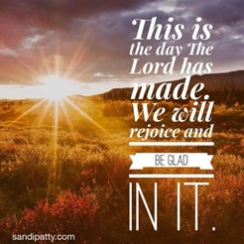

Please Inform the Church Office. . .
*when a member of your family is ill or hospitalized or if they are discharged or moved to another facility.
*when your address changes.
*when a new baby arrives.
*when a family member marries or leaves home for college, or military.
*when planning a wedding to be conducted at Zion.
*when a new family moves into your neighborhood.
*when you are planning to be out of town.
*when a brother or sister in Christ needs a visit from Pastor.

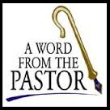
From the desk of Pastor Geske….

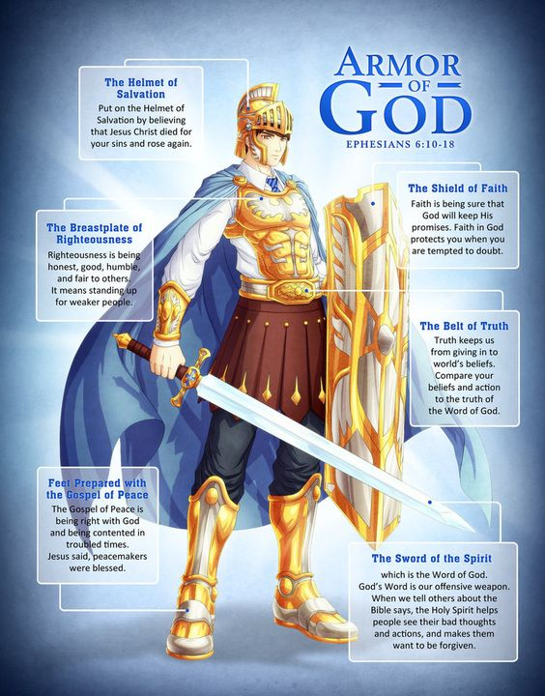
Greetings in the name of Christ! September is once again here and I love all of the activities that go along with this time of the year. Often this is also the time of the year that we see more people back in the routine of worship and Sunday School and Bible class. I so look forward to seeing each of you in worship and the study of God’s Word. In this day and age with so many things pulling on our time, it is good to reflect why we worship. One reason is God commands us to remember the Sabbath day by keeping in holy. But a better reason why we worship is in thanksgiving for what Christ did for us through His death and resurrection to give us forgiveness of our sin and eternal life. We gather to worship, to celebrate, and to praise our God for who He is and what He has done for us. We worship to grow and be strengthened as we live in this sinful world. I love how Paul reminds us that we are living in spiritual warfare. Consider his words to the Ephesians where he wrote, “Finally, be strong in the Lord and in his mighty power. Put on the full armor of God so that you can take your stand against the devil's schemes. For our struggle is not against flesh and blood, but against the rulers, against the authorities, against the powers of this dark world and against the spiritual forces of evil in the heavenly realms. Therefore put on the full armor of God, so that when the day of evil comes, you may be able to stand your ground, and after you have done everything, to stand.” (Ephesians 6:10-13 NIV)

I also am reminded of this illustration that said, “Subject: Why Go To Church? If you're spiritually alive, you're going to love this! If you're spiritually dead, you won't want to read it. If you're spiritually curious, there is still hope! Why Go To Church? A Church goer wrote a letter to the editor of a newspaper and complained that it made no sense to go to church every Sunday. ‘I've gone for 30 years now,’ he wrote, ‘and in that time I have heard something like 3,000 sermons. But for the life of me, I can't remember a single one of them. So, I think I'm wasting my time and the pastors are wasting theirs by giving sermons at all.’ This started a real controversy in the ‘Letters to the Editor’ column, much to the delight of the editor. It went on for weeks until someone wrote this clincher: ‘I've been married for 30 years now. In that time my wife has cooked some 32,000 meals. But, for the life of me, I cannot recall the entire menu for a single one of those meals. But I do know this.. They all nourished me and gave me the strength I needed to do my work. If my wife had not given me these meals, I would be physically dead today. Likewise, if I had not gone to church for nourishment, I would be spiritually dead today!’ When you are DOWN to nothing.... God is UP to something! Faith sees the invisible, believes the incredible and receives the impossible! Thank God for our physical AND our spiritual nourishment!” (--Unknown)

I pray that you look forward to gathering around God’s Word in worship and I pray that as His people at Zion Lutheran Church, we would be excited and encouraged to share the love of Jesus in our daily lives. May we ever know Christ and seek to make Him known. God’s blessings to you as you worship Him and witness to those around you.
In Christ,
Pastor Jeffrey D. Geske
Sunday Morning Bible Class
Please come and join our study of the Word of God!
Each study in the God’s Word for Today series provides an in-depth exploration of a book of the Bible. Each session includes:
- background information on the book of the Bible, its author, audience, occasion, and purpose;
- learning experiences that promote exciting and challenging discussions;
- notes for leaders that answer questions, suggest a learning process, and provide additional information;
- discussion starters that help participants apply God’s Word to their daily lives.
(13 sessions) Paul’s letter to the Ephesians is about the church and about the fellowship of believers who make up the church. It is about us, for by faith we are the church in our time and place. We, by God’s grace, are part of God’s family – a family united in Christ and sustained by the Holy Spirit.
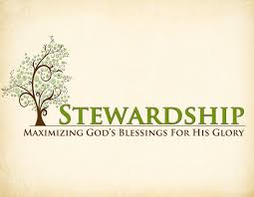
Newsletter Article – September 2022
(--From the LCMS website)

What is Stewardship?

What is a steward? Most people, when asked this question, will reply: “A manager.” That is correct, but it is only half right. A steward is indeed a manager, but he is a manager of what does not belong to him. Someone else is the owner, and the steward manages the owner’s property on the owner’s behalf.

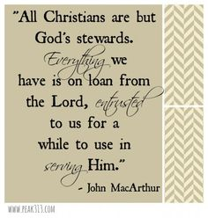
We are God’s stewards. Our stewardship is that God has made us managers of what belongs to Him. For we have brought nothing into this world, and we can take nothing out of it (1 Tim. 6:7). Everything that we have and everything that we are comes from God’s fatherly Divine goodness and mercy. God is the owner. Not only because, as the Creator, He created all things. But also, as the Redeemer, He has redeemed, that is, purchased and won all things. It all, therefore, belongs to Him.

We are simply managers of everything in this world. Like Joseph in Egypt, we are put in charge of managing what belongs to God. What a privilege. Think about that for a minute. The all-knowing, all-powerful, all-wise God has asked us to manage His possessions on His behalf here on earth. And by doing this, He invites us to take part in the allocation of His good gifts. He wants us to give our input and advise Him in where His gifts are to be used. What a privilege indeed.

What a responsibility. For to whom much is given, much shall be required (Luke 12:48). We are not the owners. And while He puts us as managers, we are still to do with His property what He wants done with it. That means we need to know what His desire and will for His property is.

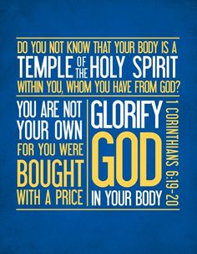
How do we know this? How can we know the will and mind of God? We find the will of God in the Bible. There God tells us what His will for all His gifts are to be used. He tells us how we are to spend our time and use our talents and treasures. He instructs us in the use of our minds, bodies, and souls.

There is nothing that we have that doesn’t belong to Him. “Or do you not know that your body is a temple of the Holy Spirit within you, whom you have from God? You are not your own, for you were bought with a price” (1 Cor. 6:19–20). He informs us of the big picture, the overarching policy, of how we as His stewards – His managers and custodians – of His property are to do the managing.

And that is what stewardship is. It is simply doing what God wants us to do with what He has given us. As St. Paul said: “Do not present your members to sin as instruments for unrighteousness, but present yourselves to God as those who have been brought from death to life, and your members to God as instruments for righteousness” (Rom. 6:13). So, let’s dive into the God’s Word and listen to what the owner desires from His stewards.
Our Church Directory is Online!
View our church directory online or via the FREE mobile app today. To view the directory online, go to members.InstantChurchDirectory.com and follow the prompts under “Sign In” to “Create a login now.” Please remember, you must confirm your email address before you can sign in. You will need to use your email address as listed in our directory to create a log-in the first time you use the directory online and via the mobile app.
Need help or have questions? Please contact Pastor Jeff.

Food Bank~ Thank you for your generous help with our Food Bank. If you have any question or would like to help in any way, please contact Rick Keck at (734) 854-4710. The Food Bank serves families and individuals on the second and fourth Tuesday of the month from 10:00 a.m. until noon.

What is a Thrivent Action Team? Thrivent Action Teams make it easy to live generously. Thrivent provides promotional resources and seed money to jump-start your fundraiser, educational event or service project. Your team provides the people power to bring it to life.

THRIVENT NEWS . . .
If you would like more information about Thrivent, its products, or its fraternal functions, please contact our area representative Greg Durivage in Maumee, OH at (419)-740-4193.

BIRTHDAYS AND ANNIVERSARIES
We would like to wish Happy Birthday and Happy Anniversary to the following individuals who are celebrating this month. If you are not listed or you know someone not listed, please contact Sandy Brady or Pastor Jeff.
Flowers on the Altar ~ If you would like to place flowers, please sign up in the hallway by the restroom.
The cost is $25.00
Please consider signing up for some time this coming year.

September Birthdays

10 Loretta VanDyke
18 Kay Stewart
19 Shirley Clark
20 Debbie Johnson
23 Bob Hardesty
23 Nancy Johnson
26 Barbara Swope
29 Jon Dellabona
September Anniversaries

16 ~ Mark and Pam Sorenson
18 ~ Gene and Karen Weimer

Community Rewards Program
Do you shop at Kroger? If you do, you can sign up for their Community Rewards Program and Kroger will give back to Zion money every quarter. Go on Kroger's website and sign up under Community Rewards. If you need help or do not have an email address, check with Pastor Jeff. (Our code is NC512)
Steps for Linking your Kroger card to help our ministry ~
1. Sign into your account at www.kroger.com or create an account.
2. Click on the NAME.
3. Scroll down to MY ACCOUNT and Click on it,
4. Scroll down to COMMUNITY REWARDS. Click on COMMUNITY REWARDS.
5. Enter Zion Lutheran Church Ottawa Lake MI (NC512)

To Join our Text alerts visit: Text the message @jgesk to the number 81010. If you’re having trouble with 81010, try texting @jgesk to (517) 682-0429. This is a free service ~ You are only charged if your cellphone charges per text

Bringing Christ to the Nations and the Nations to the Church
"The Lutheran Hour," which began in 1930, is now heard on more than 1,300 radio stations around the world. "The Lutheran Hour," hosted by Dr. Rev. Michael Zeigler, is the world's oldest continually-broadcast Gospel radio program. This weekly half-hour program proclaims the message of Jesus Christ to all people and serves as a bridge, linking them to the Church. Listen to the Lutheran Hour on Sundays at 10:00 a.m. or at AM 1560 WWYC or anytime at www.lhm.org

September 2022
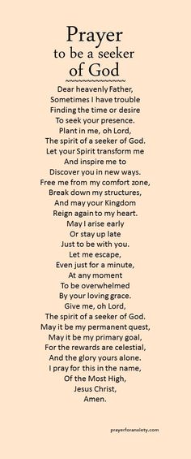
September 4
"Count the Cost"
Speaker: Rev. Dr. Michael Zeigler
Jesus offers a gracious buyout, even as He speaks of counting the cost of following Him.
(Luke 14:25-35)
September 11
"Lost and Found"
Speaker: Rev. Dr. Michael Zeigler
When Jesus told stories about lost sheep and lost coins, He was really talking about lost people.
(Luke 15:1-10)
September 18
"Fresh Start"
Speaker: Rev. Dr. Michael Zeigler
What does the canning of a corrupt and incompetent accountant teach us about the undeserved mercy of God? Hear Jesus' Parable of the Shrewd Manager, this week on The Lutheran Hour.
(Luke 16:9)
September 25
"Take This Personally"
Speaker: Rev. Dr. Michael Zeigler
Jesus wants us to take His Word seriously, not as a personal attack but as a word of warning—and promise.
(Luke 16:19-31)

