The Messenger
A newsletter of Zion Lutheran Church ~ Ottawa Lake, MI
October 2022
+ + + + + + + + + +

Join us for our German Dinner
On October 15th from 4-7 p.m., we will host our annual German Dinner. Suggested donation is $15 per meal. We will need all the help that we can get. Please plan to help or attend this fundraiser for our congregation. Please encourage people to attend, if they are not able and would like to make a donation, they can do so on our website on the main page. They can click on GERMAN Dinner Fundraiser and they will be taken to a page from Thrivent to make a donation. This event is also a Thrivent Action Team event. We are thankful for their help in our meal. Thank to Connie Sieler and Wolfgang Drescher for leading us in this fundraiser.

Lutheran Men ~Monthly Breakfast
On October 8, 2022, we will have our Lutheran Men’s Monthly breakfast. Breakfast will be served at 8:00 a.m. We will have a hot breakfast followed by devotion and a Bible study. Please come and feel free to invite a friend or neighbor.
It would be great to see you there!

Zion Lutheran Church Council
We will have our monthly Church Council Meeting after church on October 16, 2022.

Women of Zion
There will be a meeting on October 24, 2022 at 2 p.m. We will have a meeting and will continue our Bible study on the book of Revelation.
All Women are invited and encouraged to attend

Movie Night
We will have a Movie Night on Thursday, October 27, 2022. We will meet at 6:30 for a light supper and then will watch a movie. The movie that we will watch is called, “Saved by Grace” If you have not seen this movie, it will be one that you don’t want to miss.

Reformation Celebration
We will celebrate the Reformation on October 30th in worship. Please plan to wear red on this special day that we celebrate how God used Martin Luther and the Reformation to bless the church that we are saved by God’s grace alone!
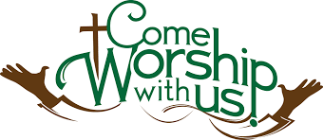
WORSHIP WITH US EACH WEEK!
Our Contemporary Service is on Saturday at 4:00 p.m.
Join us for worship on Sunday morning at 10:00 a.m.

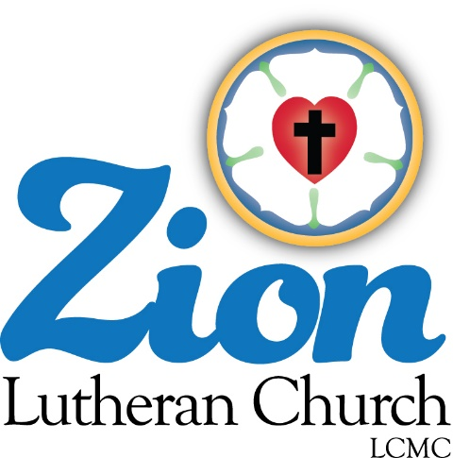
ZION Lutheran Church
LCMC ~ Lutheran congregations in mission for Christ
8307 Memorial Hwy. Ottawa Lake, MI 49267 ·
(734) 856-2921
Pastor ∙ Jeffrey Geske
(785) 340-5635
zlcolmpastor@gmail.com
www.zionlutheranottawalakemi.com

Secretary ~ Sandy brady
(419) 410-9380
skwiles2000@gmail.com
custodian and organist~ Joseph extejt

For Your Information
The following members give of their time to the leadership of this congregation. Please keep them in your prayers. If you have any questions, comments, or offers of help, please contact them.
Chairman: Ron Vincent
Secretary: Connie Sieler
Treasurer: Brian Gilliland
Financial: Sandy Bondy
Recording: MaryJo Price
Elders: Ron Clark and Lee Edignton
Deacons: Dwight Gilliland and Jim Hredzak
LCMC ~ WHO WE ARE
Free in Christ + Accountable to One Another + Rooted in Scripture and the Lutheran Confessions + Committed to the Great Commission

Prayers Are Important
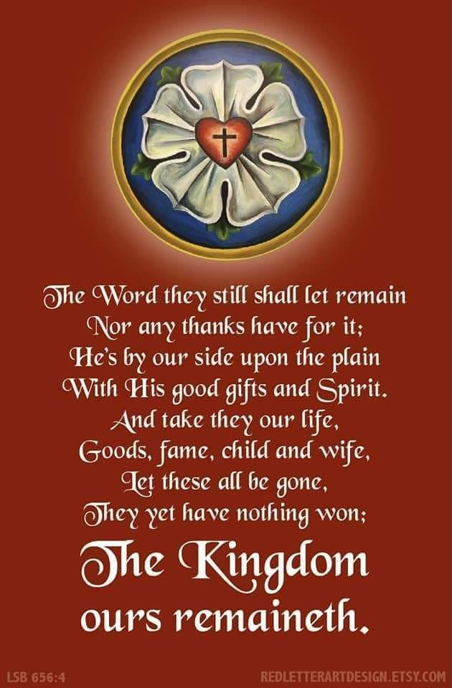
If you have an occasion to request a prayer, please call the church office. If you would like your request to be on our prayer chain, please call Sandy Brady (419) 410-9380 or Pastor Jeff at the church or on his cell phone (785)340-5635.

Please Inform the Church Office. . .
*when a member of your family is ill or hospitalized or if they are discharged or moved to another facility.
*when your address changes.
*when a new baby arrives.
*when a family member marries or leaves home for college, or military.
*when planning a wedding to be conducted at Zion.
*when a new family moves into your neighborhood.
*when you are planning to be out of town.
*when a brother or sister in Christ needs a visit from Pastor.

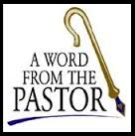
From the desk of Pastor Geske….

The Importance of Worship

In our world today, more and more seem to believe that worship is not important. Unfortunately, as one generation makes it unimportant then future generations will also forsake the worship of God. God has given us His commandments as to how we can love Him and love our neighbor as ourselves. As I have often said to you that the reason that we do anything as a child of God should be done to say thank you to God for His grace, mercy, love, forgiveness and eternal life. We worship and serve to the glory of God.

Recently Jacob and I were reading the new catechism and came across this question. I told Jacob that this is one to star as it is such a good explanation of why we should worship together as the body of Christ. I hope you too may enjoy this question and its answer.

52. Why is it vital for us to gather together with fellow Christians in public worship?
The Word of God gathers all who believe in Jesus Christ into the Holy Christian Church, and also calls believers to gather together in congregations for public worship for several reasons.
A. God is present as His Word is proclaimed and His Sacraments are administered (Matthew 28:18–20; John 10:16; 1 Corinthians 10:16; 2 Thessalonians 2:14). Through these Means of Grace, He freely gives His gifts and blessings, chiefly the forgiveness of sins (Acts 10:43; 1 John 2:2). In worship, our Shepherd, Jesus, speaks through the mouth of the shepherd (pastor) whom He has called to care for our souls (Acts 20:28). The Word of God is not simply information, but the Word actually delivers what it says (Isaiah 55:10–11). In Isaiah, we read,

“For as the rain and the snow come down from heaven
and do not return there but water the earth,
making it bring forth and sprout,
giving seed to the Sower and bread to the eater,
¹¹ so shall my word be that goes out from my mouth;
it shall not return to me empty,
but it shall accomplish that which I purpose,
and shall succeed in the thing for which I sent it. (Isaiah 55:10–11).

B. We hear God’s Word at a set place and time (Isaiah 66:23; Luke 4:16). Though it is delivered through fallible men and simple means, the Word that is read, preached, and spoken over water, bread, and wine is not to be scorned (Jeremiah 6:10; John 8:47; Luke 10:16). Sunday worship is a public testimony to our faith in Christ and His resurrection from the dead “on the first day of the week” (Luke 24:1; Acts 20:7; 1 Corinthians 16:1–2).

C. Believers are still sinners who need one another and the encouragement we receive from one another, “and all the more as you see the Day drawing near” (Hebrews 10:25). We share our blessings, burdens, and joys in petitions and hymns of praise with those present (Colossians 3:16), remembering the Church throughout the world and the saints and angels of heaven (Hebrews 12:22–24).

The Large Catechism teaches: “Whenever God’s Word is taught, preached, heard, read, or meditated upon, then the person, day, and work are sanctified. This is not because of the outward work, but because of the Word, which makes saints of us all. … Note, therefore, that the force and power of this commandment lies not in the resting, but in the sanctifying, so that a special holy exercise belongs to this day. … Here a work is to be done by which a person is himself made holy. This is done (as we have heard) only through God’s Word” (LC I 92, 94).

Luther, Martin. Luther's Small Catechism with Explanation - 2017 Edition (pp. 78-79). Concordia Publishing House. Kindle Edition.

May God bless us to joyfully worship together. May God use us to encourage others!

In Christ,
Pastor Jeffrey D. Geske

Sunday Morning Bible Class
Please come and join our study of the Word of God!
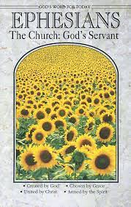
Each study in the God’s Word for Today series provides an in-depth exploration of a book of the Bible. Each session includes:
- background information on the book of the Bible, its author, audience, occasion, and purpose;
- learning experiences that promote exciting and challenging discussions;
- notes for leaders that answer questions, suggest a learning process, and provide additional information;
- discussion starters that help participants apply God’s Word to their daily lives.
(13 sessions) Paul’s letter to the Ephesians is about the church and about the fellowship of believers who make up the church. It is about us, for by faith we are the church in our time and place. We, by God’s grace, are part of God’s family – a family united in Christ and sustained by the Holy Spirit.
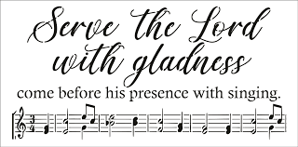
Zion Church Choir
For more information, please speak with Joseph Extejt.
HANDBELL CHOIR ~ Come join us in the fall. We meet on Saturdays at 3:00 p.m.
For more information, please speak to Karen Vollmer.

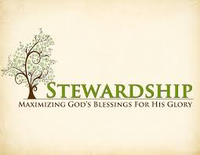
Newsletter Article – October 2022
(--From the LCMS website)

“We Are All Beggars”

In the early morning hours of Feb. 18, 1546, Martin Luther closed his eyes forever. Before that happened, the hand that hammered the 95 Theses into the door of the Castle Church in Wittenberg on Oct. 31, 1517, penned its final words: “We are all beggars. This is true.” And this is the truth that our Lord says makes you free.

Ironic, isn’t it? In order to be free, you must be a beggar. You must be utterly dependent and reliant upon God. This makes us uncomfortable – the way we’re uncomfortable when someone gets us a Christmas present when we haven’t gotten them one. We feel we owe them. And we don’t like being in someone’s debt like that.

But what Luther would remind us is that we are all indeed beggars. And we’re not just anyone’s beggars. We’re God’s beggars. Christ came for sinners. He came to seek and save the lost. He came to heal the sick and raise the dead. He came for sinners, and He dwells only with sinners.

If we are to be where He is, we must be willing to be counted among the lost, the sick, and the dead. We must be willing to be beggars. We must cry out for mercy, for grace, and for his undeserved love and kindness. We must be dependent solely on Him and what He gives.

And here’s the beauty: He gives us everything. Everything. Forgiveness of sins, salvation from death and the devil, and eternal life. This isn’t because of any worthiness or merit in us. It is because of His divine goodness, mercy, and grace. On account of Christ’s death and resurrection, the Father forgives you, saves you, and is pleased with you. You receive His love, His righteousness, His holiness, His acceptance, and His inheritance. We are all beggars. This is true.

This is the heart and soul of Christianity and the lifeblood of the Christian Church. God justifies us and declares us innocent and righteous by His grace received through faith for the sake of Christ. This isn’t because of our works but because of His work on the cross. We, who once were enemies of God, are reconciled to Him and made to be His children.

This is what Luther pointed us to when He took up his pen for the last time and scribbled “We are all beggars. This is true.” We are beggars, but we are beggars of the God who does not ignore us and who doesn’t pass by us on the other side. We are beggars of the One who descended from heaven to make His dwelling with sinners.

We are beggars of Him who deigns to dwell with us, among us, and – yes – still in us by grace for Christ’s sake. For in the bread and cup that we bless we share together with Christ and each other the riches of God’s grace. The riches of this grace – the Gospel in sermon and absolution, in Baptism, and in Holy Communion – are so inexhaustible that our cups overflow. We, who are God’s beggars, are inexhaustibly satisfied, and we have something to give back in thanksgiving and praise.

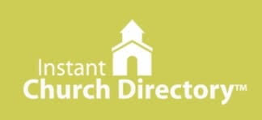
Our Church Directory is Online!
View our church directory online or via the FREE mobile app today. To view the directory online, go to members.InstantChurchDirectory.com and follow the prompts under “Sign In” to “Create a login now.” Please remember, you must confirm your email address before you can sign in. You will need to use your email address as listed in our directory to create a log-in the first time you use the directory online and via the mobile app.
Need help or have questions? Please contact Pastor Jeff.

Food Bank~ Thank you for your generous help with our Food Bank. If you have any question or would like to help in any way, please contact Rick Keck at (734) 854-4710. The Food Bank serves families and individuals on the second and fourth Tuesday of the month from 10:00 a.m. until noon.
BIRTHDAYS AND ANNIVERSARIES
We would like to wish Happy Birthday and Happy Anniversary to the following individuals who are celebrating this month. If you are not listed or you know someone not listed, please contact Sandy Brady or Pastor Jeff.
Flowers on the Altar ~ If you would like to place flowers, please sign up in the hallway by the restroom.
The cost is $25.00
Please consider signing up for some time this coming year.

October Birthdays

1 ~ Patti Vaughan
2 ~ Ron Clark
3 ~ Gene Weimer
5 ~ Bob Decator
8 ~ Susan Gaylord
10 Jeff Gorr
16 ~ Karen Schmidt
21 ~ Nick Baumgartner
29 ~ John Castell
30 ~ Sandy Brady
31 ~ Austin Castell

October Anniversaries

2 ~ Dwight and MaryJo Gilliland
17~ Ray and Karen Schmidt

Community Rewards Program
Do you shop at Kroger? If you do, you can sign up for their Community Rewards Program and Kroger will give back to Zion money every quarter. Go on Kroger's website and sign up under Community Rewards. If you need help or do not have an email address, check with Pastor Jeff. (Our code is NC512)
Steps for Linking your Kroger card to help our ministry ~
1. Sign into your account at www.kroger.com or create an account.
2. Click on the NAME.
3. Scroll down to MY ACCOUNT and Click on it,
4. Scroll down to COMMUNITY REWARDS. Click on COMMUNITY REWARDS.
5. Enter Zion Lutheran Church Ottawa Lake MI (NC512)

THRIVENT NEWS . . .
If you would like more information about Thrivent, its products, or its fraternal functions, please contact our area representative Greg Durivage in Maumee, OH at (419)-740-4193.

What is a Thrivent Action Team? Thrivent Action Teams make it easy to live generously. Thrivent provides promotional resources and seed money to jump-start your fundraiser, educational event or service project. Your team provides the people power to bring it to life.

Christmas Festival and Cookie Walk ~ The Women of Zion will host their annual event on December 10th from 9-1 p.m. We would love to have you help with this event. Please make cookies for the Cookie Walk. If you would like to have a table to sell your products, please contact Sandy Brady. Please watch for upcoming ticket sales for the event.
To Join our Text alerts visit: Text the message @jgesk to the number 81010. If you’re having trouble with 81010, try texting @jgesk to (517) 682-0429. This is a free service ~ You are only charged if your cellphone charges per text

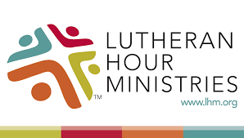
Bringing Christ to the Nations and the Nations to the Church
"The Lutheran Hour," which began in 1930, is now heard on more than 1,300 radio stations around the world. "The Lutheran Hour," hosted by Dr. Rev. Michael Zeigler, is the world's oldest continually-broadcast Gospel radio program. This weekly half-hour program proclaims the message of Jesus Christ to all people and serves as a bridge, linking them to the Church. Listen to the Lutheran Hour on Sundays at 10:00 a.m. or at AM 1560 WWYC or anytime at www.lhm.org

October 2022

October 2
"You've Got It in You"
Guest Speaker: Rev. Dr. John Nunes
Faith in Christ is something that's in you, but you didn't put it there.
(2 Timothy 1:13-14)
October 9
"Thankfulness, Eh?"
Guest Speaker: Rev. Cody Cooper
It's only right to be thankful for what we have and what we are. The question is, to whom are we thankful?
(Luke 17:11-19)
October 16
"Look at Me"
Speaker: Rev. Dr. Michael Zeigler
God hears our cry for justice, not as an indifferent judge, but as our merciful heavenly Father.
(Luke 18:1-8)
October 23
"He Gets Me"
Speaker: Rev. Dr. Michael Zeigler
It might sound strange to regard God as a friend, and the more fear, awe, and respect you have for God, the stranger it gets.
(Luke 18:9-14)
October 30
"Give Your Brother a Call"
Speaker: Rev. Dr. Michael Zeigler
God cares that we relate to Him with childlike faith and relate to others with Christlike love.
(Luke 19:1-10)

