Welcome to ZION Lutheran Church
LCMC ~ Lutheran congregations in mission for Christ
8307 Memorial Hwy. Ottawa Lake, MI 49267 ·
(734) 856-2921
Pastor ∙ Jeffrey Geske
(785) 340-5635
zlcolmpastor@gmail.com
www.zionlutheranottawalakemi.com

Our MISSION:
“SHARING THE LOVE OF JESUS”

To Our Guests
We are so glad that you have chosen to join us this morning! We pray that you will be refreshed and renewed as you come into God’s presence. Please take a moment to introduce yourself to the pastor and to those seated around you. Once again, we warmly thank you for worshipping with us this morning!

Those Assisting in Ministry Today
september 18, 2022 ~ 15th sunday after Pentecost
Organist: Joseph extejt Greeters : Ron Clark and All
deacon: Dwight Gilliland and Jim Hredzak
SCREEN: Nick Baumgartner & Jacob Geske
Reader and Assistant: Lee Edington
Altar Guild: Shirley Clark and JoAnn VanSteenkiste
Administrative assistant: Sandy Brady 419- 410-9380 or skwiles2000@gmail.com

LCMC ~ WHO WE ARE
Free in Christ + Accountable to One Another + Rooted in Scripture and the Lutheran Confessions + Committed to the Great Commission

Thoughts on our Readings ~ (-- From the Sola Publishing Website)
No one likes to be in debt to another, and yet it seems to be a reality of this human life. Our sin is a debt that cannot be repaid, yet through Christ we have been forgiven and restored to a right relationship with God. Jesus paid our debt by offering us grace and mercy through his death on the cross. We, too, are called to offer grace and mercy to our neighbors, forgiving their debt so that they also might know God’s love.

September 18, 2022 ~ 15th Sunday After Pentecost
(--From the LCMS Website)
Luke 16:8b – “For the sons of this world are more shrewd in dealing with their own generation than the sons of light.” The sons of this world know that they should use their wealth wisely to provide for their future. Shouldn’t we, as “sons of light,” know that the wealth God has allowed us to manage should be managed for God’s purposes in roles He has given us to play in Church, home, and society?

IN OUR PRAYERS:
- For our congregation members; that they may be committed to our mission of sharing the love of Jesus.
- Pastor and Jacob Geske
- For LCMC Congregation and Missionaries around the world.
- President Biden, national leaders and our country. Our nation’s military, especially our loved ones:
- For those who are sick, recovering, or in need of God’s grace at this time. We include in our prayers: Loretta VanDyke, Susan Gaylord, Betty Vesey, Parker Reau, Marilyn Bexten, Fred and JoAnn VanSteenkiste, Joann Koester, Karen Keck and those dealing with Covid.

Prayer List: Please let us know when we can take the name off of the prayer list. Thank you!.

Services covered by CCLI: 1553677 ~ Lutheran Service Book Hymn License # 100014699 ~ Lutheran Service Book Liturgy License. # 000014699

OUR STEWARDSHIP ~ Weekly budget needs are $1,908.12. Attendance last weekend was 43. Offerings given totaled $2236.25. Thank you for your support of our ministry!

Flowers on the Altar ~ If you would like to place flowers on the altar, please sign up in the hallway. Let pastor or Sandy know if you are celebrating or remembering something special. Flowers this weekend are given to the glory of God by Bob Hardesty and MaryJo Price in honor of Bob’s 96th birthday on September 23.

Worship Service Order
Welcome
Opening Hymn: LSB 904
“Blessed Jesus, at Your Word”
Confession and Absolution LSB 167
Kyrie: LSB p. 168
Hymn: LSB p. 171
“This the Feast”

†GOD’S WORD FOR US†
(On Insert)
Collect of the Day
Old Testament Reading:
Amos 8:4-7
Psalm:
Psalm 113
Epistle Reading
1 Timothy 2:1-15
Holy Gospel:
Luke 16:1-15
Hymn of the Day:
LSB 772 (Tune 478)
“In Holy Conversation”
Today’s Message:
“God Desires”
1 Timothy 2:1-15

Creed: Nicene Creed
Offering
Hymn: LSB 749
“There is a Balm in Gilead”
Prayers and Lord’s Prayer
The Celebration of the Lord’s Supper
Video: “Ancient Words”
Hymn: LSB 632
“O Jesus, Blessed Lord, to Thee”
Benediction ~ Sending
Closing Hymn:
LSB 966 St. 1,4-5
“Before You Lord We Bow”

Announcements

This Week at Zion Includes:
Today – Bible Study; Worship at 10:00 a.m.
Wednesday ~ Confirmation at 5:00 p.m.
Next Sunday – Bible Study at 9:00 a.m. Worship at 10:00 a.m.

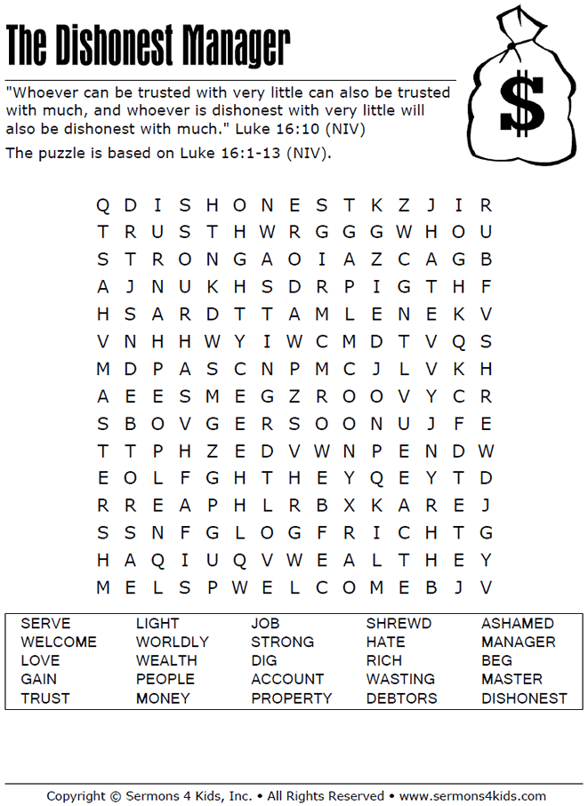
Sunday Morning Bible Study ~
We are resuming our study of the book of Ephesians. Please join us.

Israel Trip Information ~ Pick up a brochure today regarding the trip that Pastor will be hosting in June of 2023. Please pick up additional brochures for family or friends that might be interested in this exciting trip. For more information, please speak to Pastor Jeff.

New Bible Study ~ We have begun a new Bible study on Wednesday mornings at 10:30 a.m. We would love to have you join us.

Church Council ~ The Church Council will meet on September 25th instead of September 18th.

Zion Lutheran Hand bell Choir ~ They practice on Saturdays at 3:00 p.m. They would love to have you join them.

Zion Lutheran Church Choir ~ They will resume practicing this Sunday at 11:15 a.m.

Women of Zion ~ Our women will hold their next meeting on September 26th at 2:00 p.m.

Movie Night ~ Join us on September 29th at 6:30 p.m. We begin with a light meal.

