Welcome to ZION Lutheran Church
LCMC ~ Lutheran congregations in mission for Christ
8307 Memorial Hwy. Ottawa Lake, MI 49267 ·
(734) 856-2921
Pastor ∙ Jeffrey Geske
(785) 340-5635
zlcolmpastor@gmail.com
www.zionlutheranottawalakemi.com

Our MISSION:
“SHARING THE LOVE OF JESUS”

To Our Guests
We are so glad that you have chosen to join us this morning! We pray that you will be refreshed and renewed as you come into God’s presence. Please take a moment to introduce yourself to the pastor and to those seated around you. Once again, we warmly thank you for worshipping with us this morning!

Those Assisting in Ministry Today
October 9, 2022 ~ 18th sunday after Pentecost
Organist: Joseph extejt Greeters : Ron Clark and All
deacon: Dwight Gilliland and Jim Hredzak
SCREEN: Nick Baumgartner & Jacob Geske
Reader and Assistant: Karen Vollmer
Altar Guild: Shirley Clark and JoAnn VanSteenkiste
Administrative assistant: Sandy Brady 419- 410-9380 or skwiles2000@gmail.com

LCMC ~ WHO WE ARE
Free in Christ + Accountable to One Another + Rooted in Scripture and the Lutheran Confessions + Committed to the Great Commission

Thoughts on our Readings ~ (-- From the Sola Publishing Website)
Loyalty is something to cherish as a quality in friends and family. Ruth was a loyal servant to Naomi when both lost their husbands and had to begin again in an impoverished state. The psalmist praised God for his loyalty and steadfast faithfulness to his covenant with Israel. When Jesus healed ten lepers of their disease, there was only one who was grateful and expressed loyalty to Christ, and he was a Samaritan.

October 9, 2022 ~ 18th Sunday After Pentecost
(--From the LCMS Website)
Luke 17:19 – 19 – “And he said to him, ‘Rise and go your way; your faith has made you well.’ ” Only one of the 10 lepers who were cleansed returns to give thanks to Jesus. Why is that? Surely the rest were indeed thankful to be freed from such a terrible disease. But only the Samaritan leper had faith, and his faith turned into action, as all true faith does. Our generosity to God’s work in the Church is likewise our faith in action.

IN OUR PRAYERS:
- For our congregation members; that they may be committed to our mission of sharing the love of Jesus.
- Pastor and Jacob Geske
- For LCMC Congregation and Missionaries around the world.
- President Biden, national leaders and our country. Our nation’s military, especially our loved ones:
- For those who are sick, recovering, or in need of God’s grace at this time. We include in our prayers: Loretta VanDyke, Susan Gaylord, Betty Vesey, Parker Reau, Marilyn Bexten, Fred and JoAnn VanSteenkiste, Joann Koester, Karen Keck and those dealing with Covid.

Prayer List: Please let us know when we can take the name off of the prayer list. Thank you!.

Services covered by CCLI: 1553677 ~ Lutheran Service Book Hymn License # 100014699 ~ Lutheran Service Book Liturgy License. # 000014699

OUR STEWARDSHIP ~ Weekly budget needs are $1,908.12. Attendance last weekend was 42. Offerings given totaled $1794.71. Thank you for your support of our ministry!

Flowers on the Altar ~ If you would like to place flowers on the altar, please sign up in the hallway. Let pastor or Sandy know if you are celebrating or remembering something special.

Worship Service Order
Welcome
Opening Hymn: LSB 790
“Praise to the Lord the Almighty”

Opening Versicles
LSB 260

†GOD’S WORD FOR US†
(On Insert)
Collect of the Day
First Reading:
Ruth 1:1-19a
Psalm:
Psalm 111
Epistle Reading:
2 Timothy 2:1-13
Holy Gospel:
Luke 17:11-19
Responsory LSB 263
Catechism LSB 263

Hymn of the Day: LSB 664
“Fight the Good Fight"

Today’s Message:
“Remember Jesus!”
2 Timothy 2:1-13

Offering
Video: “10,000 Reasons”
Hymn: LSB 801
“How Great Thou Art"
Prayer LSB 265
Benediction ~ Sending
Closing Hymn: LSB 918
“Guide Me O Great Redeemer"

Announcements

This Week at Zion Includes:
Today – Bible Study; Worship at 10:00 a.m. Choir at 11:15 a.m.
Tuesday ~ Food Pantry from 10:00 a.m. until Noon.
Wednesday ~ Bible study at 10:30 a.m. Confirmation at 5:00 p.m.
Saturday ~ No Handbells at 3:00 p.m., Contemporary Worship at 4:00 p.m.
German Dinner from 4:30-7:00 p.m.
Next Sunday – Bible Study at 9:00 a.m. Worship at 10:00 a.m. Choir at 11:15 a.m.
And Church Council at 11:15 a.m.
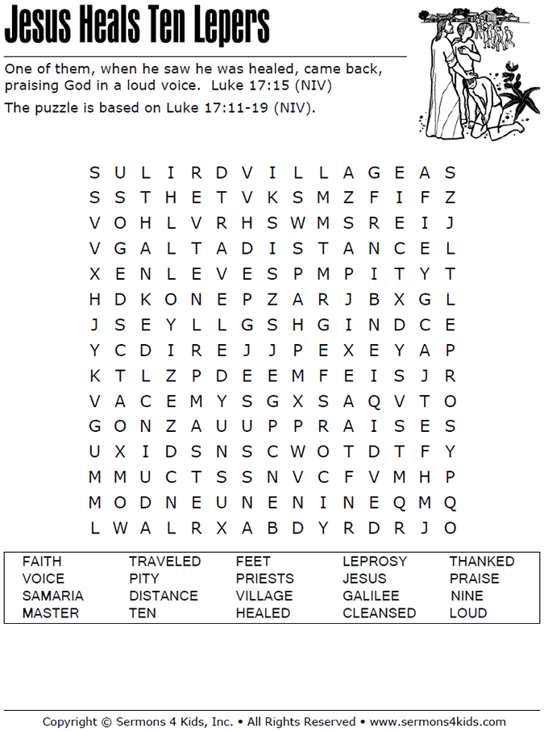
Sunday Morning Bible Study ~
We are studying the book of Ephesians. Please join us.

Israel Trip Information ~ Pick up a brochure today regarding the trip that Pastor will be hosting in June of 2023. Please pick up additional brochures for family or friends that might be interested in this exciting trip. For more information, please speak to Pastor Jeff.

Wednesday Bible Study ~ We meet on Wednesday at 10:30 a.m. We study the upcoming lessons for the next Sunday. Please join us.

Women of Zion Road Trip ~ We would love to have you join us on our trip to Shipshewana, IN on October 21st. We will leave at 8:00 a.m.

German Dinner ~ Please plan to sign up to help or to prepare for the meal, or to make pies. All help is greatly appreciated!

Women of Zion Meeting ~ They will have their meeting with at Bible Study on October 24th at 2 p.m.

Movie Night ~ We will have our Movie Night on October 20th instead of October 27th at 6:30 p.m. We will be watching, “Saved by Grace.”



