Welcome to ZION Lutheran Church
LCMC ~ Lutheran congregations in mission for Christ
8307 Memorial Hwy. Ottawa Lake, MI 49267 ·
(734) 856-2921
Pastor ∙ Jeffrey Geske
(785) 340-5635
zlcolmpastor@gmail.com
www.zionlutheranottawalakemi.com

Our MISSION:
“SHARING THE LOVE OF JESUS”

To Our Guests
We are so glad that you have chosen to join us this morning! We pray that you will be refreshed and renewed as you come into God’s presence. Please take a moment to introduce yourself to the pastor and to those seated around you. Once again, we warmly thank you for worshipping with us this morning!

Those Assisting in Ministry Today
October 16, 2022 ~ 19th sunday after Pentecost
Organist: Joseph extejt Greeters : Ron Clark and All
deacon: Dwight Gilliland and Jim Hredzak
SCREEN: Nick Baumgartner & Jacob Geske
Reader and Assistant: Connie Sieler
Altar Guild: Shirley Clark and JoAnn VanSteenkiste
Administrative assistant: Sandy Brady 419- 410-9380 or skwiles2000@gmail.com

LCMC ~ WHO WE ARE
Free in Christ + Accountable to One Another + Rooted in Scripture and the Lutheran Confessions + Committed to the Great Commission

Thoughts on our Readings ~ (-- From the Sola Publishing Website)
How often do we lament injustices that we see in the world? It is always disturbing when the innocent are victims of evil and the wicked go unpunished. The lessons today point to our God, who is a just judge; he looks out for his people, blesses them, teaches them, and finds in their favor because of his great love for them. Life might not always be fair, but with God, love is gifted to us even when we don’t deserve it.

October 16, 2022 ~ 19th Sunday After Pentecost
(--From the LCMS Website)
Genesis 32:26 – “And he said to him, ‘Rise and go your way; your faith has made you well.’ ” The great Lutheran musician J.S. Bach composed a beautiful motet using this verse. It is the cry of true faith, much the same as Peter’s words: “Lord to whom shall we go? You have the words of eternal life.” True faith clings to the Lord no matter the struggle, no matter the “hard sayings” that the Lord speaks. True faith knows that God means to bless us always.

IN OUR PRAYERS:
- For our congregation members; that they may be committed to our mission of sharing the love of Jesus.
- Pastor and Jacob Geske
- For LCMC Congregation and Missionaries around the world.
- President Biden, national leaders and our country. Our nation’s military, especially our loved ones:
- For those who are sick, recovering, or in need of God’s grace at this time. We include in our prayers: Loretta VanDyke, Susan Gaylord, Betty Vesey, Parker Reau, Marilyn Bexten, Fred and JoAnn VanSteenkiste, Joann Koester, Karen Keck, Duane Holtz
- and those dealing with Covid.

Prayer List: Please let us know when we can take the name off of the prayer list. Thank you!.

Services covered by CCLI: 1553677 ~ Lutheran Service Book Hymn License # 100014699 ~ Lutheran Service Book Liturgy License. # 000014699

OUR STEWARDSHIP ~ Weekly budget needs are $1,908.12. Attendance last weekend was 36. Offerings given totaled $2,500.21. Thank you for your support of our ministry!

Flowers on the Altar ~ If you would like to place flowers on the altar, please sign up in the hallway. Let pastor or Sandy know if you are celebrating or remembering something special. Flowers last week were given by Dick and Karen Vollmer. Flowers this week are given by Sue Beard.

Worship Service Order
Welcome
Opening Hymn: LSB 869
“With the Lord Begin Your Task”
Confession and Absolution LSB 167
Kyrie: LSB p. 168
Hymn: LSB p. 171
“This the Feast”

†GOD’S WORD FOR US†
(On Insert)
Collect of the Day
Old Testament Reading:
Genesis 32:22-30
Psalm:
Psalm 121
Epistle Reading
2 Timothy 3:14-4:5
Holy Gospel:
Luke 18:1-18
Hymn of the Day:
LSB 578 St. 1,5-6
“Thy Strong Word”
Today’s Message:
“Continue in What You Have Learned”
2 Timothy 3:14-4:5

Creed: Nicene Creed
Offering
Hymn: LSB 739
“Precious Lord, Take My Hand”
Prayers and Lord’s Prayer
The Celebration of the Lord’s Supper
Video: “Ancient Words”
Hymn: LSB 629
“What is This Bread”
Benediction ~ Sending
Closing Hymn:
LSB 924
“Lord, Dismiss Us”

Announcements

This Week at Zion Includes:
Today – Bible Study; Worship at 10:00 a.m. Choir at 11:15 a.m.
Wednesday ~ Bible study at 10:30 a.m. Confirmation at 5:00 p.m.
Friday ~ Women of Zion trip to Shipshewana at 8:00 a.m.
Saturday ~ Handbells at 3:00 p.m., Contemporary Worship at 4:00 p.m.
Next Sunday – Bible Study at 9:00 a.m. Worship at 10:00 a.m. Choir at 11:15 a.m.
And Church Council at 11:15 a.m.
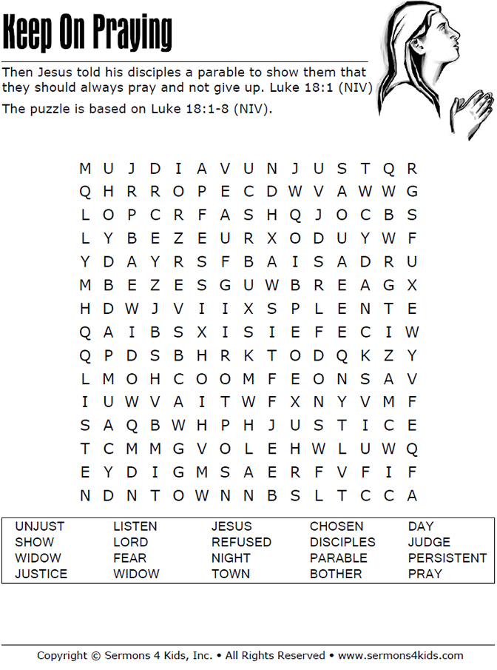
Sunday Morning Bible Study ~
We are studying the book of Ephesians. Please join us.

Israel Trip Information ~ Pick up a brochure today regarding the trip that Pastor will be hosting in June of 2023. Please pick up additional brochures for family or friends that might be interested in this exciting trip. For more information, please speak to Pastor Jeff.

Wednesday Bible Study ~ We meet on Wednesday at 10:30 a.m. We study the upcoming lessons for the next Sunday. Please join us.

Women of Zion Road Trip ~ We would love to have you join us on our trip to Shipshewana, IN on October 21st. We will leave at 8:00 a.m.

German Dinner ~ Thank you so much to all who helped with our dinner. Your help and support is so appreciated!

Women of Zion Meeting ~ They will have their meeting with at Bible Study on October 24th at 2 p.m.

Movie Night ~ We will have our Movie Night back on October 27th at 6:30 p.m. We will be watching, “Saved by Grace.”

