Welcome to ZION Lutheran Church
LCMC ~ Lutheran congregations in mission for Christ
8307 Memorial Hwy. Ottawa Lake, MI 49267 ·
(734) 856-2921
Pastor ∙ Jeffrey Geske
(785) 340-5635
zlcolmpastor@gmail.com
www.zionlutheranottawalakemi.com

Our MISSION:
“SHARING THE LOVE OF JESUS”

To Our Guests
We are so glad that you have chosen to join us this morning! We pray that you will be refreshed and renewed as you come into God’s presence. Please take a moment to introduce yourself to the pastor and to those seated around you. Once again, we warmly thank you for worshipping with us this morning!

Those Assisting in Ministry Today
October 23, 2022 ~ 20th sunday after Pentecost
Organist: Joseph extejt Greeters : Ron Clark and All
deacon: Dwight Gilliland and Jim Hredzak
SCREEN: Nick Baumgartner & Jacob Geske
Reader and Assistant: Karen Vollmer
Altar Guild: Shirley Clark and JoAnn VanSteenkiste
Administrative assistant: Sandy Brady 419- 410-9380 or skwiles2000@gmail.com

LCMC ~ WHO WE ARE
Free in Christ + Accountable to One Another + Rooted in Scripture and the Lutheran Confessions + Committed to the Great Commission

Thoughts on our Readings ~ (-- From the Sola Publishing Website)
One of the greatest human sins that causes us spiritual trouble is pride. Pride makes us obstinate and haughty, and keeps us from following Christ. There are times when we are humbled so that we might learn to let Jesus be our guide. When we fail to put God first, sin creeps in and seeks to control us as it did Cain. Holding fast to God’s Word creates a constant reminder to seek His will and not our own.

October 23, 2022 ~ 20th Sunday After Pentecost
(--From the LCMS Website)
2 Timothy 4:6 – “For I am already being poured out as a drink offering, and the time of my departure has come.” As St. Paul nears the end of his life, he continues to view it as something to be spent in sacrifice toward God – just as he had told the Romans (12:1) to be “living sacrifices.” And why does St. Paul do this? Because he knows that His Lord has already won for him the crown of life. Jesus’ sacrifice that purchased our salvation leads us to imitate His sacrifice in our living for Him.

IN OUR PRAYERS:
- For our congregation members; that they may be committed to our mission of sharing the love of Jesus.
- Pastor and Jacob Geske
- For LCMC Congregation and Missionaries around the world.
- President Biden, national leaders and our country. Our nation’s military, especially our loved ones:
- For those who are sick, recovering, or in need of God’s grace at this time. We include in our prayers: Loretta VanDyke, Susan Gaylord, Betty Vesey, Parker Reau, Marilyn Bexten, Fred and JoAnn VanSteenkiste, Joann Koester, Karen Keck, Duane Holtz and those dealing with Covid.

Prayer List: Please let us know when we can take the name off of the prayer list. Thank you!.

Services covered by CCLI: 1553677 ~ Lutheran Service Book Hymn License # 100014699 ~ Lutheran Service Book Liturgy License. # 000014699

OUR STEWARDSHIP ~ Weekly budget needs are $1,908.12. Attendance last weekend was 42. Offerings given totaled $1842.60. The Food Pantry also received $1317.00 from the German Dinner. Thank you for your support of our ministry!

Flowers on the Altar ~ If you would like to place flowers on the altar, please sign up in the hallway. Let pastor or Sandy know if you are celebrating or remembering something special. Flowers today are given by Brian and Jean Gilliland in memory of Jeffrey Scott Gilliland and Mildred Ann Gilliland.

Worship Service Order
Welcome

Opening Hymn:
LSB 803
“Joyful, Joyful, We Adore Thee”

Confession and Absolution
Kyrie: LSB p. 152
Hymn: LSB 971
“There is a Redeemer”

†GOD’S WORD FOR US†
(On Insert)
Collect of the Day
First Reading:
Genesis 4:1-5
Psalm:
Psalm 5
Epistle Reading:
2 Timothy 4:6-8, 16-18
Holy Gospel:
Luke 18:9-17
Hymn of the Day:
LSB 611
“Chief of Sinners”

Today’s Message:
“The Mercy of God”
Luke 18:9-17

Creed: Apostles’ Creed
Offering
Video: “The Commission”
Hymn: LSB 570
“Just As I Am”
Prayers and Lord’s Prayer

Benediction ~ Sending
Closing Hymn: LSB 660
“Stand Up, Stand Up for Jesus”

Announcements

This Week at Zion Includes:
Today – Bible Study; Worship at 10:00 a.m. Choir at 11:15 a.m.
Monday ~ Women of Zion at 2:00 p.m.
Tuesday ~ Food Pantry from 10:00 until noon.
Wednesday ~ Bible study at 10:30 a.m. Confirmation at 5:00 p.m.
Thursday ~ Movie Night at 6:30 p.m.
Saturday ~ Handbells at 3:00 p.m., Contemporary Worship at 4:00 p.m.
Next Sunday – Bible Study at 9:00 a.m. Worship at 10:00 a.m. Choir at 11:15 a.m.
And Church Council at 11:15 a.m.

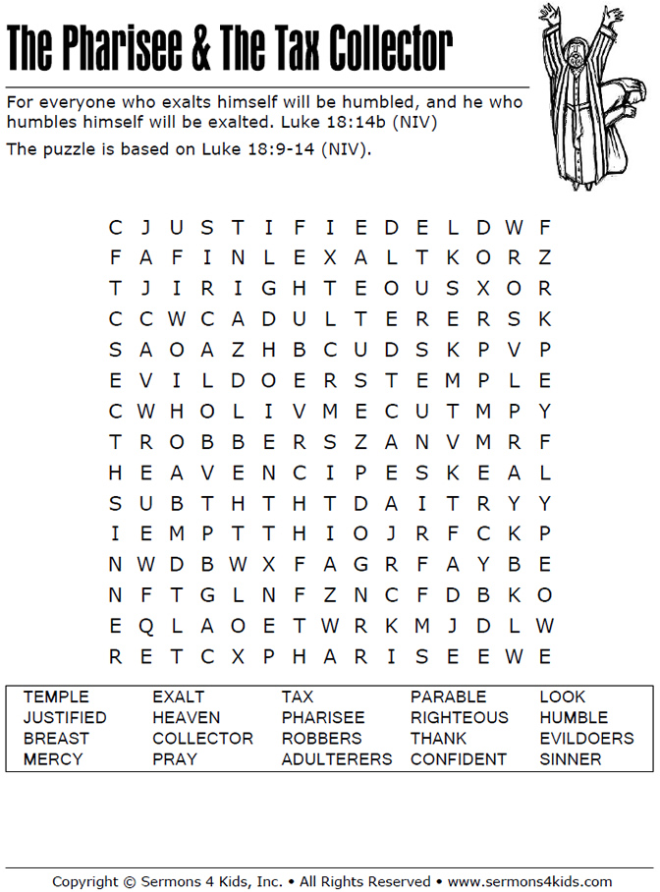
Sunday Morning Bible Study ~
We are studying the book of Ephesians. Please join us.

Israel Trip Information ~ Pick up a brochure today regarding the trip that Pastor will be hosting in June of 2023. Please pick up additional brochures for family or friends that might be interested in this exciting trip. For more information, please speak to Pastor Jeff.

Wednesday Bible Study ~ We meet on Wednesday at 10:30 a.m. We study the upcoming lessons for the next Sunday. Please join us.

Reformation Sunday ~ Please consider wearing red next Sunday in celebration that we are saved by grace.

Women of Zion Meeting ~ They will have their meeting with at Bible Study tomorrow on October 24th at 2 p.m.

Movie Night ~ We will have our Movie Night back on October 27th at 6:30 p.m. We will be watching, “Saved by Grace.”



