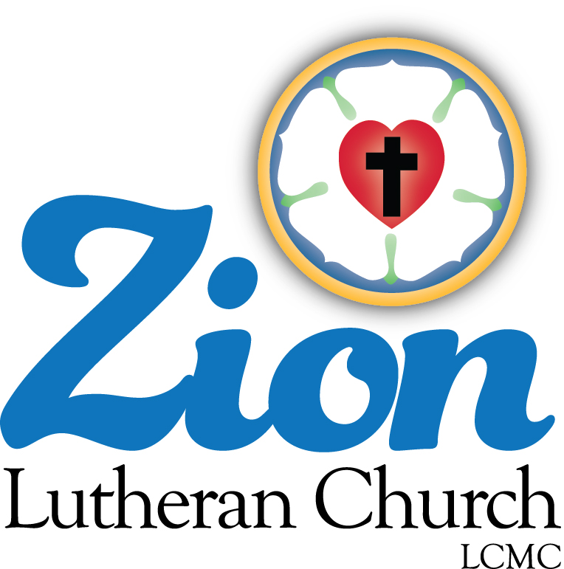
Welcome to ZION Lutheran Church
LCMC ~ Lutheran congregations in mission for Christ
8307 Memorial Hwy. Ottawa Lake, MI 49267 ·
(734) 856-2921
Pastor ∙ Jeffrey Geske
(785) 340-5635
zlcolmpastor@gmail.com
www.zionlutheranottawalakemi.com

Our MISSION:
“SHARING THE LOVE OF JESUS”

To Our Guests
We are so glad that you have chosen to join us this morning! We pray that you will be refreshed and renewed as you come into God’s presence. Please take a moment to introduce yourself to the pastor and to those seated around you. Once again, we warmly thank you for worshipping with us this morning!

Those Assisting in Ministry Today
November 6, 2022 ~ All Saints Sunday
Organist: Joseph extejt Greeters : Ron Clark and All
deacon: Dwight Gilliland and Jim Hredzak
SCREEN: Nick Baumgartner & Jacob Geske
Reader and Assistant: MaryJo Price
Altar Guild: Shirley Clark and JoAnn VanSteenkiste
Administrative assistant: Sandy Brady 419- 410-9380 or skwiles2000@gmail.com

LCMC ~ WHO WE ARE
Free in Christ + Accountable to One Another + Rooted in Scripture and the Lutheran Confessions + Committed to the Great Commission

Thoughts on our Readings ~ (-- From the Sola Publishing Website)
Freedom is not necessarily the absence of chains. We who are sinners don’t wear shackles, yet we know ourselves to be in bondage to all that draws us away from our Lord. The truth of all truths is that Jesus, the one and only Son of God, took on flesh and lived among us — pointing us to the source of true freedom, his own self. If we abide in Him, he abides in us, and we are truly free from sin and death.

REFORMATION SUNDAY
October 30, 2022
AS WE GATHER
The Lutheran Reformation recaptured the truth that any righteousness we might claim is a gift of God through faith in Jesus Christ. We come confessing our sins and are declared righteous only by the grace of God. In the Lord's Supper, God strengthens our faith to trust only in Christ's righteous sacrifice on our behalf. Scripture, not human tradition or other writings, is our only source for understanding how we stand righteous before God. God has not offered campaign slogans, promising to save us; in Christ all His promises have been kept.

RINGING OF THE BELL

WELCOME

+ PREPARATION +
Sola Gratia---Grace Alone
For our sake He made Him to be sin who knew no sin, so that in Him we might become the righteousness of God 2 Corinthians 5:21

HANDBELL CHOIR

ENTRANCE HYMN LSB 657 "A Mighty Fortress”

INVOCATION
Pastor: In the name of the Father and of the + Son and of the Holy Spirit.
People: Amen.

CONFESSION and ABSOLUTION
Pastor: Brothers and sisters in Christ, we have come together to affirm again the truths that the Reformation restored to the one holy apostolic Church. We are here to worship God because of His infinite grace in creating us, in saving us through the sacrifice of our Lord, and in working faith in our hearts so that we might receive His own righteousness. Indeed, without the promise of forgiveness, we would never admit to our failings but would, in our fallen nature, constantly flee from God. But with the gracious promise of full and free forgiveness, let us consider our sins and call on God for mercy.

(Silence for reflection on God's Word and for self-examination.)

Pastor: The Lord is merciful and gracious, slow to anger and abounding in steadfast love. Psalm 103:8
People: He does not deal with us according to our sins, nor repay us according to our iniquities. Psalm 103:10

Pastor: Gracious God,
People: we confess that we have failed to rely completely on Your grace for Jesus' sake. We have presented ourselves as deserving of Your love; we have expected Your blessings. We have sinned against You in our thoughts, words, and deeds which we consider worthy. "All have sinned and fall short of the glory of God." Romans 3:23
Forgive us, reform us to trust only in Your grace and mercy, and move us again to seek Your will, letting our "light shine before others, so that they may see [our] good works and give glory to [our] Father who is in heaven." Matthew 5:16

Pastor: "God, being rich in mercy, because of the great love with which He loved us, even when we were dead in our trespasses, made us alive together with Christ---by grace you have been saved." Ephesians 2:4-5
"In Him we have redemption through His blood, the forgiveness of our trespasses, according to the riches of his grace." Ephesians 1:7
As a called and ordained servant of Christ and by His authority I therefore forgive you all your sins in the name of the Father and of the + Son and of the Holy Spirit.
People: Amen.

HYMN LSB 655 "Lord, Keep Us Steadfast in Your Word"

COLLECT OF THE DAY
Pastor: The Lord be with you.
People: And also with you.
Pastor: Let us pray. Almighty and gracious Lord, pour out Your Holy Spirit on Your faithful people,
People: keep us steadfast in Your grace and truth,
Pastor: protect and deliver us in times of temptation,
People: defend us against all enemies,
Pastor: and grant to Your Church Your saving peace; through Jesus Christ, Your Son, our Lord, who lives and reigns with You and the Holy Spirit, one God, now and forever.
People: Amen.

+ SERVICE OF THE WORD +
Sola Scriptura---Scripture Alone

For I delivered to you as of first importance what I also received: that Christ died for our sins in accordance with the Scriptures. 1 Corinthians 15:3

COLLECT FOR THE WORD
Pastor: Let us pray. Blessed Lord, You have caused all Holy Scriptures to be written for our learning.
People: Grant that we may so hear them, read, mark, learn, and inwardly digest them that, by patience and comfort of Your holy Word, we may embrace and ever hold fast the blessed hope of everlasting life;
Pastor: through Jesus Christ, Your Son, our Lord, who lives and reigns with You and the Holy Spirit, one God, now and forever.
People: Amen.

ANNOUNCEMENT OF THE DAY
Pastor: When Martin Luther translated the Bible into the language of the people, they no longer had to have priests tell them what the Bible said; they could hear it with their own ears. Today the readings will be read from the middle of the nave to symbolize God's Word, freely available in our own hearing.

FIRST READING Revelation 14:6-7 (Fear God and give Him glory.)
Pastor: This is the Word of the Lord.
People: Thanks be to God!

PSALM Psalm 46 (God is our Refuge and Strength)

EPISTLE Romans 3:19-28 (God's Righteousness)
Pastor: This is the Word of the Lord.
People: Thanks be to God!

HOLY GOSPEL John 8:31-36 (Abide in My Word.)
Pastor: The Holy Gospel according to Saint John, the 8th chapter.
People: Glory to You, O Lord.
Pastor: This is the Gospel of the Lord.
People: Praise to You, O Christ.

HYMN LSB 566 St. 1,3,6 "By Grace I'm Saved"

SERMON Free in Jesus ~ John 8:31-36

SECOND ARTICLE OF THE APOSTLES’ CREED WITH MEANING
ALL: [I believe] in Jesus Christ, His only Son, our Lord, who was conceived by the Holy Spirit, born of the Virgin Mary, suffered under Pontius Pilate, was crucified, died and was buried. He descended into hell. The third day He rose again from the dead. He ascended into heaven and sits at the right hand of God, the Father Almighty. From thence He will come to judge the living and the dead.
PASTOR: What does this mean?
ALL: I believe that Jesus Christ, true God, begotten of the Father from eternity, and also true man, born of the Virgin Mary, is my Lord, who has redeemed me, a lost and condemned person, purchased and won me from all sins, from death, and from the power of the devil; not with gold or silver, but with His holy, precious blood and with His innocent suffering and death, that I may be His own and live under Him in His kingdom and serve Him in everlasting righteousness, innocence, and blessedness, just as He is risen from the dead, lives and reigns to all eternity. This is most certainly true.

THE GATHERING OF OUR OFFERING

VIDEO “Who You Say I Am”

PRAYER OF THE CHURCH [1 Timothy 2:1-4]
Pastor: Another biblical truth recaptured by the Reformation was "the Priesthood of All Believers." As Jesus clearly taught, each believer can pray directly to God in Jesus' name for the needs of our brothers and sisters in Christ. Today, I will invite the prayers, and members of the congregation will offer them.
Pastor: Let us pray for the Church around the world.
An elder: Protect and defend Your Church, Lord Jesus, wherever it proclaims the Gospel. Guide clergy and laity, missionaries and teachers to seek every opportunity to announce Your grace and mercy. Where the Church is in error, reform it; where it conforms to Your will, increase and strengthen it. Lord, in Your mercy,
People: hear our prayer.
Pastor: Let us pray for the nations.
A civic leader: Heavenly Father, continue to raise up men and women who will order society according to Your will, enabling the Church to grow and providing for the common good. May they protect the poor and oppressed, and work for peace with their neighbors. Use our abilities to work for the betterment of our communities, state, and nation. Lord, in Your mercy,
People: hear our prayer.
Pastor: Let us pray for those who defend our country and protect us at home.
A military member, fireman/EMT or police officer: Almighty God, we give thanks for each person in whom You have placed a sense of duty that moves him or her to go in harm's way. Protect them, give them wise judgment in unexpected crises, and enable us all to support their efforts at home and abroad. Be with their families as they deal with times of separation and thoughts of unknown dangers. Lord, in Your mercy,
People: hear our prayer.
Pastor: Let us pray for our families.
A parent: Guide us, O Holy Spirit, to make thoughtful decisions as we seek the best for our children. Give us understanding as we deal with miscommunications and hurt feelings between spouses, and children and parents. Remind us of Your presence in our homes so that they will be temples in which we reflect Your forgiveness and love. Lord, in Your mercy,
People: hear our prayer.
Pastor: Let us pray for our youth.
A child or teen: Lord Jesus, open our hearts and minds to the news of Your great love for us. Help us to grow in our trust for You and in knowing how much You have done for us. Then open our mouths to tell our families and friends about the joyful Good News of eternal life. Lord, in Your mercy,
People: hear our prayer.
Pastor: Let us pray for the sick and those who care for them.
A health care worker: Gracious Lord, instill in each of us thankfulness for every day of health. Help us to care for the bodies You have given us. When illness or injury strikes, bring healing according to Your will for us. Strengthen and guide all who care for us in times of crisis or through years of chronic conditions. Give them compassion to use their skills according to Your merciful will. We remember those, known to us, that are in need of Your healing hand. Lord, in Your mercy,
People: hear our prayer.
[Other concerns of the congregation may be inserted here, perhaps spoken by an officer of the church.]
Pastor: Into Your hands, gracious God, we commend all for whom we pray, trusting in Your mercy for the sake of Your Son, Jesus Christ our Lord.
People: Amen.

LORD'S PRAYER Matthew 6:9-11

ALL: Our Father who art in heaven, hallowed be Thy name, Thy kingdom come, Thy will be done on earth as it is in heaven; give us this day our daily bread; and forgive us our debts as we forgive our debtors; and lead us not into temptation, but deliver us from evil. For Thine is the kingdom and the power and the glory forever. Amen.

BENEDICTION
Pastor: The Lord bless you and keep you.
The Lord make His face shine on you and be gracious to you.
The Lord look upon you with favor and  give you peace. Numbers 6:24–26
People: Amen. Amen. Amen.

HYMN LSB 644 St. 1,2,5 "The Church's One Foundation" and “Go Now In Peace”


Go in Peace ~ Sharing the Love of Jesus! Thanks be to God!

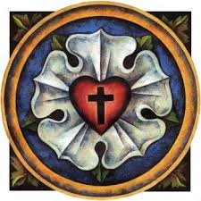
WE ARE SAVED BY GRACE AND SENT TO SHARE OUR SAVIOR!

Announcements

This Week at Zion Includes:
Today – Bible Study at 9:00 a.m. Worship at 10:00 a.m. Choir at 11:15 a.m.
Wednesday ~ Bible study at 10:30 a.m. Confirmation at 5:00 p.m.
Saturday ~ Handbells at 3:00 p.m., Contemporary Worship at 4:00 p.m.
Next Sunday – Bible Study at 9:00 a.m. Worship at 10:00 a.m. Choir at 11:15 a.m.

Stewardship Message ~ October 30, 2022 ~ Reformation Sunday (--From the LCMS Website)
Revelation 14:6 – “Then I saw another angel flying directly overhead, with an eternal gospel to proclaim to those who dwell on earth, to every nation and tribe and language and people.” During the Reformation, this text was used to refer to Luther’s ministry and the Lutheran message. We have an eternal Gospel to proclaim. Christ has freed us from our sins without any works on our part. We are saved by grace alone! And, ironically enough, Luther said this should make him the “apostle of works. Once we are freed by grace, we are truly free to serve God in works that flow from thankfulness and praise.

IN OUR PRAYERS:
- For our congregation members; that they may be committed to our mission of sharing the love of Jesus.
- Pastor and Jacob Geske
- For LCMC Congregation and Missionaries around the world.
- President Biden, national leaders and our country. Our nation’s military, especially our loved ones:
- For those who are sick, recovering, or in need of God’s grace at this time. We include in our prayers: Loretta VanDyke, Susan Gaylord, Betty Vesey, Parker Reau, Marilyn Bexten, Fred and JoAnn VanSteenkiste, Joann Koester, Karen Keck, Duane Holtz and those dealing with Covid.

Prayer List: Please let us know when we can take the name off of the prayer list. Thank you!.

Services covered by CCLI: 1553677 ~ Lutheran Service Book Hymn License # 100014699 ~ Lutheran Service Book Liturgy License. # 000014699

OUR STEWARDSHIP ~ Weekly budget needs are $1,908.12. Attendance last weekend was 47. Offerings given totaled $3177.79. Thank you for your support of our ministry!

Flowers on the Altar ~ If you would like to place flowers on the altar, please sign up in the hallway. Let pastor or Sandy know if you are celebrating or remembering something special. Flowers today are given by Bill and Sandy Brady in celebration of Sandy’s birthday.

Sunday Morning Bible Study ~
We are studying the book of Ephesians. Please join us.

Wednesday Bible Study ~ We meet on Wednesday at 10:30 a.m. We study the upcoming lessons for the next Sunday. Please join us.
Newsletters ~ Pick up your November newsletter in the Fellowship Hall.

Raffle Tickets ~ We are beginning to sell the tickets for the La-Z-Boy raffle for our Christmas Festival and Cookie Walk which will be on December 10.

ALL SAINTS DAY REMEMBRANCE ~ Next Sunday, we remember those who have passed away in the past year. Please write those names down on a piece of paper and give it to pastor or Sandy that you would like have included in the bulletin next Sunday.

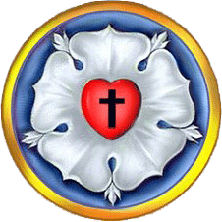
Martin Luther's Seal
"From the wilderness of Koburg Castle
8 July 1530
Honorable, kind, dear Sir and Friend!
Grace and Peace in Christ!
Since you ask whether my seal has come out correctly, I shall answer most amiably and tell you of those thoughts which now come to my mind about my seal as a symbol of my theology. There is first to be a cross, black, and placed in a heart, which should be of its natural color (red), to put me in mind that faith in Christ crucified saved us. For if one believes from the heart, he will be justified. ["For it is by believing in your heart that you are made right God, and it is by confessing with your mouth that you are saved." --Romans 10:10] Even though it is a black cross, which mortifies and which also should hurt us, yet it leaves the heart in its natural color and does not ruin nature...that is, the cross does not kill, but keeps man alive. For the just shall live by faith, by faith in the Savior. ["This Good News tells us how God makes us right in His sight. This is accomplished from start to finish by faith. As the Scriptures say, 'It is through faith that a righteous person has life.'" --Romans 1:17]
Such a heart is to be in the midst of a white rose, to symbolize that faith gives joy, comfort, and peace. In a word, it places the believer into a white joyful rose, for this faith does not give peace and joy as the world gives. ["I am leaving you with a gift--peace of mind and heart. And the peace I give isn't like the peace the world gives. So don't be troubled or afraid." --John 14:27] Therefore, the rose is to be white, not red, for white is the color of the spirits and of all angels. ["..an angel of the Lord came down from heaven and rolled aside the stone and sat on it. His face shone like lightening, and his clothing was as white as snow." --Matthew 28:2b-3 and "She saw two white-robed angels sitting at the head and foot of the place where the body of Jesus had been lying." --John 20:12]
This rose, moreover, is fixed in a sky-blue field, symbolizing that such joy in the Spirit and in faith is a beginning of the future heavenly joy. It is already a part of faith, and is grasped through hope, even though not yet manifest.
And around this field is a golden ring, to signify that such bliss in heaven is endless, and more precious than all joys and goods, just as gold is the most valuable and precious metal.
May Christ, our dear Lord, be with your spirit until the life to come. Amen."
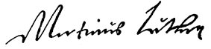
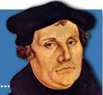

[Luther's Works - American Edition - Volume 49, pp. 356-359

