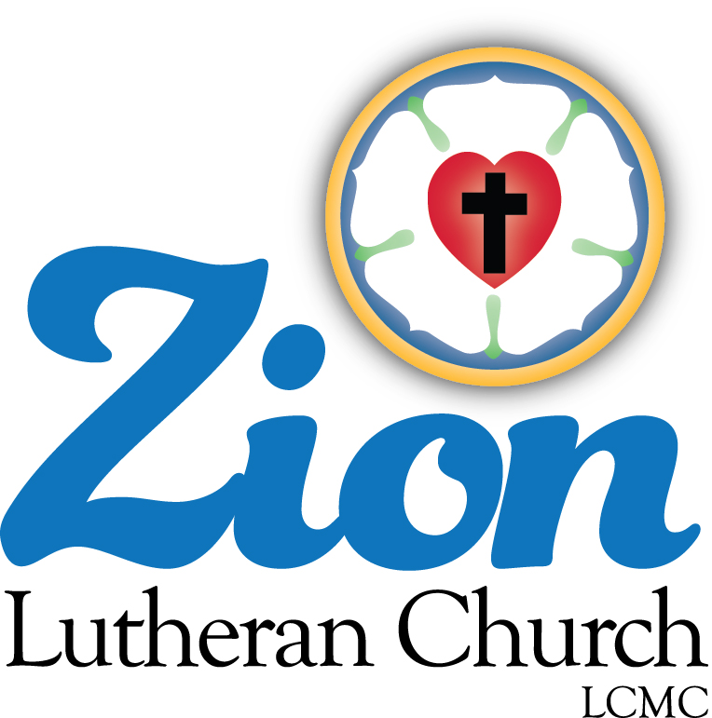
Welcome to ZION Lutheran Church
LCMC ~ Lutheran congregations in mission for Christ
8307 Memorial Hwy. Ottawa Lake, MI 49267 ·
(734) 856-2921
Pastor ∙ Jeffrey Geske
(785) 340-5635
zlcolmpastor@gmail.com
www.zionlutheranottawalakemi.com

Our MISSION:
“SHARING THE LOVE OF JESUS”

To Our Guests
We are so glad that you have chosen to join us this morning! We pray that you will be refreshed and renewed as you come into God’s presence. Please take a moment to introduce yourself to the pastor and to those seated around you. Once again, we warmly thank you for worshipping with us this morning!

Those Assisting in Ministry Today
November 6, 2022 ~ All Saints Sunday
Organist: Joseph extejt Greeters : Ron Clark and All
deacon: Dwight Gilliland and Jim Hredzak
SCREEN: Nick Baumgartner & Jacob Geske
Reader and Assistant: Dwight Gilliland
Altar Guild: Shirley Clark and JoAnn VanSteenkiste
Administrative assistant: Sandy Brady 419- 410-9380 or skwiles2000@gmail.com

LCMC ~ WHO WE ARE
Free in Christ + Accountable to One Another + Rooted in Scripture and the Lutheran Confessions + Committed to the Great Commission

Thoughts on our Readings ~ (-- From the Sola Publishing Website)
All Saints is the day when we remember those who came before us in faith, who ran the race and persevered until the end. Our hope is grounded in the resurrection of Christ as we think of our loved ones who have passed from this earthly life to a life that continues even more fully in the presence of God. We have much to be joyful about as we meditate upon God’s great love and faithfulness to his people.

ALL SAINTS DAY
November 6, 2022

RINGING OF THE BELL

WELCOME

OPENING HYMN LSB 677 St. 1-4 “For All the Saints”

INVOCATION
Pastor: In the name of the Father and of the + Son and of the Holy Spirit.
People: Amen.

OPENING SENTENCES Psalm 34:1, 3, 8–9
Pastor: I will bless the Lord at all times; His praise shall continually be in my mouth.
People: Oh, magnify the Lord with me, and let us exalt His name together!
Pastor: Oh, taste and see that the Lord is good! Blessed is the man who takes refuge in Him!
People: Oh, fear the Lord, you His saints, for those who fear Him have no lack!

CONFESSION AND ABSOLUTION
Pastor: Beloved of God, we rejoice to be numbered with the saints. In confidence, let us come before our gracious Lord to confess our sins and to receive His gracious absolution.
People: Almighty God, we are by nature sinful and unclean. We repent of our sins in thought and in word and in deed. In Your mercy, forgive us. Create in us clean hearts, O God, that we may serve You as Your redeemed people now and forever.
Pastor: Because of the sacrifice of His beloved Son for the sins of all people, God has promised His forgiveness. In the stead and by the command of my Lord Jesus Christ I forgive you all your sins in the name of the Father and of the + Son and of the Holy Spirit. May you ever live as the saints that you are in Christ Jesus.
People: Amen.

+ GOD’S WORD FOR US +

HYMN LSB 785 “We Praise You, O God”

SALUTATION
Pastor: The Lord be with you.
People: And also with you.

PRAYER OF THE DAY
Pastor: Almighty and everlasting God, You knit together Your faithful people of all times and places into one holy communion, the mystical body of Your Son, Jesus Christ. Grant us so to follow Your blessed saints in all virtuous and godly living that, together with them, we may come to the unspeakable joys You have prepared for those who love You; through Jesus Christ, our Lord, who lives and reigns with You and the Holy Spirit, one God, now and forever.
People: Amen.

PSALM Psalm 149

EPISTLE 1 John 3:1–3 (We are God’s children now.)

Lector: This is the Word of the Lord.
People: Thanks be to God.

HOLY GOSPEL Matthew 5:1–12
(Jesus speaks the ‘Beatitudes’ on the mountain.)

Pastor: The Holy Gospel according to St. Matthew, the fifth chapter.
People: Glory to You, O Lord.
The Gospel is read
Pastor: This is the Gospel of the Lord.
People: Praise to You, O Christ.

HYMN OF THE DAY LSB 677 St. 5-8 “For All the Saints”

SERMON Blessed by Jesus ~ Matthew 5:1-12

CREED The Third Article
All: I believe in the Holy Spirit, the holy Christian Church, the communion of saints, the forgiveness of sins, the resurrection of the body, and the life everlasting. Amen.
Pastor: What does this mean?
All: I believe that I cannot by my own reason or strength believe in Jesus Christ, my Lord, or come to Him; but the Holy Spirit has called me by the Gospel, enlightened me with His gifts, sanctified and kept me in the true faith. In the same way He calls, gathers, enlightens, and sanctifies the whole Christian Church on earth, and keeps it with Jesus Christ in the one true faith. In this Christian Church He daily and richly forgives all my sins and the sins of all believers. On the Last Day He will raise me and all the dead, and give eternal life to me and all believers in Christ. This is most certainly true.

THE GATHERING OF OUR OFFERING

REMEMBRANCE OF THE SAINTS
Pastor: At this time, now that we have spoken words of faith in the Creed, we remember those from our congregation/our circles of faith and friendship who have been called to the full presence of the Lord in the year span since last All Saints’ Day. We thank God for their earthly lives now concluded and ask that we may follow their examples of faith as we continue our earthly journeys.

Mel Bolte
Rocky Brandman
Bill Brooks
Bonita Deal
Bob and Charlene Dickerson
Martha Drager
Millie Gibson
Henry and Patsy Hancock
Sally Haynie
Esther Ideker
Loretta Knoblauch
June Lewis
Aggie Lumbarb
June Neitzke
Darla Northrop
Stella Shinager
Judy Smith
John Thompson
Richard Walker
Dennie Whittman

[As each name is read, a bell may be tolled as a sign of remembrance and of victory in Christ.]

HYMN LSB 801 St. 1,4 “How Great Thou Art”

PRAYER OF THE CHURCH
Pastor: Let us pray for the whole people of God in Christ Jesus and for all people according to their needs. On this day we remember with thanksgiving those who have gone before us with the sign of faith. May their memory be blessed among us, and may we follow our Lord faithfully all our days. Lord, in Your mercy,
People: hear our prayer.
Pastor: Celebrating our lives together as saints, we pray for the fellowship we enjoy as God’s holy people, asking that we may bring the sacrifices of pure hearts and may worship God in His sanctuary with joy. Lord, in Your mercy,
People: hear our prayer.
Pastor: Thankful for the saints among us in these days, we pray for those who serve in leadership positions in our national Synod, our district, and our local congregation, asking that God may bless their work among us as they set examples of devotion and dedication in Jesus’ name. Lord, in Your mercy,
People: hear our prayer.
Pastor: Confident that Your care for the saints knows no limits, Lord, we make our petitions for the sick, the sorrowing, and all who this day are in need of our prayers, [especially . . .]. May their petitions be answered according to Your good and gracious will, and may they be supported by this fellowship of saints. Lord, in Your mercy,
People: hear our prayer.
Pastor: Reflecting on the journey of life we make together as the saints below, we pray for the youngest among us, the infants and children, and also for the most senior of saints, those who have been blessed with extended lives on earth. May we cherish the company of all of God’s people and seek to bring a sense of caring to all those around us with cheerful hearts. Lord, in Your mercy,
People: hear our prayer.
Pastor: With thankfulness for the land in which we live, we ask Your blessing on our nation, its leaders, and all who work for security and a sense of community in our world and in our lives. May we cherish the freedoms we enjoy and do all in our power to maintain the public good and promote peace and harmony. Lord, in Your mercy,
People: hear our prayer.
Pastor: Into Your hands, O Lord, we commend all for whom we pray, trusting in Your mercy through Your Son, Jesus Christ, our Lord.
People: Amen.

LORD’S PRAYER (Matthew 6:9–13)

+GOD’S SACRAMENT FOR US +

WORDS OF OUR LORD Matthew 26:26–28; Mark 14:22–24; Luke 22:19–20; 1 Corinthians 11:23–25

PROCLAMATION OF CHRIST
Pastor: As often as we eat this bread and drink this cup, we proclaim the Lord’s death until He comes. 1 Corinthians 11:26
People: Amen. Come, Lord Jesus. Revelation 22:20

DISTRIBUTION HYMNS
VIDEO “Hymn of Heaven”
LSB 801 “Thine the Amen”

POST-COMMUNION THANKSGIVING
Pastor: Let us pray,
People: Almighty and ever-living God, we thank You for having fed us with the body and blood of our Savior Jesus Christ, assuring us thereby that we are truly members of His body, the Church. Having been blessed to be at Your Table in the company of the saints, we ask You to help us by Your Holy Spirit that we may continue in this fellowship and do the good works which You desire us to do; through Jesus Christ, Your Son, our Lord, to whom, with you and the same Spirit, be all honor and glory, forever and ever. Amen.

BENEDICTION
Pastor: The Lord bless you and keep you.
The Lord make His face shine on you and be gracious to you.
The Lord look upon you with favor and + give you peace. Numbers 6:24–26
People: Amen.

HYMN LSB 662 “Onward, Christian Soldiers”


Go in Peace ~ Sharing the Love of Jesus! Thanks be to God!

Announcements

This Week at Zion Includes:
Today – Bible Study at 9:00 a.m. Worship at 10:00 a.m. Choir at 11:15 a.m.
Monday ~ Women of Zion at 2:00 p.m.
Tuesday ~ Food Pantry from 10:00 until noon.
Wednesday ~ Bible study at 10:30 a.m. Confirmation at 5:00 p.m.
Saturday ~ Handbells at 3:00 p.m., Contemporary Worship at 4:00 p.m.
Next Sunday – Bible Study at 9:00 a.m. Worship at 10:00 a.m. Choir at 11:15 a.m.

November 6, 2022 ~ All Saints Sunday (--From the LCMS Website)
Matthew 5:6 – “Blessed are those who hunger and thirst for righteousness, for they shall be satisfied.” You only hunger and thirst for what you don’t have. Jesus has come to fill us up with righteousness – His own righteousness. He is the self-giving Lord whose sacrifice inspires us to be givers, too.

OUR STEWARDSHIP ~ Weekly budget needs are $1,908.12. Attendance last weekend was 41. Offerings given totaled $1988.00. Thank you for your support of our ministry!

IN OUR PRAYERS:
- For our congregation members; that they may be committed to our mission of sharing the love of Jesus.
- Pastor and Jacob Geske
- For LCMC Congregation and Missionaries around the world.
- President Biden, national leaders and our country. Our nation’s military, especially our loved ones:
- For those who are sick, recovering, or in need of God’s grace at this time. We include in our prayers: Loretta VanDyke, Susan Gaylord, Betty Vesey, Parker Reau, Marilyn Bexten, Fred and JoAnn VanSteenkiste, Joann Koester, Karen Keck, Duane Holtz and those dealing with Covid.

Prayer List: Please let us know when we can take the name off of the prayer list. Thank you!.

Services covered by CCLI: 1553677 ~ Lutheran Service Book Hymn License # 100014699 ~ Lutheran Service Book Liturgy License. # 000014699

Flowers on the Altar ~ If you would like to place flowers on the altar, please sign up in the hallway. Let pastor or Sandy know if you are celebrating or remembering something special. Flowers today are given by Jim Hredzak in memory of his father John Hredzak.

Sunday Morning Bible Study ~
We are studying the book of Ephesians. Please join us.

Wednesday Bible Study ~ We meet on Wednesday at 10:30 a.m. We study the upcoming lessons for the next Sunday. Please join us.

Men’s Breakfast ~ There will be no Men’s Breakfast as Pastor will be out of town.

Pastor on Vacation ~ Pastor will be out of town from Friday, November 11 through Friday, November 18th. For emergencies, please contact Sandy Brady 419-410-9380.

Raffle Tickets ~ We are selling tickets for the La-Z-Boy raffle for our Christmas Festival and Cookie Walk which will be on December 10.

Thanksgiving Eve Service ~ We will have our service on Wednesday, November 23 at 7:00 p.m.

Women of Zion ~ WOZ of will hold their next meeting on November 28 at 2:00 p.m.

Congregational Meeting ~ We will have our next meeting after church on December 13.

