Welcome to ZION Lutheran Church
LCMC ~ Lutheran congregations in mission for Christ
8307 Memorial Hwy. Ottawa Lake, MI 49267 ·
(734) 856-2921
Pastor ∙ Jeffrey Geske
(785) 340-5635
zlcolmpastor@gmail.com
www.zionlutheranottawalakemi.com

Our MISSION:
“SHARING THE LOVE OF JESUS”

To Our Guests
We are so glad that you have chosen to join us this morning! We pray that you will be refreshed and renewed as you come into God’s presence. Please take a moment to introduce yourself to the pastor and to those seated around you. Once again, we warmly thank you for worshipping with us this morning!

Those Assisting in Ministry Today
November 13. 2022 ~ 23rd sunday after Pentecost
Organist: Joseph extejt Greeters : Ron Clark and All
deacon: Dwight Gilliland and Jim Hredzak
SCREEN: Nick Baumgartner & Jacob Geske
Reader: MaryJo Price
Altar Guild: Shirley Clark and JoAnn VanSteenkiste
Administrative assistant: Sandy Brady 419- 410-9380 or skwiles2000@gmail.com

LCMC ~ WHO WE ARE
Free in Christ + Accountable to One Another + Rooted in Scripture and the Lutheran Confessions + Committed to the Great Commission

Thoughts on our Readings ~ (-- From the Sola Publishing Website)
Jesus explained to all who would listen that the day was coming when the temple would simply be rubble on the ground. Many will come and try to lead them astray, but they are to hold fast to the Word they have come to know as Truth. There are many in our world who seek to lead us astray, but the message is the same now as it was then: Continue in your good work and hold fast to the love of Christ.

November 13, 2022 ~ 23rd Sunday After Pentecost
(--From the LCMS Website)
Luke 21:6 – “As for these things that you see, the days will come when there will not be left here one stone upon another that will not be thrown down.” Everything in this world is headed for the graveyard, but some things are also destined to rise from the grave. On that Day of Resurrection – as we look back on our earthly life – what will we see? What will have really mattered? This is a good question to ask ourselves in this season of the church year that focuses on The Last Things.

IN OUR PRAYERS:
- For our congregation members; that they may be committed to our mission of sharing the love of Jesus.
- Pastor and Jacob Geske
- For LCMC Congregation and Missionaries around the world.
- President Biden, national leaders and our country. Our nation’s military, especially our loved ones:
- For those who are sick, recovering, or in need of God’s grace at this time. We include in our prayers: Loretta VanDyke, Susan Gaylord, Betty Vesey, Parker Reau, Marilyn Bexten, Fred and JoAnn VanSteenkiste, Joann Koester, Madeline, Ron Vincent, Karen Keck, Duane Holtz and those dealing with Covid.
Prayer List: Please let us know when we can take the name off of the prayer list. Thank you!.

Services covered by CCLI: 1553677 ~ Lutheran Service Book Hymn License # 100014699 ~ Lutheran Service Book Liturgy License. # 000014699

OUR STEWARDSHIP ~ Weekly budget needs are $1,908.12. Attendance last weekend was 49. Offerings given totaled $2340.00. Thank you for your support of our ministry!

Flowers on the Altar ~ If you would like to place flowers on the altar, please sign up in the hallway. Let pastor or Sandy know if you are celebrating or remembering something special. Flowers this weekend are given by Sue Beard in memory of her husband George.

Worship Service Order

Welcome
Opening Hymn: LSB 728
“How Firm a Foundation”

Opening Versicles
LSB 260

†GOD’S WORD FOR US†
(On Insert)
Collect of the Day
First Reading:
Malachi 4:1-6
Psalm:
Psalm 98
Epistle Reading:
2 Thessalonians 3: (1-5) 6-13
Holy Gospel:
Luke 21:5-28 (29-36)
Responsory LSB 263
Catechism LSB 263

Hymn of the Day: LSB 763
“When Peace Like a River"

Today’s Message:
“Assurance of the Coming Kingdom”
Luke 21:5-28

Offering
Video: “Living Hope”
Hymn: LSB 734
“Have No Fear Little Flock"
Prayer LSB 265
Benediction ~ Sending
Closing Hymn: LSB 878
“Abide With Me"

Announcements

This Week at Zion Includes:
Today – Bible Study; Worship at 10:00 a.m.
Wednesday ~ No Confirmation at 5:00 p.m.
Saturday ~ Handbells at 3:00 p.m. and Contemporary Service at 4:00 p.m.
Next Sunday – Bible Study at 9:00 a.m. Worship at 10:00 a.m. Church Council at 11:15 a.m.

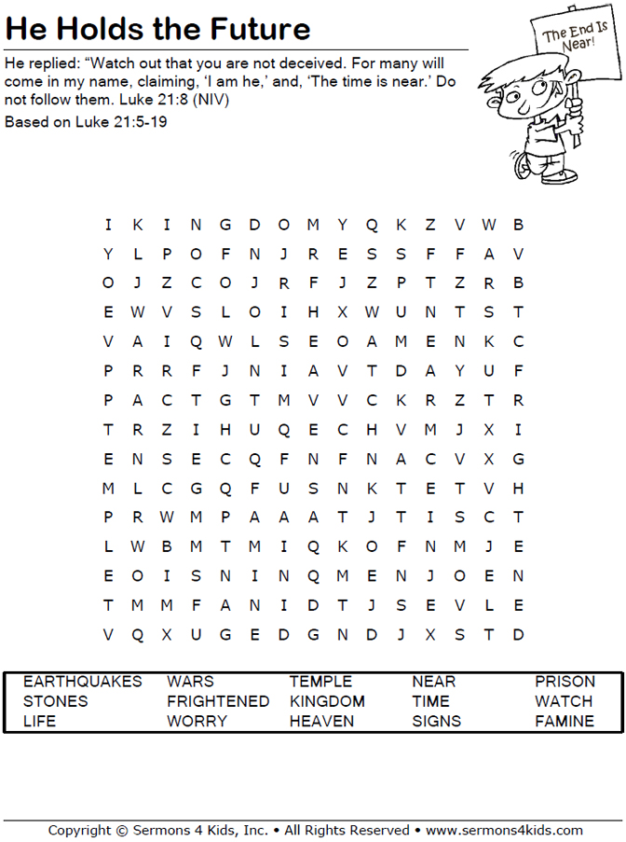
Sunday Morning Bible Study ~
We are resuming our study of the book of Ephesians. Please join us.

Wednesday Morning Bible Study ~ We will not meet this week.

Israel Trip Information ~ For more information, please speak to Pastor Jeff.

Pastor Out of Town ~ Pastor will be out of town until Friday. Please contact Sandy Brady for ministry needs.

Church Council ~ The Church Council will meet next Sunday at 11:15 a.m.

Women of Zion ~ Our women will hold their next meeting on November 28th at 2:00 p.m.

Thanksgiving Eve Service ~ We will have our service at 7:00 on Wednesday, November 23rd. We will have a food in gathering for our Food Pantry. Please bring your food gifts now through the end of November.

Advent Services ~ Our Advent Services start on Wednesday, November 30 at 7:00 p.m. with a meal before at 6:15 p.m.

Congregational Meeting ~ We will hold our bi-annual meeting after church on December 11.

