Welcome to ZION Lutheran Church
LCMC ~ Lutheran congregations in mission for Christ
8307 Memorial Hwy. Ottawa Lake, MI 49267 ·
(734) 856-2921
Pastor ∙ Jeffrey Geske
(785) 340-5635
zlcolmpastor@gmail.com
www.zionlutheranottawalakemi.com

Our MISSION:
“SHARING THE LOVE OF JESUS”

To Our Guests
We are so glad that you have chosen to join us this morning! We pray that you will be refreshed and renewed as you come into God’s presence. Please take a moment to introduce yourself to the pastor and to those seated around you. Once again, we warmly thank you for worshipping with us this morning!

Those Assisting in Ministry Today
december 11, 2022 ~ Third sunday in advent
Organist: Joseph extejt Greeters : Ron Clark and All
deacon: Dwight Gilliland and Jim Hredzak
SCREEN: Nick Baumgartner & Jacob Geske
Reader: Ron Vincent
Altar Guild: Shirley Clark and JoAnn VanSteenkiste
Administrative assistant: Sandy Brady 419- 410-9380 or skwiles2000@gmail.com

LCMC ~ WHO WE ARE
Free in Christ + Accountable to One Another + Rooted in Scripture and the Lutheran Confessions + Committed to the Great Commission

Thoughts on our Readings ~ (-- From the Sola Publishing Website)
Jesus lifted up the work and character of John the Baptist, of whom the prophet Isaiah spoke when he said that one would come to prepare the way of the Lord. With the promises of a desert in full bloom, the blind receiving sight, and the lame walking, the exhortation to be patient and persevere until the coming of the Lord’s Messiah gives us hope and courage as we wait for Christ’s return.

December 11, 2022 ~ Third Sunday in Advent
(--From the LCMS Website)
Isaiah 35:4 – “Say to those who have an anxious heart, ‘Be strong; fear not! Behold, your God will come with vengeance, with the recompense of God. He will come and save you.’” The return of our Lord at the Last Day is a cause of joy and anticipation for us believers. We know our Lord and His love, and we look forward to His Second Advent. Indeed, how we live our lives here and now flows from our certain hope of resurrection and eternal life.

IN OUR PRAYERS:
- For our congregation members; that they may be committed to our mission of sharing the love of Jesus.
- Pastor and Jacob Geske
- For LCMC Congregation and Missionaries around the world.
- President Biden, national leaders and our country. Our nation’s military, especially our loved ones:
- For those who are sick, recovering, or in need of God’s grace at this time. We include in our prayers: Loretta VanDyke, Susan Gaylord, Betty Vesey, Parker Reau, Marilyn Bexten, Fred and JoAnn VanSteenkiste, Joann Koester, Karen Keck and those dealing with Covid.

Prayer List: Please let us know when we can take the name off of the prayer list. Thank you!.

Services covered by CCLI: 1553677 ~ Lutheran Service Book Hymn License # 100014699 ~ Lutheran Service Book Liturgy License. # 000014699

OUR STEWARDSHIP ~ Weekly budget needs are $1,908.12. Attendance last weekend was 52. Offerings given totaled $2139.00 Thank you for your support of our ministry!

Flowers on the Altar ~ If you would like to place flowers on the altar, please sign up in the hallway. Let pastor or Sandy know if you are celebrating or remembering something special. Flowers this weekend are given to the glory of God by Art and Dorothy Gaynier in celebration of their daughter’s birthday.

Worship Service Order
Welcome
Opening Hymn: LSB 341
“Lift Up Your Heads”

Opening Versicles
LSB 260

†GOD’S WORD FOR US†
(On Insert)
Collect of the Day
First Reading:
Isaiah 35:1-10
Psalm:
Psalm 146
Epistle Reading:
James 5:7-11
Holy Gospel:
Matthew 11:2-15
Responsory LSB 263
Catechism LSB 263

Hymn of the Day: LSB 349
“Hark the Glad Sound"

Today’s Message:
“The Coming of the Lord”
Isaiah 35:1-10

Offering
Video: “Thrive”
Hymn: LSB 361
“O Little Town"
Prayer LSB 265
Benediction ~ Sending
Closing Hymn: LSB 380
“Hark the Herald Angels"

Announcements

This Week at Zion Includes:
Today – Bible Study at 9:00 a.m.; Worship at 10:00 a.m. Congregational Meeting at 11:15 a.m.
Tuesday ~ Food Pantry at 10:00 a.m.
Wednesday ~ Bible study at 10:30 a.m. Confirmation at 5:00 p.m. Advent Meal at 6:15, Advent Service at 7:00 p.m.
Saturday ~ Handbells at 3:00 p.m., Contemporary Worship at 4:00 p.m.
Next Sunday – Bible Study at 9:00 a.m. Worship at 10:00 a.m. Open House at the Parsonage 2:00 p.m.
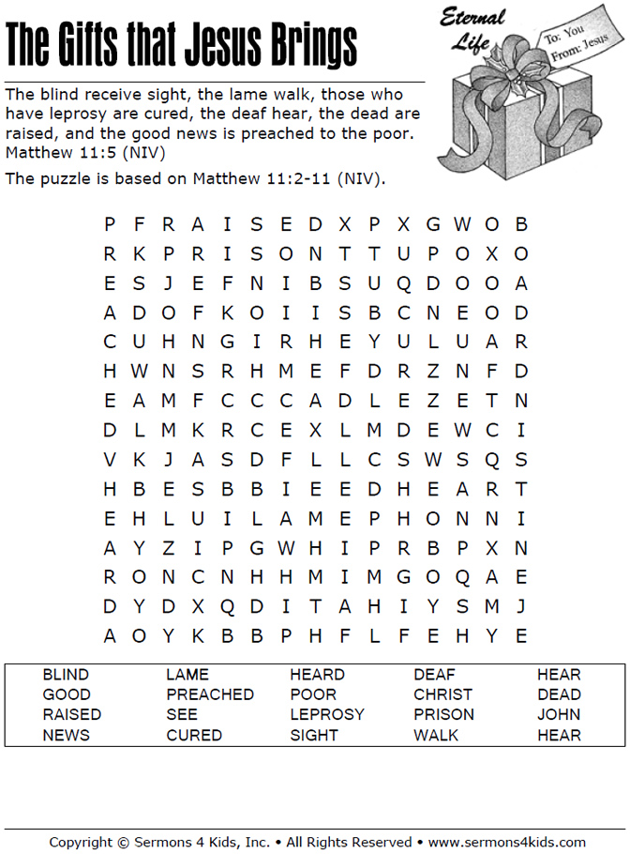
Sunday Morning Bible Study ~
We are studying the book of Ephesians. Please join us.

Wednesday Bible Study ~ We meet on Wednesday at 10:30 a.m. We study the upcoming lessons for the next Sunday. Please join us.

Advent Midweek Service ~ We will have an Advent Service on Dec. 14 at 7:00 p.m. A light meal will be served at 6:15 p.m.

Congregational Meeting Reminder ~ We will have our bi-annual Congregational Meeting on today at 11:15 a.m.

Thank you! ~ Thank you to all who helped in any way to make our Festival and Cookie Walk such a great day.

Poinsettia Orders ~ Place your order in the offering plate today.

Staff Christmas Gift. ~ Please consider giving a gift to our staff. We will gather money through Sunday, December 18th and bless our staff on Christmas Eve.

Christmas Open House ~ Pastor and Jacob invite you to stop by for some refreshments and visiting next Sunday, December18th from 2-5 p.m.

Christmas Worship Services ~ Mark your calendars and invite your family, friends and loved ones to our Christmas Eve Services at 4:00 p.m. and 6:30 p.m. Both services will have Communion and Candlelight. We will have a Christmas Day Service at 10:00 a.m.

