The Messenger
A newsletter of Zion Lutheran Church ~ Ottawa Lake, MI
June 2023
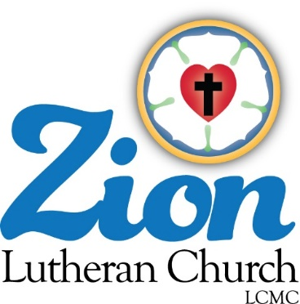
+ + + + + + + + + +
ZION Lutheran Church
LCMC ~ Lutheran congregations in mission for Christ
Mailing Address - P.O. Box 75, Ottawa Lake, MI 49267
Located at 8307 Memorial Hwy. Ottawa Lake, MI 49267
(734) 856-2921
Pastor ∙ Vacant
www.zionlutheranottawalakemi.com

Church Secretary ~ Brenda Blum 419-343-3381 bcc220@aol.com

custodian and organist~ Joseph extejt

For Your Information
The following members give of their time to the leadership of this congregation. Please keep them in your prayers. If you have any questions, comments, or offers of help, please contact them.
Chairman: Ron Vincent
Secretary: MaryJo Gilliland
Treasurer: Brian Gilliland
Financial Secretary: Sandy Bondy
Recording Secretary: MaryJo Price
Elders: Ron Clark and Lee Edignton
Deacons: Dwight Gilliland, Jim Hredzak

WORSHIP WITH US EACH WEEK!
Join us for worship on Sunday morning at 10:00 a.m.
Our Saturday Contemporary Service will resume after we have a pastor.

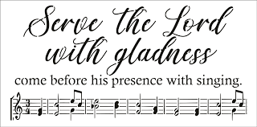
Zion Church Choir
If you love singing, please join our church choir. They meet after church in the choir room. For more information, please speak with Joseph Extejt.

Our handbell choir has postponed practice for now. If you are interested
in joining, please see Karen Vollmer. They practice on Saturdays.

LCMC ~ WHO WE ARE
Free in Christ + Accountable to One Another + Rooted in Scripture and the Lutheran Confessions + Committed to the Great Commission

Prayers Are Important
If you have an occasion to request a prayer, please call the church office. If you would like your request to be on our prayer chain, please call Sandy Brady (419) 410-9380.

Please Inform the Church Office. . .
*when a member of your family is ill or hospitalized or if they are discharged or moved to another facility.
*when your address changes.
*when a new baby arrives.
*when a family member marries or leaves home for college, or military.
*when planning a wedding to be conducted at Zion.
*when a new family moves into your neighborhood.
*when you are planning to be out of town.
*when a brother or sister in Christ needs a visit from Pastor.
*when there is a death of a member.

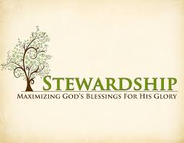
Newsletter Article – June 2023
(--From the LCMS website)

What Do You Want?

One of the best-known and most-beloved psalms is Psalm 23, the “Shepherd Psalm.” There we learn that the Lord is our Shepherd. And since He is our Shepherd, we will not want. We will not suffer want because the Lord, our Shepherd, will lead us to green pastures and beside still waters. In other words, the Lord, our Shepherd, will provide for all that we need in both body and soul.

Yet, we live as though this is not the case. We live as though we actually suffer from want, that the Lord, our Shepherd, will not provide for all that we need. And thus, we live as though the Lord is not our Shepherd. And that means that we live as though we are not the Lord’s sheep.

When do we live as though the Lord is not our Shepherd? When we put anything else before Him and His provision for us. When we think that going to work is more important than receiving His gifts in church on Sunday (in violation of the First and Third Commandments). When we fail to give generously of the first fruits of what the Lord has provided for us because we don’t know what the future will bring (even though He has promised that He will lead us to green pastures and still waters).

We live as though we are not the Lord’s sheep when we think that the Lord is only in the busi-ness of helping those who will help themselves. We act this way because our minds are set on earthly, temporal things and not on heavenly, eternal things. We act this way because we have stopped hearing the call of our Shepherd, which comes through His Word.

Through the Word of God, the Shepherd calls us to Himself. Through the Word, the Holy Spirit gathers and enlightens us with His gifts. Through the Word, we are kept holy and nourished in the one true faith, the faith that follows our Shepherd wherever He leads us. He promises to lead us to our true home, to the land flowing with milk and honey, to a better country, not of this world, but a heavenly one.

And so, here’s the Good News: the Lord is your Shepherd, even and especially for wayward sheep. For Jesus seeks and saves those who are lost. He finds the lost sheep and carries them back to the fold. He is the Shepherd who lays down His life for His sheep. The Lord is your Shepherd. Let us live as His sheep.

Women of Zion – Meetings will resume September 25, 2023.

BIRTHDAYS AND ANNIVERSARIES We would like to wish Happy Birthday and Happy Anniversary to the following individuals who are celebrating this month. If you are not listed or you know someone not listed, please contact Sandy Brady.
.
Flowers on the Altar ~ If you would like to place flowers, please sign up in the hallway by the restroom.
The cost is $25.00
Please consider signing up for some time this coming year.

June Birthdays

8 Karen Weimer
13 Dwight Gilliland
16 Connie Sieler
17 Eric Baumgartner

June Anniversaries

10 Ben & Alex Schmidt
19 Ron & Sheila Vincent
25 Brian & Jean Gilliland

If we miss your birthday or anniversary
and would like to see it in the newsletter please give the information to Brenda Blum.
Please fill out the form that is located next to the flower chart and give to Brenda Blum. Your check can be made out to Zion and note in the memo on your check it is for flowers.

Food Bank~ Thank you for your generous help with our Food Bank. If you have any question or would like to help in any way, please contact Rick Keck at (734) 854-4710. The Food Bank serves families and individuals on the second and fourth Tuesday of the month from 10:00 a.m. until noon.

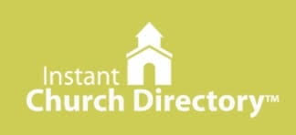
Our Church Directory is Online!
View our church directory online or via the FREE mobile app today. To view the directory online, go to members.InstantChurchDirectory.com and follow the prompts under “Sign In” to “Create a login now.” Please remember, you must confirm your email address before you can sign in. You will need to use your email address as listed in our directory to create a log-in the first time you use the directory online and via the mobile app.
Need help or have questions? Please contact Sandy Brady.

Euchre
Do you like to play Euchre? Join the group on the first and third Wednesday of the month at 1:00 p.m.

Community Rewards Program
Do you shop at Kroger? If you do, you can sign up for their Community Rewards Program and Kroger will give back to Zion money every quarter. This is free money for the church, at no cost to you. If you need help see Brenda. Go on Kroger's website and sign up under Community Rewards. (Our code is NC512)
Steps for Linking your Kroger card to help our ministry ~
1. Sign into your account at www.kroger.com or create an account.
2. Click on the NAME.3. Scroll down to MY ACCOUNT and Click on it,
4. Scroll down to COMMUNITY REWARDS. Click on COMMUNITY REWARDS.
5. Enter Zion Lutheran Church Ottawa Lake MI (NC512)

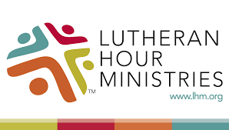
Bringing Christ to the Nations and the Nations to the Church
"The Lutheran Hour," which began in 1930, is now heard on more than 1,300 radio stations around the world. "The Lutheran Hour," hosted by Dr. Rev. Michael Zeigler, is the world's oldest continually-broadcast Gospel radio program. This weekly half-hour program proclaims the message of Jesus Christ to all people and serves as a bridge, linking them to the Church. Listen to the Lutheran Hour on Sundays at 10:00 a.m. or at AM 1560 WWYC or anytime at www.lhm.org

JUNE 2023

June 4
"It's All Good--Eve When It's Not"
Guest Speaker: Rev. Dr. John Nunes
The key to growing closer to others is by growing closer to God.
(Genesis 1)

June 11
"Strength Out of Weakness"
Lutheran Hour Speaker: Rev. Dr. Michael Zeigler
The human 'heroes' of the Bible are normal people, deeply flawed and dearly loved by the God Who made them.
(Judges 6:14-16)

June 18
"Just Around the Corner"
Lutheran Hour Speaker: Rev. Dr. Michael Zeigler
Dr. Michael Zeigler discovers a place where God's love is being poured, just around the corner.
(Romans 5:1-11)

June 25
"Tears, Fires, and a Song"
Guest Speaker: Rev. Dr. Dean Nadasdy
Despite their tears, prophetic Christians are on fire with the Word of God and always have a song to sing. We embody both the deep sadness and the unrelenting commitment of the God we serve, and we never lack a reason for praise.
(Jeremiah 20:78-13)

