Welcome to ZION Lutheran Church
LCMC ~ Lutheran congregations in mission for Christ
8307 Memorial Hwy. Ottawa Lake, MI 49267 ·
(734) 856-2921
Worship Leader – Pastor Lois Clark
www.zionlutheranottawalakemi.com

Our MISSION:
“SHARING THE LOVE OF JESUS”

To Our Guests
We are so glad that you have chosen to join us this morning! We pray that you will be refreshed and renewed as you come into God’s presence. Please take a moment to introduce yourself to the pastor and to those seated around you. Once again, we warmly thank you for worshipping with us this morning!

Those Assisting in Ministry Today
may 14 , 2023 ~ Sixth Sunday of Easter
Organist: Joseph extejt Greeters : Ron Clark and All
deacon: Dwight Gilliland and Jim Hredzak
SCREEN: Nick Baumgartner
Reader and Assistant: Karen Vollmer
Altar Guild: Shirley Clark and JoAnn VanSteenkiste
Administrative Assistant: Brenda Blum 419-343-3381 or bcc220@aol.com

LCMC ~ WHO WE ARE
Free in Christ + Accountable to One Another + Rooted in Scripture and the Lutheran Confessions + Committed to the Great Commission

Thoughts on our Readings ~ (-- From the Sola Publishing Website)
The Common Thread
Have you been led into trouble lately? Have you felt your security slip? All of our readings today deal with this issue: being surrounded by a culture of idols, the crushing burdens and refining tests of the psalmist, suffering for righteousness, losing a loved one. God will not let you slip altogether. He has given you his Spirit so that you may have confidence—in the day of judgment, but also now, when you need peace. Listen! The Holy Spirit is reminding you of all of God’s promises in Christ, including his promise of peace in troubled times.

Announcements

This Week at Zion Includes:
Happy Mother’s Day!!!
Today – Worship at 10:00 a.m.
Wednesday – Euchre at 1:00 p.m.
Next Sunday – Worship at 10:00 a.m. Council meeting. There will be a special congregation meeting immediately after the service.

IN OUR PRAYERS:
- For our congregation members; that they may be committed to our mission of sharing the love of Jesus.
- For LCMC Congregation and Missionaries around the world.
- President Biden, national leaders and our country. Our nation’s military, especially our loved ones:
- For those who are sick, recovering, or in need of God’s grace at this time. We include in our prayers: Susan Gaylord, Betty Vesey, Parker Reau, Marilyn Bexten, and those dealing with Covid.

Prayer List: Please let us know when we can take the name off of the prayer list. Thank you!.

Services covered by CCLI: 1553677 ~ Lutheran Service Book Hymn License # 100014699 ~ Lutheran Service Book Liturgy License. # 000014699

OUR STEWARDSHIP ~ Weekly budget needs are $1,908.12. Sunday attendance was 43and offering was $1730.00. Thank you for your support of our ministry!

Flowers on the Altar ~ If you would like to place flowers on the altar, please sign up in the hallway. Let Brenda know if you are celebrating or remembering something special. Please fill out the slip located by the flower chart and give to Brenda. Flowers this week are given to the glory of God by Ron and Shirley Clark.

Worship Service Order
Welcome

Opening Hymn:
LSB 790
“Praise to the Lord, the Almighty”

Confession and Absolution
LSB 151
Kyrie: LSB 152
Hymn of Praise LSB 154

†GOD’S WORD FOR US†
(On Insert)
Collect of the Day
First Reading:
Acts 17:16-31
Psalm:
Psalm 66:7-18
Epistle Reading:
1 Peter 3:13-22
Holy Gospel:
John 14:15-21
Hymn of the Day:
LSB 739
“Precious Lord, Take My Hand”
SERMON

Creed: Apostles’ Creed

Offering
Offering Hymn:
LSB 570
“Just as I Am, without One Plea”
Prayers and Lord’s Prayer

Benediction ~ Sending

Closing Hymn:
LSB 922
“Go, My Children, with My Blessing”
Announcements

“Go Now in Peace”
(Overhead)

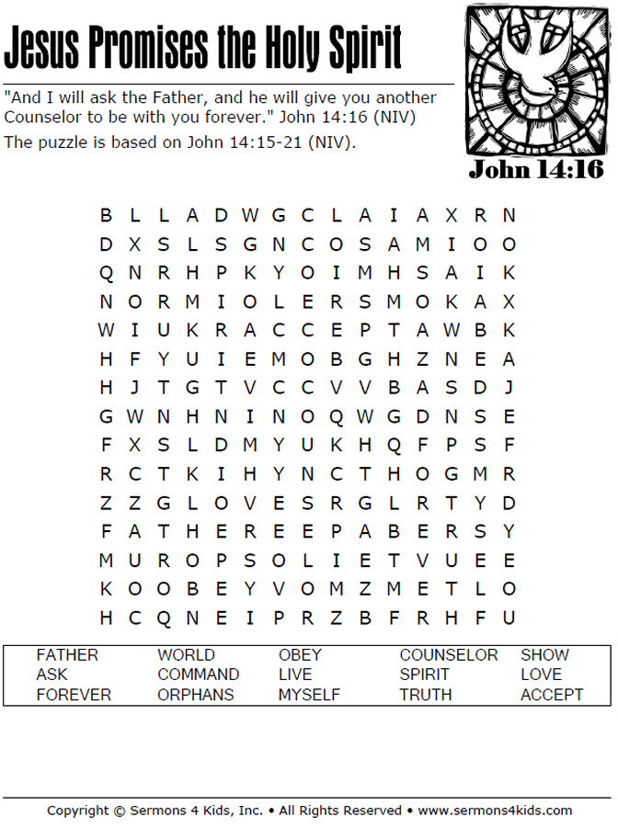

Zion Lutheran Church

May 14, 2023

