Welcome to ZION Lutheran Church
LCMC ~ Lutheran congregations in mission for Christ
8307 Memorial Hwy. Ottawa Lake, MI 49267 ·
(734) 856-2921
Worship Leader – Pastor Lois Clark
www.zionlutheranottawalakemi.com

Our MISSION:
“SHARING THE LOVE OF JESUS”

To Our Guests
We are so glad that you have chosen to join us this morning! We pray that you will be refreshed and renewed as you come into God’s presence. Please take a moment to introduce yourself to the pastor and to those seated around you. Once again, we warmly thank you for worshipping with us this morning!

Those Assisting in Ministry Today
may 28 , 2023 ~ Day of Pentecost
Organist: Joseph extejt Greeters : Ron Clark and All
deacon: Dwight Gilliland and Jim Hredzak
SCREEN: Nick Baumgartner
Reader and Assistant: Jim Hredzak
Altar Guild: Shirley Clark and JoAnn VanSteenkiste
Administrative Assistant: Brenda Blum 419-343-3381 or bcc220@aol.com

LCMC ~ WHO WE ARE
Free in Christ + Accountable to One Another + Rooted in Scripture and the Lutheran Confessions + Committed to the Great Commission

Thoughts on our Readings ~ (-- From the Sola Publishing Website)
The Common Thread
Wait for God. Too often, individuals and entire congregations rush ahead of the Spirit. They are determined to do things their way—even if that is the same old way, “the way we’ve always done it in our church.” But God is doing something new, and we may see it, if we wait. Without the outpouring of the Holy Spirit, and his guidance (inspiration), we stumble, at best. Alcoholics Anonymous describes insanity as “doing the same thing over and over again and expecting different results.” We may feel that we must move ahead, but faith (not feelings or emotions) bids us wait on the Lord so that we have renewed strength and godly courage (Isa 40:31, Psa 27:14).

Announcements

This Week at Zion Includes:
Today – Worship at 10:00 a.m.
Next Sunday – Worship at 10:00 a.m.

IN OUR PRAYERS:
- For our congregation members; that they may be committed to our mission of sharing the love of Jesus.
- For LCMC Congregation and Missionaries around the world.
- President Biden, national leaders and our country. Our nation’s military, especially our loved ones:
- For those who are sick, recovering, or in need of God’s grace at this time. We include in our prayers: Susan Gaylord, Betty Vesey, Parker Reau, Marilyn Bexten, and those dealing with Covid.

Prayer List: Please let us know when we can take the name off of the prayer list. Thank you!.

Services covered by CCLI: 1553677 ~ Lutheran Service Book Hymn License # 100014699 ~ Lutheran Service Book Liturgy License. # 000014699

OUR STEWARDSHIP ~ Weekly budget needs are $1,908.12. Sunday attendance was 35 and offering was $1875.00. Thank you for your support of our ministry!

Flowers on the Altar ~ If you would like to place flowers on the altar, please sign up in the hallway. Let Brenda know if you are celebrating or remembering something special. Please fill out the slip located by the flower chart and give to Brenda. Flowers this week are given to the glory of God by Fred and JoAnn VanSteenkiste.

There will be a Celebration of Life for Cindi Vaughan Young on August 11, 2023 at Oak Openings, 5402 Wilkins Rd., Whitehouse, OH from 2:00 p.m. -10:00 p.m.

Worship Service Order
Welcome

Opening Hymn:
LSB 904
“Blessed Jesus at Your Word”

Confession and Absolution
LSB 151
Kyrie: LSB 152
Hymn of Praise LSB 154

†GOD’S WORD FOR US†
(On Insert)
Collect of the Day
First Reading:
Numbers 11:24-30
Psalm:
Psalm 25:1-14
Second Reading:
Acts 2:1-21
Holy Gospel:
John 7:37-39
Hymn of the Day:
LSB 497
“Come Holy Ghost, God and Lord”
SERMON

Creed: Apostles’ Creed

Offering
Offering Hymn:
LSB 955
“Let the Vineyards Be Fruitful”
Prayers and Lord’s Prayer

Benediction ~ Sending

Closing Hymn:
LSB 809
“Great is Thou Faithfulness”
Announcements

“Go Now in Peace”
(Overhead)

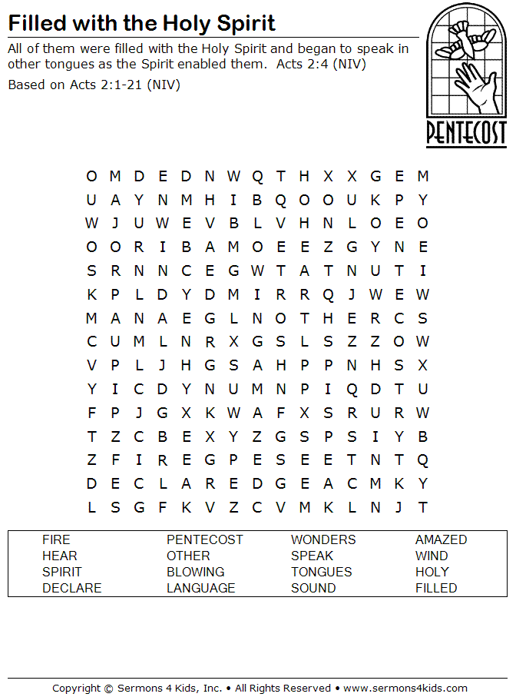

Zion Lutheran Church

May 28, 2023



